**The Great St Stephen’s Sleepout**

Well what a weekend that was! Huge thanks to all who camped out over the past 2 nights and to those who came along to support, to enjoy the BBQ, to sponsor or in any other way get

involved. It will take a few days to get sponsor money in and so hopefully we can announce the grand total in the next week or two.

**Big Brunch**

Thanks to everyone who came along to support the Big Brunch last week. After some additional cake and raffle sales last week, the final total raised for our Raising the Roof Campaign is a whopping £500! Well done all!

**Magazine**

The new parish magazine is available this morning in the conservatory. Please do pick up your copy and take one for anyone who you think might find it interesting.

**An Extraordinary PCC!**

Please could all members of PCC stay behind after the service for a very short meeting to agree the terms of our recent grant offer. Many thanks.

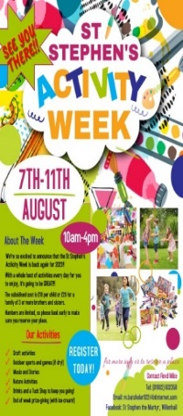**Play Week 2025**

We have already begun a waiting list for this year’s Activity Week as places have gone so quickly! Due to a few regulars not being around this year, we are in desperate need of volunteers during the week. If you are able to help out, please speak to Jane. If anyone is able to donate a bottle of squash to keep the children well-hydrated that would be gratefully received.

**Time and Talents**

Thank you to everyone who completed a Time and Talents questionnaire over the past few weeks. Look out for some new faces appearing in unexpected places over the next few weeks!



**All Creatures Great and Small**

On Saturday 9th August at 4pm, our St Stephen’s Pet Blessing Service is back by popular demand! Furry, feathered, scaly, big or small – all God’s creatures (and their humans) are welcome at this very relaxed and informal outdoor service, followed by refreshments.

**A Warm Welcome**

On Tuesday, Fr Philip Garrett was welcomed into his new ministry at St Giles’ and St Anne’s. After a long vacancy, it is great to see Philip taking up his new role and we look forward to working with him in the future.

**New Rotas**

The new welcomers rota is now out. Please pick up your copy from the back of church if you are involved in this ministry. The readers and intercessions rota will be available next week.

✞ St Stephen the Martyr

*Wolverhampton Street, Willenhall, WV13 2PS*

**7th Sunday of Trinity**

**3rd August 2025**

***Leader: Revd Ros Wilshire Preacher: Revd Kerry Holt***

|  |  |  |
| --- | --- | --- |
| WEEKDAY SERVICES | | |
| Sunday 3rd | 10am | Sung Mass |
| Wednesday 6th | 9.30am  9am  7pm | Morning Prayer in church  ‘Virtual’ Morning Prayer  Said Mass |



|  |  |
| --- | --- |
| **NEXT SUNDAY: Trinity 8 10th August 2025** | |
| *2nd Sunday of the Month* | Revd Ros Wilshire |
| **10am Sung Mass** | |