

**WELCOME**

**ST.STEPHEN’S CHURCH**

**is open 10am-3pm daily**

**for Private Prayer and Reflection**

**TODAY**

**3rd August 2025**

**THE SEVENTH SUNDAY AFTER TRINITY**

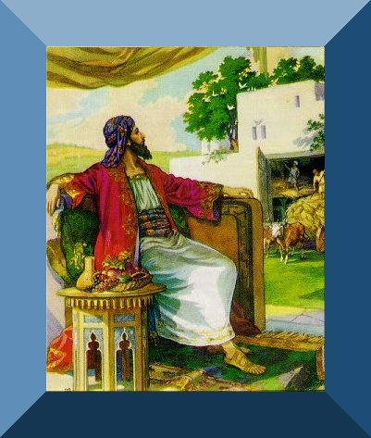

**9am Holy Communion**

**10.30am All Age Worship with The Music Group**

Any Notices for inclusion in the bulletin please email to me by Tuesday of each week

***officeststephenfradley@gmail.com***

**Please take Bulletin away with you**



Please note – in the Benefice there is a said Communion Service (Common Worship) at

10am every Wednesday - All Saints Church, Alrewas

**Diary Dates**

**Wednesday 6th August**

**2-4pm** Wednesday Welcome

**Friday 8th August**

**12. 30pm Funeral** of Josephine Anne Bowen at

Fradley Crematorium

**Sunday 10th August**

**10.30am Family Communion**

**Tuesday 12th August**

**3.30pm Bowbrook Service**at Bowbrook Care Home

**Wednesday 13th August**

**9.30-11.30am Churchyard Gang** in the churchyard

**Friday 15th August**

**11.55am VJ Day Commemorative Service**

**Sunday 17th August**

**10.30am Family Communion**

**Thursday 21st August**

**9.30am Events Committee (in church)**

**Next events**

**Saturday 13th September Ride & Stride**

Church is open to offer hospitality to riders, striders and drivers!

**Saturday 4th October 7pm Harvest Supper**

in Fradley Youth & Community Hall

**St Stephen’s Church**

**A Commemorative Service**

**for the 80th Anniversary**

**of**

**VJ Day**

(Victory over Japan Day)

**Friday 15th August**

Do join us as we take the opportunity to honour and pay tribute to those of the WW2 generation who paid such a great sacrifice for the freedom we enjoy today.

A short service will begin at **11.55am**

as we acknowledge the Two-minute National Silence at 12 noon.

There will be readings, music and prayers followed by light refreshments.

Welcome to our Worship today

If you are visiting for the first time, please introduce yourself so that we may welcome you personally.

Refreshments are served after every service – do join us!

**3rd August 2025**

**Collect**

Generous God,

you give us gifts and make them grow:

though our faith is small as mustard seed,

make it grow to your glory

and the flourishing of your kingdom;

through Jesus Christ our Lord.

**Readings**

Ecclesiastes 1.2, 12-14; 2.18-23

Luke 12. 13-21

**Post Communion**

Lord God, whose Son is the true vine and the source of life,

ever giving himself that the world may live:

may we so receive within ourselves

the power of his death and passion

that, in his saving cup,

we may share his glory and be made perfect in his love;

for he is alive and reigns, now and for ever.

***In our thoughts and prayers……***

God of peace and justice,  
we pray for the people affected by war and conflict today.  
We pray for peace and the laying down of weapons.  
We pray for all those who fear for tomorrow,  
that your Spirit of comfort would draw near to them.  
We pray for those with power over war or peace,  
for wisdom, discernment and compassion to guide their decisions.  
Above all, we pray for all your precious children, at risk and in fear,  
that you would hold and protect them.  
We pray in the name of Jesus, the Prince of Peace. Amen.

Keep us, good Lord,  
under the shadow of your mercy  
in this time of uncertainty and distress.  
Sustain and support the anxious and fearful,  
and lift up all who are brought low;  
that we may rejoice in your comfort  
knowing that nothing can separate us from your love  
in Christ Jesus our Lord. **Amen.**



…….Lichfield Food Bank relies on your generous donations. There is a collecting box in church – please bring along any donations.

GIVE HELP DONATE FOOD

Our food bank relies on your goodwill and support-

*Thank you!*



As a Dementia Friendly Church we support those impacted by this devastating illness.

Our Dementia Team support Bowbrook Care Home – a specialist dementia home in the heart of Fradley.

Our next service at Bowbrook is

Tuesday 12th August at 3.30pm.

We love to sing, share stories and crafts

More information contact our Dementia Champion –

Jenny Summers 07795 076661

**Re-ordering Project**

St Stephen’s PCC are working on a possible reordering of the interior of St Stephen’s Church.

The church is Victorian and to meets the needs of the growing community in Fradley whilst preserving the history and heritage of our beautiful building, suggestions have been made to reorder the interior.

The re-reordered space would allow our work with children – Messy Church and school events- to be facilitated as well as a more hospitable space for functions and services.

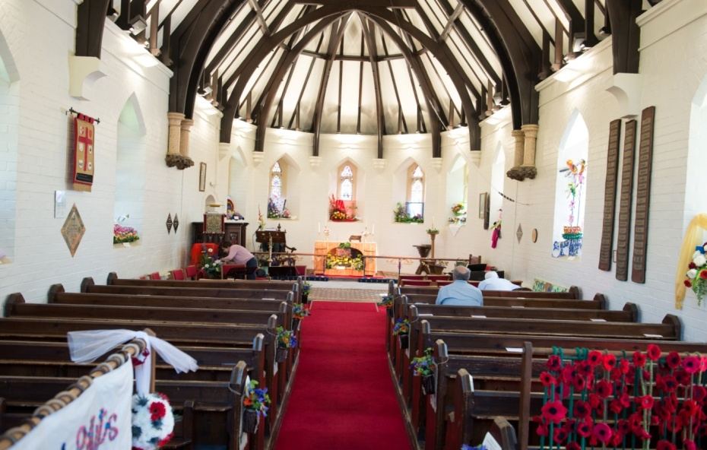

In 2007 work began on adding a very sympathetically and pleasing extension to make a meeting room on the north side.

In 2020 this was refurbished with more modern kitchen facilities.

A display will be in church from Sunday 27th July.

Please do view this and we will be appreciative of your comments as we try to serve the community in Fradley to the best of our ability.

 Can you help to support St Stephens Church?

St Stephen’s Church is heavily dependent on voluntary donations and income from events in order to fulfil its ministry to the local and wider communities.

If you would like to support us at this time,

donations can be made via our **Just Giving** page.

*We are grateful for any donation, large or small.*

[**https://www.justgiving.com/fundraising/ststephensfradley**](https://www.justgiving.com/fundraising/ststephensfradley)



## Contact us

## Revd Elizabeth Wall

## 01543 254891

## Email: [ayton265@gmail.com](mailto:ayton265@gmail.com)

## Churchwarden

## Marian Derry 01283 791573

## 

## St Stephen’s Administrator: Di Cooper  07930162991

## Email: officeststephenfradley@gmail.com

## Find us on

## ACNY https://www.achurchnearyou.com/church/4123/

**Face book:** [**www.facebook.com/ststephensfradley**](http://www.facebook.com/ststephensfradley)

DC 30/07/25