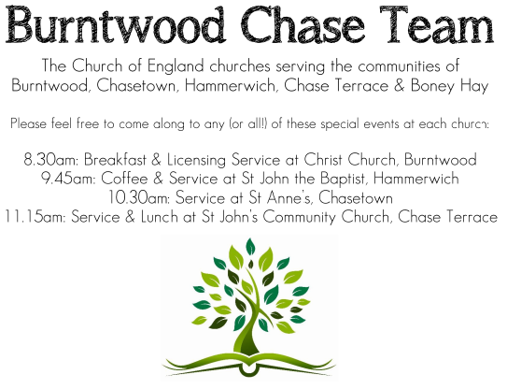 **CHRIST CHURCH**

SUNDAY 31st August 2025 at 10am

**SERVICES:**

**Sunday 31st August 2025**

**Morning Worship**

**11th Sunday after Trinity**

**Readings:**

**Hebrews 13: 1-8, 15-16**

Let mutual love continue. **2**Do not neglect to show hospitality to strangers, for by doing that some have entertained angels without knowing it. **3**Remember those who are in prison, as though you were in prison with them; those who are being tortured, as though you yourselves were being tortured.[[a](https://www.biblegateway.com/passage/?search=hebrews%2013%3A%201-8&version=NRSVA#fen-NRSVA-30228a)] **4**Let marriage be held in honour by all, and let the marriage bed be kept undefiled; for God will judge fornicators and adulterers. **5**Keep your lives free from the love of money, and be content with what you have; for he has said, ‘I will never leave you or forsake you.’ **6**So we can say with confidence,

‘The Lord is my helper;  
    I will not be afraid.  
What can anyone do to me?’

**7**Remember your leaders, those who spoke the word of God to you; consider the outcome of their way of life, and imitate their faith. **8**Jesus Christ is the same yesterday and today and for ever.

**15**Through him, then, let us continually offer a sacrifice of praise to God, that is, the fruit of lips that confess his name. **16**Do not neglect to do good and to share what you have, for such sacrifices are pleasing to God.

**Luke 14: 1, 7-14**

On one occasion when Jesuswas going to the house of a leader of the Pharisees to eat a meal on the sabbath, they were watching him closely.

**7**When he noticed how the guests chose the places of honour, he told them a parable. **8**‘When you are invited by someone to a wedding banquet, do not sit down at the place of honour, in case someone more distinguished than you has been invited by your host; **9**and the host who invited both of you may come and say to you, “Give this person your place”, and then in disgrace you would start to take the lowest place. **10**But when you are invited, go and sit down at the lowest place, so that when your host comes, he may say to you, “Friend, move up higher”; then you will be honoured in the presence of all who sit at the table with you. **11**For all who exalt themselves will be humbled, and those who humble themselves will be exalted.’

**12**He said also to the one who had invited him, ‘When you give a luncheon or a dinner, do not invite your friends or your brothers or your relatives or rich neighbours, in case they may invite you in return, and you would be repaid. **13**But when you give a banquet, invite the poor, the crippled, the lame, and the blind. **14**And you will be blessed, because they cannot repay you, for you will be repaid at the resurrection of the righteous.’

**COLLECT FOR TODAY**

Our God, you declare your almighty power

most chiefly in showing mercy and pity:

mercifully grant to us such a measure of your grace,

that we, running the way of your commandments,

may receive your gracious promises,

and be made partakers of your heavenly treasure;

through Jesus Christ your Son our Lord,

who is alive and reigns with you,

in the unity of the Holy Spirit,

one God, now and for ever.

***WHAT’S GOING ON***

**Upcoming Services**

**Monday 1st September Cameo Cafe 10-12noon**

**Wednesday 3rd September Morning Prayer 9.30am**

**Saturday 6th September Art Cafe 3-5pm**

**Sunday 7th September Holy Communion 10am**

**Cameo Cafe**

Cameo Cafe will be open on Monday 1st September at 10am.

All welcome to join us for a cuppa and biscuits.

**Art Cafe**

Art Cafe will be open on Saturday 6th September 3 till 5pm.

All welcome to join.

**FLOODLIGHTING**If you think about commemorating a special occasion by floodlighting our Church.  Please contact Chris Brown on 01543 683862 for details.

PRAYER CHAIN

Christ Church is blessed with a very active prayer chain. If you, or anyone you know, feel that they would like others to pray for them, please speak to Chris Brown on 01543 683862.

HOME COMMUNION

For anyone who is unable to attend church and would like Home Communion,

Steve Morgan is able to carry this out.

VICAR CONTACT DETAILS

Stephen Morgan Tele: 07305 852152

**CHURCH WARDENS CONTACT DETAILS**

**Judith Rogers Tele: 01543 324718**

**Mike Holmes Tele: 01543 672970**

**Church Office Tele: 01543 642187** *[leave a message and we will respond]*

Church Web Site:www.christchurchburntwood.org.uk

Church Email: [christchurchburntwood15@gmail.com](mailto:christchurchburntwood15@gmail.com)

Facebook: [www.facebook.com/group/christchurchburntwood/](http://www.facebook.com/group/christchurchburntwood/)

**Other Contacts**

**Matt Wallace St. John’s, Chase Terrace— Tele: 01543 670078**

**Richard Westwood St. Anne’s, Chasetown—Tele: 01543 686111**

**NEXT SUNDAY SERVICE**

**Sunday 7th September at 10am**

**Holy Communion**

**Philemon 1-21**

**Luke 14: 25-33**

**12th Sunday after Trinity**