Acrise Church News for September 2025
Services for September (all at 9.30am)
Sunday 7th September Holy Communion Sharon
Sunday 14th September Matins BCP Paul
Sunday 21st September Morning Prayer Diana
Sunday 28th September Family Harvest Service Janet

The Rector’s Message

By the time you read this message I shall hopefully be away on holiday.
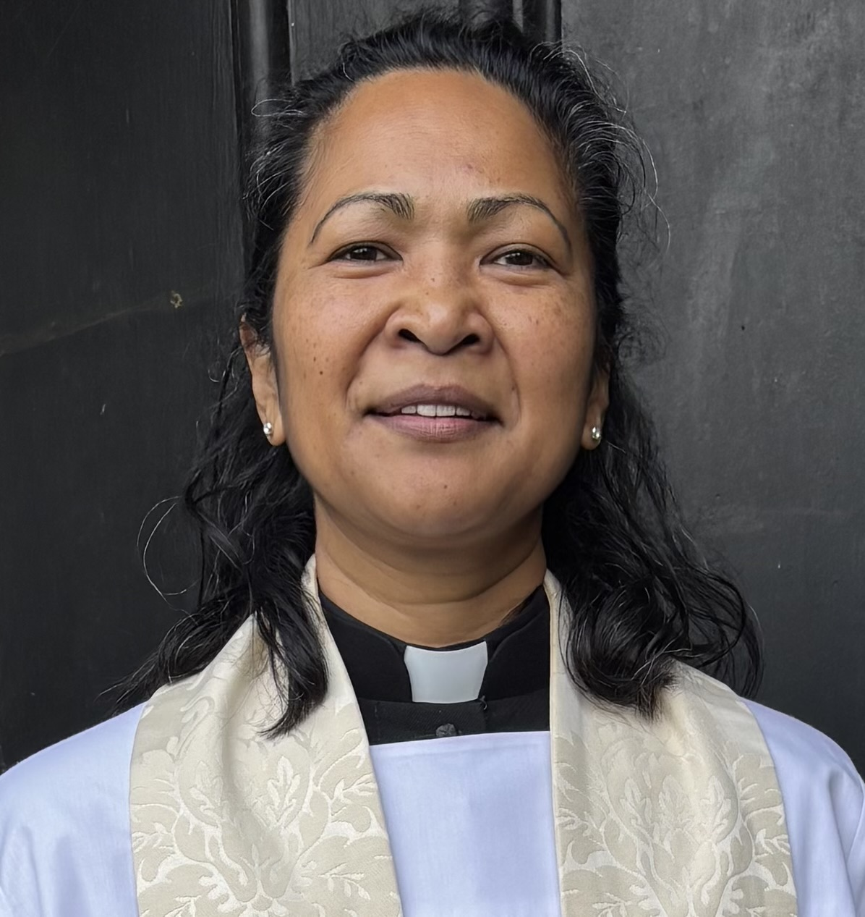
Some of you will have already returned home or back to work after having been away.
Some may not have been away at all and spent the summer maintaining your daily routine.

However we spend our time, whether we go or stay, rest or play, let us be grateful for the gift of each new day in God’s grace. Let us celebrate and strive for peace in our nation and work for the common good.

As we rejoice in the gift of this new day, so may the light of your presence, O God, set our hearts on fire with love for you; now and forever. Amen.
Preparation prayer for Morning Prayer

Acrise Festival
We were lucky to have a fine day for the Festival, which might partly account for what must have been a record attendance, judging by the car park which was full for most of the time between 10.00 am and 2.30 pm. The event illustrates what can be achieved when everyone works together as a team to create a welcoming and friendly atmosphere.
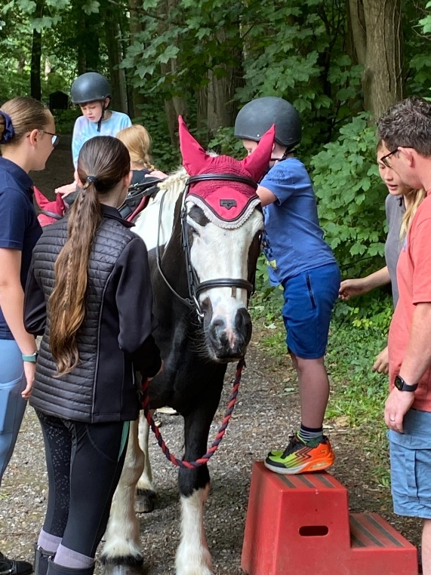

The PCC would like to thank everyone who helped in any way, with preparation, on the day itself, or with clearing up. All the generous donations were also a great help. We are grateful to all the visitors who attended to make the day so successful. All this support made the event a success in terms of money raised, which was approaching £6,000, but also in terms of a happy community gathering where we were able to meet up with existing friends and acquaintances as well as making new contacts.
What is so special about Acrise Festival is the historic church, set in this area of natural beauty on the North Downs, which is transformed by the array of colorful and fragrant flower decorations. This year most of the flowers were from people’s gardens or the local Gingerly Green Flower Farm at Selsted. Our flower arrangers, (and anyone is welcome to join them), have avoided the use of oasis wherever possible and used more natural materials.
The Festival is popular, not just as a place to meet up, but it is a traditional event and nothing is too expensive. The parking is free and there is no charge for entry. All the stalls and activities raise money for the upkeep and expenses of the church: no one is there to make money for themselves.
While the church is at the centre of the Festival, there is much going on outside on the Green. The programme of varied music and songs added to the atmosphere of the day. The refreshment tent, serving ploughmen’s lunches, cakes, savouries and drinks was kept busy. Visitors could enjoy food and drink while listening to the music or between browsing among the various stalls.
There was a range of stalls offering a variety of interesting goods for sale, including many bargains, as well as the Raffle and Tombola. The bowling for child and adult prizes was well run by Oscar and his friends and we are grateful for the pony rides along the drive thanks to Fiona and the Pony Club girls. We also had children’s games such as guess the name of the soft toy.

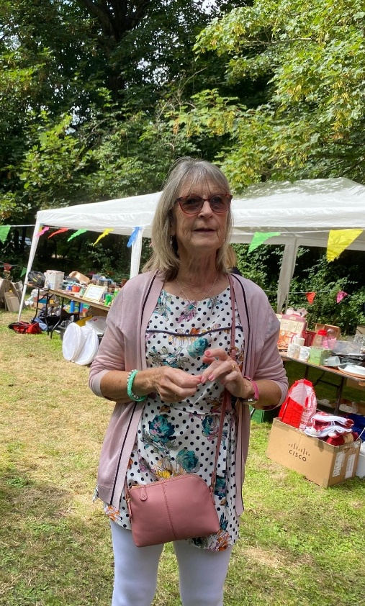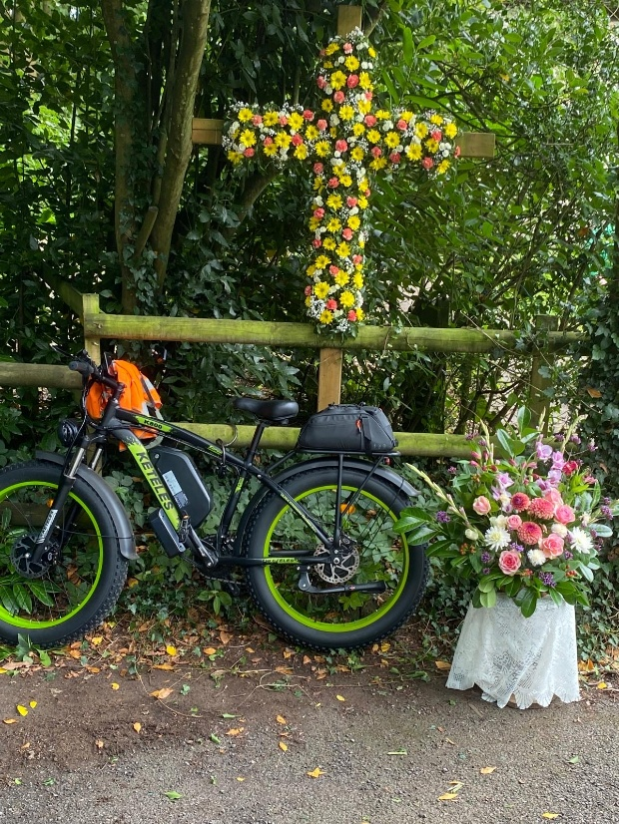

Thanks again to everyone and we hope to see you in 2026 when the Acrise Festival is on Saturday 1st August.

Renewal of Marriage Vows
Holy Communion on Sunday 3rd of August was followed by the Renewal of Marriage vows for Joan and John Reymond on their 50 years of marriage and for their daughter and son-in-law Claudine and Paul Rowley after 25 years of marriage. This was a very happy and moving occasion led by Rev Sharon and the congregation was pleased to join in the celebration for both couples with music, readings and poems from family and friends.
The service was followed by light refreshments, champagne and or coffee and a celebration cake. It was lovely to be able to share this happy occasion with the family at St Martin’s.


St John’s Commandery, Swingfield
This is one of our local historic buildings which will be open to the public from 12th to the 29th September. It is usually open only by appointment on 07590753394.
The 13th Century Chapel is the only remaining building of the Commandery of the Knights Hospitallers of St John of Jerusalem. A Commandery was an administrative unit (or an estate) of the Hospitallers’ possessions set up after they came to England in 1100. Eventually there were 38 of these Commanderies in England, four in Kent, one of which was Swingfield.
These estates are often referred to as Preceptories with a Preceptor but these terms belong properly to the Knights Templars. When the order of the Knights Templars was dissolved by the Pope in 1312 its estates were confiscated and given to the Hospitallers. The two terms, Commandery/Commander and Preceptory/Preceptor came to be used indiscriminately.
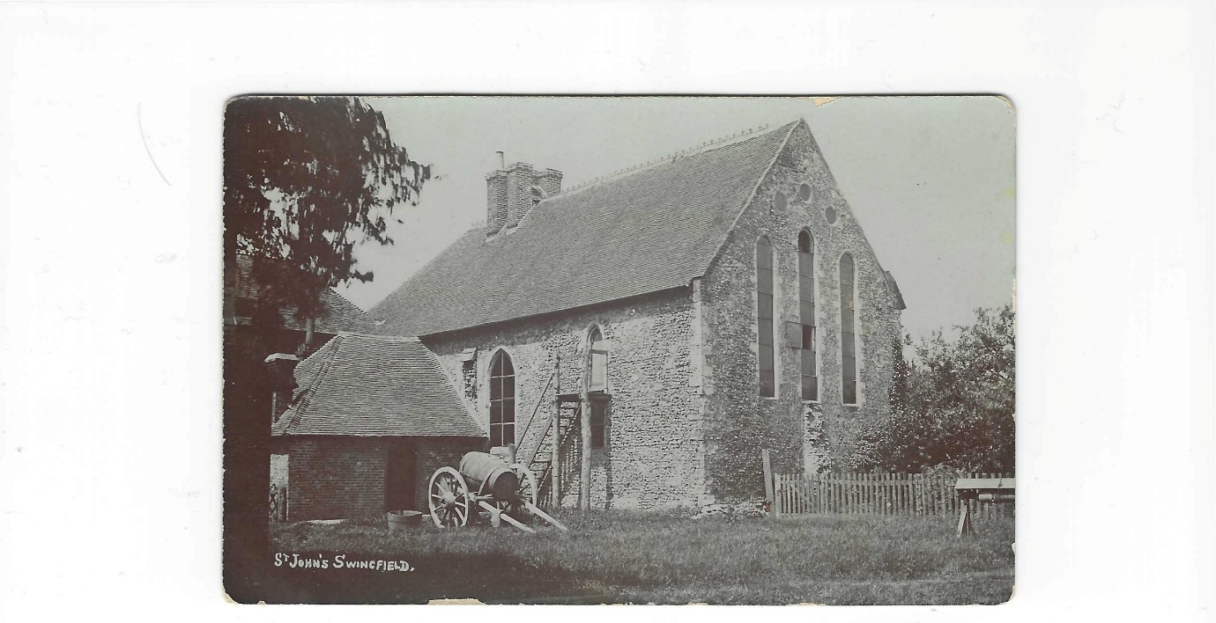
This is a family postcard of the chapel as a farmhouse in 1908 when Thomas Prebble was farming at St John’s.
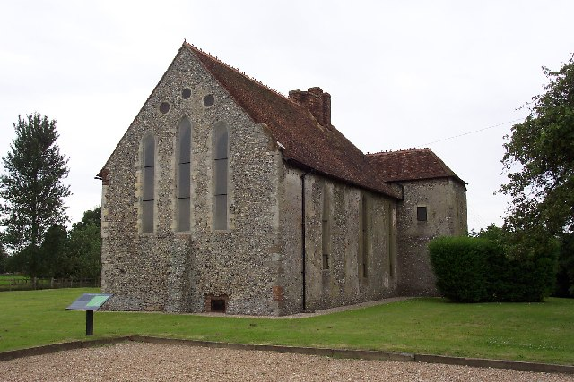
In the early 1970s English Heritage took over the Chapel and restored it. Here is a recent photo. More detail about the Commandery will be in next month’s News.

Ride and Stride for Kent Churches
This takes place on Saturday 13th September. As mentioned in last month’s News the Friends of Kent Churches gave grants totaling £169,500 to 36 churches to help with essential repairs. This year’s Ride and Stride is also the 40th anniversary of Ride and Stride.
The church will be open from 10.00am until 6.00pm. We have volunteers to man the church from 10 until 12 but would also appreciate volunteers between 12 and 6. As there is a wedding on that day the table of paperwork and refreshments will need to be in a corner of the carpark or in the drive until the wedding is finished.
Sue, Mike and Richard will be riding or striding on the day and would be grateful for any sponsors. Their sponsor forms will be in church on 24th August and 7th September.
Shepway Foodbank/Rainbow Centre
Please continue to support the local foodbank by leaving items at the back of the church or in the porch if the church is locked. Alternatively you can donate money online.
We always receive generous donations of food as part of our Family Harvest Service (this year on Sunday28th September) and at our Harvest Communion on the first Sunday in October.
Most urgently needed items are: veggie meals in a tin, curry sauce, white cooking sauce, honey, chocolate spread, washing capsules.
Other items often needed are: coffee, marmite, tinned meat, fruit or veg, long life milk, jam, mashed potatoes, biscuits/chocolate.

The Acrise Environmental Group
In the June report the Acrise Heritage Ponds Project was mentioned. Our District Councillor Stephen Scoffham put in a bid for the District Council’s Green Grant Scheme (there were 59 bids) and the good news is that the bid for around £10,000 was successful. It is to be used for a trial Heritage Pond Project in Acrise.
At the last meeting of the Environmental Group on 28th April Stephen agreed to liaise with Saly Evans of Kent Downs National Landscapes to arrange a talk from ecology and archeology experts on what the Heritage Ponds Project will involve. A good time for this talk would be this autumn.

A Topical Poem
Refugees by Brian Bilson
Born in 1970 and known as the poet laureate of Twitter and the Banksy of the poetry world, he wrote this poem in 2016.
Refugees
They have no need of our help
So do not tell me
These haggard faces could belong to you or I
Should life have dealt a different hand
We need to see them for who they really are
Chancers and scroungers
Layabouts And loungers
With bombs up their sleeves
Cut throats and thieves
They are not
Welcome here
We should make them
Go back to where they came from
They cannot
share our food
Share our homes
Share our countries
Instead let us
Build a wall to keep them out
It is not ok to say
These are people just like us
A place should only belong to those who are born there
Do not be stupid to think that
The world can be looked at another way
_______________________

(Now read from bottom to top, line by line)

