** SPIRE & LIGHT United Churches**

United Benefice of St Keverne, St Ruan with St Grade & St.Wynwallow (The Lizard)

**\*If you do not wish to receive these notices, please let your Churchwarden know\***

**27th July 2025**

***Trinity 6***

**Readings**

**Genesis 18:20-32**

**Psalm 138**

**Colossians 2:6-15**

**Luke 11:1-13**

9.30am –– Morning Prayer - St.Peter’s, Coverack

9.30am – Holy Communion– St.Ruan, Ruan Minor

11am – Holy Communion - St.Keverne Church

11.15am – Café Church – St.Wynwallow, The Lizard

Next week – Sunday August 3rd

9.30am –– Holy Communion- St.Peter’s, Coverack

9.30am –– Holy Communion (BCP) - St.Wynwallow, The Lizard

11am –- Morning Prayer (BCP) - St.Keverne Church

11am – Vintage Rally - Ruan Minor

**The Prayer Spot**

Dear Heavenly Father, as we come to pray to you today, remind us of the love we must share with others, that love given to us by you. Help us to remember those in need within our churches and community and how we can be there for them - it may just need an act of kindness just to show we really care for them.

It says in 1 PETER 1 “Therefore prepare your minds for action, be self-controlled, set your hope fully on the grace to be given to you when Jesus Christ was revealed to you. As obedient children of God do not conform to self-desires you had when you lived in ignorance but as he who has called you is Holy so be holy in all you do for it is written to be holy because I am Holy.”

Remember God has given you gifts to use for the needs of others. Use them well because everyone needs your help in times of troubles. Be generous and full of God’s love, pray for all those who are in need of hospital treatment and that God will be present with them and for those who have the job of taking them. Pray for all our benefice that God will guide us in our care for everyone and to remember them all in our prayers.

*We praise you for your kindness and all the love you give us, for your endless willingness to forgive us when we fail you. We thank you for the love shown to us as members of your flock, for being the shepherd who guides us through each day. Thank you for those wonderful gifts given to us of forgiveness, justice, generosity, and peace and of course that great joy of knowing your presence in our lives.*

As always, I tell you God will be ever present in your prayer time and will answer all your prayers in the name of His Son Jesus Christ. Be blessed by all you do in His name.

*O God our Father, grant that whatever happens to us today we may take it to thee. If we shall have decisions to make help us to ask for your guidance and grant us humility and obedience to take it when you give it to us. If we shall have problems to solve, help us ask for thy light upon them so we may see a clear way through them. Help us through today to decide everything by thy will and to test everything by thy presence so that we may come to the days ending without mistakes and without regrets through Jesus Christ our Lord. Amen*

***The Diocese of Truro’s Prayer Diary for this week***

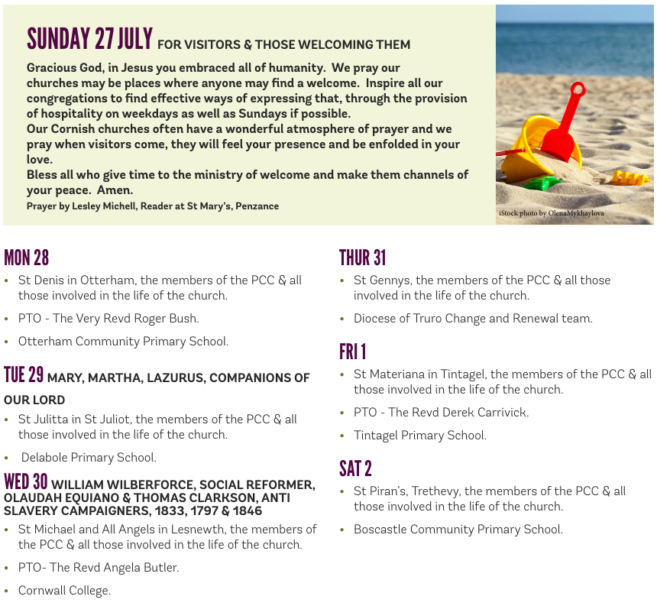

**On the Way Prayers**

Lord we just take a moment to breathe, to listen; confident that you are listening to us. We pray that as a Deanery, we are listening to you.

Recently another successful Deanery Day at Gunwalloe was held for over 50 Year 6s from several of our schools. As part of that day they reflect on the fact that life is a journey and they are at one of the important cross roads.

We pray that as a Deanery we are altering, so that we will grow. This is the whole purpose of the On the Way Process; that we will grow in faith, that we will grow in number and that we will grow in confidence to spread your Gospel in this incredible part of your world, where you have very particularly placed us.

As individuals we are all on a journey; the journey of life. Some of us have dramatically changed the course of our lives in the last few years. In a moment of quiet let us each reflect on our own personal journey – has it been smooth? Has it altered its course? Are we happy with where we currently are? Just pray to God to help you on your way.

Now let us think about the church that we are most involved with. Has that changed, has it grown? If it has, give thanks. If it hasn’t changed, how could it? Let us all ask God for guidance to show us how we can keep changing, how we can keep up with this radically changing world and, in the midst of all this, how we can provide stability, security and safe spaces. We pray that we keep your church alive, relevant and sustaining for all our current congregations as well as moving forward. Living and Loving God,the God of all our journeying, we give you thanks and praisethat you are always ‘On the Way’ with us,walking step by step along the pilgrim path. God within us, God beside us, God behind us, God before us.

We give thanks for all the volunteers and clergy who helped with the Gunwalloe Beach days, particularly Lord, asking for your blessing on Henrietta, who did so much work organising everything.

At Deanery Synod last week, the proposal to alter our Deanery plan to appoint a third stipendiary priest received unanimous support. This was very much supported by the Diocese so now the process can begin to find the right person for this post. And let us give thanks too for all members of the Deanery Implementation Team who meet regularly and who do so much work on our behalf.

Some of us are going through really turbulent times in our life’s journey. Let us now take a moment to bring before God anyone known to us who needs our special prayers at this time.

Our schools have now broken up and the summer holidays start in earnest, let us pray for everyone involved in the tourist industry, let us pray for good weather and let us conclude our prayers with confidence. God within us, God beside us, God behind us.