Acrise Church News: August 2025

Church Services for August (all at 9.30am)
Sunday 3rd August Holy Communion Sharon
This will include the Renewal of Marriage Vows for Joan and John Reymond and their daughter Claudine and son-in-law Paul.
Everyone is welcome to join us for light refreshments after the service.
Sunday 10th August Matins BCP Janet
Sunday 17th August Morning Prayer CW Janet
Sunday 24th August Service of the Word Paul

Benefice Service
Sunday 31st August 10.00am at Swingfield Rev Martin Jewitt

The Garage Sale and Raffle 28th June - 5th July
This was a great success and raised £2,359.20, which is a record.
Our thanks go to Richard who organised the event opened his garage as well as using his house as a store and providing refreshments. Thanks also to all those who helped or attended to buy items. Also to those who generously provided raffle prizes.
. Not only does the Garage Sale raise money for St Martin’s Church but it is a community event when people meet up to chat and enjoy refreshments while browsing and buying.

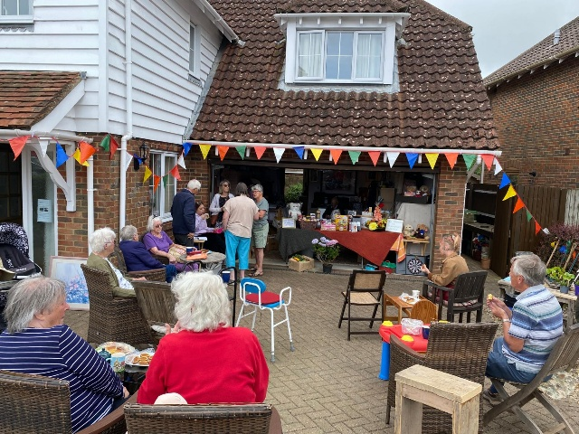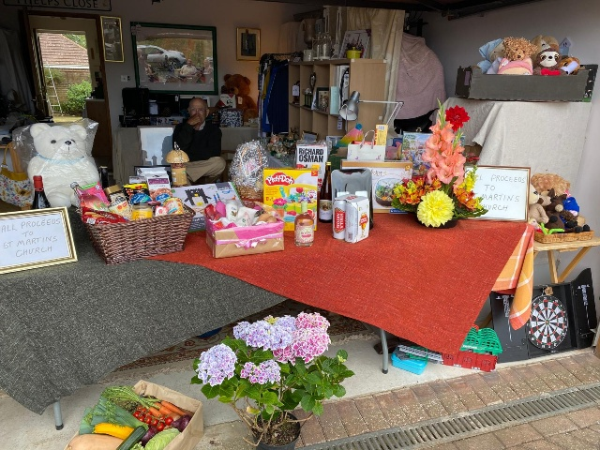
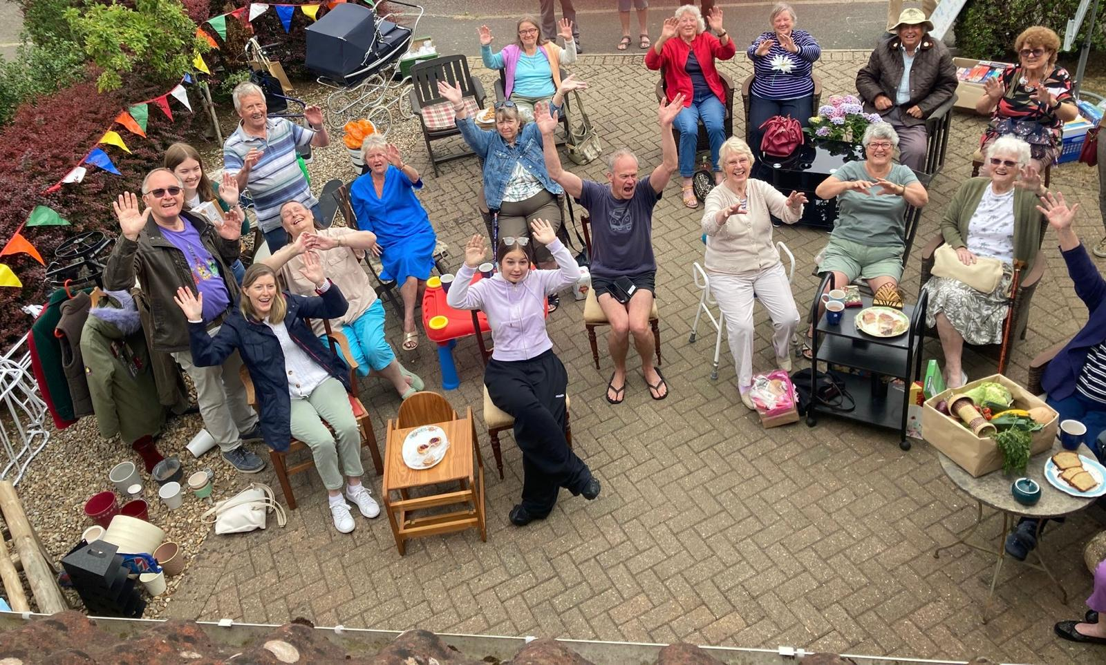

FUND RAISER FOR ST MARTIN’S CHURCH ACRISE 2005

THANK YOU!
You helped raise a total of (at the time of writing) £2,359.20

Thank you for your support …we hope you enjoyed this year’s Garage Sale and Raffle /as much as we did/or you picked yourself up a bargain or perhaps were lucky enough to be a prize winner?!

Items left over will go to the stalls at the Church Fete at St Martin’s Acrise on Saturday 2nd August, open from 10 a.m.to 5 p.m. Others will go to a variety of charities so that nothing isc wasted.

With our best wishes

Richard and the Garage Sales Team

Treasurer Needed
St Martin’s Parochial Church Council is looking for someone with experience of bookkeeping/finance who would be willing to take on the role of Treasurer from March 2026. Ideally this person could work with our current long-standing Treasurer Jean Grieb to find out about the role before she steps down in March 2026.
We would be grateful for anyone willing to help. For more information please contact Jean on 01303892364 or our Church Warden Simon Smith on 07999515551.
Ride and Stride for Kent Churches
This will take place on Saturday 13th September 2025.
Last year the Friends of Kent Churches gave grants totalling £169,500 to 36 churches to help with essential repairs. This was possible because the magnificent sum of £151,018 was raised by last year’s Ride and Stride.
2025 is the 40th anniversary of Ride and Stride, and St Martin’s Church and Sue’s family have been involved in raising money since it began. We have not yet applied for a grant but may need to do so for roof repairs sometime in the future.
We will again be taking part, and our church will be open from 10.00am until 6.00pm on 13th September. As there is a wedding that day the paperwork and refreshments will need to be outside while the wedding is on. If anyone can sit in the church in the morning,outside while the wedding in on or back inside after that, please let us know.
We (Sue and Mike, and Richard) would be grateful for sponsors nearer the time.

Shepway Foodbank / Rainbow Centre
Over 90% of the food distributed by Foodbanks in the Trussell Trust network are donated by the public- that’s why these donations are vital to the foodbanks’ ability to give everyone referred to them a balanced and nutritious three day supply of food.
Please continue to support the foodbank by leaving items at the back of the church or in the porch if the church is locked. Alternatively you can donate money online. Thanks for recent donations.
Most urgently needed items are: gluten free foods, white cooking sauce, tinned meat, mashed potatoes, washing pods, toilet rolls.
We take donations to the local collection point at Hawkinge Community Centre.

Acrise Festival: Final Reminder
Saturday 2nd August 10.00am until 5.00pm
On Monday 28th July from 10.00am we will be spring cleaning the church in preparation for decorating it with flowers on Friday 1st August. We will also be tidying up outside. Any volunteers will be welcome.
On Friday 1st August the church will be decorated with flowers and foliage and the site will be prepared for the Saturday. Gazebos will be put up, stalls prepared, tables and chairs put out and the car park made ready.
If you can donate any flowers or foliage from your garden and leave them outside the church on the morning of 1st August, we would be grateful.
Many thanks to all those peole who have volunteered to help at the Festival on Saturday 2nd August. More volunteers would be very welcome!
Donations
We would be grateful for raffle and tombola prizes, good quality bric a brac, and any home grown produce for the produce stall.
Donation of cakes, biscuits and savouries would be welcome on the Saturday morning.
Contact
For Tombola prizes contact Jean Grieb on 01303892364
For collection of items or enquiries contact Sue on 01303844640
