**God is Good!!**

Thank you to everyone who has been praying for the past few weeks for our big Raising the Roof grant application. We heard on Monday that this has been accepted! We have been awarded a huge £50,000 towards our Raising the Roof Campaign. We have 3 smaller grant applications outstanding, but all being well, this means that we will be

able to begin work on the roof at the end of September and be watertight in time for the Winter. We thank God for his faithfulness and his amazing provision!

**Messy Church in the Park**

For our Messy Church this month we are joining in with the Salvation Army Picnic in the Park event. We will meet at 3pm by the craft tent near the band stand to enjoy the live music and crafts. Do bring your friends and family along.

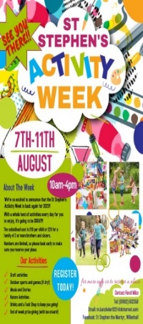**Play Week 2025**

We have already begun a waiting list for this year’s Activity Week as places have gone so quickly! Due to a few regulars not being around this year, we are in desperate need of volunteers during the week. If you are able to help out, please speak to Jane. If anyone is able to donate a bottle of squash to keep the children well-hydrated that would be gratefully received.

**Big Brunch**

On Saturday 26th from 9am – 1pm we will be holding a Big Brunch in aid of the Raising the Roof campaign. All the

****usual breakfast fare will be available at very reasonable prices, along with a raffle, cake counter and a few activities. A bottomless coffee/tea pot will be available for all eating customers! We are on the look-out for donations of cakes to sell at this event. If you are able to help out, please speak to Jean Taylor. Many thanks.

**The Great St Stephen’s Sleepout**

Only 2 weeks until the great sleep-out. If you would like to join in by pitching your tent (either on the roof or on the floor!), please speak to Ros. Posters and sponsor forms are now available.

Please spread the news and encourage friends and family to sponsor us.

**Meet the Romans!**

The Romans course continues this Saturday 2-3.30pm. If you weren’t able to make it to the first session, don’t worry, you can quickly catch up!



**Time and Talents**

The short questionnaire given out this morning gives us all the opportunity to reflect on our gifts and talents and to think about if there are opportunities we would like to explore in using these at St Stephen’s. A post box will be available at the back of church for the next couple of weeks for the return of the questionnaires.

✞ St Stephen the Martyr

*Wolverhampton Street, Willenhall, WV13 2PS*

**5th Sunday of Trinity**

**20th July 2025**

***Leader: Revd Ros Wilshire Preacher: Tina Titley***

|  |  |  |
| --- | --- | --- |
| WEEKDAY SERVICES | | |
| Sunday 20th | 10am  3pm | Sung Mass  Messy Church in the Park |
| Wednesday 23rd | 9.30am  9am  7pm | Morning Prayer in church  ‘Virtual’ Morning Prayer  Said Mass |



|  |  |
| --- | --- |
| **NEXT SUNDAY: Trinity 6 27th July 2025** | |
| *3rd Sunday of the Month* | Revd Kerry Holt |
| **10am Sung Mass** | |