

**WELCOME**

**ST.STEPHEN’S CHURCH**

**is open 10am-3pm daily**

**for Private Prayer and Reflection**

**TODAY**

**27th July 2025**

**THE SIXTH SUNDAY AFTER TRINITY**

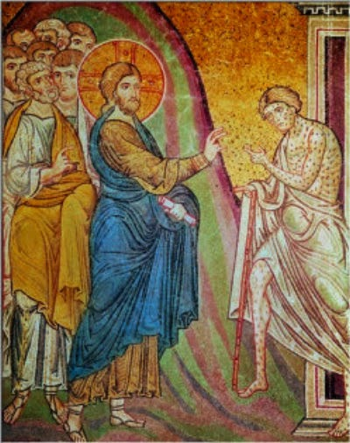

**10.30am Family Communion**

Any Notices for inclusion in the bulletin please email to me by Tuesday of each week

***officeststephenfradley@gmail.com***

**Please take Bulletin away with you**

Welcome to our Worship today

If you are visiting for the first time, please introduce yourself so that we may welcome you personally.

Refreshments are served after every service – do join us!

**27th July 2025**

**Collect**

Creator God,

you made us all in your image:

may we discern you in all that we see,

and serve you in all that we do;

through Jesus Christ our Lord.

**Readings**

**Exodus 24.3-8 Psalms 50. 1-6, 14-15**

**Matthew 13. 24-30**

**Post Communion Prayer**

Lord of all power and might,

the author and giver of all good things:

graft in our hearts the love of your name,

increase in us true religion,

nourish us with all goodness,

and of your great mercy keep us in the same;

through Jesus Christ your Son our Lord,

who is alive and reigns with you,

in the unity of the Holy Spirit,

one God, now and for ever.



**In our thoughts and prayers……**

God of peace and justice,  
we pray for the people affected by war and conflict today.  
We pray for peace and the laying down of weapons.  
We pray for all those who fear for tomorrow,  
that your Spirit of comfort would draw near to them.  
We pray for those with power over war or peace,  
for wisdom, discernment and compassion to guide their decisions.  
Above all, we pray for all your precious children, at risk and in fear,  
that you would hold and protect them.  
We pray in the name of Jesus, the Prince of Peace. Amen.

Keep us, good Lord,  
under the shadow of your mercy  
in this time of uncertainty and distress.  
Sustain and support the anxious and fearful,  
and lift up all who are brought low;  
that we may rejoice in your comfort  
knowing that nothing can separate us from your love  
in Christ Jesus our Lord. **Amen.**

**Calling all local**

**Staffordshire historians!**

The Staffordshire History Development Trust supports the work of the new Staffordshire History Centre where many ecclesiastical parishes have deposited their unique and informative registers and records.  The Diocese of Lichfield appoints a trustee to the Trust which meets usually online around 3 times a year.  There is currently a vacancy for a Diocesan appointee so if you are keen on local history and Staffordshire, and wish to help promote and support both,  please do contact Mithra Tonking at [mithra.tonking@lichfield.anglican.org](mailto:mithra.tonking@lichfield.anglican.org) or at St Mary’s House, The Close, Lichfield WS13 7LD for any further information

[https://www.staffordshirehistory.org.uk/staffordshire-history-centre/](https://anglican.us2.list-manage.com/track/click?u=acaad43ba0b06e97275112db2&id=ae9b6a3edd&e=e30a7fc49e)

**Re-ordering Project**

St Stephen’s PCC are working on a possible reordering of the interior of St Stephen’s Church.

The church is Victorian and to meets the needs of the growing community in Fradley whilst preserving the history and heritage of our beautiful building, suggestions have been made to reorder the interior.

The re-reordered space would allow our work with children – Messy Church and school events- to be facilitated as well as a more hospitable space for functions and services.

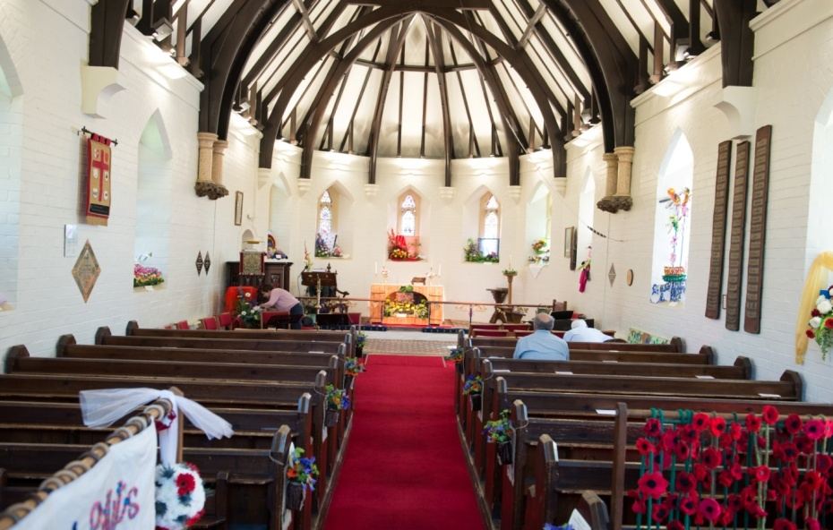

In 2007 work began on adding a very sympathetically and pleasing extension to make a meeting room on the north side.

In 2020 this was refurbished with more modern kitchen facilities.

A display will be in church from Sunday 27th July.

Please do view this and we will be appreciative of your comments as we try to serve the community in Fradley to the best of our ability.

**News from Lichfield Cathedral**

**Wildlife Photographer of the Year**

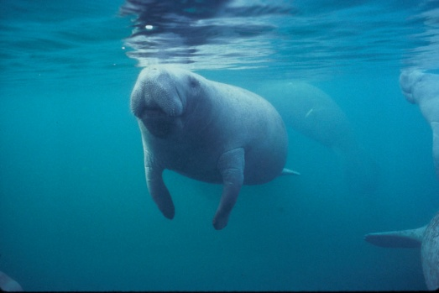

From Saturday 26 July to Sunday 31 August 2025, Lichfield Cathedral is hosting the Natural History Museum's Wildlife Photographer of the Year Exhibition.

This world-renowned exhibition, now in its 60th year, celebrates the wonder of the natural world through the best wildlife photography. Each year, the exhibition embarks on an international tour seen by millions of people all over the world. For the summer of 2025, its home will be Lichfield Cathedral, where visitors can explore over 80 breathtaking images alongside soundscapes and film footage. This multi-media exhibition offer insights into the diversity, fragility and beauty of life on Earth,

and what we can do to protect it.

The exhibition will be presented inside the Cathedral alongside our regular summer activities, **including the extremely popular Beach on the Cathedral's West Front which will return for its fourth summer.**

**Diary Dates**

Please note – in the Benefice there is a said Communion Service (Common Worship) at

**10am every Wednesday - All Saints Church, Alrewas.**

**Wednesday 30th July 2-4pm ‘Wednesday Welcome’**

A Places of Welcome Drop –in for tea, coffee, cake and chat. All welcome**.**

**Sunday 3rd August**

**9am Holy Communion** (Book of Common Prayer)

**10.30am All Age Worship** with The Music Group

**Next events ……**

**Saturday 13th September Ride & Stride**

Church is open to offer hospitality to riders & striders!

**Saturday 4th October 7pm Harvest Supper**

in Fradley Youth & Community Hall

**PARISH NEWS**

We have a wonderful e-magazine for the Churches of Alrewas, Fradley and Wychnor, very ably collated by Nikki Burns. After such success with this and several years of service, Nikki has decided to step back and we have a new Editor, Ethan Griffiths.

Thank you, Nikki for all your hard work!

We thank Ethan for taking up the baton

and look forward to new editorship.

**Deadline for the August issue**  
If you would like anything included in the next issue then please email [ethangriffiths.graphic@gmail.com](mailto:ethangriffiths.graphic@gmail.com)

**by** **27th** **July**

 Can you help to support St Stephens Church?

St Stephen’s Church is heavily dependent on voluntary donations and income from events in order to fulfil its ministry to the local and wider communities.

If you would like to support us at this time,

donations can be made via our **Just Giving** page.

*We are grateful for any donation, large or small.*

[**https://www.justgiving.com/fundraising/ststephensfradley**](https://www.justgiving.com/fundraising/ststephensfradley)



## Contact us

## Revd Elizabeth Wall

## 01543 254891

## Email: [ayton265@gmail.com](mailto:ayton265@gmail.com)

## Churchwarden

## Marian Derry 01283 791573

## 

## St Stephen’s Administrator: Di Cooper  07930162991

## Email: officeststephenfradley@gmail.com

## Find us on

## ACNY https://www.achurchnearyou.com/church/4123/

**Face book:** [**www.facebook.com/ststephensfradley**](http://www.facebook.com/ststephensfradley)

DC 24/07/25