door will be opened to you. **10**For everyone who asks receives; the one who seeks finds; and to the one who knocks, the door will be opened.

**11**‘Which of you fathers, if your son asks for a fish, will give him a snake instead? **12**Or if he asks for an egg, will give him a scorpion? **13**If you then, though you are evil, know how to give good gifts to your children, how much more will your Father in heaven give the Holy Spirit to those who ask him!’

Next collection will be **August 6th** please leave donations in church.

If you would like to pray privately with someone at Sun 10.30 service at SMM, please sit in the front pew with the green ribbon at the end of the service or speak to one of the vergers. Someone will pray with you.

Small Pilgrim Places are: Small places, simple, quiet & unpretentious, with the

presence of the Divine. St Laurence’s Ch.

[www.smallpilgrimplaces.org](http://www.smallpilgrimplaces.org) Thur 10 - 11 am and Saturdays 2-4pm.

**SMM** is a designated collectionpoint for **Small Electrical Items’.** recycling box is in the narthex for items: radios, remote controls, sat navs, freeview box, phones, irons, digital cameras etc

g

Spirit-led prayer group: Dates for Aug: 10.30am on 1st & 15th August at SMM

St Laurence cream teas: August 2nd & 23rd: 2.00-4.00pm

**SMM PCC** meeting postponed until 11th August at 6.30pm in Narthex

Parish Hall: August 2nd at 7pm. £3pp and 6 in team. BYO refreshments.

**For our prayers this week:**

Pray for those who are unwell or asked for our prayers: Jean Dennison, Andrew Dover, Sylvia Dawson, Anna Harvey, Mike Jackson, Anne Johnson (P’ton), George Kitching, Trevor Uren, AlfieWalton, Geoffrey Winter. Those who havebeen bereaved:- the family of Thomas Close, the family of Andrew Maddison.

**The Benefice of**

**St Mary Magdalene, Belmont &**

**St Laurence, Pittington**

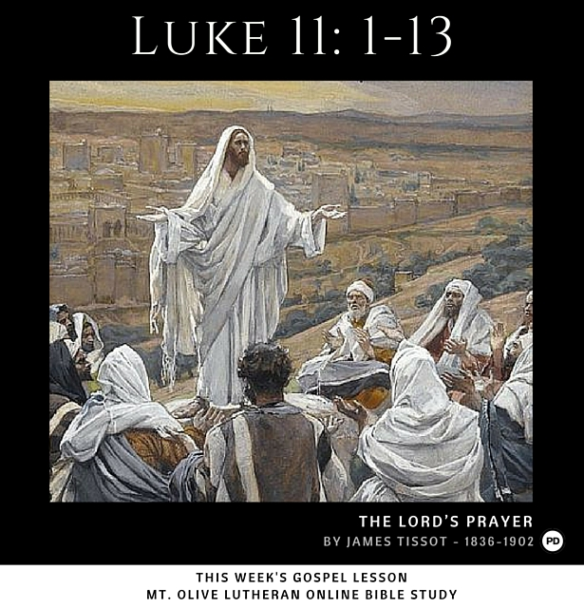

**Trinity 6**

**July 27th 2025**

**Collect**

Creator God, you made us all in your image: may we discern you in all that we see, and serve you in all that we do; through Jesus Christ our Lord. Amen

**SMM Hymns: 373** Leadus heavenlyFather**; 564** Rejoice O Lord in God thy might**; 565** Rejoice the Lord is King**; 637** The Lord’s my shepherd; **578** She sits like a bird**; 445** Meekness and majesty**; 416** Shine

**Bible Readings**

**Readings:** Genesis 18:20-32

Colossians 2:6-15

**Gospel Reading:** Luke 11:1-13

**Upcoming services**

**w/b Sunday 27th July**

9.00 am Holy Communion BCP SMM

9.30 am Holy Communion SL

10.30 am Holy Communion SMM

Wed 10.00am Holy Communion SMM

Thur 10 -11am Church open for prayer SL

**w/b Sunday 3rd August**

9.30 am Joint Holy Communion SL

10.30 am Holy Communion SMM

Wed 10.00am Holy Communion SMM

Thur 10 -11am Church open for prayer SL

**From our Parish weekly prayer cycle:**

Junior Church leaders: University Hospital of North Durham, staff, and patients; those seeking asylum; residents of St Lawrence Close, Pittington; Thrushcross Place, High Street, Filby Drive, Willowtree Avenue, Belmont.

**Genesis 18:20-32**

20Then the Lord said, ‘The outcry against Sodom and Gomorrah is so great and their sin so grievous 21that I will go down and see if what they have done is as bad as the outcry that has reached me. If not, I will know.’

22The men turned away and went towards Sodom, but Abraham remained standing before the Lord. 23Then Abraham approached him and said: ‘Will you sweep away the righteous with the wicked? 24What if there are fifty righteous people in the city? Will you really sweep it away and not spare the place for the sake of the fifty righteous people in it? 25Far be it from you to do such a thing – to kill the righteous with the wicked, treating the righteous and the wicked alike. Far be it from you! Will not the Judge of all the earth do right?’

26The Lord said, ‘If I find fifty righteous people in the city of Sodom, I will spare the whole place for their sake.’ 27Then Abraham spoke up again: ‘Now that I have been so bold as to speak to the Lord, though I am nothing but dust and ashes, 28what if the number of the righteous is five less than fifty? Will you destroy the whole city for lack of five people?’

‘If I find forty-five there,’ he said, ‘I will not destroy it.’

29Once again he spoke to him, ‘What if only forty are found there?’ He said, ‘For the sake of forty, I will not do it.’ 30Then he said, ‘May the Lord not be angry, but let me speak. What if only thirty can be found there?’

He answered, ‘I will not do it if I find thirty there.’ 31Abraham said, ‘Now that I have been so bold as to speak to the Lord, what if only twenty can be found there?’ He said, ‘For the sake of twenty, I will not destroy it.’

32Then he said, ‘May the Lord not be angry, but let me speak just once more. What if only ten can be found there?’

He answered, ‘For the sake of ten, I will not destroy it.’

**Colossians 2:6-15**

6So then, just as you received Christ Jesus as Lord, continue to live your lives in him, 7rooted and built up in him, strengthened in the faith as you were taught, and overflowing with thankfulness.

8See to it that no one takes you captive through hollow and deceptive philosophy, which depends on human tradition and the elemental spiritual forces of this world rather than on Christ.

9For in Christ all the fullness of the Deity lives in bodily form, 10and in Christ you have been brought to fullness. He is the head over every power and authority. 11In him you were also circumcised with a circumcision not performed by human hands. Your whole self ruled by the flesh was put off when you were circumcised by Christ, 12having been buried with him in baptism, in which you were also raised with him through your faith in the working of God, who raised him from the dead.

13When you were dead in your sins and in the uncircumcision of your flesh, God made you alive with Christ. He forgave us all our sins, 14having cancelled the charge of our legal indebtedness, which stood against us and condemned us; he has taken it away, nailing it to the cross. 15And having disarmed the powers and authorities, he made a public spectacle of them, triumphing over them by the cross.

**Luke 11:1-13**

One day Jesus was praying in a certain place. When he finished, one of his disciples said to him, ‘Lord, teach us to pray, just as John taught his disciples.’

**2**He said to them, ‘When you pray, say:

‘“Father, hallowed be your name,  
your kingdom come.  
**3**Give us each day our daily bread.  
**4**Forgive us our sins,  
    for we also forgive everyone who sins against us.  
And lead us not into temptation.”’

**5**Then Jesus said to them, ‘Suppose you have a friend, and you go to him at midnight and say, “Friend, lend me three loaves of bread; **6**a friend of mine on a journey has come to me, and I have no food to offer him.” **7**And suppose the one inside answers, “Don’t bother me. The door is already locked, and my children and I are in bed. I can’t get up and give you anything.” **8**I tell you, even though he will not get up and give you the bread because of friendship, yet because of your shameless audacity he will surely get up and give you as much as you need.

**9**‘So I say to you: ask and it will be given to you; seek and you will find; knock and the