Westfield Church Notices Sunday 6th July

Valerie writes:

Unity: We are One Body

What a joy it was last Sunday to worship with Julie and Nigel and their beautiful Celtish music, all together with our three churches.

Julie spoke to us about unity in the church; that we all make up different valuable parts of the body of Christ.

She emphasised that we all have our own unique gifts and voices, to tell our own stories. We thank God that we are all different and can all offer our gifts as we continue to grow our Church as one body.

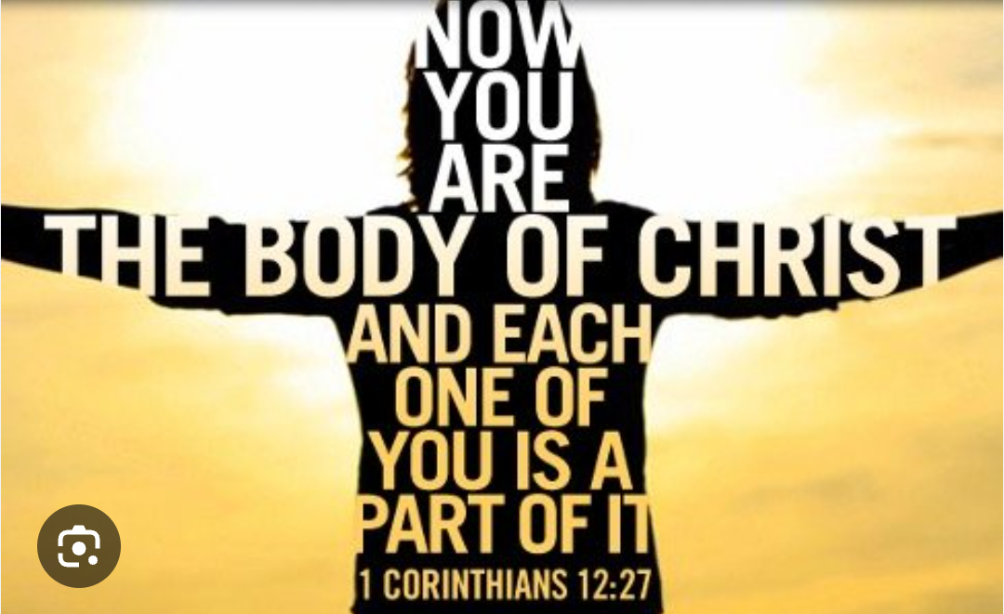

What’s On:
Sunday July 6th
8.00am: Prayer Book Communion
9.30am Holy Communion
Wednesday July 9th
9.30am Holy Communion
10.30am Warm Space Community Hub
Saturday July 12th
3.00pm Messy Church
Sunday 13th July

9.30 Pet Service

Messages:

From Sandi

Sandi’s first ministerial development review will be with Archdeacon Angela on Tuesday 29th July. Before meeting AD Angela there are forms I need to pray about as I assess my ministry here and also a 360 feedback form for you to complete too. The instructions with the forms say to send to four people but I’d like to take this opportunity to hear more widely from you please, especially as we are three parishes with six different congregations. Please would you be so kind as to take a few minutes answering the questions on the attached form. I’ll print some and bring them to our all together service this Sunday morning if you’d prefer to hand write.

With my thanks and prayers,
Sandi

Prayer:

If you would like a situation prayed about urgently, please contact the church Prayer Share. Contact Dawn 01424 255423 / 0750 7745 159

If you know anyone who would like to be added to the notices, please send me an email with their details. If you don’t want to receive this email each week, or would rather receive it in a different format, please let me know.
Please give information for notices to me by Thursday morning (contact details below).
Have a good week everyone,
Tony Demarco
tonydemarcohastings@gmail.com

