** SPIRE & LIGHT United Churches**

United Benefice of St Keverne, St Ruan with St Grade & St.Wynwallow (The Lizard)

**\*If you do not wish to receive these notices, please let your Churchwarden know\***

**20th July 2025**

***Trinity 4***



**Readings**

**Genesis 18:1-10**

**Psalm 15**

**Colossians 1:15-28**

**Luke 10:38-42**

9.30am –– Holy Communion- St.Peter’s, Coverack

9.30am –– Holy Communion - St.Wynwallow, The Lizard

11am –- Morning Prayer - St.Keverne Church

11.15am – Family Service - St.Ruan, Ruan Minor

Next week – Sunday July 27th

9.30am –– Morning Prayer - St.Peter’s, Coverack

9.30am – Holy Communion– St.Ruan, Ruan Minor

11am – Holy Communion - St.Keverne Church

11.15am – Café Church – St.Wynwallow, The Lizard



**The Prayer Spot**

Dear Heavenly Father, as we come to pray to you today, remind us of the love we must share with others, that love given to us by you. Help us to remember those in need within our churches and community and how we can be there for them - it may just need an act of kindness just to show we really care for them.

It says in 1 PETER 1 “Therefore prepare your minds for action, be self-controlled, set your hope fully on the grace to be given to you when Jesus Christ was revealed to you. As obedient children of God do not conform to self-desires you had when you lived in ignorance but as he who has called you is Holy so be holy in all you do for it is written to be holy because I am Holy.”

Remember God has given you gifts to use for the needs of others. Use them well because everyone needs your help in times of troubles. Be generous and full of God’s love, pray for all those who are in need of hospital treatment and that God will be present with them and for those who have the job of taking them. Pray for all our benefice that God will guide us in our care for everyone and to remember them all in our prayers.

*We praise you for your kindness and all the love you give us, for your endless willingness to forgive us when we fail you. We thank you for the love shown to us as members of your flock, for being the shepherd who guides us through each day. Thank you for those wonderful gifts given to us of forgiveness, justice, generosity, and peace and of course that great joy of knowing your presence in our lives.*

As always, I tell you God will be ever present in your prayer time and will answer all your prayers in the name of His Son Jesus Christ. Be blessed by all you do in His name.

*O God our Father, grant that whatever happens to us today we may take it to thee. If we shall have decisions to make help us to ask for your guidance and grant us humility and obedience to take it when you give it to us. If we shall have problems to solve, help us ask for thy light upon them so we may see a clear way through them. Help us through today to decide everything by thy will and to test everything by thy presence so that we may come to the days ending without mistakes and without regrets through Jesus Christ our Lord. Amen*

***The Diocese of Truro’s Prayer Diary for this week***

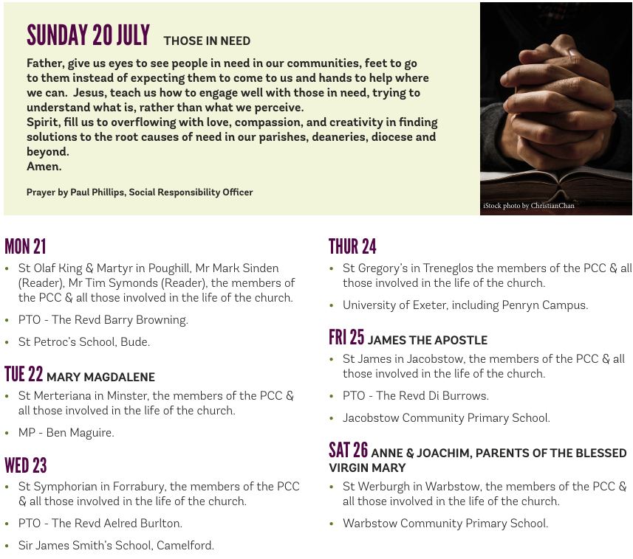

**On the Way Prayers**

We pray for our Deanery and for all the things going on in our churches and villages at this time, that events will be blessed with decent weather. We particularly ask for your blessing on the beach day held on Friday for Year 6 leavers taking place at Gunwalloe; for all those of us getting ready to lead the activities and for all our children as they prepare to break up for the summer holidays. We pray too for our teachers at this manic time of year, that you will give them the strength and patience they need to keep calm.

Nelson Mandela said “History will judge us by the difference we make in the everyday lives of children”. Lord, we pray that in our churches, among our congregations and in our PCC meetings that we can really start thinking about what we offer our children and how we can do, even little things, to help make a difference in their everyday lives. We pray too that they can come to know of your incredible love for them.

Our Deanery Synod met with Archdeacon Clive this week - a prayerful evening, an evening of listening and learning, sharing and caring - for each other and all our churches, congregations and communities. Let us pray for all our leaders in your church in Cornwall – Bishops David and Hugh, Archdeacons Kelly and Clive and particularly for Heidi our Rural Dean as she nears the end of her sabbatical period. And now let us pray for all priests and lay ministers who work with and for us.

We give thanks for the slightly cooler weather, and pray for rain, not just for our gardens but particularly for our farmers and our reservoirs. May we be careful with water, conscious of what a precious resource it now is. And we pray particularly for those places in suffering from severe drought and famine throughout your world. May we all learn to share resources, particularly with those who most need them. We know that you wish us to quench the thirsty, and to be aware of who the thirsty are.

And now let us pray for anything or anyone who needs the comfort of our collective prayers right now.

So, as we go about whatever else we have to do, help us Lord to feel you at our side. Help us to be your faithful servants and let us always put our trust in you. We give you thanks that you are always present, in all things each day and each night. We give you thanks for your gifts of creation, life and friendship. We give you thanks for the blessings of each day. Thank you. Amen