NEWSLETTER NUMBER 279
I hope you have all survived the excessive heat we have endured over the last week or so. I am grateful that we have returned to more normal temperatures. On one evening last week it was 35C in my bedroom!

OUR SERVICE ON SUNDAY 20TH JULY 2025
OUR SERVICE ON SUNDAY WILL BE A SAID COMMUNION WITHOUT HYMNS STARTING AT 9.00 A.M.
THE CELEBRANT WILL BE REV ANDY BARTON AND, HOPEFULLY, REFRESHMENTS AFTER.

LOOKING FORWARDS – REV ANDY
Mary and Martha
Are you a Mary or a Martha? Are you naturally someone who finds it easy to stop, take time out, sit in contemplation and pray? Or do you find yourself busy with the various important tasks that need doing, and wish there was more hands to help do them? Perhaps there is a bit of both Mary and Martha in us all. I enjoy taking time out to pray, whether on a walk, in a church or in my office, but I must admit to finding it all too easy to fill my day with the many tasks that need doing.
This Sunday’s reading reminds us that the better way is to make time to talk with God. In our busy lives that will be a conscious choice which will require a discipline to maintain. No amount of effort, activity and striving will ever substitute receiving the grace that only God offers. Our invitation is to live in the unforced rhythms of grace, offered by Jesus.

“Are you tired? Worn out? Burned out on religion? Come to me. Get away with me and you’ll recover your life. I’ll show you how to take a real rest. Walk with me and work with me, watch how I do it. Learn the unforced rhythms of grace. I won’t lay anything heavy or ill-fitting on you. Keep company with me and you’ll learn to live freely and lightly.”
Matthew 11. 28-30

We are entering a season where each of the churches in the benefice is invited to think about the future they desire. The future for both them as a church, and for their local community. The PCCs will be asking for your thoughts, your hopes, your concerns. As we conduct this conversation, we are encouraged that God has a future for us. Not simply a distant promise for after our day, but an exciting future that awaits us right now. We will be thinking about all the things which we can do to serve those around us, just like Martha.
However, unless we are also spending time in prayer, listening to God’s still small voice, then our efforts will come to nothing. If we find ourselves saying “I wish there were more hands to help” then perhaps we need to become a little more like Mary.
Please join the conversation when you are asked to do so. Please help your PCCs by offering to support them. Please think about those you know, who are not yet engaged in our church life, but to whose voice we need to listen. Please pray and ask God to send down the riches of the Holy Spirit, to kindle in all of us, the countless gifts of grace.

ROTA FOR SUNDAY 20TH JULY 2025 – 5TH SUNDAY AFTER TRINITY
Sidesmen:- Veronica Tatnall and Lorna Grinter
Reader:- Stephanie Emery
Coffee:- Veronica Tatnall and Lorna Grinter
Flowers:- Ann Fry
If you arrange to swap your date, please let me know. I would rather be told four times than not at all. It does cause particular concern to those who thought they had swapped, to see themselves down to be on duty.

READINGS FOR SUNDAY 20TH JULY 2025
Collect:- Almighty and everlasting God, by whose Spirit the whole body of the Church is governed and sanctified: hear our prayer which we offer for all your faithful people, that in their vocation and ministry they may serve you in holiness and truth to the glory of your name; through our Lord and Saviour Jesus Christ, who is alive and reigns with you, in the unity of the Holy Spirit, one God, now and for ever. Amen

Readings:-
Genesis Chapter 18, vv 1 – 10a
Colossians Chapter 1, vv 15 – 28
Luke Chapter 10, vv 38 – end

PRAYER LIST
Cynthia Sansom
Elizabeth Miles
Eunice Durrance
Ian Sansom
Mike Toogood
Pam Wilkie
Paul
Nigel and Rev Paul Chaplin on the death of their mother, Mary
Stephen Daley
Susan Dobson

YEARS MIND FOR JULY
23RD John Douglas Symons
27TH Lillian Eva (Eve) Richards

OUTREACH GROUPS
Why not give one of these groups a try? They would all welcome new members.
Recycled Teenagers
It will be back to normal for the next meeting, which will take place at 2.30 p.m. on Tuesday, 22nd July 2025. There will be the normal chat as well as a superb tea of sandwiches and cakes to demolish.
Knit, Sew and Natter
The next meeting will be on Thursday, 7th August 2025 starting at 2.00 p.m. It will be the usual meeting with lots of chat and refreshments.

Soup ‘n’ a Bite
The next meeting of this group will be on Saturday, 9th August 2025 at 12.00 noon. The group offers a choice of soups, a variety of bread and/or rolls, various cheeses, fresh fruit. tea or coffee. There is also a free raffle.

OUR NEXT SERVICE
The next service at All Saints will be a Sung Eucharist starting at 11.15 a.m. on Sunday, 27/7/2025. The celebrant will be Rev Andy Barton. There will be refreshments served after the service. We hope to see you there.

FORTHCOMING EVENTS
Fund raising committee event
The next event will be a Treasure Hunt with tea and cake starting at 3.00 p.m. on Sunday, 24/8/2025. There will be two treasure hunts on offer. Route 1 will be a walking treasure hunt and Route 2 will be a car treasure hunt.

Fund raising events further ahead
The exact dates will be finalised shortly.
September on a Saturday or Sunday afternoon
Talk on the building of All Saints’ Church followed by tea and cakes

October
Cocktails and Mocktails with the same format as last time.

November
Quiz night with jacket potato and filling supper.
Same format as before with teams of up to 6 people, bring your own drinks. Start eating fish now to get the brain in tiptop condition.

December
Christmas tree festival
This will be a two day event with the trees staying up until the school has had its two Christmas services in the church.

NEWS FROM WEST TONE BENEFICE
STAWLEY
Saturday 7th September 2025 – Flower Show
This will be held at the Appley Pavilion on Saturday, 7th September 2025, between
2.30 p.m. & 5.00pm. There is usually no admission charge, but I'll let you know if that changes.

OTHER INFORMATION
From Rev Andrew Norris
The “Home Service” is a weekly programme which brings Christian worship into your front room which is broadcast on 105.3 FM on Wednesdays at 11.00am and repeated Sunday at 10.00 am. It is also available via the internet at any time on www.10radio.org .
This week: In the wake of a very exciting weekend in the life of the Evangelical Church in Wiveliscombe, Revd Martyn Parry and his wife Felicity lead our act of worship on the theme of Baptism. We shall also hear about why St Swithun is remembered, amongst other things, by weather watchers and forecasters alike! If you have prayer or song requests or want others to know about what is happening in your church, contact revandrew@10Radio.org

FUN CORNER

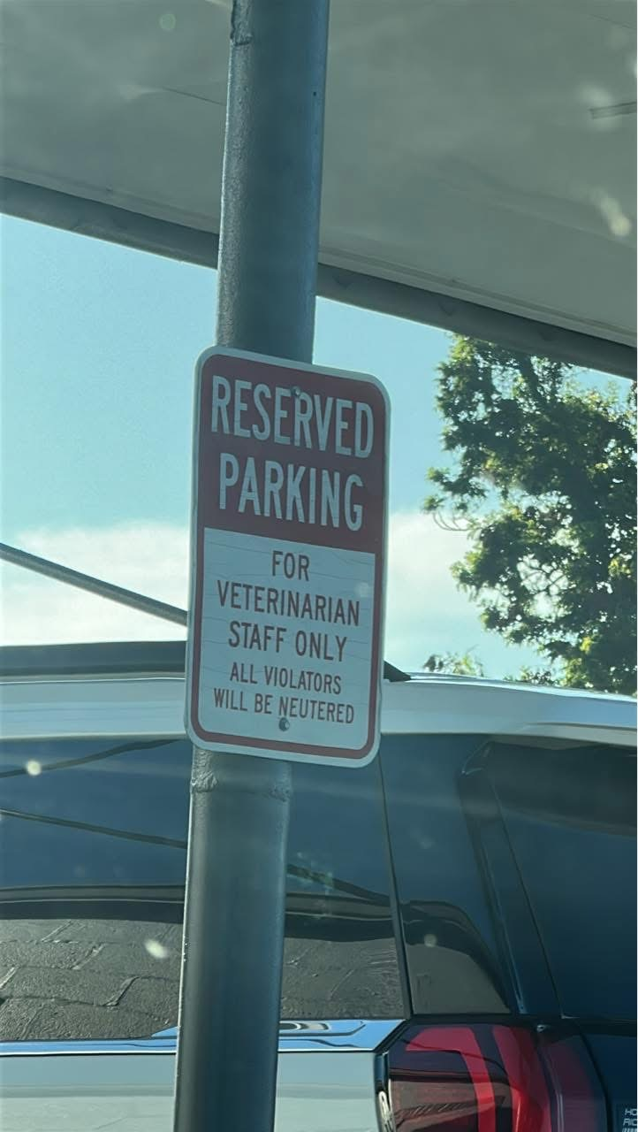

You have been warned!

