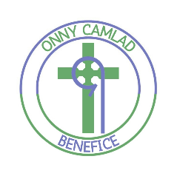**Onny Camlad Benefice**

**Our Regular Pattern of Monthly Church Services**

|  |  |  |  |
| --- | --- | --- | --- |
| **Day** | **Time** | **Church** | **Service Type** |
|  | | | |
| **First Sunday** | 9.30am | St Etheldreda, Hyssington | Morning Prayer |
| 10.30am | St Margaret, Ratlinghope | Morning Praise - Lay led |
| 11.15am | All Saints, Norbury | Holy Communion |
| 5.00pm | St Michael & All Angels, Wentnor | BCP Evening Prayer |
|  | | | |
| **Second Sunday** | 9.30am | St Margaret, Ratlinghope | Holy Communion |
| 11.15am | St Peter, More | Holy Communion |
|  | | | |
| **Third Sunday** | 9.30am | St Michael & All Angels, Wentnor | Holy Communion |
| 11.15am | St Etheldreda, Hyssington | Holy Communion |
| 6.00pm | All Saints, Norbury | Evening Prayer – Lay led |
|  | | | |
| **Fourth Friday** | 10.30am | St Peter, More | BCP Morning Prayer |
|  | | | |
| **Fourth Sunday** | 9.30am | All Saints, Norbury | Holy Communion |
| 11.15am | St Margaret, Ratlinghope | Holy Communion |
|  | | | |
| **Fifth Sunday** | On fifth Sundays we hold a joint Benefice service – please see notice board for details or visit our Church Near You pages on-line at  https://www.achurchnearyou.com/benefice/18-273BJ/ | | |

***Visitors, members of other Christian denominations and children***

***are warmly welcome at all our Church services***

***as are well behaved dogs on leads.***

***Refreshments are served after all church services.***