**Wellbeing Event at All Saints’ Church Elm**

**Monday 28th July 11.30am – 2.30pm**

*Health MOTs * BP checks*

*Fire Safety * Community Safety*

*Cybercrime & Fraud Awareness*

*Dementia Awareness*

*ActionFraud - National Fraud & Cyber Crime Reporting Centre - Call 0300 123 2040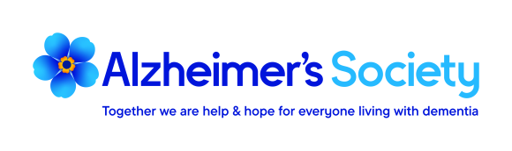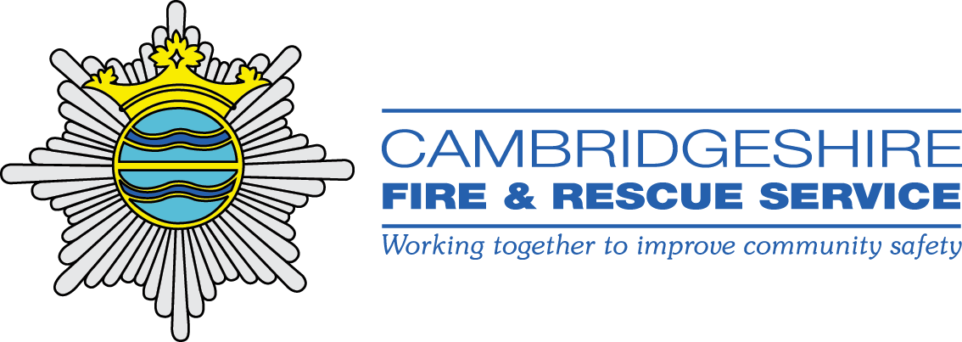Come along and have a chat and a bit of lunch or just a cuppa!*

* 