Westfield Church Notices Sunday 22nd June

Valerie writes:

Wycliffe Bible Translators

We welcome Klaas-Jan Duursma to our church this week to share with us news from Wycliffe.

Wycliffe Bible Translators is one of the six missions we are supporting this year.
In the 14th Century John Wycliffe translated Scripture into Middle English enabling ordinary people to read the Bible.

Today his legacy continues as the whole Bible has been translated into over 750 different languages.

There are four thousand active translation projects in progress but one in five people are still waiting to read the Bible in their own language.

Let's pray for Wycliffe's mission to bring God's word to local communities in the language which speaks to them best.

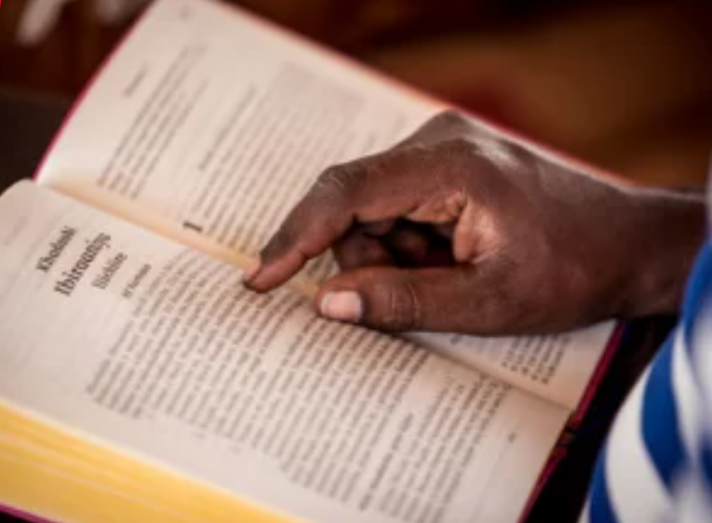

What’s On:
Sunday June 22nd
8.00am: Prayer Book Communion
9.30am: Morning Praise
Wednesday June 25th
9.30am Holy Communion
10.30am Warm Space Community Hub
Saturday June 28th
7.30pm St Andrews Church, Fairlight:
“Celtish”: Nigel Cameron and Julie Cameron-Hall in Concert, see attached flyer for details.
Sunday June 29th
10.30am All together Service, St Andrew’ Fairlight, followed by bring and share lunch
Saturday July 5th

Open Day, Crowhurst Christian Healing Centre

10.30am Thanksgiving Service with Speaker John Ryeland; see attached flyers for details

Sunday 13th July

9.30 Pet Service

Messages:

FSW

Collection Sunday 22nd June Westfield Church, or by morning Wednesday 25th June to Kathy and Eric’s house

Not Giving Up Day

“It’s enough to make you feel like giving up!”

If you've been watching the news, scrolling social media or just paying attention in general, you’ll know that there are many things in our world conspiring to get us all to give up right now.

To persist in hope feels like an act of resistance, doesn’t it?

And yet, that is what Jesus calls us to.

So, you’re invited to join with people across the world for a special event at the midpoint of this tumultuous year – we’re calling it Not Giving Up Day 2025.

What’s Not Giving Up Day and how can you join in?

1. Go to churchmissionsociety.org/ngu25 and sign up to take part in Not Giving Up Day – NGUD for short.
2. You’ll see there’s an opportunity for you to sign the CMS Not Giving Up pledge– or create your own!
3. Mark your diary for the We’re Not Giving Up online event, midday on 2 July 2025 (UK time). When you sign up for NGUD you’ll receive a Zoom link ahead of the day.

To thank you for being part of NGUD, we will send you a free seven-day devotional called How Not to Give Up to keep encouraging you to persist in hope, with Jesus and each other.

It’s been a turbulent year so far. If you’ve ever felt like giving up, you aren’t alone. Please join us as we recommit to living in hope.
Yours in Christ - the reason we don’t give up,
The Church Mission Society

Prayer:

If you would like a situation prayed about urgently, please contact the church Prayer Share. Contact Dawn 01424 255423 / 0750 7745 159

If you know anyone who would like to be added to the notices, please send me an email with their details. If you don’t want to receive this email each week, or would rather receive it in a different format, please let me know.
Please give information for notices to me by Thursday morning (contact details below).
Have a good week everyone,
Tony Demarco
tonydemarcohastings@gmail.com

