**Acrise Church News: July 2025**

**Reminder: The Benefice Service** on Sunday 29th June is at St Peter’s Church, Swingfield, at 10.00am.

**Services for July (all at 9.30am)**

Sunday 6th July Holy Communion Sharon

Sunday 13th July Matins BCP Bill

Sunday 20th July Morning Prayer CW Paul

Sunday 27th July Service of the Word CW Janet

**The Rector’s Message**

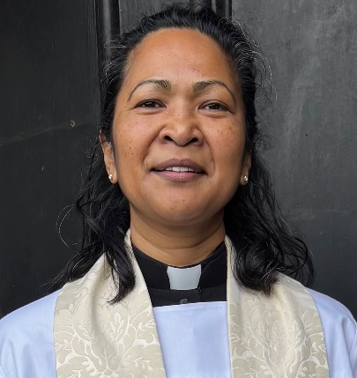July is the time our Teachers & school staff look forward to a well-earned rest – *Schools Out for Summer!*

We all need rest and God gave us the gift of Sabbath rest : Regular time to stop, to pause, to have a break from the busyness, stress and grind of work. To enjoy and take satisfaction from the goodness & beauty around us, to be refreshed, to reflect and take care of ourselves, spending time with those who care for us.

It is in our best interests to accept this God given gift and not make ourselves too busy to receive it.

Jesus said, *“Come to me. Come away with me and you’ll recover your life. Walk with me…watch how I do it. Learn from the unforced rhythms of grace…Keep company with me and you’ll learn to live freely and lightly.”*

***Matthew 11: 28-30 (The Message Bible)***

**Fundraising**

**Our next fundraising event, the week-long super garage sale, starts at 8.00am on Saturday, 28th June. There is also a grand Raffle with great prizes.**

**The wide range of items includes clothing, household goods, tools, furniture, books, toys, puzzles, plants and much more. Here are a few examples, including a canoe and cuddly toys.**

**Shepway Foodbank**

Donations have recently been taken to the local collection point. Please continue to support the foodbank by leaving items at the back of the church or in the porch if the church is locked.

Most urgently needed items are: gluten free foods, white cooking sauce, tinned meat, mashed potatoes, washing pods, toilet rolls.

**Acrise Festival**

**Of Flowers and Music**

**Saturday 2nd August 10.00am – 5.00pm**

**Flowers** in the church and **music** on the green. Church records will be displayed. There will be a variety of stalls, raffle, tombola, children’s games, and **pony rides.**

**Refreshments**, including ploughmen’s lunches, will be available.

**Volunteers**

On **Monday 28th July** from 10.00am we will be spring cleaning the church and tidying the paths, graveyard and parking area. We would be grateful for any volunteers to help on that day.

On **Friday 1st August** the church will be decorated with flowers and the site will be prepared for the Saturday. Any help will be welcome. Any new volunteers who could help on **2nd August** would be welcome.

**Donations**

We would also be grateful for donations of cakes, biscuits and savouries; raffle and tombola prizes, good quality bric a brac; any home grown produce for the produce stall.

If anyone could donate **foliage or flowers** from their gardens and leave them at the church on the morning of 1st August, we would be grateful.

**Contact**

Please contact Sue on 01303844640 ([sue1954prebble@gmail.com](mailto:sue1954prebble@gmail.com)) if you could volunteer on Monday 28th July or on 1st and/or 2nd August, or could make a donation for the 2ndAugust.

Jean Grieb has already started collecting **tombola prizes** so please give them to her. She can be contacted on 01303892364.

