Westfield Church Notices Sunday 1st June

Valerie writes:

Give us this day our Daily Bread
We say this line regularly in the Lord's Prayer but what does it really mean?
As we pray, we're asking God, the source of life to provide us with all we need to nourish and sustain us and all we need to flourish.
We're asking God, in His spirit of generosity to feed us physically and spiritually.
One day at a time we ask for sustenance and in turn we can pass on this spirit of generosity to others.

Here is a poem about bread written by David Adams, former miner and Canon of York Minster.

Be gentle when you touch bread,
Let it not lie uncared for, unwanted.
So often bread is taken for granted.
There is such beauty in bread-
Beauty of sun and soil,
Beauty of patient toil.
Wind and rain have caressed it.
Christ often blessed it.
So let us be gentle in touching bread.

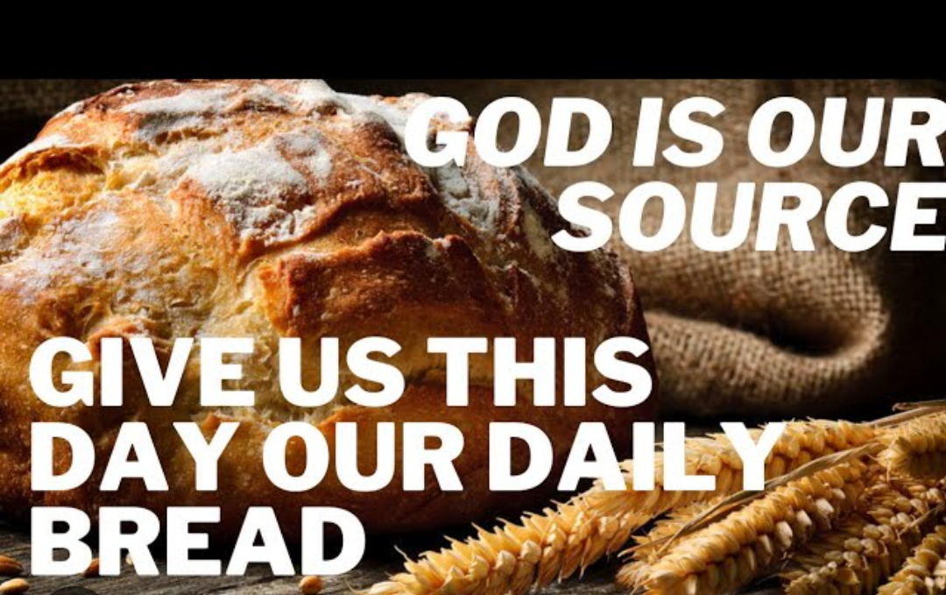

Messages:

Fairlight Prayer Room

St Peter’s Church Fairlight will be transformed into a prayer space full of creative and interactive ways to pray for a few days during Thy Kingdom Come.

Where: St Peter’s Church, Corner of Waites Lane and the Broadway (next to the Village Hall), Fairlight, TN35 4DA

When: Thursday 29th May (Ascension Day) from 9am to Monday 2nd June 5pm. Closed between 8pm and 7am daily

Booking: Please use this link to book a time to pray so we can ensure everything is ready for you. https://pray.24-7prayer.com/signup/893d64 If you aren’t online please phone Sandi on 07395 106514 or email revsandiwickens@gmail.com and she will book you in.

Access: There are four steps with a handrail at the front door. Level access is available to the back door from the pavement on Waites Lane. Please let Sandi know in advance if you require this.

What to expect: A small oasis of calm; a still place in a busy world for you to spend some time with God. There will be prayer stations with suggestions of ways you may wish to pray themed around the Lord’s Prayer. Come alone, bring a friend, or your homegroup. There will be help yourself refreshments in the kitchen and yes, there is a loo.

What’s On:
Sunday June 1st
8.00am: Prayer Book Communion
9.30am: Holy Communion
Tuesday June 3rd
7.30pm Prayer group at Brenda’s House, Greenacres
Wednesday June 4th
9.30am Holy Communion
10.30am Warm Space Community Hub

Prayer:

If you would like a situation prayed about urgently, please contact the church Prayer Share. Contact Dawn 01424 255423 / 0750 7745 159

If you know anyone who would like to be added to the notices, please send me an email with their details. If you don’t want to receive this email each week, or would rather receive it in a different format, please let me know.
Please give information for notices to me by Thursday morning (contact details below).
Have a good week everyone,
Tony Demarco
tonydemarcohastings@gmail.com

