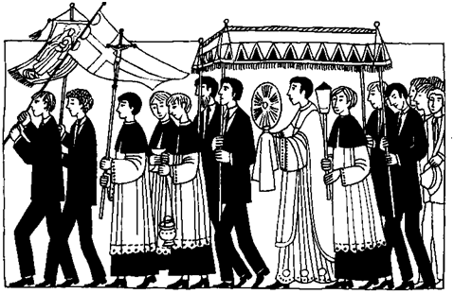



This Week

|  |  |
| --- | --- |
| **Monday 23rd** |  |
| **Tuesday 224th** | 12pm Mass - Solemnity of the Nativity of St John the Baptist |
| **Wednesday 25th** |  |
| **Thursday 26th** |  |
| **Friday 27th** | 12pm Funeral - Bernadette McShane |
| **Saturday 28th** | 11am Sponsored Walk – Meet at Church |
| **Sunday 29th** | 11am Parish Mass – SS Peter & Paul 2pm Ordination – Cathedral  Alex Walker – ***Deacon***  Fr Ben Jennings – ***Priest*** |

Dates for your Diary

|  |  |
| --- | --- |
| **June** | |
| **Monday 30th** | **7pm** First Mass of Fr Ben Jennings at Holy Family, Failsworth |
| **July** | |
| **Thursday 3rd** | **11am** – Funeral for the late Ernita Sherives |
| **Sunday 6th** | **12.15pm** – Parish BBQ |
| **Tuesday 8th** | **7.30pm** – Deanery Synod at St Nicholas’, Burnage |
| **Wednesday 9th** | **7.30pm** – Social and Fund Raising Committee |
| **Wednesday 16th** | **11am** – Funeral for the late Philip Malloy |

**SERVING TEAM**

We are still looking to recruit servers for our Sunday Services. If you are interested, please speak to Fr Richard.

**SANCTUARY LAMP**

If you would like the Sanctuary Lamp to burn in memory of a loved one (for 7 days), please speak to Fr Richard, Philip of Colin. The cost is £10.

**CHURCH GROUNDS**

There is still a lot of tidying to be done around the grounds, especially around the boundary fences where shrubs are overgrowing onto the surrounding pavements. If you have any free time to help with this, please speak to Fr Richard