**Westfield Church Notices Sunday 11th May**

**Valerie writes:**

The Road to Emmaus.

One of my favourite stories is the 'Road to Emmaus'. The story tells us that Jesus came near and started to walk alongside them. How comforting and reassuring to know Jesus still does this, walking with us daily.

It's the way Jesus reveals himself as he breaks and shares bread that is also special to me.

Let's look for Jesus in the ordinary this week as he reveals himself to us time and again. We will see him in a simple act of kindness, a friendly smile, a beautiful flower, the joy of hearing birdsong or children playing or the simple sharing of food with family and friends.

**Messages:**

**Phil Toze**

Our father, Phil Toze, sadly passed away on Easter Sunday, 20th April.  His Funeral date is Wednesday 14th May @ 3.15pm, at Hastings Crematorium.  All are welcome. Family flowers only but donations if desired, to St Michaels Hospice.

Amanda and James

**What’s On:**

**Sunday May 11th**

8.00am: Prayer Book Communion

9.30am: Café Church

**Wednesday May 14th**

9.30am Holy Communion

10.30am Warm Space Community Hub

**Wednesday May 14th**

Rye Deanery trip to Chichester Cathedral

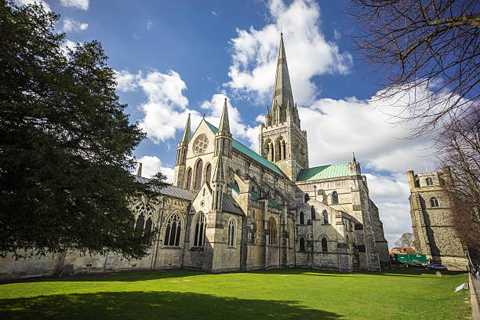

Come and join us on a day-trip journey to Chichester Cathedral – our Mother Ship, in this the 950th year of our Diocese.

We will be leaving in the morning and can arrange to have a Eucharist especially for us at lunchtime, followed by a meal, if you would like to. Tours of the Cathedral can be arranged if you would like to do this.

If you are interested, please let Rev. Kate Bailey know as soon as possible. If enough people would like to join us, then we will look into the cost and availability of coach hire, as well as the lunch and tour costs of the Cathedral.

We hope that as we travel as a Deanery, we will find ourselves joined closer together in our faith, as we visit the heartbeat of our Diocese.

Rev. Kate Bailey

01797 253118 [rector@stmaryschurchnorthiam.co.uk](mailto:rector@stmaryschurchnorthiam.co.uk)

**Sunday 25th May:**

As part of the Peasmarsh Flower Festival: Organ Concert

Stephen Page will be playing the organ at St Peter & St Paul’s Church Peasmarsh

at 6pm. For details and tickets please see attached.

**Prayer:**

If you would like a situation prayed about urgently, please contact the church Prayer Share. Contact Dawn 01424 255423 / 0750 7745 159

If you know anyone who would like to be added to the notices, please send me an email with their details. If you don’t want to receive this email each week, or would rather receive it in a different format, please let me know.  
Please give information for notices to me by Thursday morning (contact details below).

Have a good week everyone,

Tony Demarco

[tonydemarcohastings@gmail.com](mailto:tonydemarcohastings@gmail.com)