**Westfield Church Notices Sunday 4th May**

**Valerie writes:**

A Prayer for V.E. Day

O God of truth and justice,

We hold before you those men and women

who have died in active service,

particularly in the Second World War,

whose sacrifice brought Victory in Europe.

As we honour their courage and cherish

their memory,

may we put our faith in your future;

for you are the source of life and hope,

now and forever.

Amen

**Messages:**

**Phil Toze**

Our father, Phil Toze, sadly passed away on Easter Sunday, 20th April.  His Funeral date is Wednesday 14th May @ 3.15pm, at Hastings Crematorium.  All are welcome. Family flowers only but donations if desired, to St Michaels Hospice.

Amanda and James

**APCM meeting dates**

4th May Westfield

11th May Guestling

18th May Fairlight

**What’s On:**

**Sunday May 4th**

8.00am: Prayer Book Communion

9.30am: Westfield Memorial Service to Commemorate VE Day 80 at Westfield War Memorial followed by Holy Communion in Church.

**Wednesday May 8th**

9.30am Holy Communion

10.30am Warm Space Community Hub

**Sunday 4th May & Monday 5th May**

Westfield Community Association, in association with the Parish Council, will be hosting a free exhibition of Westfield memories and recollections of everyday life to mark the end of WW2 and the 80th Anniversary of VE Day. This will be in Westfield Community Hall from 10.30am on Sunday 4th and Monday 5th May. See the back page of your February-May Westfield Community Newsletter (spare copies in The New Inn or Strawberry Fair) for more information.

Janice

**Saturday 10th May**

Please find the following poster for the Diocesan Vocations Day being held on Sat 10th May at St Mary's Church, Horsham.

**Wednesday May 14th**

Rye Deanery trip to Chichester Cathedral

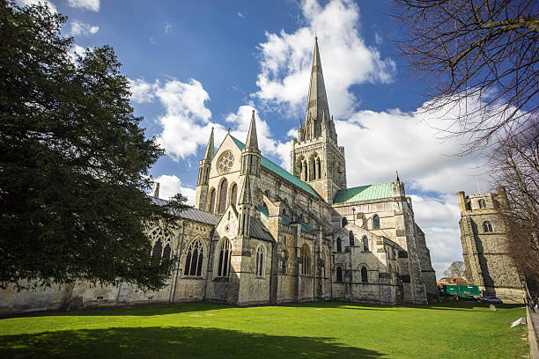

Come and join us on a day-trip journey to Chichester Cathedral – our Mother Ship, in this the 950th year of our Diocese.

We will be leaving in the morning and can arrange to have a Eucharist especially for us at lunchtime, followed by a meal, if you would like to. Tours of the Cathedral can be arranged if you would like to do this.

If you are interested, please let Rev. Kate Bailey know as soon as possible. If enough people would like to join us, then we will look into the cost and availability of coach hire, as well as the lunch and tour costs of the Cathedral.

We hope that as we travel as a Deanery, we will find ourselves joined closer together in our faith, as we visit the heartbeat of our Diocese.

Rev. Kate Bailey

01797 253118 [rector@stmaryschurchnorthiam.co.uk](mailto:rector@stmaryschurchnorthiam.co.uk)

**Prayer:**

If you would like a situation prayed about urgently, please contact the church Prayer Share. Contact Dawn 01424 255423 / 0750 7745 159

If you know anyone who would like to be added to the notices, please send me an email with their details. If you don’t want to receive this email each week, or would rather receive it in a different format, please let me know.  
Please give information for notices to me by Thursday morning (contact details below).

Have a good week everyone,

Tony Demarco

[tonydemarcohastings@gmail.com](mailto:tonydemarcohastings@gmail.com)