Prayers for the week
Collect
God, who in generous mercy sent the Holy Spirit
upon your Church in the burning fire of your love:
grant that your people may be fervent
in the fellowship of the gospel
that, always abiding in you,
they may be found steadfast in faith
and active in service;
through Jesus Christ your Son our Lord,
who is alive and reigns with you,
in the unity of the Holy Spirit,
one God, now and for ever.
Post Communion
Keep, O Lord, your Church, with your perpetual mercy;
and, because without you
our human frailty cannot but fall,
keep us ever by your help from all things hurtful,
and lead us to all things profitable to our salvation;
through Jesus Christ our Lord.
The Worldwide Church
We pray for the Anglican Church of Tanzania.
Our Parish MAP Prayer
God of Mission, who alone brings growth
to your Church.
Send your Holy Spirit to bring
Vision to our planning, Wisdom to our actions,
Faith to our lives, Hope to our community,
and love to our hearts.
Through Jesus Christ our Lord. Amen.
12th September 2021
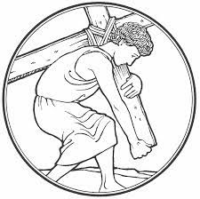
THE SECOND SUNDAY
OF CREATION SEASON
The Parish of the
Woodford Valley with
Archers Gate & Kings Gate
Vicar: The Rev’d Mike Perry 01722 782 310
mikeperry@posteo.net
Parish Administrator: Jocelyn Egan
woodfordoffice@yahoo.com
www.woodfordvalleyparish.co.uk
www.facebook.com/woodfordvalleyarchersgate

Sunday 12th September THE SECOND SUNDAY OF CREATION SEASON
8.30am Holy Communion at All Saints, Middle Woodford
10.00am Parish Eucharist at St Andrews, Great Durnford Readings: James 3. 1-12, Mark 8. 27-end
6.00pm Second Sunday at Six at All Saints, Middle Woodford
Wednesday 15th September
9.30am Holy Communion at All Saints, Middle Woodford
Saturday 18th September
3.00pm Marriage of Joseph Bentley and Sarah Collett at St Andrews, Great Durnford
Sunday 19th September HARVEST
10.00am OPEN AIR HARVEST SERVICE at All Saints, Middle Woodford
Readings: Joel 2. 21-27 Mark 6. 25-33
6.00pm HARVEST Evensong at St Andrews, Great Durnford Readings: Joel 2. 21-27 Mark 6. 25-33
Wednesday 22nd September
9.30am Holy Communion at All Saints, Middle Woodford

The Offertory & Giving Online
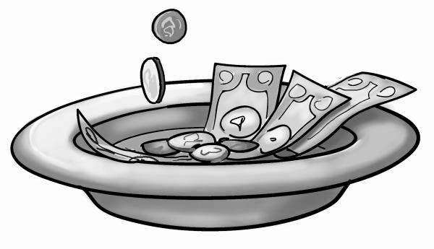
Due to the pandemic we cannot pass an offertory around,
but a plate is available at the back for donations to the church.
You can also donate (and, if you wish, gift aid) from our website www.woodfordvalleyparish.co.uk by clicking the ‘Give a Little’ icon.
James 3. 1-12
¹ Not many of you should become teachers, my brothers and sisters, for you know that we who teach will be judged with greater strictness. ² For all of us make many mistakes. Anyone who makes no mistakes in speaking is perfect, able to keep the whole body in check with a bridle. ³ If we put bits into the mouths of horses to make them obey us, we guide their whole bodies. ⁴ Or look at ships: though they are so large that it takes strong winds to drive them, yet they are guided by a very small rudder wherever the will of the pilot directs. ⁵ So also the tongue is a small member, yet it boasts of great exploits.
How great a forest is set ablaze by a small fire! ⁶ And the tongue is a fire. The tongue is placed among our members as a world of iniquity; it stains the whole body, sets on fire the cycle of nature, and is itself set on fire by hell. ⁷ For every species of beast and bird, of reptile and sea creature, can be tamed and has been tamed by the human species, ⁸ but no one can tame the tongue—a restless evil, full of deadly poison. ⁹ With it we bless the Lord and Father, and with it we curse those who are made in the likeness of God. ¹⁰ From the same mouth come blessing and cursing. My brothers and sisters, this ought not to be so. ¹¹ Does a spring pour forth from the same opening both fresh and brackish water? ¹² Can a fig tree, my brothers and sisters, yield olives, or a grapevine figs? No more can salt water yield fresh.

Mark 8. 27-38
²⁷ Jesus went on with his disciples to the villages of Caesarea Philippi; and on the way he asked his disciples, ‘Who do people say that I am?’ ²⁸ And they answered him, ‘John the Baptist; and others, Elijah; and still others, one of the prophets.’ ²⁹ He asked them, ‘But who do you say that I am?’ Peter answered him, ‘You are the Messiah.’ ³⁰ And he sternly ordered them not to tell anyone about him.
³¹ Then he began to teach them that the Son of Man must undergo great suffering, and be rejected by the elders, the chief priests, and the scribes, and be killed, and after three days rise again. ³² He said all this quite openly. And Peter took him aside and began to rebuke him. ³³ But turning and looking at his disciples, he rebuked Peter and said, ‘Get behind me, Satan! For you are setting your mind not on divine things but on human things.’
³⁴ He called the crowd with his disciples, and said to them, ‘If any want to become my followers, let them deny themselves and take up their cross and follow me. ³⁵ For those who want to save their life will lose it, and those who lose their life for my sake, and for the sake of the gospel, will save it. ³⁶ For what will it profit them to gain the whole world and forfeit their life? ³⁷ Indeed, what can they give in return for their life? ³⁸ Those who are ashamed of me and of my words in this adulterous and sinful generation, of them the Son of Man will also be ashamed when he comes in the glory of his Father with the holy angels.’

