Prayers for the week
Collect
Almighty God,
whose only Son has opened for us
a new and living way into your presence:
give us pure hearts and steadfast wills
to worship you in spirit and in truth;
through Jesus Christ your Son our Lord,
who is alive and reigns with you,
in the unity of the Holy Spirit,
one God, now and for ever.
Post Communion
Lord God, the source of truth and love,
keep us faithful to the apostles’ teaching and fellowship,
united in prayer and the breaking of bread,
and one in joy and simplicity of heart,
in Jesus Christ our Lord.
The Worldwide Church
We pray for the Province of the Episcopal Church of Sudan.
Our Parish MAP Prayer
God of Mission, who alone brings growth
to your Church.
Send your Holy Spirit to bring
Vision to our planning, Wisdom to our actions,
Faith to our lives, Hope to our community,
and love to our hearts.
Through Jesus Christ our Lord. Amen.
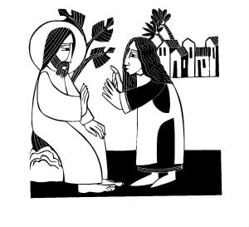
5th September 2021
THE FIRST SUNDAY
OF CREATION SEASON
The Parish of the
Woodford Valley with
Archers Gate & Kings Gate
Vicar: The Rev’d Mike Perry 01722 782 310
mikeperry@posteo.net
Parish Administrator: Jocelyn Egan
woodfordoffice@yahoo.com
www.woodfordvalleyparish.co.uk
www.facebook.com/woodfordvalleyarchersgate

Sunday 5th September THE FIRST SUNDAY OF CREATION SEASON
8.30am Holy Communion at St Andrews, Great Durnford
10.00am Parish Eucharist at All Saints, Middle Woodford
Readings: James 2. 1-10, 14-17 Mark 7.24-end
6.00pm Evensong at St Michael’s. Wilsford Readings: James 2. 1-10, 14-17 Mark 7.24-end
Wednesday 8th September
9.30am Holy Communion at All Saints, Middle Woodford
Sunday 12th September THE SECOND SUNDAY OF CREATION SEASON
8.30am Holy Communion at All Saints, Middle Woodford
10.00am Parish Eucharist at St Andrews, Great Durnford Readings: James 3. 1-12, Mark 8.27-end
6.00pm Second Sunday at Six at All Saints, Middle Woodford
Wednesday 15th September
9.30am Holy Communion at All Saints, Middle Woodford

The Offertory & Giving Online
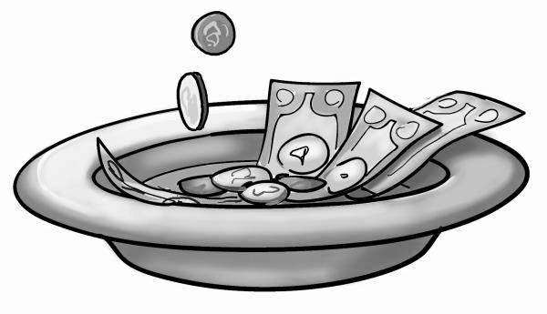
Due to the pandemic we cannot pass an offertory around, but a plate is available at the back for donations to the church.
If you would like to donate to the church later in the day, you can do so at our donations page www.bit.ly/WV-DONATE

James 2. 1-10, 14-17
My brothers and sisters, do you with your acts of favouritism really believe in our glorious Lord Jesus Christ? For if a person with gold rings and in fine clothes comes into your assembly, and if a poor person in dirty clothes also comes in, and if you take notice of the one wearing the fine clothes and say, ‘Have a seat here, please’, while to the one who is poor you say, ‘Stand there’, or, ‘Sit at my feet’, have you not made distinctions among yourselves, and become judges with evil thoughts? Listen, my beloved brothers and sisters. Has not God chosen the poor in the world to be rich in faith and to be heirs of the kingdom that he has promised to those who love him? But you have dishonoured the poor. Is it not the rich who oppress you? Is it not they who drag you into court? Is it not they who blaspheme the excellent name that was invoked over you?
You do well if you really fulfil the royal law according to the scripture, ‘You shall love your neighbour as yourself.’ But if you show partiality, you commit sin and are convicted by the law as transgressors. For whoever keeps the whole law but fails in one point has become accountable for all of it.
What good is it, my brothers and sisters, if you say you have faith but do not have works? Can faith save you? If a brother or sister is naked and lacks daily food, and one of you says to them, ‘Go in peace; keep warm and eat your fill’, and yet you do not supply their bodily needs, what is the good of that? So faith by itself, if it has no works, is dead.

Mark 7.24-37
From there he set out and went away to the region of Tyre. He entered a house and did not want anyone to know he was there. Yet he could not escape notice, but a woman whose little daughter had an unclean spirit immediately heard about him, and she came and bowed down at his feet. Now the woman was a Gentile, of Syrophoenician origin. She begged him to cast the demon out of her daughter. He said to her, ‘Let the children be fed first, for it is not fair to take the children’s food and throw it to the dogs.’ But she answered him, ‘Sir, even the dogs under the table eat the children’s crumbs.’ Then he said to her, ‘For saying that, you may go—the demon has left your daughter.’ So she went home, found the child lying on the bed, and the demon gone.
Then he returned from the region of Tyre, and went by way of Sidon towards the Sea of Galilee, in the region of the Decapolis. They brought to him a deaf man who had an impediment in his speech; and they begged him to lay his hand on him. He took him aside in private, away from the crowd, and put his fingers into his ears, and he spat and touched his tongue. Then looking up to heaven, he sighed and said to him, ‘Ephphatha’, that is, ‘Be opened.’ And immediately his ears were opened, his tongue was released, and he spoke plainly. Then Jesus ordered them to tell no one; but the more he ordered them, the more zealously they proclaimed it. They were astounded beyond measure, saying, ‘He has done everything well; he even makes the deaf to hear and the mute to speak.’

