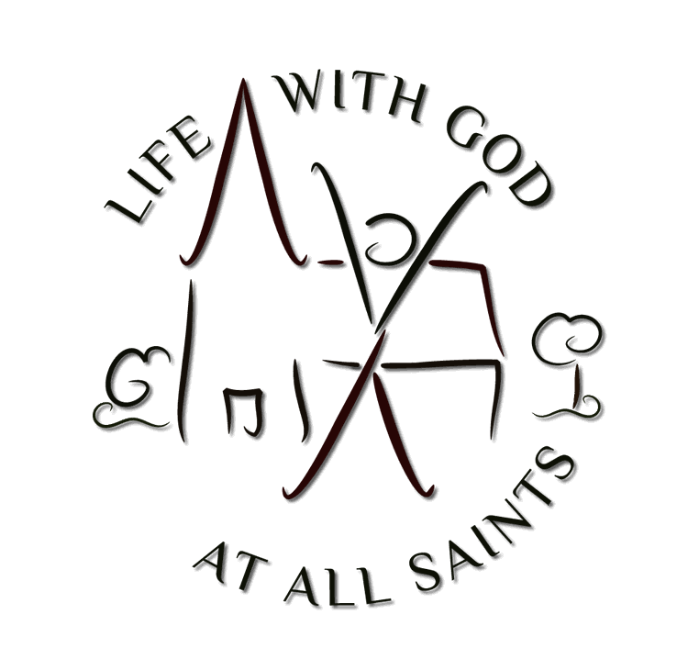
Welcome
29th August 2021
Thirteenth Sunday after Trinity
to All Saints, a church where all are welcome, especially committed to serving the communities of Garston and Leavesden. We are members of Inclusive Church.

Praying together:
- Please pray for those infected by the coronavirus around the world, for those who care for them.
- Please pray for Emily and Lyla as they prepare to be baptized in September
- Please pray for Stephen as he prepares to be licensed as a reader
- Please pray for children preparing to return to a new school year
- Please pray for the situation in Afganistan
- Please pray for the crisis in Haiti
- Please pray for the Church family as we gradually remove restrictions and welcome people back
- .We pray for those in special need:
Julie Parry | Rufus & Family
Rachel Packman | Rosemary Dawson
Judy Kurlander | Jean Hewitt
Judy Davies | Kelvin Porter
Jackie Kyrioucu | Chris Gardner
James
- We pray for the departed Claire Dickinson and those whose Anniversaries of Death fall this week: Fred Morgan
- Rest eternal grant unto them O Lord, and let light perpetual shine upon them
To add a name to the prayer list
please phone / email the office

This Week
All events listed below are subject to change at short notice

Sunday 29th Thirteenth Sunday of Trinity
BCP Eucharist | 08.00
Parish Eucharist invitation and streamed online | 10.00

Monday 30th Bank Holiday
Office Closed

Tuesday 31st

Wednesday 1st
Midweek Eucharist | 12.00
Open Church for Private Prayer | 12.30-14.00
Standing Committee | 20.00

Thursday 2nd

Friday 3rd

Saturday 4th

Sunday 5th Thirteenth Sunday after Trinity
BCP Eucharist | 08.00
Parish Eucharist in person and streamed online | 10.00
Baptism | 13:00
Open Space | 15:00

Notices
COVID update
For everyone to feel welcome returning to Church it is vital we all follow the rules:
- Stay away if you are feeling unwell
- Pre booking via contacting charles@allsaintslife.com or text 07308124492 for all in person worship
- Wearing a Facemask is recommended.
- Maintaining a social distance before and after the service is recommended.
- Do not walk around Church unless invited by a steward to do so.
- Respect others personal space.

Giving
The PCC would like to thank all givers for their gifts at this vital time.
Our collections at Services are fundamental
to the life of the church:
its ministry, mission, and charitable giving.
At In Person Services gifts can be received at the beginning or end of the Service using the Electronic Donation Station or the Perspex Donation Box located at the back of Church.
PCC’s bank details are
Lloyds Bank sortcode 309921
Bank account number 02701885
Leavesden Parish Church,
Parish Giving Scheme
Call 0333 002 1271 with your bank account details, church/parish name
All Saints Leavesden and
PGS parish code 320632231.

Reaching New People
Creator God, you call us to proclaim your love afresh to every generation.
We pray for your blessing as we explore fresh expressions of church,
And see your love extended in our local communities.
Grant us the creativity, imagination and courage to share your good news among new disciples.
May we be prophets and teachers, artists and encouragers;
And through your Spirit share in your mission of love, seeing lives transformed.
Through Jesus Christ our Lord. Amen

Online:
https://www.justgiving.com/
allsaintschurchleavesden

Lighthouse Café – returns on 6th September
Session will run from 10am - 12pm at Leavesden Green Community Hub.
To book a space please text 07308 124 492.
Please respect the Centre’s rules and do not attend if you are feeling unwell.
Cameo – 2pm Wed 8th September
At All Saints Hall, friendship and conversation with musical entertainment and light refreshments. Please leave a message on the office answer machine if you wish to book in.
Bike'n'Hike: Sat. 11th Sep. 9am - 5pm.
It's time to start planning your adventure for this fundraising event, to visit churches and gain sponsorship. Your visiting may be on foot, by bike, on the bus, by car, Ask Sue for an envelope with all the instructions. It would be good if the church could be open to welcome visitors. If you could help in this way, please tell Sue; (you too can be sponsored.) If you are unable to take part on the day, perhaps be ready to sponsor those who are participating (and ask your friends and family as well!)
All Saints for All Seasons 12th September 3pm

There are activities for everyone - from the youngest members of the church family to the most grown up! You just need to make sure you are wearing appropriate clothing - and that you have something to sit down on if you need to.

office@allsaintslife.com

Tel 01923 661862 www.allsaintslife.com

Charity No: 1160135

