Prayers for the week
Collect
Almighty God,
who called your Church to bear witness
that you were in Christ reconciling the world to yourself:
help us to proclaim the good news of your love,
that all who hear it may be drawn to you;
through him who was lifted up on the cross,
and reigns with you in the unity of the Holy Spirit,
one God, now and for ever.
Post Communion
God our creator,
you feed your children with the true manna,
the living bread from heaven:
let this holy food sustain us through our earthly pilgrimage
until we come to that place
where hunger and thirst are no more;
through Jesus Christ our Lord.
The Worldwide Church
We pray for the Province of the Episcopal Church of South Sudan.
Our Parish MAP Prayer
God of Mission, who alone brings growth
to your Church.
Send your Holy Spirit to bring
Vision to our planning, Wisdom to our actions,
Faith to our lives, Hope to our community,
and love to our hearts.
Through Jesus Christ our Lord. Amen.
29th August 2021
THE THIRTEENTH
SUNDAY AFTER TRINITY
The Parish of the
Woodford Valley with
Archers Gate & Kings Gate
Vicar: The Rev’d Mike Perry 01722 782 310
mikeperry@posteo.net
Parish Administrator: Jocelyn Egan
woodfordoffice@yahoo.com
www.woodfordvalleyparish.co.uk
www.facebook.com/woodfordvalleyarchersgate

Sunday 29th August THE THIRTEENTH SUNDAY AFTER TRINITY
10.00am Parish Eucharist at All Saints, Middle Woodford Readings: James 1. 17-end, Mark 7. 1-8, 14-15, 21-23
Tuesday 31st August
11.00am Funeral of the late Mrs Christine Mary Martin at St Andrews Church, Great Durnford
Wednesday 1st September
9.30am Holy Communion at All Saints, Middle Woodford
Saturday 4th September
11.00am Marriage of Christopher Hazzard and Dana Broom at All Saints, Middle Woodford
Sunday 5th September THE FIRST SUNDAY OF CREATION SEASON
8.30am Holy Communion at St Andrews, Great Durnford
10.00am Parish Eucharist at All Saints, Middle Woodford
Readings: James 2. 1-10, 14-17 Mark 7.24-end
6.00pm Evensong at St Michael’s. Wilsford Readings: James 2. 1-10, 14-17 Mark 7.24-end
Wednesday 8th September
9.30am Holy Communion at All Saints, Middle Woodford

The Offertory & Giving Online
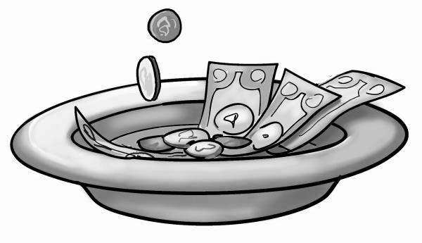
Due to the pandemic we cannot pass an offertory around, but a plate is available at the back for donations to the church.
If you would like to donate to the church later in the day, you can do so at our donations page www.bit.ly/WV-DONATE
James 1. 17-27
Every generous act of giving, with every perfect gift, is from above, coming down from the Father of lights, with whom there is no variation or shadow due to change. In fulfilment of his own purpose he gave us birth by the word of truth, so that we would become a kind of first fruits of his creatures.
You must understand this, my beloved: let everyone be quick to listen, slow to speak, slow to anger; for your anger does not produce God’s righteousness. Therefore rid yourselves of all sordidness and rank growth of wickedness, and welcome with meekness the implanted word that has the power to save your souls.
But be doers of the word, and not merely hearers who deceive themselves. For if any are hearers of the word and not doers, they are like those who look at themselves in a mirror; for they look at themselves and, on going away, immediately forget what they were like. But those who look into the perfect law, the law of liberty, and persevere, being not hearers who forget but doers who act—they will be blessed in their doing.
If any think they are religious, and do not bridle their tongues but deceive their hearts, their religion is worthless. Religion that is pure and undefiled before God, the Father, is this: to care for orphans and widows in their distress, and to keep oneself unstained by the world.

Mark 7. 1-8, 14-15, 21-23
Now when the Pharisees and some of the scribes who had come from Jerusalem gathered around him, they noticed that some of his disciples were eating with defiled hands, that is, without washing them. (For the Pharisees, and all the Jews, do not eat unless they thoroughly wash their hands, thus observing the tradition of the elders; and they do not eat anything from the market unless they wash it; and there are also many other traditions that they observe, the washing of cups, pots, and bronze kettles.)So the Pharisees and the scribes asked him, ‘Why do your disciples not live according to the tradition of the elders, but eat with defiled hands?’ He said to them, ‘Isaiah prophesied rightly about you hypocrites, as it is written,
“This people honours me with their lips,
but their hearts are far from me;
in vain do they worship me,
teaching human precepts as doctrines.”
You abandon the commandment of God and hold to human tradition.’
Then he called the crowd again and said to them, ‘Listen to me, all of you, and understand: there is nothing outside a person that by going in can defile, but the things that come out are what defile.’
For it is from within, from the human heart, that evil intentions come: fornication, theft, murder, adultery, avarice, wickedness, deceit, licentiousness, envy, slander, pride, folly. All these evil things come from within, and they defile a person.’

