**St John the Apostle**

**Sunday Bulletin for Week beginning 22nd August, 2021**

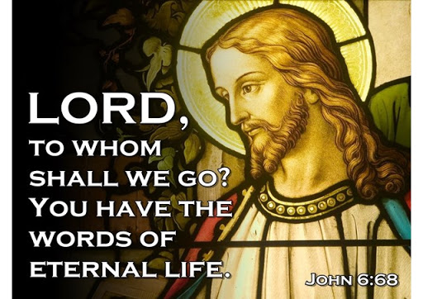

**Services this week**

**The Church is open for private prayer and public worship. Those attending services are encouraged to continue to observe social distancing, the wearing of masks/face coverings and hand-sanitising.**

**Wednesday 25th August**

*All Saints, Torre, 10.30am, Eucharist*

**Thursday 26th August**

*St Luke, 10.15am, Eucharist*

**Friday 27th August**

St John, 11.00am, Eucharist

**Sunday 29th August**

*All Saints, Torre, 9.30am Eucharist.*

*St. Luke, 11.00am Eucharist.*

St John, 11.00am Eucharist.

**21st Sunday in Ordinary Time**

Collect

O God, who cause the minds of the faithful

to unity in a single purpose,

grant your people to love what you command

and to desire what you promise,

that, amid the uncertainties of this world,

our hearts may be fixed on that place

where true gladness is found.

Through our Lord Jesus Christ, your Son,

who lives and reigns with you in the unity of the Holy Spirit,

God, for ever and ever. **Amen.**

**Hymns:**

Readings

Joshua 24:1-2, 15-18

Psalm 34

*R/ Taste and see that the Lord is good.*

Ephesians 5:21-32

John 6:60-69

Post Communion Prayer

Complete within us, O Lord, we pray,

the healing work of your mercy

and graciously perfect and sustain us,

so that in all things we may please you.

Through Christ our Lord. **Amen.**

**MUSIC AT ST. JOHN’S**

Every Wednesday during

August at 1.15pm

**“TEA & TOCCATA”**

Enjoy refreshments with 30 mins

of Organ music,

played by local Organists

Admittance free – donations accepted

**Keeping in Touch**

Send us your email address if you would like to receive the weekly bulletin and updates.

Follow the Parish on Facebook:

St John’s Over the Harbour

***Fr. Peter March S.S.C 01803 312754 p.j.march@hotmail.co.uk***

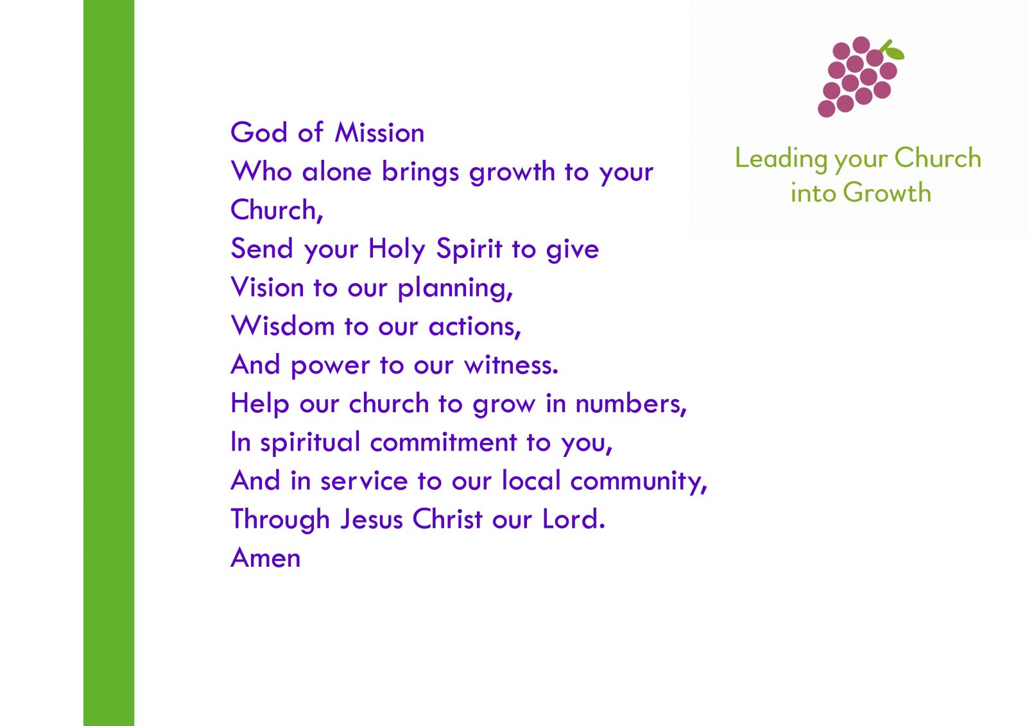

**Time to Read and Pray with**

**Scripture each day.**

Here are the Gospel readings set for each day this week. You might like to take the time to read them and pray with them.

**Sunday,** John 6:60-69

**Monday**, Matthew 23:13-22

**Tuesday**, John 1:45-51

**Wednesday**, Matthew 23:27-32

**Thursday**, Matthew 24:42-51

**Friday**, Matthew 25:1-13

**Saturday,** Matthew 25:14-30

**August at a glance**

4th St John Vianney, Patron Saint of Parish Priests. Please pray for all priests in Parish ministry.

6th Transfiguration of the Lord.

9th Mary Sumner, Founder of the Mother’s Union. Please pray for all members of the Mother’s Union.

10th St Laurence, Deacon and Martyr. Please prayer for all Deacons of the Church.

11th St Clare of Assisi, Founder of the “Poor Clares”.

13th Florence Nightingale. Please pray for all nurses and those who care for the sick.

14th St Maximilian Kolbe.

15th Assumption of the B.V.M.

20th St Bernard of Clairvaux.

William and Catherine Booth, founders of the Salvation Army.

24th St Bartholomew, Apostle.

27th St Monica, mother of St Augustine of Hippo.

28th St Augustine of Hippo.

31st St Aiden, Bishop of Lindisfarne.

**Prayers for use at this time**

God of compassion,

be close to those who are ill, afraid or in isolation.

In their loneliness, be their consolation;

in their anxiety, be their hope;

in their darkness, be their light;

through him who suffered alone on the cross,

but reigns with you in glory,

Jesus Christ our Lord.

**Amen.**

Find more prayers like these on the Church of England website: www.churchofengland.org.