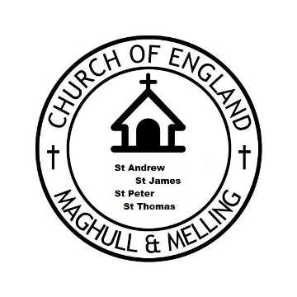

GDPR CONSENT FORM

Your privacy is important to us by signing this form you are confirming that you are consenting to the Church of England in Maghull and Melling
(overseen by the Parochial Church Councils of St Andrew, St Peters, St James in Maghull and St Thomas Melling) holding and processing your personal data for the reasons stated below.
(please tick the boxes where you grant consent): -
I consent to the Church of England in Maghull and Melling contacting me by
Post.□ Phone.□ Email.□
To keep me informed about news, events, activities and services within the Church of England in Maghull and Melling (The Churches of St Andrew, St James, St Peters Maghull and St Thomas Melling)
Name _____________________________________________________
Address: ___________________________________________________
___________________________________________________
Email Address: ________________________________________________
Phone Number: ________________________________________________

Signed: ______________________________
Dated: _______________________________
You can grant consent to all the purposes; one of the purposes or none of the purposes. Where you do not grant consent, we will not be able to use your personal data; (so for example we may not be able to let you know about forthcoming services and events); except in certain limited situations, such as where required to do so by law or to protect members of the public from serious harm. You can find out more about how we use your data from our “Privacy Notice” which is available from the Church.
You can withdraw or change your consent any time by contacting any of the Team Clergy
Revd. Simon Elliott revsimonelliott76@gmail.com
Revd. Dave Hamlett dhamlett@blueyonder.co.uk
Revd. Gordon MacLeod gordonimacleod@gmail.com
or in writing to c/o The Parish Office, St Andrews Church, 22 Damfield Lane, Maghull L31 6DD

Please note that all processing of your personal data will cease once you have withdrawn consent, other than where this is required by law, but this will not affect any personal data that has already been processed prior to this point.
Please send completed form to C/O St Andrews Parish Office, 22 Damfield Lane, Maghull L31 6DD

