**St John the Apostle**

**Sunday Bulletin for Week beginning 1st August, 2021**

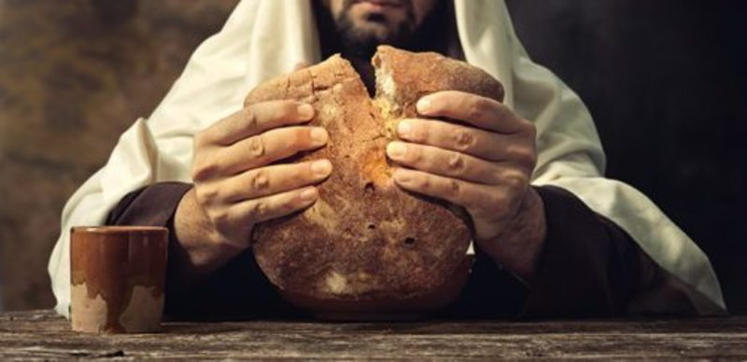

**Services this week**

**The Church is open for private prayer and public worship. Those attending services are encouraged to continue to observe social distancing, the wearing of masks/face coverings and hand-sanitising.**

**Wednesday 4th August**

*All Saints, Torre, 10.30am, Eucharist*

**Thursday 5th August**

*St Luke, 10.15am, Eucharist*

**Friday 6th August**

St John, 11.00am, Eucharist

**Sunday 8th August**

*All Saints, Torre, 9.30am Eucharist.*

*St. Luke, 11.00am Eucharist.*

St John, 11.00am Eucharist.

**18th Sunday in Ordinary Time**

Jesus the Bread of Life

Collect

Draw near to your servants, O Lord, and answer their prayers with unceasing kindness,

that, for those who glory in you as their Creator and guide,

you may restore what you have created

and keep safe what you have restored.

Through our Lord Jesus Christ, your Son,

who lives and reigns with you in the unity of the Holy Spirit,

God, for ever and ever.

**Amen.**

Readings

Exodus 16:2-4, 12-15

Psalm 78

*R/ The Lord gave them bread from heaven.*

Ephesians 4:17, 20-24

John 6:24-35

Post Communion Prayer

Accompany with constant protection, O Lord,

those you renew with these heavenly gifts

and, in your never-failing care for them,

make them worthy of eternal redemption.

Through Christ our Lord.

**Amen.**

**Keeping in Touch**

Send us your email address if you would like to receive the weekly bulletin and updates.

Follow the Parish on Facebook:

St John’s Over the Harbour

***Fr. Peter March S.S.C 01803 312754 p.j.march@hotmail.co.uk***

**Time to Read and Pray with**

**Scripture each day.**

Here are the Gospel readings set for each day this week. You might like to take the time to read them and pray with them.

**Sunday,** John 6:24-35

**Monday**, Matthew 14:13-21

**Tuesday**, Matthew 14:22-36

**Wednesday**, Matthew 15:21-28

**Thursday**, Matthew 16:13-23

**Friday**, Mark 9:2-10

**Saturday,** Matthew 17:14-20

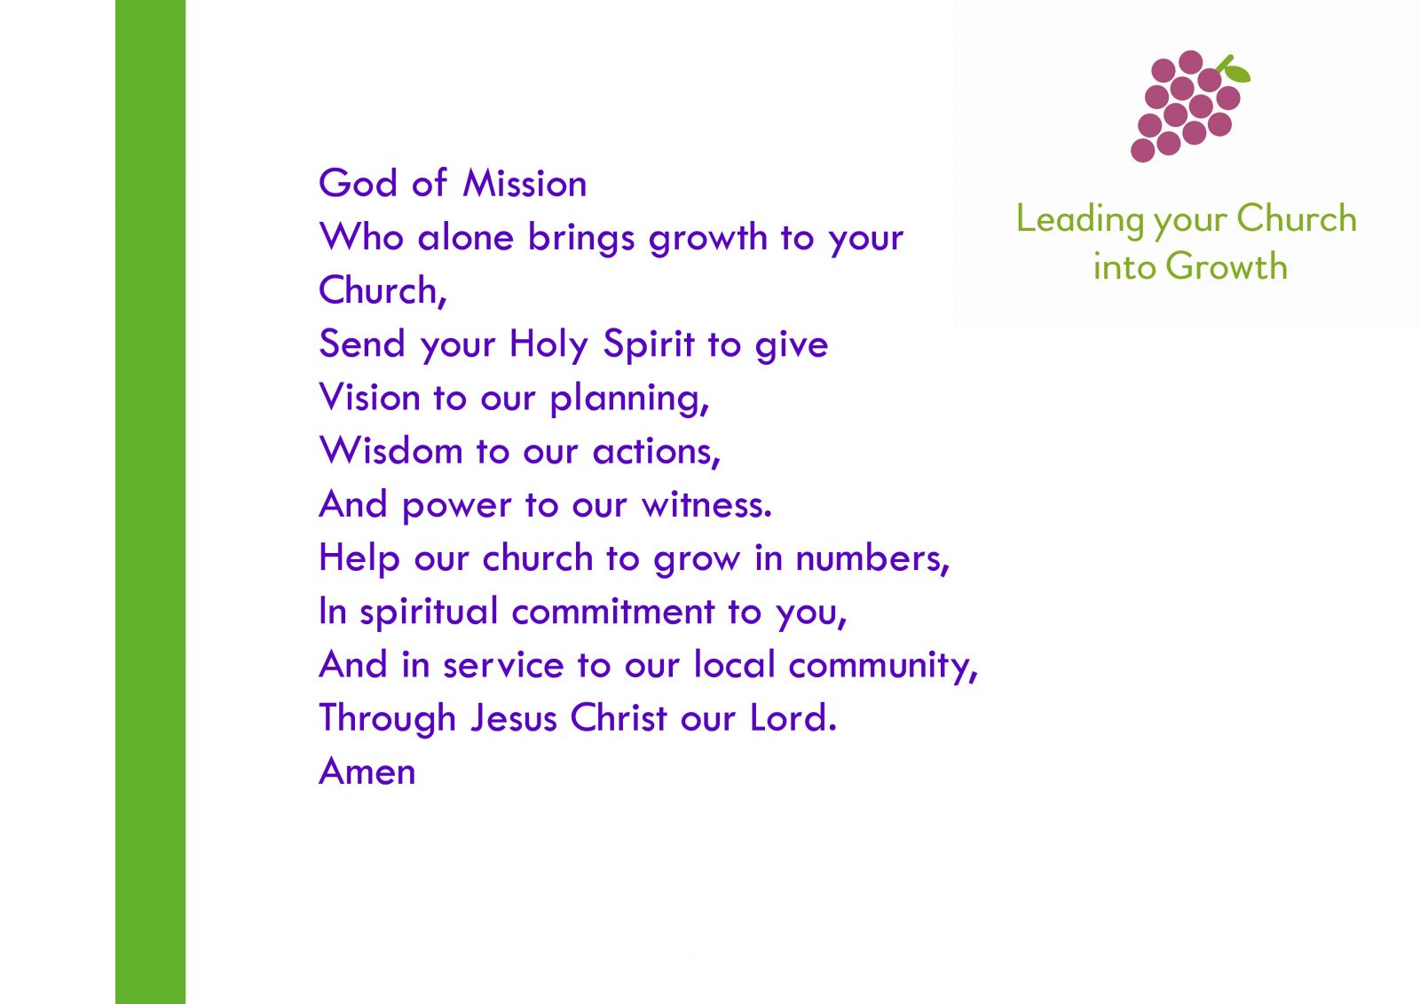

**Prayers for use at this time**

Keep us, good Lord,

under the shadow of your mercy

in this time of uncertainty and distress.

Sustain and support the anxious and fearful,

and lift up all who are brought low;

that we may rejoice in your comfort

knowing that nothing can separate us

from your love in Christ Jesus our Lord.

**Amen**

Lord Jesus Christ,

you taught us to love our neighbour,

and to care for those in need

as if we were caring for you.

In this time of anxiety, give us strength to comfort the fearful, to tend the sick, and to assure the isolated of our love, and your love,

for your name’s sake.

**Amen**

God of compassion,

be close to those who are ill, afraid or in isolation.

In their loneliness, be their consolation;

in their anxiety, be their hope;

in their darkness, be their light;

through him who suffered alone on the cross,

but reigns with you in glory,

Jesus Christ our Lord.

**Amen.**

Find more prayers like these on the Church of England website: www.churchofengland.org.

**August at a glance**

4th St John Vianney, Patron Saint of Parish Priests. Please pray for all priests in Parish ministry.

6th Transfiguration of the Lord.

9th Mary Sumner, Founder of the Mother’s Union. Please pray for all members of the Mother’s Union.

10th St Laurence, Deacon and Martyr. Please prayer for all Deacons of the Church.

11th St Clare of Assisi, Founder of the “Poor Clares”.

13th Florence Nightingale. Please pray for all nurses and those who care for the sick.

14th St Maximilian Kolbe.

15th Assumption of the B.V.M.

20th St Bernard of Clairvaux.

William and Catherine Booth, founders of the Salvation Army.

24th St Bartholomew, Apostle.

27th St Monica, mother of St Augustine of Hippo.

28th St Augustine of Hippo.

31st St Aiden, Bishop of Lindisfarne.