All Saints, Torre, St. Luke, St. John the Apostle
Sunday Bulletin for Week beginning 11th July, 2021

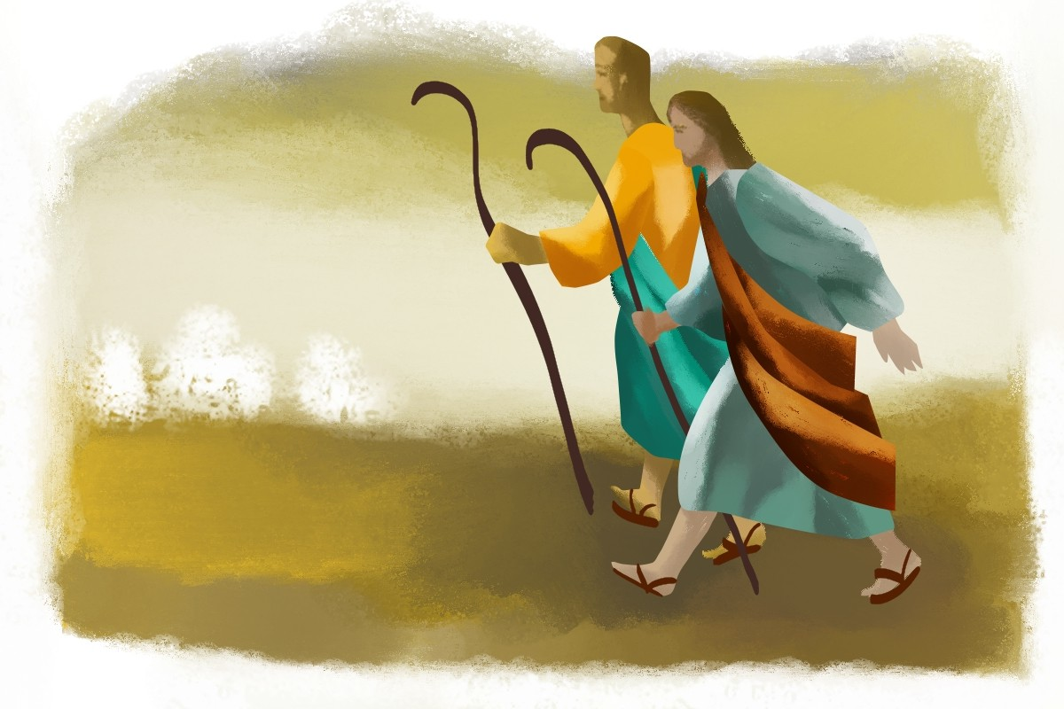

Services this week

Government guidelines permit churches to remain open for private prayer and public worship. Those attending services are asked to continue to observe social distancing, the wearing of masks/face coverings and hand-sanitising.

Wednesday 14th July
All Saints, Torre, 10.30am, Eucharist

Thursday 15th July
St Luke, 10.15am, Eucharist

Friday 16th July
St John, 11.00am, Eucharist

Sunday 17th July
All Saints, Torre, 9.30am Eucharist.
St. Luke, 11.00am Eucharist.
St John, 11.00am Eucharist.

Please note church will be open 15 minutes before the start of the service.

July at a glance

3rd St Thomas the Apostle
15th St Swithun, Bishop of Winchester. Pray for fine weather!!
22nd St Mary Magdalene – Pray for our brothers and sisters in the Parish of St Mary Magdalene
26th St Anne and St Joachim, Parents of the Blessed Virgin Mary, patron saints of grandparents. Pray for all grandparents.
29th St Mary, St Martha and Lazarus, Companions of Our Lord

Time to Read and Pray with
Scripture each day.

Here are the Gospel readings set for each day this week. You might like to take the time to read them and pray with them.

Sunday, Mark 6:7-13
Monday, Matthew 10:34-11:1
Tuesday, Matthew 11:20-24
Wednesday, Matthew 11:25-27
Thursday, Matthew 11:28-30
Friday, Matthew 12:1-8
Saturday, Matthew 12:14-21

Requests for Prayer

If you have particular requests for prayer, or would like specific intentions remembered at the Eucharist, please contact Fr Peter using the details below.

Keeping in Touch
Send us your email address if you would like to receive the weekly bulletin and updates.
Follow the Parishes on Facebook:
All Saints Church, Torre, Torquay, St Luke’s Parish Church Torquay, St John’s Over the Harbour

Fr. Peter March S.S.C 01803 312754 p.j.march@hotmail.co.uk

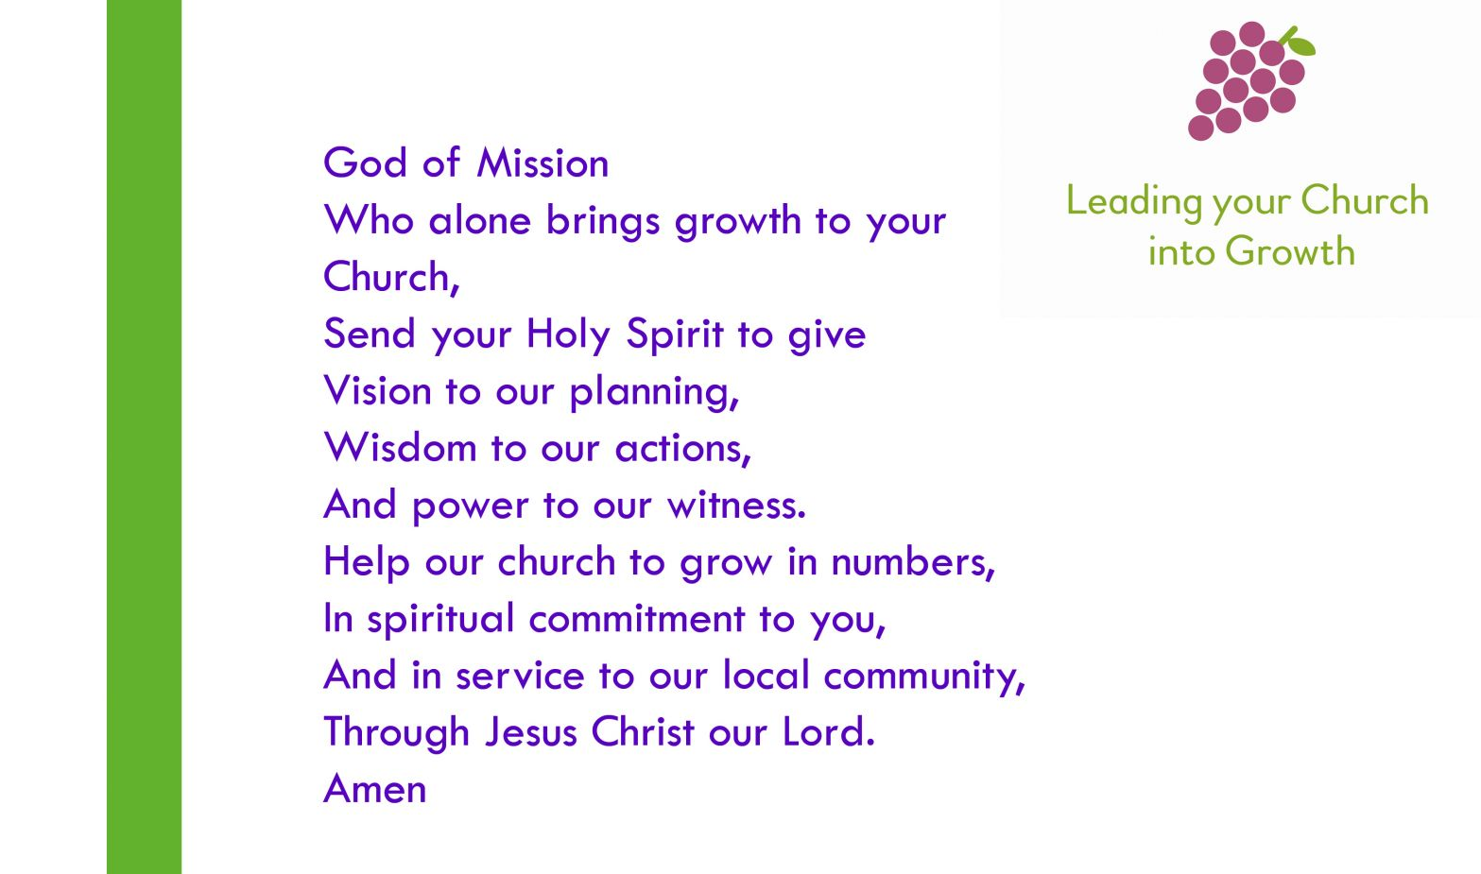

Prayers for use at this time

Keep us, good Lord,
under the shadow of your mercy
in this time of uncertainty and distress.
Sustain and support the anxious and fearful,
and lift up all who are brought low;
that we may rejoice in your comfort
knowing that nothing can separate us
from your love in Christ Jesus our Lord.
Amen

Lord Jesus Christ,
you taught us to love our neighbour,
and to care for those in need
as if we were caring for you.
In this time of anxiety, give us strength to comfort the fearful, to tend the sick, and to assure the isolated of our love, and your love,
for your name’s sake.
Amen

God of compassion,
be close to those who are ill, afraid or in isolation.
In their loneliness, be their consolation;
in their anxiety, be their hope;
in their darkness, be their light;
through him who suffered alone on the cross,
but reigns with you in glory,
Jesus Christ our Lord.
Amen.

Find more prayers like these on the Church of England website: www.churchofengland.org.

14th Sunday in Ordinary Time

Collect

O God, who show the light of your truth
to those who go astray,
so that they may return to the right path,
give all who for the faith they profess
are accounted Christians
the grace to reject whatever is contrary to the name of Christ
and to strive after all that does it honour.
Through our Lord Jesus Christ, your Son,
who lives and reigns with you in the unity of the Holy Spirit,
God, for ever and ever.
Amen.

Readings

Amos 7:12-15

Psalm 85
R/ Let us see, O Lord, your mercy, and give us your saving help.

Ephesians 1:3-14

Mark 6:7-13

Post Communion Prayer

Having consumed these gifts, we pray, O Lord,
that, by our participation in this mystery,
its saving effects upon us may grow.
Through Christ our Lord.
Amen.

Lectio Divina

Introduction

Make whatever preparations you need to leave the shadow world behind and encounter the fire of the Spirit and the light of God.
If you have chosen to prepare the space and the place in some way (perhaps drawing a curtain or lighting a candle), make that preparation.
Eliminate distractions and the possibility of interruption.

Sign of the Cross

We invoke God, in whose name we act.

In the name of the Father, ✠
and of the Son,
and of the Holy Spirit,
Amen.

Invocation of the Holy Spirit

We invoke the Holy Spirit, who will speak to us and listen in us.

Come, Holy Spirit, fill the hearts of your faithful
and kindle in them the fire of your love.

Send forth your Spirit, and they shall be created.
And you shall renew the face of the earth.

Act of Contrition

By acknowledging our sinfulness and admitting that by ourselves we can do nothing that is not flawed, we ask God to take the initiative in this encounter.

Have mercy on us, O Lord:
For we have sinned against you.
Show us, O Lord, your mercy:
And grant us your salvation.

May almighty God have mercy on us, forgive us our sins, and bring us to everlasting life.
Amen.

The Gospel

A reading from the holy Gospel according to Mark

⁷ He called the twelve and began to send them out two by two, and gave them authority over the unclean spirits. ⁸ He ordered them to take nothing for their journey except a staff; no bread, no bag, no money in their belts; ⁹ but to wear sandals and not to put on two tunics. ¹⁰ He said to them, ‘Wherever you enter a house, stay there until you leave the place. ¹¹ If any place will not welcome you and they refuse to hear you, as you leave, shake off the dust that is on your feet as a testimony against them.’ ¹² So they went out and proclaimed that all should repent. ¹³ They cast out many demons, and anointed with oil many who were sick and cured them.

________

The Response

Meditatio (reflection)

What does the Gospel say to me?
God has willed me to be here, now, today, for a reason. Now is the time to reflect, and find that reason, and hear what God has chosen to tell me.

A good pattern is this:
- What has drawn my attention or struck me in some way?
- Why? Was it a person? A word? A situation? A gesture?
- What, therefore, is God saying to me through these words, here and now, today?

The “I” and the “me” are important. To say “we” or “us” is to evade the encounter by softening the focus and hiding behind membership of a group. The meeting with Jesus is face to face, one to one.

Oratio (prayer)

God has spoken to me. What do I reply?
Silently, each of us responds to what God has said to them through the passage we have read.

Contemplatio (contemplation)

Sometimes we may be led beyond prayer into a quiet and attentive resting in the presence of God.

Conclusion

We prepare to return to the everyday world, carrying with us what we have received in our minds and our hearts today.

Our Father, who art in heaven,
hallowed be thy name.
Thy kingdom come.
Thy will be done on earth, as it is in heaven.
Give us this day our daily bread,
and forgive us our trespasses,
as we forgive those who trespass against us,
and lead us not into temptation,
but deliver us from evil.
________

May the Lord bless us, and keep us from all evil, and bring us to everlasting life.
Amen

