

**Parish Newsletter   
and Notices**

**This Sunday 13th June 2021-   
The Second Sunday after Trinity**

8.00am [13th June 8am BCP Trinity 2 - YouTube](https://www.youtube.com/watch?v=VPOAsrXUvkI)  
9.30am [Trinity 2 June 13th 2021 9.30 Eucharist - YouTube](https://www.youtube.com/watch?v=C1tekR_CYSE)  
11.30am [ChurchCast Live on Trinity Sunday - YouTube](https://www.youtube.com/watch?v=xFQnvEj3Jto)

**Next Sunday -****- 20th June 2021 In Church and Online**  **The Birth of John the Baptist –(Patronal Festival)**

8.00am BCP Holy Communion  
9.30am Sung Eucharist  
11.30am Family Communion **Readings : Isiah 40. 1-11, Acts 13. 14-26, Luke 1. 57-66, 80**

**Revd Chris Davies (Day off on Monday) 020 8508 2912** [**chris@loughtonchurch.org.uk**](mailto:chris@loughtonchurch.org.uk) **Revd Barbara Read (Day off on Mon and Fri) 01992 679375** [**revbarbararead@talktalk.net**](mailto:revbarbararead@talktalk.net)

**Revd Sam Rossiter-Peters (Day off on Friday) 07708 378459 frspeters@gmail.com  
Revd Sam Maginiss (Day off on Saturday) 07305 654804  
 rev.smlt@gmail.com**

**Parish Office - Sammy Alder 07740 025926** [**loughton.church@outlook.com**](mailto:loughton.church@outlook.com)

**Services Restarted**

Has you can see all public worship has now restarted, we are still working under restriction so our grateful if you could continue to book in and follow the guidelines, we hope and prayer that normality will resume soon. We will keep our procedures under review and after Government changes we will let you know how this effects life at St Johns.

Sam Rossiter-Peters goes on his holiday from Wednesday if you need to get in touch after this please contact another member of the team all leave a message for his return,

**Week commencing Monday 14th June - Please join us in prayer.**

**Monday**9.00am Morning Prayer  
5.00pm Rosary Group  
6.00pm Evening Prayer  
6,30pm Eucharist

**Tuesday**

9.00am Morning Prayer   
9.30am Parents and children – Stay and Play and Coffee Morning (Shop)  
1.00pm Book Club, St Johns on the Broadway **please book in**   
6.00pm Evening Prayer

**Wednesday**

9.00am Morning Prayer   
9.30am Eucharist   
3.00pm-5pm Debden Youth on the Broadway, children up to Yr9  
6.00pm Evening Prayer  
5.00pm-7pm Debden Youth on the Broadway, young people Yr9-Yr13

**Thursday**

8.30am Morning Prayer   
3.00pm Over 65’s Tea and Chat @ St Johns on the Broadway  
5.00pm Tree of hope @ St Johns on the Broadway  
6.00pm Evening Prayer

**Friday**

9.00am Morning prayer @ St Johns on The Broadway

**Saturday**

9.30am Eucharist

**For your Prayers**: Bishop Guli, and those preparing for Ordination  
**The Sick:** William Wickens, Aidan Chesher, Don MacBean, Alan Clark, Stephen Pendergast, Susan Cole, Doug Pratt, Peter Kitchen, Lorna Clark, Rocky Myles, Ruby Mifsud, David Southgate, Ann Woodland, Jamie Lode, Elizabeth Staples, Luke Davies, Colin Cane, Hilary Waters, Gabriella Alexander, Matthew Maynes, Andrew Gurney, Andrew Forsyth, Fergie Quinn-Smith, Dorothy McCall, Richard Stancevic, Terry Varty, Beryl Evans, Autumn, Kathleen McGrath, Joyce Piper, Chris, Alan Kennett, Bill,. Raylen, William Rippingale, Robert, Jeanne Mellor, Lee Moss, Libby Cotts, Gary Warman, Shen Smith, Michael Asker, Susan Raymond, Pam Studman, Betty Vale, Kai Kermani

**Those who have died**: Valerie Adams, Sharon

**A call for volunteers**  
"St John's-on-the-Broadway is part of the ministry of our whole church community and we are always looking for more volunteers to help us run and develop our activities in Debden. If you are interested then please contact Fr Sam Maginnis on **07305 654804** [**rev.smlt@gmail.com**](mailto:rev.smlt@gmail.com) **or** drop into one our sessions on Tuesday, Wednesday or Friday**.**

**Book club, St Johns on the Broadway Tuesday 15th June @ 1pm.**  
Anyone wishing  to come along please email Shen to book in as there may be limited numbers on the day, shen.smith1@yahoo.com

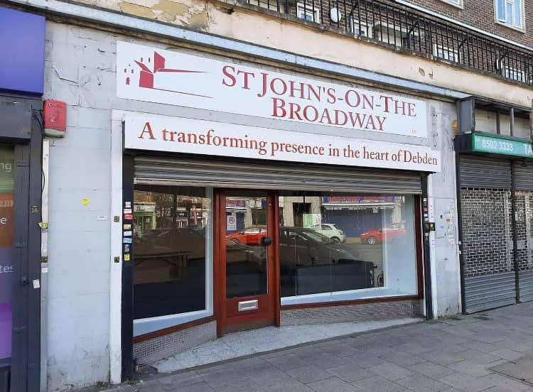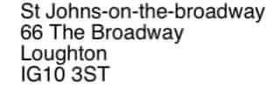

**Job vacancies @ Davenant**Davenant are currently looking to recruit for the following roles :   
Cleaners, Midday Assistants, Teaching Assistants, Product Design Technicians. all details can be found on the school website:

**Betty Vale**We sadly have to announce our dear sister, Betty has developed Pneumonia and is not responding to antibiotics. Bettys family and the medical team have taken the decision to switch to end of life care. Please keep Betty and your family in your prayers.

**Rocky Myles**Rocky is still undiagnosed with his syndrome and has many complex health needs which require specialist equipment and care. This has means Claire and Robert’s home needs some building alterations to make it fit for purpose, a campaign has been launched to raise £10,000 to fund the work. Can you help either put a donation in an envelope labelled Rocky Myles and drop to the rectory or donate online: [Fundraiser by Chloe Rich : Rocky's home renovation and equipment (gofundme.com)](https://www.gofundme.com/f/rickys-home-renovation-and-equipment?utm_campaign=p_cp+share-sheet&utm_medium=chat&utm_source=whatsApp). Thanks, in advance

**Intercessions, for the Second Sunday after Trinity, 13th June 2021 written by Geoffrey Wolfson**

May we walk by our faith in God the Father, God the Son, and God the Holy Spirit, not by our sight of the world’s illusions, temptations and sins.  
Father God, we approach your throne of grace with our concerns, our burdens and our thanksgiving for all your people throughout the world.  We pray that your Love will help us to put our trust in you and in our Saviour Jesus Christ, who taught us that you love us as a parent and want only what is right for us.

Father God, we pray for the Church throughout the world and especially for churches in places where religious faith is suppressed or where Christianity is the faith of an unwelcome minority.

We pray for our Clergy, and for all who serve this Church, and we pray that the guidance and wisdom of your Holy Spirit will move through all the work that they do to enable this Parish to function day by day, doing Your Son’s work in our community.

May the seeds that are being planted in our Parish grow into branches that reach out into every part of the Loughton community, and may your Holy Spirit guide and help us as we try to focus on the issues, responsibilities and concerns that sometimes threaten to overwhelm us.

Creator God, we pray for our world, which is unremittingly caught up in violence and conflict. Through the Press, television and other media, we are witnesses to both state and terrorist violence in so many parts the world. As we continue to pray unceasingly for peace and goodwill towards and among all people, we bring before you the innocent victims and their families, caught up in conflicts that are not of their making, or under the oppression of tyranny, against which they have no recourse, nor any voice. We pray for the balm of God’s mercy and peace.

We pray for our world leaders, meeting in Cornwall as the G7 group of nations; may your Spirit of wisdom, justice and mercy guide and inform their deliberations and decisions.  We also pray for our community leaders and those in public office dealing with difficult situations, and, especially, for all those dealing with the Covid Pandemic – such as clinicians, carers, scientists, workers in local authorities, shops, schools, public transport and utilities.  Loving Father, may the strength of your Holy Spirit help us be aware of the part that *we* can play by always acting carefully and unselfishly.

Gracious God, we pray for our children and young people as they near the end of the academic year. We pray that your caring Spirit will be with and watch over all students who are beginning important examinations at school and university, and with those who will soon start new lives in the world of work or apprenticeships. Help us, through your Grace, to create a society in which young and old, gifted and less able, feel valued and proud to belong.

Loving God, we bring before you all people in need, in our own community and further afield: the elderly, the housebound and those in care homes, hospitals and hospices. We give thanks for all those who care for the sick within the family, and for all our medical and voluntary services. We bring before your tender mercy the victims of casual or domestic violence, abuse or cruelty.  We pray that we may be kind to the homeless, to the unemployed, to refugees and to all who are oppressed or dispossessed.

We commend into your hands, O Lord, those whom we have known and loved, and those who have shaped us, especially remembering today the lives of, Valerie Adams  
You gave them breath, and loved them through their lives. Receive them now, we pray, in your infinite tenderness, and give them peace.  
Almighty God, Father of all mercies and giver of all comfort: deal graciously, we pray, with those who mourn, that, casting all their care on you, they may know the consolation of your love. We ask this in the name of your Son, Jesus Christ, our Lord and Saviour.

Loving Lord, we ask you to lead us into the coming week and to watch over us as we seek to do your will; we pray that, through your Holy Spirit, we will know that you are close by, keeping us firm in our faith, and helping us never to disappoint or fail You, our families, friends and colleagues …. or ourselves.   
Rejoicing in the fellowship of St. John the Baptist, St Nicholas, St Francis, and all the Saints, we commend ourselves and all creation to your everlasting love. **Merciful Father, accept these prayers for the sake of your Son, our Saviour, Jesus Christ. Amen**