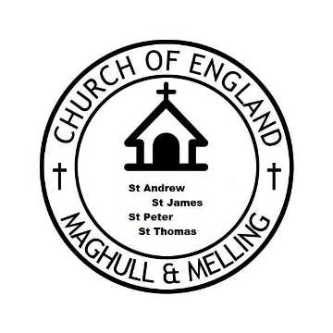

“M&M C3G” 2021
MAGHULL AMD MELLING CHRISTIANS OF THE THIRD GENERATION

Our Aim:
To engage with others in promoting the Love of Jesus through fellowship and faith.

MMC3G THIS YEARS PROGRAMME

July Thursday 8th Afternoon visit Bents Garden centre 2.00pm
Aug Sunday 8th Barbeque followed by Songs of Praise - St Andrews 2.30pm
Sep Thursday Sept 9th Celebration of Age Service St Andrews 6,30pm
Oct Thursday 7th Cathedral Twilight tour-followed by meal in town 6.00pm.
Oct Friday 29th Cheese and Wine Evening with quiz-Tithebarn St Thomas 7.30pm.
Dec Thursday 9th December Christmas Songs of Praise -St James 6.00pm.

All welcome to come along -watch for further details in the weekly churches notice sheets.
For any other info contact Revd Dave 07972577801
Email;dhamlett@blueyonder.co.uk

