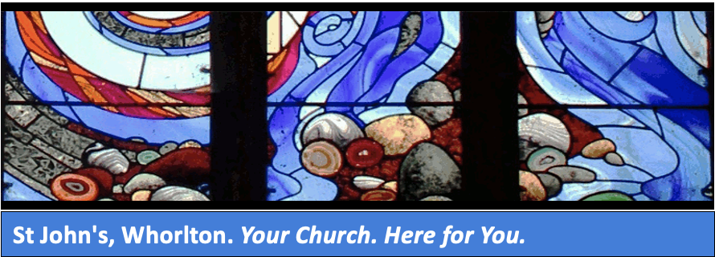
St John's Church, Whorlton June 2021
A Message from Reader Anne Morris

As I type the date of this newsletter, I wonder how we ever got here. Over a year of our lives has gone past in a blur of disbelief and anxiety. Many of us have survived and many have lost their lives leaving a society that has had to cope with loss, uncertainty and a sense of not knowing what the future will bring. As a church we have just celebrated Pentecost. The Day that marks fifty days since Easter Day and brings the Easter season to an end. It is a major feast of the Church’s year when Christians recall how God’s Holy Spirit was given to the disciples after Jesus’ ascension, empowering them to begin the work of making disciples of all nations. When God sends the Spirit, chaos is changed into creation --- the Red Sea opened up to a highway of freedom. When God sends the Spirit: a young woman says ‘Yes”. Jesus is born and life is never the same. When God sends the Spirit amazing things happen, we are about to see this in our own lives today as we begin to see an end of this dreadful Virus which has swept the world. Communities are beginning to come together; life as we know it is being re-established, we have an amazing healthcare system that has helped to combat this Disease. Hope is established. Families are reunited. Today the Spirit of God is present and we’re about to see the reopening of all churches.
As we look back all those years ago at the beginning of the Church, I see similarities in our situation in the world today. The Holy Spirit gave the Disciples the ability to speak in tongues (no I don’t mean we are going to speak in multiple languages) just as it gives us the ability to take a fresh look around us and see the changes that have occurred. We have a new road structure, new houses and new families.

We should also take this opportunity to take a long hard look at how we have managed the good and the bad during these difficult times. We should embrace the good and build upon it and allow the spirit of the Lord to work through us.

Time to reflect on the words of Jeremiah 20 v 11
‘For I know the plans I have for you declares the Lord, plans to prosper you and not to harm you, plans to give you hope and a future’

