|  |  |
| --- | --- |
| facebook logo | **The Parish of Saint Peter with st martin**  **Edmonton (1817)** IN THE **DIOCESE OF LONDON**  Vicar: The Revd Tina Kelsey  **Tel: 020 8807 7431**  **For pastoral, prayer, or other conversations**:[tina.jk42@yahoo.co.u](mailto:tina.jk42@yahoo.co.u)k  Church Office: [stpetersedmonton@gmail.com](mailto:stpetersedmonton@gmail.com)    **Follow us on Facebook, Twitter and YouTube Find us on** [**www.achurchnearyou.com**](http://www.achurchnearyou.com) |

**Passion Sunday: 21 March 2021**

**Sunday zoom Mass time 9.30am**

Readings

**Jeremiah 31:31-34**

*Author*: Possibly Zabud son of Nathan *Date:* after 930BC

*Recipient*: The Israelites

*Purpose: Kingship & Covenant*

**Hebrews 5:5-10**

*Author*: possibly Barnabas or Apollos *Date*: sometime before 70AD

*Recipients:* Jewish converts, possibly Jewish Christians thinking of merging with a Jewish sect such as Qumran near the Dead Sea

*Purpose:* The supremacy and efficacy of Jesus Christ as revealer and mediator of God’s grace

**John 12:20-33**

*Author*: John the apostle *Date*: 50-70AD

*Recipient:* The Early Church

*Purpose:* To clarify the identity of Jesus of Nazareth as the Son of God

**Psalm 119**

***R: O Lord, how I love your law***

How shall the young cleanse their way?

by keeping to your words

With my whole heart I seek you: let me not stray from your commandments ***R***

I treasure your promise in my heart

that I may not sin against you

Blessed are you O Lord

instruct me in your statues ***R***

With my lips will I recite all the

judgements of your mouth

I have taken greater delight in the way of your decrees than in all manner of riches ***R***

I will meditate on your commandments

and give attention to your ways

my delight is in your statues

I will not forget your word ***R***

**Collect**

Most merciful God

who by the death and resurrection of your Son Jesus Christ

delivered and saved the world

grant that by faith in him who suffered on the cross

we may triumph in the power of his victory

through Jesus Christ your Son our Lord

who is alive and reigns with you

in the unity of the Holy Spirit

one God, now and for ever

**Amen**

**Jeremiah 31:31-34**

The days are surely coming, says the Lord, when I will make a new covenant with the house of Israel and the house of Judah. **32**It will not be like the covenant that I made with their ancestors when I took them by the hand to bring them out of the land of Egypt—a covenant that they broke, though I was their husband, says the Lord.

**33**But this is the covenant that I will make with the house of Israel after those days, says the Lord: I will put my law within them, and I will write it on their hearts; and I will be their God, and they shall be my people. **34**No longer shall they teach one another, or say to each other, ‘Know the Lord’, for they shall all know me, from the least of them to the greatest, says the Lord; for I will forgive their iniquity, and remember their sin no more.

**Hebrews 5:5-10**

So also Christ did not glorify himself in becoming a high priest, but was appointed by the one who said to him, ‘You are my Son, today I have begotten you’; **6**as he says also in another place, ‘You are a priest for ever, according to the order of Melchizedek.’

**7**In the days of his flesh, Jesus offered up prayers and supplications, with loud cries and tears, to the one who was able to save him from death, and he was heard because of his reverent submission. **8**Although he was a Son, he learned obedience through what he suffered; **9**and having been made perfect, he became the source of eternal salvation for all who obey him, **10**having been designated by God a high priest according to the order of Melchizedek.

**John 12:20-33**

Now among those who went up to worship at the festival were some Greeks. **21**They came to Philip, who was from Bethsaida in Galilee, and said to him, ‘Sir, we wish to see Jesus.’ **22**Philip went and told Andrew; then Andrew and Philip went and told Jesus. **23**Jesus answered them, ‘The hour has come for the Son of Man to be glorified. **24**Very truly, I tell you, unless a grain of wheat falls into the earth and dies, it remains just a single grain; but if it dies, it bears much fruit.

**25**Those who love their life lose it, and those who hate their life in this world will keep it for eternal life. **26**Whoever serves me must follow me, and where I am, there will my servant be also. Whoever serves me, the Father will honour.

**27**‘Now my soul is troubled. And what should I say—“Father, save me from this hour”? No, it is for this reason that I have come to this hour. **28**Father, glorify your name.’ Then a voice came from heaven, ‘I have glorified it, and I will glorify it again.’

**29**The crowd standing there heard it and said that it was thunder. Others said, ‘An angel has spoken to him.’ **30**Jesus answered, ‘This voice has come for your sake, not for mine. **31**Now is the judgement of this world; now the ruler of this world will be driven out. **32**And I, when I am lifted up from the earth, will draw all people to myself.’ **33**He said this to indicate the kind of death he was to die.

**Sermon**

This year we have had to break open our old routines to keep people safe and help stop the virus. As we prepare to come back into church, I thank you for your willingness to embrace the changes we have made as a church community. New life has come out this and new relationships have been formed, so as we look to mark the first anniversary of lockdown on Tuesday it seems to me that even when conditions are tough, creation finds ways to keep going.

Take our peace garden for instance. It is certainly turning the heads of those who pass by and I think giving them some joy and hope even if just for a moment. For despite the difficulties of the past twelve months, the trees are flourishing, the daffodils are blooming and there are buds and shoots breaking through the winter soil, with the promise of better things to come.

One of them is our passion flower. Bought with a congregational donation it is now growing happily and I am looking forward to seeing it flower in the summer. Until then we have one in full bloom on the front of our noticesheet. Originating in Brazil it got its name from the medieval friars and missionaries who first discovered it. They saw it as representative of the last few days of Jesus’ life and so called it the passion flower, in recognition of his sufferings.

They likened the pointed leaf tips to the [lance](http://en.wikipedia.org/wiki/Holy_Lance) which pierced his side on the cross. The flower tendrils to the whips used to deliver the 39 lashes. The filaments to his crown of thorns, the 3 stigmas, to the nails, the 5 anthers to his wounds, and finally, the ten [petals](http://en.wikipedia.org/wiki/Petal) to his faithful [apostles](http://en.wikipedia.org/wiki/Apostles). Ten because they excluded [Peter](http://en.wikipedia.org/wiki/St._Peter) on account of his denial and Judas because of his betrayal.

The colours too, blue, white and purple were important. Blue represents divinity, white, purity and purple, the colour of Lent and Advent, signifies penitence, royalty and mourning. This deep symbolism is still with us today and helps us to understand better why today is known as Passion Sunday.

Like its botanical namesake, this Sunday turns our attention to the events of Holy Week, the most significant week in the Christina year. In preparation, from today many churches cover all icons and crosses with purple cloths. They are removed two weeks later on Easter Day reminding us that the healing love of God can never be completely hidden; its light will always find a way to break through, whatever the cost.

Jesus says as much in our gospel passage: Very truly, I tell you, unless a grain of wheat falls into the earth and dies, it remains just a single grain; but if it dies, it bears much fruit.

Let’s take a moment to consider his words. Grains consist of a hard outer kernel within which is an embryonic plant and some stored food. When it falls to the ground, the moisture and warmth of the soil softens the outer layer, triggering the growth of the tiny plant.

Nourished by the food, the grain’s hidden potential is released and in the case of wheat provides food and shelter, life and protection for both animals and humans. If the grain does not spilt, all this is lost, so perhaps what we can take from his words is that in a breaking, there can be life.

And so we come to Holy Week. We start by holding up our palm crosses and standing with the crowd bearing witness to the triumphal entry of Jesus to Jerusalem for the Passover.

Then, on Maundy Thursday we see him entrust his disciples with a ministry of service and the gift of unity though his body and blood.

On Good Friday we watch this body break for the good of all as God accepts the sacrifice of his Son as reparation for our mistakes.

On Holy Saturday we question how life could ever be restored after such trauma, then on Easter Sunday all is revealed as God’s love shows its fullest form. Through his broken body the world is fed. All is forgiven. The gift of eternal life belongs to us all.

Jesus’ life is quite a journey, and if If we are to follow him, ours too must include a willingness to be broken. For only where there is space can God come in and do his work. If we stay as we are, then we will be like an unplanted seed, full of unrealised potential, but, if we let ourselves be broken, that is we open ourselves to his love, then this can be released and the world will be a better place.

Very truly, I tell you, unless a grain of wheat falls into the earth and dies, it remains just a single grain; but if it dies, it bears much fruit.

Amen

**PRAYERS OF INTERCESSION**

*Wherever we are let us pray in the name of Jesus Christ and in the power of the Spirit alongside Christians throughout the ages and around the world*

Let us pray to the Father who loved the world so much that he sent his only Son to give us life

Simon of Cyrene was forced to carry the cross for him.

Give us grace to carry heavy loads for those we meet

*Lord in your mercy hear our prayer*

Your Son watched the soldiers gamble for his clothes

Transform the hearts of those who profit from the misfortunes of others

*Lord in your mercy hear our prayer*

The thief crucified with him was promised a place in your kingdom

Give pardon and hope, healing and peace to all who face death today

*Lord in your mercy hear our prayer*

From the cross your Son entrusted Mary and John to each other’s care

Help us to care from one another across all human boundaries

*Lord in your mercy hear our prayer*

The centurion was astonished to see your glory in your crucified Son

May the world see in him the true meaning of life and the depth of your love

*Lord in your mercy hear our prayer*

Joseph of Arimathea took your Son and laid him in his own tomb

May the bereaved know your hope and help us to minister to them with compassion.

Father, your forgiveness is our gift of eternal life and so we pray for all who now live with you in the fullness of your presence…

*Rest eternal grant unto them O Lord, and let light perpetual shine upon them.*

*May they rest in peace and rise in glory*

Our Father who art in heaven,

hallowed be thy name

thy kingdom come thy will be done

on earth as it is in heaven

give us this day our daily bread

and forgive us our trespasses

as we forgive those who trespass against us

and lead us not into temptation,

but deliver us from evil

for thine is the kingdom

the power and the glory

for ever and ever

Amen

**SERVICES AND GROUPS THIS WEEK**



**Tuesday 23 March**

**11.45am-12.30pm** *Church open for*

*National Day of Reflection including q minute silence at 12pm.*

**2pm-4pm** *Foodbank*

**7pm** *Zoom Study: Stations of the Cross*

**Wednesday 24 March**

**7.30pm** *Prayer Vigil with the Blessed*

*Sacrament*

**Sunday 28 March: Palm Sunday**

**9.30am** Mass *starting in the grounds for the Blessing of the Palms. We will sing ‘All glory laud and honour’ together before going into church. The dramatic reading of the gospel, includes congregation participation with ‘crowd’ & ‘bystander’ (words will be provided)*

**\*\*\*\*\*\*\*\*\*\*\*\*\*\*\*\*\*\*\*\*\*\*\*\*\*\*\*\*\*\*\*\*\*\*\*\*\*\*\*\*\*\*\*\*\***



C*hurch will be open 11.45am-12.30pm*

A short prayer service will be held, including the one minute silence at 12pm to mark the 1st anniversary of lockdown.

Link to the YouTube prayer video has been emailed with this noticesheet and is on our social media. Please share with friends

Dear God,  
Be with us as we think about all that has changed this year and help us to trust that you are always with us.  
Be close to us as we remember those who have died and help us to trust they are at peace with you.  
Show us how to reach out to others with kindness and care so that hope shines out in every heart and home

Amen

**TUESDAY BIBLE STUDY: 7pm**

Join in on zoom for an informal discussion on one or more of the Sunday readings or on some weeks a particular topic

**WEDNESDAY PRAYERS OF VIGIL WITH THE BLESSED SACRAMENT: 7.30pm**

We gather to underpin with prayer the work of caring for our hurting and grieving world.

***Opening prayer***

***Readings with the prayers***

**1 Kings 19:1-8**

For those in need in our parish

& communities

**2 Corinthians 4:5-9**

We give thanks for our world and pray for

her brokenness

**Luke 23:32-33, 39-43**

For all the recently departed

**1 Thessalonians 4:13-18**

We pray for those whose year’s mind falls

at this time

***The Collect***

Other prayers ending with Merciful Father **accept these prayers for the sake of your Son our Saviour Jesus Christ. Amen**

***The Lord’s Prayer***

***Night Prayer***

Be present be present O merciful Lord

as we enter the silent hours of this night,

so we who are wearied

by the changes and chances of this fleeting world

may rest upon your eternal changelessness

Restore us again O God of hosts

show us the light of your countenance

and we shall be saved

bless and keep us this night and always

**Amen**

**30 minutes silent vigil with the Blessed Sacrament**



 **STATIONS OF THE CROSS**

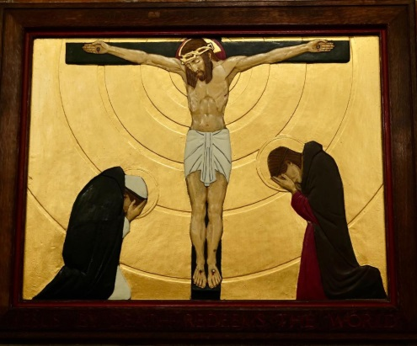

**The Twelfth Station**

**Jesus by death redeems the world**

We adore you O Christ and we bless you,

because by your holy cross you have redeemed the world

*I give you a new commandment, that you love one another as I have loved you. (John 13:34)*

*After this, when Jesus knew that all was finished he said (in order to fulfil the scripture) ‘I am thirsty’ A jar full of sour wine was standing there. So the put a sponge full of the wine on a branch of hyssop and held it to his mouth. When Jesus had received the wine he said’ It is finished’ Then he bowed his head and gave up his spirit. (John 19:28-30)*

Every death brings change. Like the ripples that spread out in concentric circles from a single raindrop, change and remake the surface of the water, the loss of another sends out its own vibrations, disturbing then remaking our lives. Whatever our relationship with them had been, their absence becomes as much a part of our journey as their presence, and nothing is ever quite as it was. Jesus’ death has sent shock waves across the whole of creation. His final act; to face the Father’s anger on our behalf, continues to unsettle, disturb and challenge, just as the forgiveness that followed still calls for the remaking of a world.

Father our lives have been disturbed, challenged and changed. Families, friends, communities and nations are no longer what they were. In your life-changing, life giving love, hold us, heal us and rebuild us. Amen

Holy God, holy and strong, holy and immortal, have mercy on us

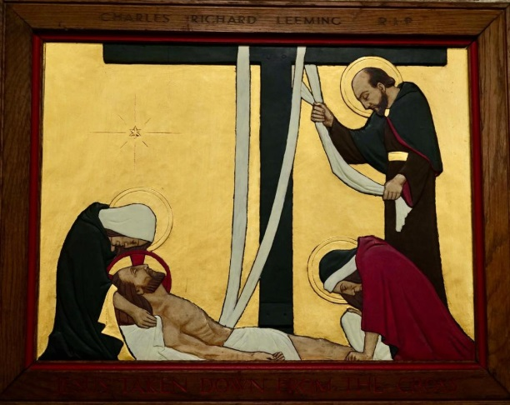

**The Thirteenth Station**

**Jesus taken down from the cross**

We adore you O Christ and we bless you,

because by your holy cross you have redeemed the world

*When the time came for their purification according to the law of Moses, they brought him up to Jerusalem to present him to the Lord (as it is written in the law of the Lord, ‘Every firstborn male shall be designated as holy to the Lord’), and they offered a sacrifice according to what is stated in the law of the Lord, ‘a pair of turtle-doves or two young pigeons.’ Then Simeonsaid to his mother Mary, ‘This child is destined for the falling and the rising of many in Israel, and to be a sign that will be opposed so that the inner thoughts of many will be revealed—and a sword will pierce your own soul too.’ (Luke 2:22-24, 34-35)*

As Mary sits beneath the wooden cross waiting to receive the broken body of her son into her arms, she is transported to another time, another place and another moment. Lying next to the wooden crib she had stretched out her arms as he in his first few seconds of life was gently handed to her.

His birth had been a night of wonder and hope, but when she and Joseph had taken him to the Temple a shadow had fallen and the true shape of that hope was revealed. Now, she knew what then she heard. The sword had come.

Father when our hearts are pierced with pain look upon us as we look upon you. Amen

Holy God, holy and strong, holy and immortal, have mercy on us

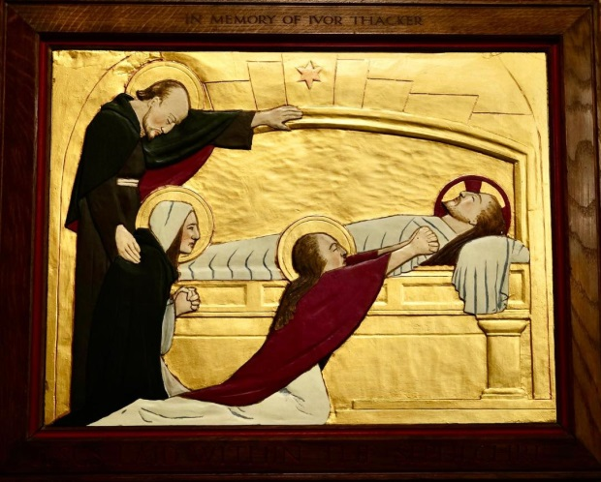

**The Fourteenth Station**

**Jesus laid in the sepulchre**

We adore you O Christ and we bless you,

because by your holy cross you have redeemed the world

*When it was evening, there came a rich man from Arimathea, named Joseph, who was also a disciple of Jesus. He went to Pilate and asked for the body of Jesus; then Pilate ordered it to be given to him.**So Joseph took the body and wrapped it in a clean linen cloth and laid it in his own new tomb, which he had hewn in the rock.  (Matthew 27:57-61)*

A borrowed crib. A borrowed boat. Borrowed bread and fish. A borrowed donkey. A borrowed room. Jesus was dependent on others from the moment he came into this world. Now, in a borrowed tomb laid his silent body wrapped in borrowed cloths stained red. The only thing of his own was the cross and that he possessed for us.

Father, in everything you bore for us and everything you give to us, you are our light and our salvation

Holy God, holy and strong, holy and immortal, have mercy on us

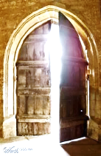**PARISH NOTICES: Find us on Twitter Facebook YouTube &** [**www.achurchnearyou.com**](http://www.achurchnearyou.com)

***HOLY WEEK***

Subject to Church of England guidance Masks, hand sanitising & social distancing apply.

***28 March Palm Sunday:*** 9.30am Blessing of the Palms outside then Mass in church & on zoom

***29 March Holy Monday:*** 8.30pm YouTube/Zoom Compline

***30 March Holy Tuesday:*** 7.30pm Mass in church & on zoom

***31 March Spy Wednesday:*** 9.30am Requiem Mass on zoom

7.30pm Zoom Prayer Vigil with the Blessed Sacrament YouTube service to be sent

***1 April Maundy Thursday:*** 7.30pm Mass with the Watch in church & on zoom until 12pm

***2 April Good Friday:*** 1.30pm Stations of the Cross with Good Friday Liturgy in church & zoom

***4 April Easter Day:*** 9.30am Easter Mass with lighting of Paschal Candle & renewal of baptism

vowsin church & zoom

***\*\*\*\*\*\*\*\*\*\*\*\*\*\*\*\*\*\*\*\*\*\*\*\*\*\*\*\*\*\*\*\*\*\*\*\*\*\*\*\*\*\*\*\*\*\*\*\*\*\*\*\*\*\*\*\*\*\*\*\*\*\*\*\*\*\*\*\*\*\*\*\*\*\*\*\*\*\*\*\*\*\*\*\*\*\*\*\*\*\*\*\*\*\*\*\*\*\*\****

**FUNDRAISING** Thank you for financially supporting our life together

[*https://www.easyfundraising.org.uk/causes/stpeterschurchloweredmonton/?invite=9VWB6W&referral-campaign=c2s*](https://www.easyfundraising.org.uk/causes/stpeterschurchloweredmonton/?invite=9VWB6W&referral-campaign=c2s)

**Tuesdays 2pm-4pm:** *Enfield Health and Well Being food bank is now the St Peter’s Foodbank.* EHW has moved to another project although still supporting us with fresh food. We along with community volunteers are continuing this ministry. Your help is very much needed. Thank you

**Clothing for Sri Lanka** can be left in the greencupboard by the vicarage door

**Parish Magazine 2021 ‘The Church Year’** The March/April edition is now available.

**ELECTORAL ROLL REVISION *21 March – 4 April***

The roll is revised each year before the APCM. If you have been attending for at least six months are not yet on the roll you can join.  Forms available from Marilyn or an electronic copy can be obtained by emailing the Church Office.

***Please return by 4 April*** ***Revised Roll published in church 11 April* APCM *27 April***

 **Congratulations to our February 100 Club winners:** Timothy Munt & Ashley McLoughlin

BIRTHDAY & ANNIVERSARY BLESSINGS TO ALL CELEBRATING THIS WEEK

Smiling face with no fill**Welcome** to our weekly St. Peter’s quiz. Take time to chat with family and friends,

work out the answers, have some fun and learn something new. (46)

**Bible: (tricky this week): The first for Leading up to Easter**

1 Who made the statement, “Take ye him, and crucify him, for I find no fault in him.”?

2 Jesus body was placed in a sepulchre and a rock was rolled to cover the opening.

What is a sepulchre?

3 How many angels were guarding the sepulchre?

4 Which disciple is not present when Jesus goes to see them after his resurrection?

**General Knowledge: Dogs**

1 Which dog breed is the favourite of The Queen of England?

2 Can you give the name of the Queen’s first Corgi?

3 What is a mixture of Dachshund and Corgi called

4 Which breed of dog has a black tongue?

**Answers to Quiz 45**

**Round 1 Bible**  **Round 2: General knowledge**

1) Nicaea 1) Provides information about their environment ie spatial

2) 27:52-53 2) It makes them happy or calm

3) Tomb 3) Their fur is not designed to repel water (desert origins)

4) Fainted 4) It provides them with folic acid and they like the taste

*If you feel like a chat or want me to light a candle in church for someone just let me know.*

*Stay safe and keep hoping. Revd Tina*