THE FIRST SUNDAY of LENT
And so Lent begins … in this strange time when we are already living our lives pared down and having to deny ourselves so many things. How can we fruitfully spend this time? We begin on Ash Wednesday reminded we are “but dust” and walking with Jesus through the 40 days and nights of fasting and prayer, until we come through to the glory of Resurrection: No longer simply dust but children of Light, raised with Him for eternity. Jesus goes into the desert immediately after His baptism by John, when His Father owns Him: “You are my Son, whom I love; with You I am well pleased.” He knows He is not alone and that He is loved. Part of His struggle is with those aspects of life which could trip Him up in His quest. These two things could be a good beginning for us as we set out on our Lenten journeys.

Your love Lord reaches to the heavens! And your faithfulness to the clouds
We praise you Father for Your amazing LOVE
HYMN: Forty days and forty nights https://youtu.be/9N29ZnwU4LM
PRAYER
Let us pray that we may be given grace to keep Lent faithfully.
Heavenly Father, all hearts are open to you.
No secrets are hidden from you.
Purify us with the fire of your Holy Spirit
that we may love and worship you faithfully,
through Jesus Christ our Lord. Amen.

Collect for Ash Wednesday
Almighty and everlasting God,
you hate nothing that you have made
and forgive the sins of all those who are penitent:
create and make in us new and contrite hearts
that we, worthily lamenting our sins
and acknowledging our wretchedness,
may receive from you, the God of all mercy,
perfect remission and forgiveness;
through Jesus Christ our Lord. Amen

TIME of CONFESSION
Heavenly Father, long~suffering and of great goodness,
I confess to You, I confess to You with my whole heart
My neglect and forgetfulness of Your commands, my wrong~doing, thinking and speaking,,
The hurts I have done to others, and the good I have left undone.
O Lord, forgive me, cleanse my heart, and raise me to new Life with You
Through Jesus Christ our Lord. Amen.
Old Testament Reading
From The Book of Genesis Chapter 9 verses 8 to 17
Then God said to Noah and to his sons with him:
"I now establish my covenant with you and with your descendants after you
and with every living creature that was with you ~
the birds, the livestock and all the wild animals, all that came out of the ark with you ~
every living creature on earth.
I establish my covenant with you:
Never again will all life be cut off by the waters of a flood;
never again will there be a flood to destroy the earth."
And God said, "This is the sign of the covenant I am making
between me and you and every living creature with you,
a covenant for all generations to come:
I have set my rainbow in the clouds,
and it will be the sign of the covenant between me and the earth.
Whenever I bring clouds over the earth and the rainbow appears in the clouds,
I will remember my covenant between me and you and all living creatures.
Never again will the waters become a flood to destroy all life.
Whenever the rainbow appears in the clouds,
I will see it and remember the everlasting covenant
between God and all living creatures of every kind on the earth."
So God said to Noah, "This is the sign of the covenant I have established
between me and all life on the earth."

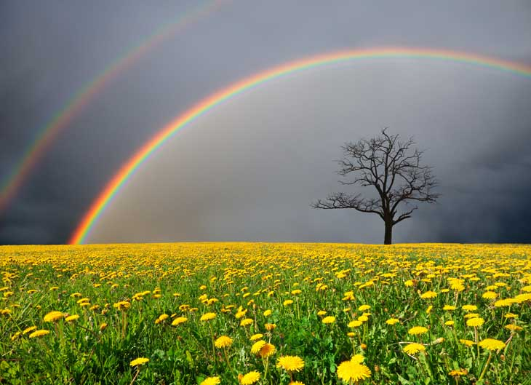
This Photo by Unknown Author is licensed under CC BY-SA
TIME to REFLECT
Although we begin on Ash Wednesday “grovelling” in the dust, our Old Testament Reading on this first Sunday of Lent reminds us of God’s eternal Love for us. The scintillating multi~coloured seal of His promise. The sign that God painted in the sky to seal His promise of Love for the World He made, is the most colourful sign there could be. Far from dusty, murky grey, it has the whole range of colours known. A reminder to all creation of our Father’s dedication and love. A love He longs to be reciprocated. A positive, sparkling sign that is to be reflected, as people of the covenant, that special relationship, in our lives. This colourful quality is worth striving for. The path that we take along that way will be individually marked out, each of us is different, at different stages, with different challenges ahead and different lessons to learn.
COLLECT for LENT 1
Almighty God, your Son Jesus Christ fasted forty days in the wilderness,
And was tempted as we are, yet without sin: giive us grace to discipline ourselves
in obedience to your Spirit; and, as you know our weakness,
so may we know your power to save, through Jesus Christ our Lord. Amen
Psalm 51
Lord, restore your image within me that I may live for your glory
¹ Have mercy on me, O God, according to your steadfast love;
according to your abundant mercy blot out my transgressions.
² Wash me thoroughly from my iniquity, and cleanse me from my sin.
³ For I know my transgressions, and my sin is ever before me.
⁴ Against you, you alone, have I sinned, and done what is evil in your sight,
so that you are justified in your sentence
and blameless when you pass judgement.
Lord, restore your image within me that I may live for your glory
⁵ Indeed, I was born guilty, a sinner when my mother conceived me.
⁶ You desire truth in the inward being therefore teach me wisdom in my secret heart.
⁷ Purge me with hyssop, and I shall be clean; wash me, and I shall be whiter than snow.
⁸ Let me hear joy and gladness; let the bones that you have crushed rejoice.
Lord, restore your image within me that I may live for your glory
⁹ Hide your face from my sins, and blot out all my iniquities.
¹⁰ Create in me a clean heart, O God, and put a new and right^{[b]} spirit within me.
¹¹ Do not cast me away from your presence, and do not take your holy spirit from me.
¹² Restore to me the joy of your salvation, and sustain in me a willing spirit.
Lord, restore your image within me that I may live for your glory
SONG: Restore, O Lord, the honour of your Name https://youtu.be/1g4p3v06lhk
Pause for Thought
Take time to reflect on your life at the moment. Think about the Rainbow with its range of vibrant colours. Are there “colours” in your life that are missing, shadowy, dusty grey? What needs restoring in your life? Pray for God’s help to renew you to your full vibrancy.

The Gospel Reading From Mark Chapter 1 verses 9 to 20
At that time Jesus came from Nazareth in Galilee and was baptized by John in the Jordan.
As Jesus was coming up out of the water,
he saw heaven being torn open and the Spirit descending on him like a dove.
And a voice came from heaven: "You are my Son, whom I love; with you I am well pleased." At once the Spirit sent him out into the desert, and he was in the desert forty days,
being tempted by Satan. He was with the wild animals, and angels attended him.
After John was put in prison, Jesus went into Galilee, proclaiming the good news of God.
"The time has come," he said.
"The kingdom of God is near. Repent and believe the good news!"
As Jesus walked beside the Sea of Galilee, he saw Simon and his brother Andrew
casting a net into the lake, for they were fishermen.
"Come, follow me," Jesus said, "and I will make you fishers of men."
At once they left their nets and followed him.
When he had gone a little farther, he saw James son of Zebedee and his brother John
in a boat, preparing their nets.
Without delay he called them,
and they left their father Zebedee in the boat with the hired men
and followed him. .
PRAYERS
Brother Christ, our Saviour and Friend, Help us to follow you into the waters of baptism
to face and break the chain of past wrongs
That we may be renewed and fit to take up our place in Your Kingdom.
Lord, raise us up from the dust: Restore us and renew us as your rainbow people Help us to follow you into the desert, to fast with you, denying false luxury values,
Refusing the tempting ways of self~indulgence,
The ways of success at all costs, the way of coercive persuasion.
Lord, raise us up from the dust: Restore us and renew us as your rainbow people Help us to follow you wherever our own ministry calls:
To heal and restore …. To cast out the dark forces of greed, resentment,
Communal hatred and self~destructive fears ~ so rampant in our world.
Lord, raise us up from the dust: Restore us and renew us as your rainbow people Help us to follow you into our places of quiet retreat,
To pray for the confused, the despairing, the anxiety~driven,
To allow you to prepare ourselves for your service whatever it may cost us
Lord, raise us up from the dust: Restore us and renew us as your rainbow people Help us to follow you along the road to Jerusalem,
To set our faces firmly against alluring suggestions to live a safe, self~centred life
And to embrace the way of self~offering.
Lord, raise us up from the dust: Restore us and renew us as your rainbow people Help us to follow you even to the Cross …
May we recognize there and set our hope in Your self~giving Love,
To die with You to all that is not born of that great Love.
Lord, raise us up from the dust: Restore us and renew us as your rainbow people Then, Lord, help us, with You, to burst out of that dark, sealed tomb;
Help us to embrace daily Your resurrection Life, to be transformed into Your image of Love,
To serve daily, together as Your new body, the body that is broken for You in Your world.
Lord, raise us up from the dust: Restore us and renew us as your rainbow people
HYMN: O Jesus I have promised to serve Thee to the end https://youtu.be/IaKT4scxct0

