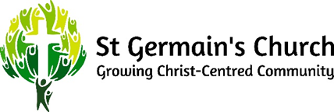
Sunday 14th February
^{6th} Sunday of Epiphany
Welcome to St Germain’s!

He said to me: “It is done. I am the Alpha and the Omega, the Beginning and the End. To the thirsty I will give water without cost from the spring of the water of life. Those who are victorious will inherit all this, and I will be their God and they will be my children.
Rev 21 verses 6-7
UPCOMING SERVICES

Sunday 14th February 6pm – Evening service

Wednesday 17th February 10.30am – Morning prayer

Wednesday 17th February 12.30-1.00 pm – Ashes to Go in front of church

Thursday 18th February 9.30am – Morning Prayer with Ruth Briggs

Sunday 21st February 10.30am – Morning service with Rev Sarah Hayes

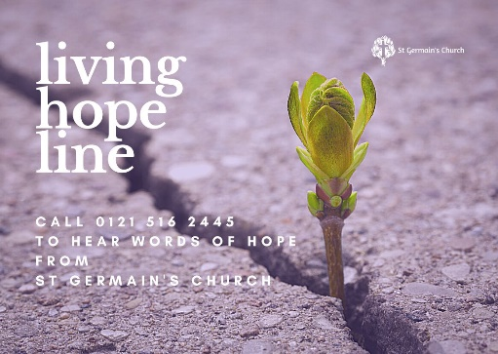

St Germain’s new Living Hope Line has a short version of the Sunday service and other prayers and reflections. To access call 0121 516 2445. As it is a landline number, it will be free if your phone package includes free calls.

MORNING PRAYER: Ruth Briggs will host morning prayer on Zoom every Thursday at 9.30 am. She will largely follow the service as set in Common Worship and use the daily lectionary readings. The link to join is https://us02web.zoom.us/j/87854058617 and the passcode is 264361.

Key Contact Information
Vicar | Rev Dr Sarah Hayes |  | sarah@stgermains.org.uk
 | Sarah’s day off is Tuesday.
Office | Les Allan | office@stgermains.org.uk; 07716 256 435
 | Les is on leave Monday & Friday
Wardens | John Hopkins & Richard Eaton
facebook.com/stgermainschurch www.stgermains.org.uk
Notices

The food hub is very short of items at the moment. Please donate the following:

- CARRIER BAGS
- UHT/Long life milk
- Toilet roll
- Tinned veg, soup, beans, tomatoes, and fruit

If you find it difficult to shop but want to help, we can accept donations and our super shoppers can purchase items on your behalf.

St Germain’s now has an easy way of sharing payers and praying for others. You can join our online community of prayer by visiting our Prayer Wall at www.stgermains.org.uk/prayer-wall
Following on from our Unconscious Bias training last summer and in continuing our “courageous conversation” on equality, racial justice and unity, we will be running two pop-up life groups produced by Tearfund in collaboration with Ben Lindsay and Pastor Agu Irukwu.
The dates for these will be;
Monday 15th February at 19.15pm - Black Lives Matter, Recognising and Responding to systemic racism
Wednesday 24th March at 19.15pm - Jesus and Communal sin
If you would like to be included or would like more information, please get in touch with Jane Edwards or Linda Germain.

- Healing for Mr and Mrs Hall both in hospital with Covid.
- For vaccine to be rolled out to countries less privileged than us & for leaders to accept the vaccine for their people.
- Prying for Key workers to draw on God’s strength and find ways to minister grace and love to colleagues and all they meet.
- Praying that each of us would be blessed by the teachings and discussions in the Tearfund Bible Study on 15th Feb
- For my sister Grace, who has terminal cancer, to keep her faith strong
Mission Update: Penny Marces
Please feel free to share your prayer requests at office@stgermains.org.uk. These are printed in the space below each week. If you would like to share a prayer request for someone else, please make sure you ask their permission first and don’t disclose their full name.
Confidential requests can be emailed here too, just ensure they are marked as such.

Prayer Requests

1. Please pray for the health situation in Peru. Give thanks for the vaccines that have arrived and pray that future consignments will arrive quickly. Pray too for the huge shortage of oxygen in Peru, resulting in deaths and frustration, and pray that the authorities will act to facilitate optimum use of what is available.
2. Pray for the Presidential and Congress elections which will take place on 11 April. Pray that God will raise up leaders who have a desire to serve both God and the country.
3. Pray for the online marriage course, due to start on Saturday 20th Feb, and for Juan Carlos and Penny leading it.
3. Pray for Juan Carlos and Penny with their different responsibilities in the Cathedral, in Jesús el Nazareno, and in the Diocese.

Many thanks to you all!
God bless,
Juan Carlos and Penny

