December 2020 - January 2021

“Growing Disciples: Wider, Younger, Deeper”
‘Healthy People, Healthy Church, Healthy Communities’

Published by the Church of England Parish of Ollerton with Boughton:
St Giles, St Paulinus and St Matthew
Sharing the Love of Jesus in Ollerton, New Ollerton and Boughton, and with our group partner churches in Bilsthorpe, Eakring, Egmanton, Kirton, Kneesall, Laxton, Moorhouse, Rufford, Walesby and Wellow

NEWS
Welcome to our monthly newsletter!
Page 2 Full service rota; Carols on the Doorstep
Page 3 Heather writes
Page 4 Latest Church News
Page 5 Christingle by Zoom
Page 6 A Christmas Gift; Food Bank
Page 7 Trees; A Christmas Greeting
Page 8 A Christmas Carol - THE END
Page 10 Prayer
Page 11 Contacts
4U
Christmas Week
 | Ollerton/  Boughton | Kirton/Wellow/Walesby/  Laxton/Egmanton | Bilsthorpe /  Eakring
20.12.20  Advent 4 | HC, 10.30am  St Matthew, Boughton | HC 9.00am Egmanton  HC 9.00am Walesby  HC 10.30am Wellow | MP 9am Eakring  MP 10.30am Bilsthorpe
Wednesday  23.12.20 | EP for Christmas 7pm St Giles
Christmas Eve & Christmas Day
 | Ollerton/  Boughton | Kirton/Wellow/Walesby/  Laxton/Egmanton | Bilsthorpe /  Eakring
Christmas Eve  24.12.20 | 4pm Christingle service via Zoom (not in church) See separate article on page 5 for details. | Mass for Christmas  6pm Kirton  6pm Laxton | Mass for Christmas  4pm Bilsthorpe  5pm Christingle at Eakring
Christmas Day  25.12.20 | HC 10.30am St Paulinus | MP 10.00am Eakring
For other services in December and January see next page

Service rota for December-January
Don't forget to look out for services on Facebook as well!
(HC=Holy Communion; MP=Morning Prayer; EP=Evening Prayer)

 | Ollerton/  Boughton | Kirton/Wellow/Walesby/  Laxton/Egmanton | Bilsthorpe /  Eakring
6.12.20  Advent 2 | HC, 10.30am  St Giles, Ollerton | HC 9.00am Kirton  EP 4pm Wellow | MP 9am Eakring  MP 10.30am Bilsthorpe
13.12.20  Advent 3 | HC 10.30am St Paulinus | HC 9.00am Walesby  HC 10.30am Laxton  EP 4pm Egmanton | MP 9.00am, Eakring  MP 10.30am Bilsthorpe
20.12.20  Advent 4 | HC, 10.30am  St Matthew, Boughton | HC 9.00am Egmanton  HC 9.00am Walesby  HC 10.30am Wellow | MP 9am Eakring  MP 10.30am Bilsthorpe
20th - 25th December: see front cover
27.12.20  Christmas 1 | No services today in the group
3.1.21  Christmas 2 | HC, 10.30am  St Giles, Ollerton | MP 9.00am Eakring  MP 10.30am Bilsthorpe | HC 9.00am Kirton  EP 4.00pm Wellow
10.1.21  Epiphany 1/ Plough Sunday | HC 10.30am St Paulinus, Ollerton | HC 9.00am, Eakring  HC 10.45am Bilsthorpe | MP 10.30 am Laxton  EP 4pm Egmanton
17.1.21  Epiphany 2 | HC 10.30am  St Matthews | MP 9.00am Eakring  MP 10.30am Bilsthorpe | HC 9.00am Egmanton  HC 9.00am Walesby  HC 10.30am Wellow
24.1.21  Epiphany 3 | HC 10.30am St Paulinus | MP 9.00am Eakring  MP 10.30am Bilsthorpe | MP 10.30am Kirton
31.1.21  Epiphany 4 |  |  | HC 9.00am Walesby  HC 10.30am Laxton

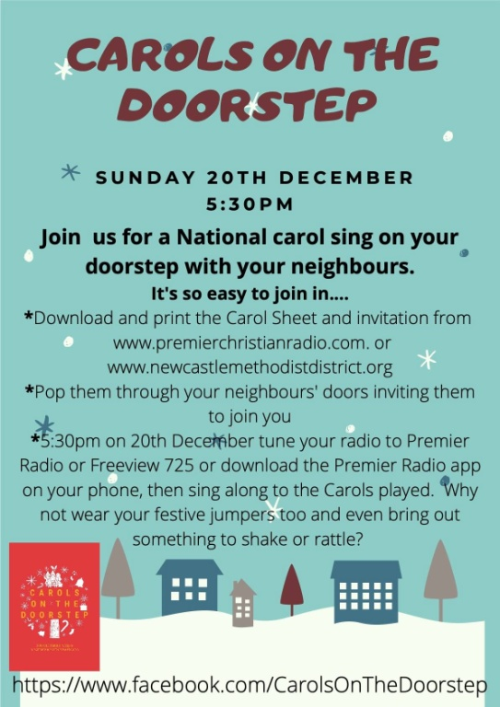

MINISTER'S LETTER_- Heather Brown

I am writing this letter for News4U at the end of November, ready for the December issue, which ordinarily, I imagine, would be full of information about exciting things happening in our parishes and communities as we prepare for Christmas.
Usually in Eakring, where I live, we have a Christmas Fayre, a craft event for local children, the Women's Institute Christmas Party, the Parish Council's evening of mince pies and mulled wine with the big light switch on, a Christmas Jumper event in the pub, as well as the Great Eakring Bake Off competition. And of course, there would have been all the lovely Christmas services in church, including the Carol Service and the Christingle and Nativity, where often it's hard to find a spare seat.
But not this year. And it's such a shame. All those lovely Christmas events, which brought communities together, have had to be cancelled.
At the time of writing it has been decided that after the latest lockdown has ended, Nottinghamshire will be in Tier 3, the highest of Covid tier restrictions. However, I am hopeful that despite this, our church services will be able to resume in December, and that we will be able to celebrate Christmas in our churches, albeit with limited numbers and subject to the usual Covid precautions.
I am hopeful too, that with a new vaccine just around the corner, we will be able to celebrate Easter Day together next year (which of course was impossible this year), when we will be able to sing our hearts out, sit close to our families, friends and neighbours in church, share a cup of tea and cake after the service (maybe Simnel Cake!) ... and be reminded once again that Jesus is the light of the world, the light that the darkness cannot and will not overcome.
But back to this year. It's now the season of Advent, a time when we look forward to the birth of Jesus, as well as to the time when he will come here again. A time for us to joyously look forward to our Christmas celebrations, as well as to take time for personal reflection in readiness for his return. A real mixture of emotions.
Christmas is not going to be the same this year. We know that. But we have to remember that the truth of Christmas, the meaning of Christmas will always be the same. The love of Jesus will always be the same. And in a time of uncertainty, may that love keep us ever hopeful.
And so, in the words of St Paul, I pray that this Christmastime that the God of hope, fills us all with the joy and peace of believing in Him and that we may abound in hope by the power of Holy Spirit.
Happy Christmas everyone, and a hope filled, peaceful, Covid free new year. 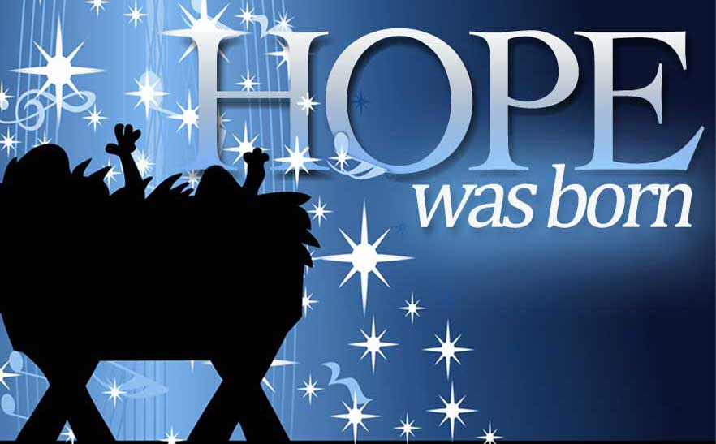

Latest church news

Church Opening
Apart from the very first Sunday of the month, November was another period of complete lockdown, with services online only. Nationally there were protests at the highest level about the closure of places of worship, including from the Archbishop of Canterbury, claiming that religious groups had been treated unfairly.
Thankfully under the new tier system we seem likely to reopen and stay open for the foreseeable future, which will mean Christmas services can go ahead. However we will still need to be vigilant, and some of our most popular seasonal services have had to be rethought in order to stay safe.

Remembrance Sunday
Falling during lockdown, it was not possible to have public events this Remembrance tide, but there were some small scale gatherings, which stayed in line with government guidance.
At Ollerton, Alistair led a service in the Ollerton Memorial Gardens - streamed online - where representatives of the Queen, the British Legion and local councillors laid wreaths on behalf of the community.
A similar event took place at Bilsthorpe led by Margaret. Many groups had already laid their wreaths individually in advance of the ceremonies.

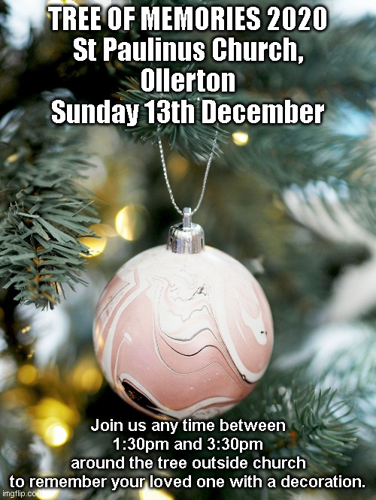

Christingle by Zoom!
4pm Christmas Eve
We are looking forward to Eakring's Christingle at 5pm on Christmas Eve.
However, our annual Christmas Eve Christingle service at Ollerton cannot take place in person this year - there would just be too many people to be safe.
So we are doing a Zoom version, so you can join us from home!
You will be invited to make your own Christingle, during the service, if you would like to.
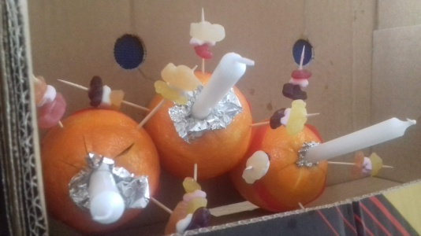
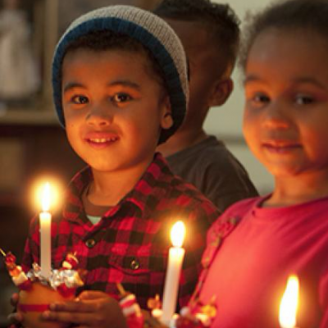
If you would like to join in the Zoom, please email Alistair on 1alistairlittlewood@gmail.com, and you will be sent a link. We will also advertise the link on social media much closer to the date. You do not have to make a Christingle to be part of the service.
If you want to join in making a Christingle, you will need:
- an orange (or a big lump of playdough!),
- some red tape/ribbon/red sharpie pen or similar
- Pritt stick or similar glue
- 4 cocktail sticks
- Small jelly sweets or small pieces of fruit (e.g. raisins)
- A small thin candle and matches/lighter*
- Some tin foil
- A pair of sharp scissors*
*Please ensure adult supervision is available.
If you are struggling to resource any of these items please let us know. We may be able to help.

Christingle is organised by The Children's Society and we use this event each year to raise money for them. If you would like to donate, please follow this link.
Donate | The Children's Society
CHRISTMAS GIFT
The gift is a child, The gift is a mystery -
The gift is a man. Terrible.
He comes to all
Yet is not received The gift is a wonder -
By everyone. Joyous.

The gift is to all The gift is the love
But not to the crowd; of Almighty God.
Not spread, not thin,
It goes singly to each
All of it.

The gift is precious,
The gift is free;
But not to you
Unless you reach out
And take it. Margaret Grey

____________________________________________________________________________

The Dukeries and District Food Bank

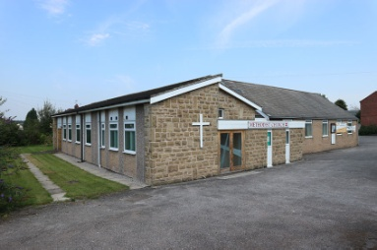
The Ollerton food bank (Dukeries and District Food Bank) based at the Methodist Church has unfortunately closed. It stayed open during the lockdown earlier in the year despite most of the volunteers being in the elderly or at risk group. But recently there have been very few people using it since the Community Action Response was set up, based at Life Spring Church, where they have greater facilities and can deliver food parcels by car through a team of volunteers and do other valuable work amongst the community. During the nearly 9 years that the Food Bank operated, thousands of people have benefited from its existence. I would like to thank everyone who has supported us in the past in any way. It has always been greatly appreciated. I hope that you will continue and support the Community Action Response team.
Also a mention of thanks must go to R.O.B. and Tesco for their invaluable help and support over the years.
Derek Homer

Trees by Derek Homer

I like trees.

I never really grew up, every autumn I collect a few conkers and acorns and plant them. Trees not only look good but they provide timber for building and making things, shade in the summer and most importantly they are a major part in God's great eco plan. They absorb carbon dioxide and give out oxygen. Recent studies have shown that they also give out chemicals that improve our mental state. Trees look good especially when in full leaf in summer, or as recently in the autumn with all the changing colours.

But if you've ever worked with wood, or admired a piece of wooden furniture, especially some of the hard woods such as Yew, you'll see a whole new beauty in the grain and knots, which cannot be seen through the bark. Some of the most beautiful and intricate patterns are found in the most gnarled and twisted trees.

This reminds me of people. As with trees there is an exterior which we all see, but inside is what God sees and makes the tree or person individual, and we are all special and unique to God who created us. As with trees or wood every person has different qualities, gifts and characteristics. God sees through the exterior to the beauty inside and what we really are. No two pieces of wood are the same. Likewise, no two people are the same. We are all different, God made people not robots. But everyone is equally special and precious to God.

He made us and loves us, knots and all.

Derek Homer
A Christmas greeting
Wishing everyone a very happy and blessed Christmas and all that's good in 2021.

The Light shines in the darkness, and the darkness can never put it out.

Love and blessings
from Derek and Margery Homer

A CHRISTMAS CAROL: THE END
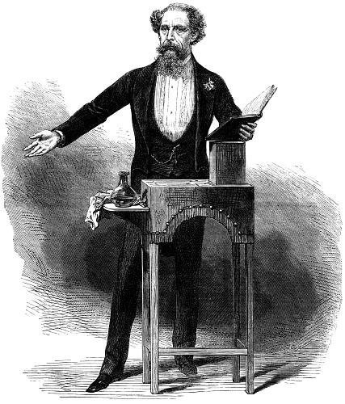
By Alistair Littlewood
A middle aged man limps awkwardly out of the wings onto a brightly lit Victorian stage. He looks tired and drawn, his beard is greying a little, and his figure seems tiny and isolated on the wide empty boards, but the excited chattering in the theatre becomes a roar of delight at his arrival. The crowd stand as one to honour him, and the applause at his advent among them is like a great wave of warmth, bathing him in love. His adoring public barely notice his frailty, and he, in turn, is buoyed by greeting them. Eventually, with much amusement and shows of modesty, he urges them to take their seats and settle down. They know what is coming next: many of them know the words he is about to say almost as well as he does. Tense anticipation hushes them. He makes a last, long, teasing survey of the auditorium, his eyes ranging from the Gods to the stalls, and finally utters the famous opening line of A Christmas Carol, perhaps his most famous book: "Marley was dead, to begin with…"
In all, between 1853 and 1870, Charles Dickens performed 127 readings of the book on many different stages. It was a second life for the novel which he had completed, on 2nd December 1843, by writing "THE END", in an emphatic upper case, followed by three double underlinings.
His final paragraphs feel a bit hurried, as if Dickens can’t wait to get them off to the printers, which is probably true. He covers years of Scrooge's subsequent life in just over two hundred words: he tells of Scrooge's kindness to the Cratchit family, especially to the disabled Tiny Tim "who did NOT die"; Scrooge's lack of embarassment at becoming a figure of fun and his newfound passion for Christmas. And when Dickens has finished pouring all this out onto the page, he ends with the simplest of closing phrases, 'The End'.
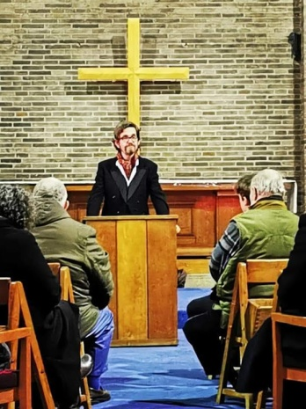
However, off the page, this was far from being the last word. The following year Dickens capitalised on his success by publishing a second Christmas book, The Chimes. This set a sometimes overwhelming precedent: over the next four years he felt obliged to meet public demand with three further Christmas books, at a creative cost to other projects. He finally decided to make The Haunted Man the last in the series, but continued to contribute Christmas stories and essays to the two magazines he edited: Household Words and All theYear Round.
Then, in 1853, Dickens was invited to perform a reading of A Christmas Carol in aid of charity, and took to the stage two days after Christmas, at St Martin's Hall in Long Acre, Birmingham. He had an audience of over 2,000 people. He was thrilled at the reception; it soothed his insecurities, affirming his status as a national treasure. It was the first of many readings. They became particularly important to him when, in 1858, he separated from his wife, and feared the scandal would turn his readers against him: public enthusiasm, however, proved impervious to his faults, and a successful series of Christmas readings in London eased his mind and massaged his ego. Over the years, the strain of the readings took a toll on his physical and mental health, and yet, while he was on the stage, he felt invincible. He had become, as it was often said, 'Mr Christmas'.
Traditionally Christmas was never just a single day. As recently as Dickens' youth, celebrations had continued for nearly two weeks, until Twelfth Night on 6th January, the biggest party of the year. In the twenty-first century, by contrast, 'The End' of Christmas can feel as if it comes almost immediately after it has begun. Once presents have been exchanged on the 25th, the turkey carved and the crackers pulled, what more is there? The church bravely tries to keep the season until Epiphany on January 6th, or even longer until Candlemas on 2nd February, but few others seem to notice after New Year's Day…
Scrooge's first vow, following his conversion by a series of ghostly visits, was to "honour Christmas in my heart, and try to keep it all the year." Much like Dickens, he never reached 'The End' of his own festivities.
So what would it mean to keep Christmas all the year? Theologically, Christmas is an eternal event, outside of time, so it is by nature both no particular day and every day. From the beginning “The Word became flesh and made his dwelling among us,” as St John’s gospel says. In anything which is made new or remade, in every new birth, Christmas is experienced again, whether it is December or June. It is mystery, it is joy, it is beauty.
I wonder, though, who Scrooge’s Jesus – Dickens’ Jesus - was? Was he an eternal baby, lying cute in the manger, never allowed to grow up into the controversial, challenging adult who might ask you a difficult question or two. The Christmas-every-day baby is the acceptable face of Christianity to many today, a lifeless doll cradled less than carefully by a five year old wearing a tea towel on her head. A nice story.
This wasn’t the wise men’s Jesus; their presents show their prescience, their expectation that he would have a future which would be golden, in spite of the conspicuous poverty of his birth. This life would need clouds of mystical frankincense, and the bitterness of myrrh. Good Friday, the day of Jesus’ death, is also an eternal event, outside of time; Easter Sunday, his resurrection day, is also both no particular day and every day.
You can have a Yuletide that does not reach 'THE END', but keeping Christmas all the year requires you to keep Good Friday and Easter in your heart too. Dickens did perhaps understand that, if not explicitly, then in his concern for the poor, which walked hand in hand with his love of a good party.
He wanted nobody to be left out of God’s love, and so his cry at the end of those gruelling performances, milking the tears from every eye in the house, had considerable sincerity: “God bless Us, Every One!”

Margaret Grey writes:

LET US PRAY

- Church: Let us ask God to set the church free throughout the land, to worship Him with praises and music and to seek him together in prayer.
- Christmas: Pray for children to be included in the Christmas celebrations and for the true story of Christ’s birth to be presented on the streets, in schools, in churches with joy and love.
- Our Leaders: Pray for more God-shaped style of leadership that builds consensus rather than arguments with M.P’s civil servants, local government, media and leaders of other nations.
- Brexit: Ask for God’s will to be done among the trading nations and for justice, co-operation and compassion to be placed above pride and profit.

----------------------------------------------------------------------------------------------------------------------------------------------

We have a rota of prayer for our group of parishes, praying for each community twice a month. On each day, please say a particular prayer for those who live, work and worship in the community s
shown, especially in this time of discernment for the future of our group:

1st and 16th: Bilsthorpe 9th and 24th: Eakring
2nd and 17th: Boughton 10th and 25th: Ollerton Village
3rd and 18th: Walesby 11th and 26th: Kneesall
4th and 19th: Kirton 12th and 27th: Laxton
5th and 20th: Rufford 13th and 28th: Egmanton
6th and 21st: New Ollerton 14th and 29th: Newark Deanery
7th and 22nd: Moorhouse 15th and 30th: Churches Together
8th and 23rd Wellow

THE TEAM FOR OUR FAMILY OF CHURCHES

There is currently no vicar.

Ministry Team:
The Rev Margaret Groves: 01623 870679 Heather Brown 01623 870517
The Rev Alistair Littlewood: 07946 040287 Janice Hannington 07964 441723
Joan Wood 01623 882175

Churchwardens (Ollerton & Boughton):
Lynda Conroy 01623 836462; Jean Newton; Pauline Walters; Janice Hannington; Andrea Ellis
____________________________________________________________________________
CAR Group - Ollerton & District
During the lockdown, many families have already benefitted from the great work being undertaken by the Ollerton and District Community Action Response Group, which also covers local villages. If you are affected by the lockdown and in need of an emergency food parcel call the group on 07754536530 or email office@lifespring.org.uk.
You might want to keep an eye out on your neighbours and pass on this information to them. We have to look out for each other: together we will get through this.
___________________________________________________________________________
St Paulinus Community & Church Hall

Booking of the Hall is extremely limited by the current circumstances. Enquiries should be made to 01623 836462.
_______________________________________________________________________
Baptisms, Weddings and Funerals:
Our prayers are with all our engaged couples and baptism candidates, and their families, and especially with those who are bereaved. Some of our churches will remain closed, including for weddings, funerals and baptisms. Most will now be opening, and weddings are permitted by the government, but what is possible within a service is limited by strict regulations. We are currently planning for baptisms; there is likely to be a lengthy waiting list. Funerals will usually be held at the graveside or in the crematorium, with limited attendance, although funerals are now possible inside churches. Anybody wanting a baptism should contact Janice with any queries (07964 441723 or email jkrh1954@gmail.com). For weddings contact Margaret (01623 870679). Funerals are arranged through your funeral director, but anybody on the ministry team (listed above) would be happy to talk if you need to. For the time being there will be no ‘Open Vestry Hour’. Although we have no choice, we hope you will understand that in complying with regulations we are loving our neighbour and protecting our NHS. We look forward to fully marking these important milestones in the Christian journey more fully as soon as possible.
_______________________________________________________________________________________
Help us keep in touch.
Online: If you know someone who would like a copy of this newsletter, please forward it! If you are reading this and do not yet receive a copy online, but would like to, please email 1alistairlittlewood@gmail.com.
Offline: For those who are not online, we have a mailing list of people who will receive an abbreviated, printed copy of News4U. If you know someone who would like a copy, let us know, or ask them to contact us so that we can add them to the list. Thank you!

