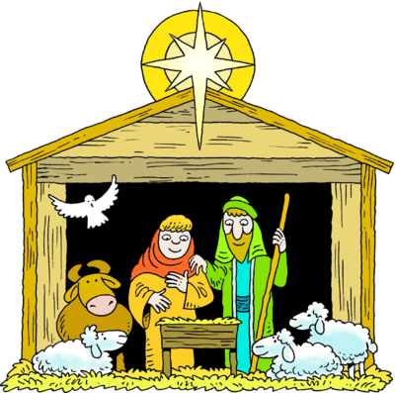





Church Services for Christmas

Thursday 24th December – Christmas Eve

3:00 pm All Saints Briston – Crib Service
Please book you places with Jeremy Sykes either on 01263 860280 or by e-mail Briston.Vicarage@Gmail.com

5:00 pm St George Hindolveston – An Open Air Crib & Carol Service Wrap up warm and bring a torch or lantern

11:30 pm All Saints Briston – 1st Communion of Christmas
Please book you places with Jeremy Sykes either on 01263 860280 or by e-mail Briston.Vicarage@Gmail.com

Friday 25th December – Christmas Day

9:15 am St Mary Burgh Parva Holy Communion BCP

10:30 am St Peter Melton Constable – An Open Air Service for
Christmas Day (Wrap up warm and bring you own seating – hopefully we will have some cover if the weather is bad)

To comply with Government Covid Regulations everyone over 11
need to wear a face covering and social distancing must be maintained.

