Eds Bulletin
Community news for Allenton and Shelton Lock
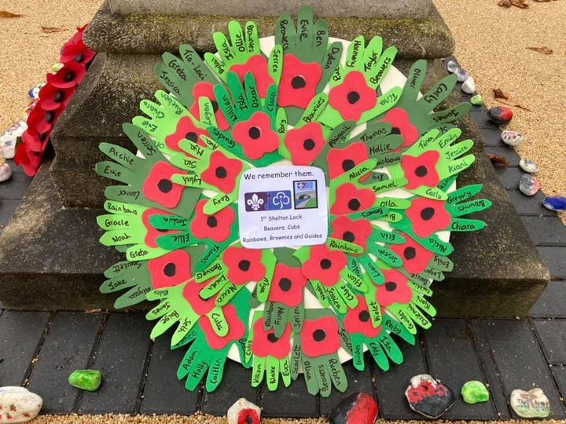  Wreath by 1st Shelton lock scouts  Remembrance reflection  Terry Nash  This year we have had the difficult task of trying to keep the anniversary of Remebrance.  I think as community we rose to the challenge.  we the church streamed a service and read the names of service men who had fallen in the second world war, and the war memorial village held a small socially distanced service. And the rest of our community came together to stand at their doors to hold 2 minutes silence and decorated their windows with poppies.  We as a community did not let the pandemic stop us from remembering them.  “They shall grow not old, as we that are left grow old: age shall not weary them, nor the years condemn. At the going down of the sun and in the morning, we shall remember them.”  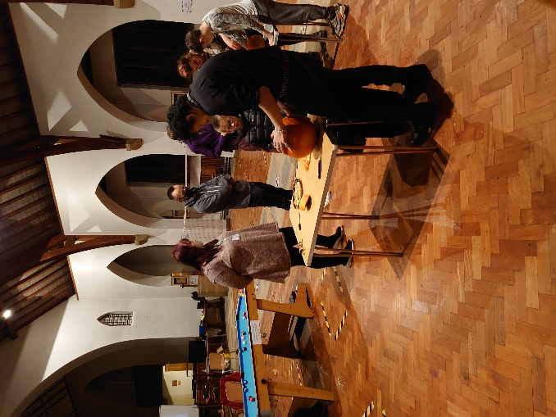  Halloween; The group getting creative with a pumpkin carving competition | 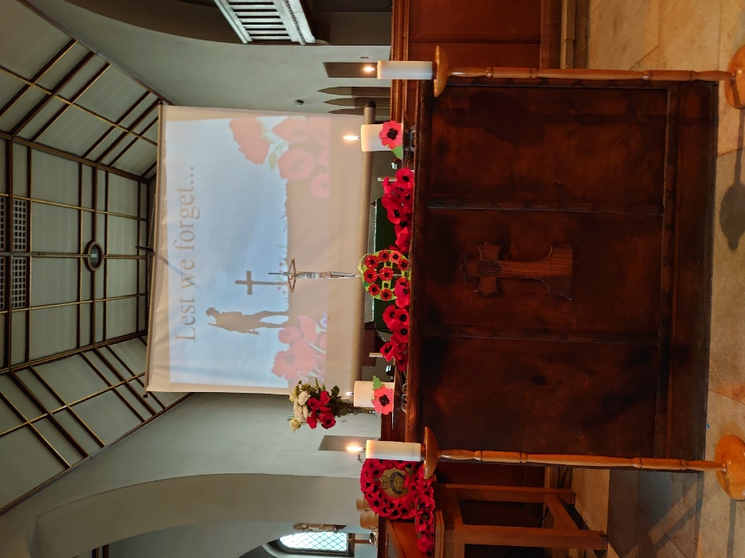  WE WILL REMEMBER ; Altar at St Edmunds for Rembrance Sunday  Shelton Lock Youth group
 | After a strong start earlier in the year and the disruption of Covid-19 the group tentatively reopened following government guidelines and procedures in October we had two meetings.  Its important that the young people in the area have a safe space to socialize and have fun.  During lockdown two the group paused again whilst the situation was assessed.  The group has had to change the nature of the group and we have now become a Support | Bubble open only to invited members!, the hope is to return to an open group as national guidlines permit.  Keep up to date on Facebook, search for Sheltonlockyouthgroup.  In the meantime please get in touch for any help or advice during these difficult times.
IN THIS ISSUE
Quiz | Diocese news | Shoeboxes
This years ‘Love in a box’ campaign as organized by Derby Rotary club has had a great response!
Filled shoeboxes need to be ready to send this week. If you require shoeboxes to be collected from your home please contact one of the Team

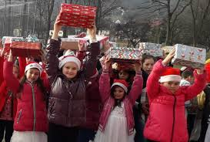
- What is the oldest recorded town in the UK?
- !n the Harry Potter series what animal represents Hufflepuff house?
- Who is playing Batman in the new Batman movie?
- What are the three main ingredients in a Moscow mule cocktail?
- Who played Dot Cotton in Eastenders for 35 years?
- What is the best selling Christmas song of all time (Artist and Song)
- What is the theme tune to FRIENDS called?
- Who played the original Inspector Morse?
- What is capital of India?
- What colours feature on the Italian flag?

Downing Street has announced that Her Majesty The Queen has approved the nomination of the Revd Canon Malcolm Macnaughton, presently Chief of Staff to the Archbishop of York, as the next Suffragan Bishop of Repton in the Diocese of Derby.

Canon Malcolm Macnaughton said: “I am much looking forward to working with Bishop Libby and colleagues in the Diocese of Derby, and am excited by the task ahead. The COVID crisis is tough for everyone, and we need to be focussed on bringing real hope to those most at risk, those living in poverty, and young people who have so much to offer, but whose opportunities for education, development, and employment, are so limited just now. It is great to see the Church in Derby and Derbyshire finding new ways, alongside the old, of being church and seeking the common good. What a privilege to be called by God to join you and to share the next stage of this journey! ”
Shelton Lock caterpillar  Lockdown rocks! |  | Service details  Online services  10am Sunday live on Facebook  Church services  10.45am Private Prayer (until dec 2nd)
Neighbourhood Board and The Shelton Lock Lockdown Caterpillar  Folks, The Shelton Lock Lockdown Caterpillar has finally installed today at Fullens Lock. Well worth a walk down to have a look, there is some amazing creative art work on display that tells such a story.  The Caterpillar and the art work tells the story of 2020. I understand that while I was away that painting the rocks and finding them was a way of spreading some joy and happiness in trying times.  Well done Ana who started the The Shelton Lock/Chellaston Lockdown Caterpillar and thank you to the Neighbourhood Board for backing and financing the permeant memorial to the time spent in lockdown in 2020.  Contact  Churchwarden  Terry - 07834997825  Secretary/ Events  Pauline  Treasurer/ Youth  Tom – tomnashwoodfarm@yahoo.co.uk  Find us on Facebook  Facebook.com/stedmundsasl  Website  Achurchnearyou.com  search St Edmunds Allenton and Shelton lock | CATERPILLAR : The rocks in there final setting.  CATERPILLAR : The rocks in there final setting.  Prayer list  We pray for those we love and those who have asked for our love,  Pam  Fred Higginbottom  June Lord  Heather Staton  Pamela  Our local schools and Nurseries  Community groups  Care Homes and care workers  NHS Staff  For additions to the prayer list please get in touch.

