

Connect

Welcome

to the Benefice of Walton and Trimley

**Sunday 15th November 2020**

Second Sunday before Advent

**The Collect**

Heavenly Lord,

you long for the world’s salvation:

stir us from apathy,

restrain us from excess

and revive in us new hope

that all creation will one day be healed

in Jesus Christ our Lord.

**Amen**

**Today’s Reading**

Matthew 25:1-13

**Grow in Faith**

**Make Jesus known**

**Be His light**

**A Message From Rev Paul**

Dear friends,

How has your first week of lockdown v2 been?

For me it has been a very different experience compared to the first lockdown. For starters, the children are at school and many of the shops seem to be open. Town and the seafront are still busy with all the lovely weather we have been having. In many ways it is more difficult to keep to a lockdown when everything around us seems to be carrying on as normal.

Of course, meeting in our churches is one of those things that have stopped. I think it is actually more tiring to keep changing our plans every month than it is to plan the services! It is for this reason we have decided that online will stay our primary way of worshipping, no matter what the restrictions are for the rest of the year. It is a difficult thing to accept but does mean that we will all be gathered for worship together via Zoom every week at 10am, guaranteed and we can plan to use the space as creatively as possible.

It is of course lovely to be in church when we can, but the most important thing we can do is worship and pray together. In Sunday morning’s service I will talk about how we are called to live life focussed on God, and that should affect all of the decisions we make. Our Archbishops have called us to a month of prayer during November. Let’s use this time to come ever closer to God as a benefice, seeking to worship and pray at every opportunity.

The first lockdown was also spiritually tough for many as all of our routines and rituals were suddenly stripped away from us and many felt distant from God. This time, we can be more prepared than before.

If you can think of anything spiritually that you would like to nourish you during this period, I would be happy to point you towards some resources. We meet for morning prayer via Zoom every Wednesday morning. I know some do not like Zoom but I think it is important that we join together in prayer by whatever means possible.

*Rev Paul*

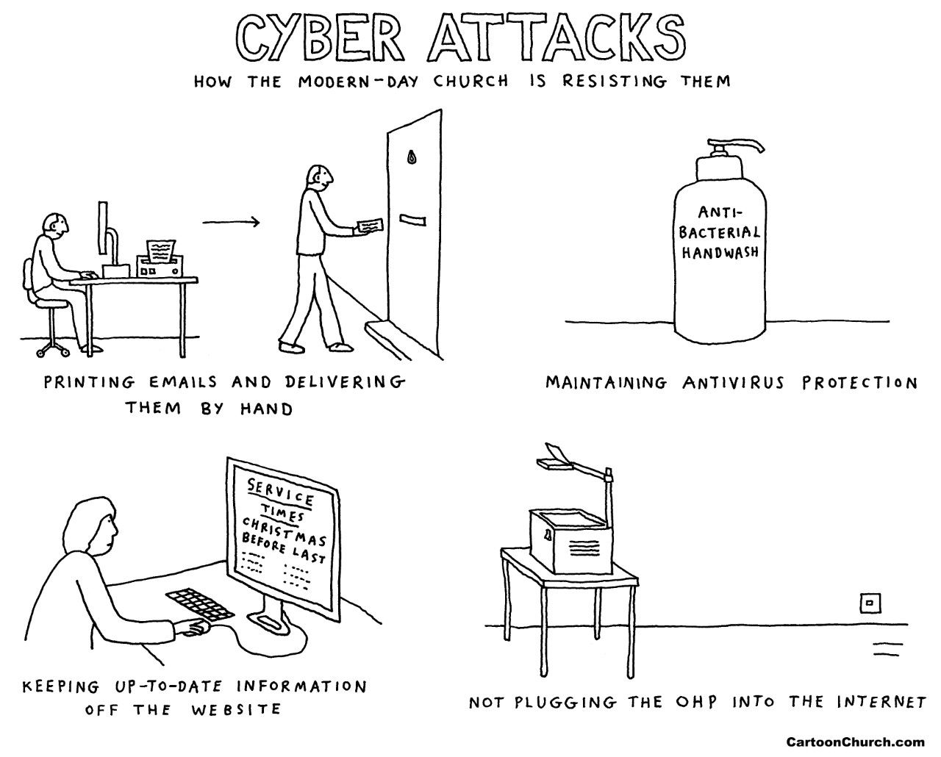

|  |  |
| --- | --- |
|  | **Walton Churches’ Advent Course – Worship in the Waiting**  We are holding a joint Advent Course again this year and you are warmly invited to attend. The sessions will be every Monday at 7.30pm starting Monday 23rd November via Zoom. Please contact the office for joining details. |

**Current Online & Radio Service Information:**

**Morning Worship Service** at 10am via Zoom, followed by an opportunity to have a chat over coffee. To request the zoom invitation please email Georgina.

**Morning Prayer** at 9.30am on Wednesdays via zoom. To request the zoom invitation please email Georgina.

**The Benefice official Youtube channel is available here:**

[https://www.youtube.com/channel/UCiB4rkHvq2ytsa-R\_4GJvNw/featured](https://www.youtube.com/channel/UCiB4rkHvq2ytsa-R_4GJvNw/featured" \t "_blank)

It will include all recordings and school assemblies by Rev Paul and some sermons. Please do access and view whenever you like. The live stream services will appear on this channel as well.

**Radio Worship -** Rev Paul and Rev Chris host **The Sunday Service** live on Felixstowe Radio every Sunday at 5pm. Rev Paul and Ellis now host **The Home Run** on Thursdays 4-6pm.

You can find the station at 107.5 FM, via your smart speaker or online at [www.felixstoweradio.org.uk/](http://www.felixstoweradio.org.uk/) Or you can listen to past episodes at <https://www.mixcloud.com/TechFXR/>



**Online Donations** – you are now able to make a donation to either church via our A Church Near You pages.

To donate to St Martin’s Church, click here:

<https://www.achurchnearyou.com/church/1992/>

To donate St Mary’s Church, click here:

<https://www.achurchnearyou.com/church/2343/>

and choose the ‘Give Now’ button.

**Christmas Cards!** This year it will not be possible to use the churches to swap your Christmas cards. This will be a disappointment to all, but the risk of cross contamination is too great. So this year, why don’t you consider making a donation to the Children’s Society instead? We will be able to hold Christingle Services so making a donation will continue to support the society’s work. You can donate online here: <https://www.childrenssociety.org.uk/how-you-can-help/donate>

Or by cheque payable to The Children’s Society to:

Freepost RSYH-HEEE-XZEG

The Children’s Society

50 Banner Street

London

EC1Y 8ST

If you particularly want to send Christmas Greetings to your church families, please do email the Office with your greeting, just as you would like it to be read. All the messages will be collated and sent out with the Connect for Sunday 20th December.

St Mary’s Church electricity bill – If you access the church, please can you ensure that you turn off any electrical equipment before you leave? There have been instances of lights and heaters being left on and our recent electricity bill is somewhat higher than expected (or wanted!). Thank you, *Carolyn Jones*, Treasurer

**Churches Together in Felixstowe** AGM & Forum Meetings

Monday 16th November, 7.30pm on Zoom. This is an open meeting and you are welcome to attend. Any voting will be by Forum members only.

Meeting ID: 815 9412 7693

Passcode: 810516

Join Zoom Meeting by clicking or tapping here:

[https://us02web.zoom.us/j/81594127693?pwd=NzA3Qzh4Mm5ObDd3SzU1V1ZiNUxsQT09](https://churchestogetherfelixstowe.us17.list-manage.com/track/click?u=33444116869314de9716d5e5c&id=b26c8731e4&e=39d007ac72)

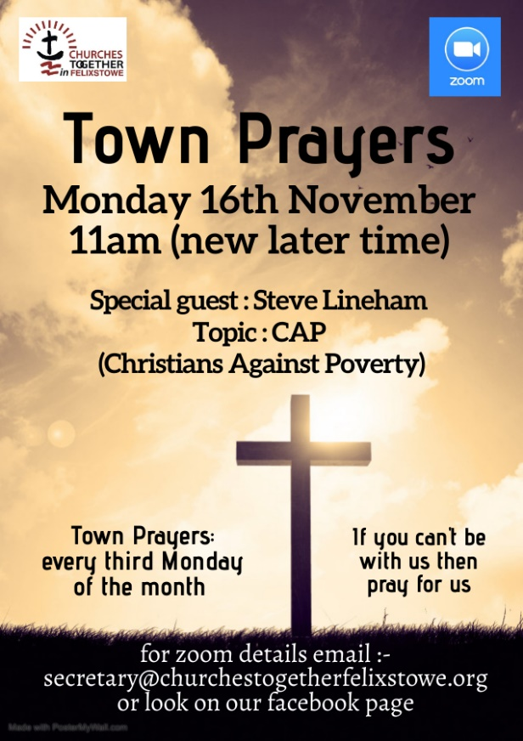

|  |  |
| --- | --- |
| C:\Users\Church Office\AppData\Local\Microsoft\Windows\INetCache\IE\EWNJHTQR\1433483_quiz_calcio_thumb_big[1].png | A Remote Quiz has been organised in aid of Trimley Church Funds for Saturday 5th December, commencing at 7.30pm. Teams ideally of up to 4 computer households are most welcome to participate. |
| Only Team Leader needs a laptop (to send questions to)… iPads for other members fine.  Interested teams please apply to me at [trimleyquizzes@btinternet.com](mailto:trimleyquizzes@btinternet.com). RSVP ASAP including details of:-   * Team **name** and Team **leader** AND leader’s email address. * PLUS names of other team members and the names that will come up on their individual screen devices (so Dave Smith can put you all in the breakout group to answer questions together).   Thank you, *Sandra Kingston* | |

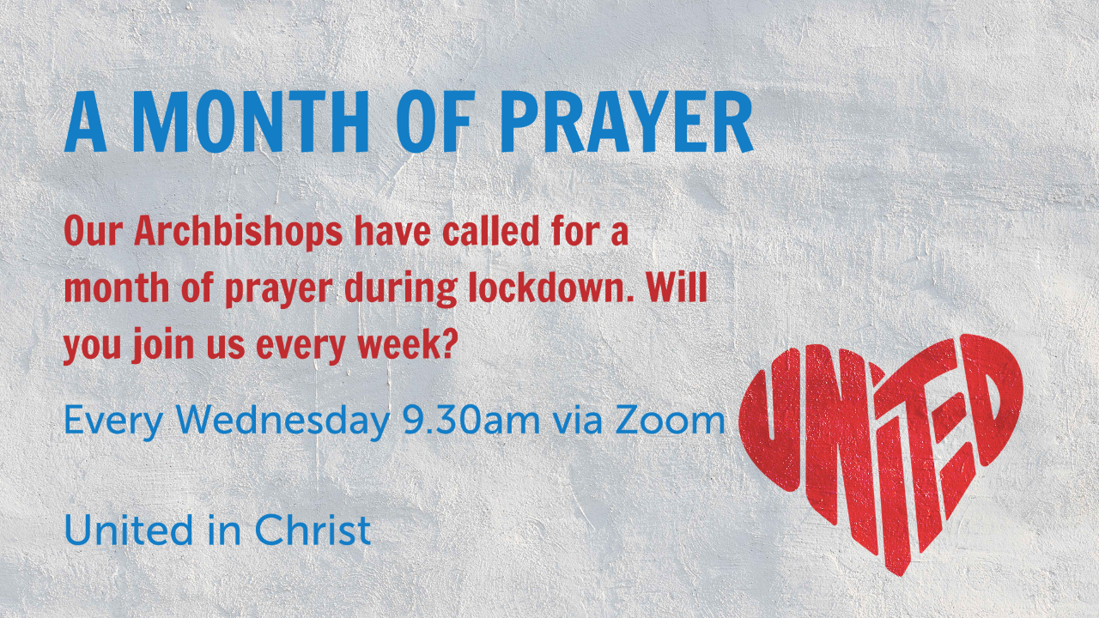

**Garden Elf!** Walton Church PCC give their heartfelt thanks to Ian Cobb who has cleared the garden, removed moss & grass and trimmed bushes in St Mary’s Hall frontage and in the churchyard. Your gift of time, effort and love has not gone unnoticed, and is greatly appreciated.

**Prayer Please**

Please pray for the decision makers at all levels of government, for the scientists and medical advisers and especially for all those who are working to produce a vaccine.

This week we offer our thanks to and pray for all those who serve at Pop-up. We give thanks for those who collect food throughout the week, who turn up early to set up tables, make coffee, and those who lovingly interact with customers as they make their choices. We thank all those who loyally make Jesus known by being His light.

Please pray for the bereaved and for those who are sick, especially Helen and Andrew King’s granddaughter Eleanor Ruth, her parents and all the family. Please also pray for Bob Curtis, John & Kay Miller, Rev Wendy Smith, Joan Davies, Mary, Ann Faiers, Lynda Ham, Lorna Roberts, Gerda & John Bailey, Michael & Mabel Lucas, John Morley, Rosemary Shelley, Romaine H, Sue, Jane Allen and those who prefer their names not to be listed.



**Benefice Contacts**

Rev Paul Clarke (Rector)

[rector@waltonandtrimley.org.uk](mailto:rector@waltonandtrimley.org.uk)

07903 452010

Please note, Paul’s day off is Friday

Rev Wendy Smith (Associate Priest) and

Dave Smith (Lay Pastor)

**Contact Us:**

We have a new benefice website:

[www.waltonandtrimley.org.uk](http://www.waltonandtrimley.org.uk).

Benefice Facebook: [https://www.facebook.com/stmaryswalton/](about:blank)

Benefice Office: 01394 670090 or email [officemanager@waltonandtrimley.org.uk](mailto:officemanager@waltonandtrimley.org.uk)

**Readers:**

Mary Rowe, Wendy Fellingham, Margaret White, Rachel Clarke & Roy Allen (Emeritus).

**Walton**

Church Wardens:

Lynda Tempest & Phil Rawe

[waltonwarden1@waltonandtrimley.org.uk](mailto:waltonwarden1@waltonandtrimley.org.uk)

Elders: Lynda Tempest, Pam Allen, Mary Wakefield, Annie Woodard, and Georgina South.

**Trimley**

Church Wardens:

Andrew King [trimleywarden1@waltonandtrimley.org.uk](mailto:trimleywarden1@waltonandtrimley.org.uk)

Rob Rushen-Smith [trimleywarden2@waltonandtrimley.org.uk](mailto:trimleywarden2@waltonandtrimley.org.uk)

Elders: Joan Wardle, Sylvia Allen, and June Stockdale.