All Saint, Torre, St. Luke, St. John the Apostle
Sunday Bulletin for Week beginning 2nd August, 2020

August at a glance

6th Transfiguration of the Lord.
10th St Laurence, Deacon and Martyr.
16th Assumption of the Blessed Virgin Mary.
24th St Bartholomew, Apostle.
28th St Augustine.
29th The Beheading of John the Baptist.
Throughout this month we continue in ordinary time, a ‘green’ season when we pray for the growth of the church both in numbers and in spiritual commitment.
.
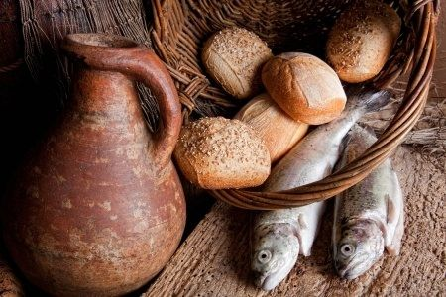

FACE MASKS

In keeping with the government’s guidance, we are now advised that face masks should be worn by those attending church services. Whilst there will be those who are exempted from the guidelines, we are strongly encouraged to adopt good practice in helping to safeguard one another. The government has advised that from 8th August the wearing of masks in places of worship will be mandatory.

Services this week

We begin to offer public worship again in accordance with government and church guidelines.

Wednesday 5th August
All Saints, Torre, 10.30am Said Eucharist

Thursday 6th August
St Luke, 10.15am, Said Eucharist

Friday 7th August
St John, 11.00am, Said Eucharist

Sunday 8th August
All Saints, Torre, 9.30am Said Eucharist.
St. Luke, 11.00am Said Eucharist.
St John, 11.00am Said Eucharist.

Please note church will be open 15 minutes before the start of the service.

Time to Read and Pray with
Scripture each day.

Here are the Gospel readings set for each day this week. You might like to take the time to read them and pray with them.

Sunday, Matthew 14:13-21
Monday, Matthew 14:22-end
Tuesday, Matthew 15:1-2
Wednesday, Luke 11:27-28
Thursday, Luke 9:28-36
Friday, Matthew 16:24-28
Saturday, Matthew 17:14-20

Keeping in Touch
Send us your email address if you would like to receive the weekly bulletin and updates.
Follow the Parishes on Facebook:
All Saints Church, Torre, Torquay, St Luke’s Parish Church Torquay, St John’s Over the Harbour

Fr. Peter March S.S.C 01803 312754 p.j.march@hotmail.co.uk

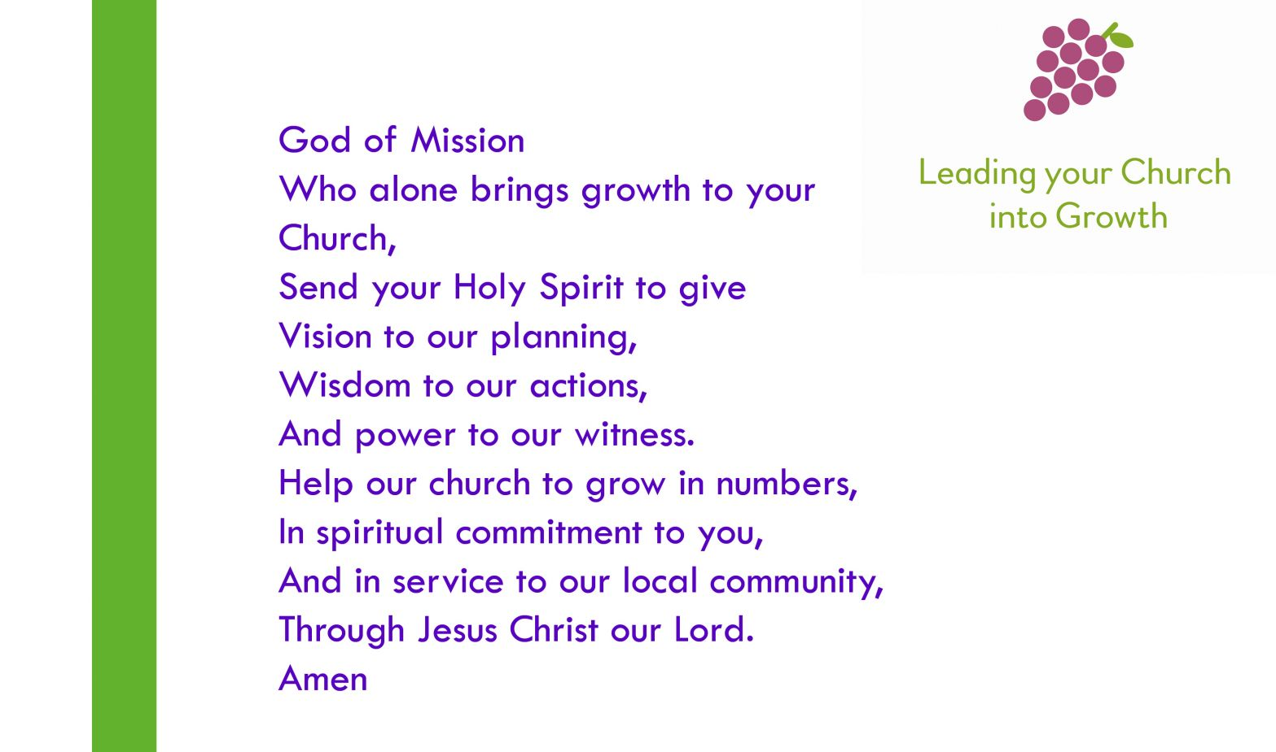

Bible passages on the themes of healing and well-being

Isaiah 35.3-6 Strengthen the weak hands

Ecclesiasticus 38.1-9 The Lord created medicines out of the earth

Luke 7.1-10 Jesus heals a centurion’s servant

Romans 12.1-8 The gifts of the Body of Christ

Colossians 3.9-14 Put on compassion and kindness

James 5.13-16 Anointing the sick

Revelation 22.1-5a The tree of life

How generous is your goodness, O God,
how great is your salvation,
how faithful is your love;
help us to trust you in trial
and praise you in deliverance;
through Jesus Christ our Lord.
Amen

Prayers for use at this time

Keep us, good Lord,
under the shadow of your mercy
in this time of uncertainty and distress.
Sustain and support the anxious and fearful,
and lift up all who are brought low;
that we may rejoice in your comfort
knowing that nothing can separate us
from your love in Christ Jesus our Lord.
Amen

Lord Jesus Christ,
you taught us to love our neighbour,
and to care for those in need
as if we were caring for you.
In this time of anxiety, give us strength to comfort the fearful, to tend the sick, and to assure the isolated of our love, and your love,
for your name’s sake.
Amen

God of compassion,
be close to those who are ill, afraid or in isolation.
In their loneliness, be their consolation;
in their anxiety, be their hope;
in their darkness, be their light;
through him who suffered alone on the cross,
but reigns with you in glory,
Jesus Christ our Lord.
Amen.

Find more prayers like these on the Church of England website: www.churchofengland.org.

Lectio Divina

Introduction

Make whatever preparations you need to leave the shadow world behind and encounter the fire of the Spirit and the light of God.
If you have chosen to prepare the space and the place in some way (perhaps drawing a curtain or lighting a candle), make that preparation.
Eliminate distractions and the possibility of interruption.

Sign of the Cross

We invoke God, in whose name we act.

In the name of the Father, ✠
and of the Son,
and of the Holy Spirit,
Amen.

Invocation of the Holy Spirit

We invoke the Holy Spirit, who will speak to us and listen in us.

Come, Holy Spirit, fill the hearts of your faithful
and kindle in them the fire of your love.

Send forth your Spirit, and they shall be created.
And you shall renew the face of the earth.

Act of Contrition

By acknowledging our sinfulness and admitting that by ourselves we can do nothing that is not flawed, we ask God to take the initiative in this encounter.

Have mercy on us, O Lord:
For we have sinned against you.
Show us, O Lord, your mercy:
And grant us your salvation.

May almighty God have mercy on us, forgive us our sins, and bring us to everlasting life.
Amen.

The Gospel

A reading from the holy Gospel according to Matthew

Feeding the Five Thousand
¹³ Now when Jesus heard this, he withdrew from there in a boat to a deserted place by himself. But when the crowds heard it, they followed him on foot from the towns. ¹⁴ When he went ashore, he saw a great crowd; and he had compassion for them and cured their sick. ¹⁵ When it was evening, the disciples came to him and said, ‘This is a deserted place, and the hour is now late; send the crowds away so that they may go into the villages and buy food for themselves.’ ¹⁶ Jesus said to them, ‘They need not go away; you give them something to eat.’ ¹⁷ They replied, ‘We have nothing here but five loaves and two fish.’ ¹⁸ And he said, ‘Bring them here to me.’ ¹⁹ Then he ordered the crowds to sit down on the grass. Taking the five loaves and the two fish, he looked up to heaven, and blessed and broke the loaves, and gave them to the disciples, and the disciples gave them to the crowds. ²⁰ And all ate and were filled; and they took up what was left over of the broken pieces, twelve baskets full. ²¹ And those who ate were about five thousand men, besides women and children.

________

The Response

Meditatio (reflection)

What does the Gospel say to me?
God has willed me to be here, now, today, for a reason. Now is the time to reflect, and find that reason, and hear what God has chosen to tell me.

A good pattern is this:
- What has drawn my attention or struck me in some way?
- Why? Was it a person? A word? A situation? A gesture?
- What, therefore, is God saying to me through these words, here and now, today?

The “I” and the “me” are important. To say “we” or “us” is to evade the encounter by softening the focus and hiding behind membership of a group. The meeting with Jesus is face to face, one to one.

Oratio (prayer)

God has spoken to me. What do I reply?
Silently, each of us responds to what God has said to them through the passage we have read.

Contemplatio (contemplation)

Sometimes we may be led beyond prayer into a quiet and attentive resting in the presence of God.

Conclusion

We prepare to return to the everyday world, carrying with us what we have received in our minds and our hearts today.

Our Father, who art in heaven,
hallowed be thy name.
Thy kingdom come.
Thy will be done on earth, as it is in heaven.
Give us this day our daily bread,
and forgive us our trespasses,
as we forgive those who trespass against us,
and lead us not into temptation,
but deliver us from evil.
________

May the Lord bless us, and keep us from all evil, and bring us to everlasting life.
Amen
