

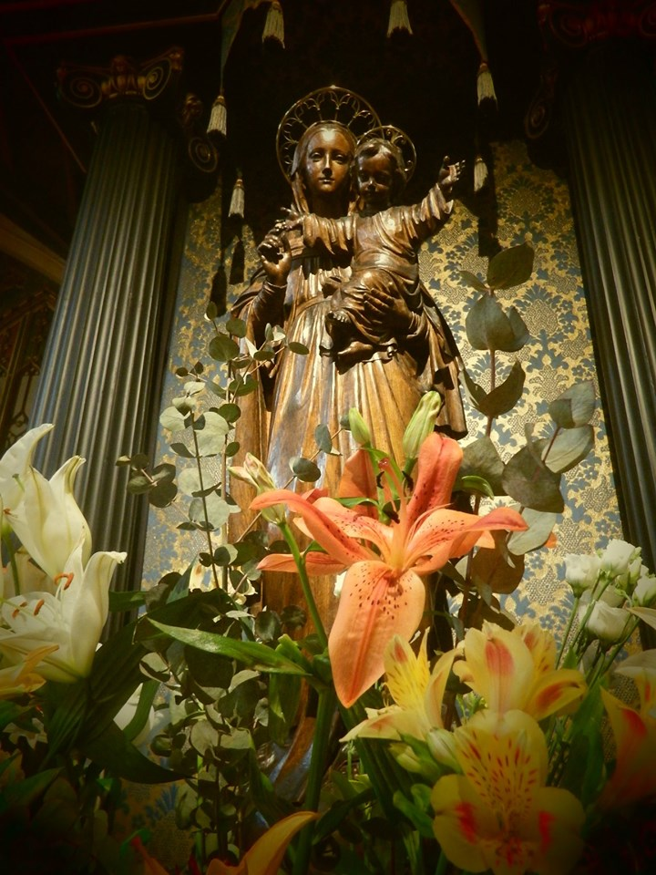

TOGETHER IN PRAYER

DURING AUGUST AND SEPTEMBER 2020

TOGETHER IN PRAYER

As we navigate together the challenges of covid-19 we offer this publication from St Stephen’s, Gloucester Road to provide resources for praying together in our return to church, as well as in our homes.

CONTENTS

3 “We had hoped…” *A reflection from the Parish Priest*

6 News from St Stephen’s *Information on the return to Public worship, and*

*other news for the next few weeks*

9 Order for Mass *An outline for those joining in the livestream of*

*Mass in their homes*

15 A simple outline for Morning and Evening Prayers

17 Calendar for Prayer *Daily Prayer intentions*

19 Sunday Gospel Readings *with an accompanying reflection*

30 Contact Details *Telephone and email details for the Parish Office*

*and the Clergy*

“WE HAD HOPED…”

One of the things that we’re getting used to now is putting cherished plans on hold. As I write this the news is full of the latest travel restrictions which means that many are having to put their holiday plans on hold; I’d have expected to be in Walsingham this week helping with the Youth Pilgrimage with 800 or so young people, but this year is not to be; a dear friend has had to change the plans for her wedding in September, as she’ll only be able to have a faction of the guest list present. All sorts of events from the Proms to personal celebrations are being cancelled, or adapted, or postponed. We know that this is all for a ‘greater good’ as we try to halt the spread of the virus, but we can’t help but feel disappointed, and living with disappointment can be hard. In our better moments we might be able to keep things in perspective, but we wouldn’t be human if we didn’t get a pang of regret over it all.

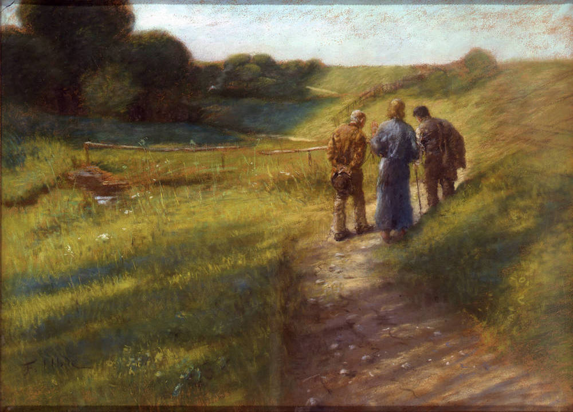The feeling of disappointing is one that works its way into Scripture. Many of the psalms express a disappointment that God’s action seems obscured by the sadness of the world. Psalm 13 asks “How long, O Lord? Will you forget me forever? How long will you hide your face from me?” This experience is taken into the Gospels, and a sense of disappointment that Jesus is not the kind of Messiah expected by many of his followers. Just think of the conversation of the two disciples on the Road to Emmaus, who tell the companion they fail to recognise as Jesus of their dashed hopes, “we *had* hoped that he was the one who was going to redeem Israel.” (Luke 24.21)

Fritz von Uhde ( 1848 – 1911) The Road to Emmaus

One of the things that these expressions of disappointment in Scripture help us work through is how we deal with these feelings in our own lives. They teach us that God is the mystery in whom we live every moment of every day, and that life is not a sort of obstacle course designed only to merit the perfect. No life exists of nothing but success and satisfaction, security and self-justification. Disappointment and regret, loss and pain are natural parts of the human equation.

Faith is not about relentlessly ‘looking on the bright side’, in a bid to cover up the real feelings we’ve got in a rather emotionally unhealthy way. Rather, it calls us to be aware of another reality beyond the immediate, beyond the instant perception of things, and to trust the God who made us and who walks with us all the way. It calls us, too, to recognise that our lives are part of a larger story. In the liturgy of the Church when we recite the psalms at Morning and Evening Prayer we conclude each one by saying

Glory be to the Father, and to the Son, and to the Holy Spirit.

As it *was* in the beginning, is *now*, and *ever shall* be,

world without end. Amen.

The story of our own lives with their individual joys and sorry, fulfilments and disappointments are set in the context of the God who was, is, and will be. The God who seeks us all our days offers us a Life that transcends the confusion of the present.

I think the real question is, “what do I do with the disappointment I’m feeling?” Are we honest about it, or do we hide it away so it festers? The disappointments might be fairly minor – I’m disappointed I’ve had to postpone my holiday plans, but there’ll be another next year. Or they might be major – disappointment about a job loss perhaps. But we need to tell God about them so he can heal them, and we need to tell trusted friends about them so they can share them with us.

I came across an interesting interpretation of the parable Jesus tells, recorded in Matthew 25, of the master who entrust three servants with his goods. You might remember two of the servants invest what they’ve been given, and are duly rewarded by their master. The other is afraid of losing the investment and instead buries it. He is sternly reprimanded for his behaviour.

The American Presbyterian writer Frederick Buechner suggests that one of the questions this parable invites us to ask ourselves is; what do we do with the mixed lives we are given? Do we bury the feelings of disappointment we carry, because, like the third servant, we are a bit afraid of what has come our way? Or do we take the risk of ‘trading with it’, which Buechner suggests means reaching out to one another in shared experience, so that we can find healing and hope.

Maybe if we do that, like the disappointed disciples on the Road to Emmaus, we will discover the Christ who is walking with us, even in the bewilderment of our present experience.

I hope that that knowledge will bring you vision and courage in the days of summer ahead of us. It might not quite be the summer you’d planned and expected, disappointment is real, but it is also set in the perspective of an eternal Kingdom, and, as Moses tells the children of Israel “The eternal God is your dwelling place, and underneath are the everlasting arms.” (Exodus 33.27)

with my love and prayers,

Fr Philip

**A prayer for all those affected by coronavirus**

Keep us, good Lord,

under the shadow of your mercy.

Sustain and support the anxious,

be with those who care for the sick,

and lift up all who are brought low;

that we may find comfort

knowing that nothing can separate us from your love

in Christ Jesus our Lord.

NEWS

**TIMES OF MASSES**

It is a huge joy to be able to gather for Mass again, both on Sundays and throughout the week. Mass is celebrated at the following times.*

***Sunday***

Mass 9am

Sung Mass 11am *this Mass is live streamed on our YouTube channel*

***Monday***

*Mark and I keep this as our days off and the church will be closed*

***Tuesday***

Mass 12.30pm

*The church will be open from 9am until after Mass*

***Wednesday***

Mass 7pm

*The church will be open from 2pm until after Mass*

***Thursday***

Mass 12.30pm

*The church will be open from 9am until after Mass*

***Friday***

Holy Hour 5pm – 6pm

*This is a lovely chance to spend some quiet time before the Lord at the end of a busy week*

Mass 6pm

*The church will be open from 2pm until after Mass*

***Saturday***

Mass 10am

*The church will be open from 9am until 2pm*

*\* Fr Philip will be away on leave August 17 – 22, 24 – 28 and Mass will be celebrating on Wednesday evening only during those two weeks.*

**GATHERING FOR MASS**

In order that we may gather safely the following measures are in place:

* Please use the sanitising gel to cleanse your hands as you enter church, and as you leave.
* Observe social distancing, and find a seat at least two metres from your neighbour. Remember to keep the social distance when you arrive and leave, conscious of the anxieties others may have.
* You may wish to wear a face covering, though this is not mandatory in our large and airy building
* The service booklet will guide you through necessary adaptations to the liturgy.
* The 11am Mass on Sunday will include music from organ and cantor, and although we are unable to join in singing together this music beautifully enhances our worship. Highlight in August will be a Mass for two cantors (from the same household!) specially written by Gregory Drott on the 9th, and the celebration of The Assumption of the Blessed Virgin Mary on the 16th.
* There is no collection during the Mass. We encourage those who haven’t yet joined the Planned Giving scheme to do so (forms at the back of church), or there is a plate to receive your offering at the door after Mass.
* We much regret that we are unable to offer the usual hospitality following the 11am Sung Mass. There is an opportunity to greet each other outside as we leave.

**LIVE-STREAMING**

During the next few weeks we will be continuing to live-stream the Sunday 11am Sung Mass for those unable to be present. The live-stream will be on our YouTube channel.

**RECORDED DEVOTION**

A devotion recorded by Fr Philip is also uploaded each week on our YouTube Channel. These are intended to complement the themes of the Sunday Mass, and to provide an opportunity for further reflection.

**CAN YOU HELP…**

As we make our return to church following the easing of restrictions we’d be grateful for any help that you might be able to offer in the following:

**Reading at Mass**

Would you be able to read one of the lessons at the 11am Sung Mass? Even if you’ve not tried this before now could be the moment to see if this is for you. Simply sign up on the rota at the back of the church.

**Cleaning following Sunday Mass**

As part of our commitment to keeping everyone safe we need to thoroughly clean the church after Sunday Mass and we’d be grateful for a hand with this. Two or three of us each week would be great – gloves are provided.

**INTERCESSIONS LIST**

In order to keep the timing ‘tight’ for Mass we’re advised to omit the usual Prayers of Intercession, but we’re praying for the sick and needy during the weekday Masses. Please speak to Fr Philip if you’d like someone included.

**BUILDING DEVELOPMENT WORK**

We hope to receive the faculties for the lighting scheme and the renewal of the sound system in the next couple of weeks, and that work will be able to start in September. The contractor has indicated that this will take ten weeks to complete, and that we will need to close the church to the public whilst this work is carried out. Mass times will continue unaffected. Confirmation of the start date for this work and subsequent changes to our open hours will be published on the weekly news sheet, on our Facebook page and on the website.

We have received approval from the Diocesan Advisory Committee for our architect’s plans for the renovation of the Sacristy, WC and kitchen areas, and for the new disabled access work to the north porch. The Public Notice is now up, and we look forward to this work beginning in the next few months.

THE ORDER FOR MASS

*On Sundays Mass is livestreamed at 11am. This outline order is provided to assist you in joining in at home.*

INTRODUCTORY RITES

*The cantor sings the Entrance Antiphon as the Priest enters and censes the altar.*

In the name of the Father, + and of the Son, and of the Holy Spirit.

**Amen.**

The Lord be with you. **And with your spirit.**

*The Priest introduces the Mass and invites us to confess our sins.*

**I confess to almighty God and to you, my brothers and sisters, that I have greatly sinned, in my thoughts and in my words, in what I have done and in what I have failed to do, through my fault, through my fault, through my most grievous fault; therefore I ask blessed Mary ever-Virgin, all the Angels and Saints, and you, my brothers and sisters, to pray for me to the Lord our God.**

May almighty God have mercy on us, forgive us our sins, and bring us to everlasting life. **Amen.**

*The cantor sings:*

***Kyrie eleison***

Kyrie, eleison. *Lord, have mercy.*

Christe, eleison. *Christ, have mercy.*

Kyrie, eleison. *Lord, have mercy.*

***Gloria in Excelsis***

*Glory to God in the highest and on earth peace to people of good will. We praise you, we bless you, we adore you, we glorify you, we give you thanks for your great glory, Lord God, heavenly King,*

*O God, almighty Father.*

*Lord Jesus Christ, Only Begotten Son, Lord God, Lamb of God, Son of the Father, you take away the sins of the world, have mercy on us;*

Gloria in excelsis Deo et in terra pax hominibus

bonae voluntatis.Laudamus te, benedicimus te,

adoramus te, glorificamus te, gratias agimus tibi

propter magnam gloriam tuam,Domine Deus,

Rex caelestis,Deus Pater omnípotens.

Domine Fili unigenite, Jesu Christe,

Domine Deus, Agnus Dei, Filius Patris,

qui tollis peccata mundi, miserere nobis;

qui tollis peccata mundi, suscipe deprecationem nostram. Qui sedes ad dexteram Patris,

*you take away the sins of the world, receive our prayer; you are seated at the right hand of the Father, have mercy on us. For you alone are the Holy One, you alone are the Lord, you alone are the Most High, Jesus Christ, with the Holy Spirit, in the glory of God the Father. Amen.*

miserere nobis.

Quoniam tu solus Sanctus, tu solus Dominus,

tu solus Altissimus, Jesu Christe, cum Sancto

Spiritu: in gloria Dei Patris. Amen.

***The Collect***

Let us pray.

*After a pause for silent prayer the Priest says the Collect to which we acclaim:*

**Amen.**

THE LITURGY OF THE WORD

*Two readings follow. At the end of each reading:*

The word of the Lord. **Thanks be to God.**

*Between the readings the Psalm is said, and we make the response after each verse.*

***Gospel acclamation***

*The cantor sings the Alleluia.*

***Gospel***

The Lord be with you. **And with your spirit.**

+ A reading from the holy Gospel according to *N.*

**Glory to you, O Lord.**

*At the end the Priest acclaims:*

The Gospel of the Lord. **Praise to you, Lord Jesus Christ.**

*A homily is given.*

***Profession of Faith***

**I believe in one God, the Father almighty, maker of heaven and earth, of all things visible and invisible.**

**I believe in one Lord Jesus Christ, the Only Begotten Son of God, born of the Father before all ages. God from God, Light from Light, true God from true God, begotten, not made, consubstantial with the Father; through him all things were made. For us men and for our salvation he came down from heaven, and by the Holy Spirit was incarnate of the Virgin Mary, and became man. For our sake he was crucified under Pontius Pilate, he suffered death and was buried, and rose again on the third day in accordance with the Scriptures. He ascended into heaven and is seated at the right hand of the Father. He will come again in glory to judge the living and the dead and his kingdom will have no end.**

**I believe in the Holy Spirit, the Lord, the giver of life, who proceeds from the Father and the Son, who with the Father and the Son is adored and glorified, who has spoken through the prophets.**

**I believe in one, holy, catholic and apostolic Church. I confess one baptism for the forgiveness of sins and I look forward to the resurrection of the dead and the life of the world to come. Amen.**

THE LITURGY OF THE EUCHARIST

*The gifts of bread and wine are placed upon the altar. The cantor sings the Offertory Antiphon.*

***Invitation to Prayer***

Pray, brothers and sisters, that my sacrifice and yours may be acceptable to God, the almighty Father.

**May the Lord accept the sacrifice at your hands, for the praise and glory of his name, for our good and the good of all his holy Church.**

*The Priest says the Prayer over the Offerings, at the end of which we acclaim:* **Amen.**

***The Eucharistic Prayer***

The Lord be with you. **And with your spirit.**

Lift up your hearts. **We lift them up to the Lord.**

Let us give thanks to the Lord our God. **It is right and just.**

*At the end of the Preface of the prayer the cantor sings:*

Sanctus, Sanctus, Sanctus Dominus Deus Sabaoth.

Pleni sunt cæli et terra gloria tua. Hosanna in excelsis.

Benedictus qui venit in nomine Domini. Hosanna in excelsis.

*Holy, Holy, Holy Lord God of hosts.*

*Heaven and earth are full of your glory. Hosanna in the highest.*

*Blessed is he who comes in the name of the Lord. Hosanna in the highest.*

*The Eucharistic Prayer continues with the words of institution.*

*This acclamation is used:*

The mystery of faith.

**We proclaim your Death, O Lord, and profess your Resurrection until you come again.**

*As the prayer reaches its conclusion we boldly acclaim:*

**Amen.**

THE COMMUNION RITE

***The Lord’s Prayer***

At the Saviours command, and formed by Divine teaching, we dare to say:

**Our Father, who art in heaven, hallowed be thy name; thy kingdom come; thy will be done; on earth as it is in heaven. Give us this day our daily bread. And forgive us our trespasses, as we forgive those who trespass against us. And lead us not into temptation; but deliver us from evil.**

Deliver us, Lord, we pray, from every evil, graciously grant peace in our days, that, by the help of your mercy, we may be always free from sin and safe from all distress, as we await the blessed hope and the coming of our Saviour, Jesus Christ.

**For the kingdom, the power and the glory are yours now and for ever.**

Lord Jesus Christ, who said to your Apostles: Peace I leave you, my peace I give you, look not on our sins, but on the faith of your Church, and graciously grant her peace and unity in accordance with your will. Who live and reign for ever and ever. **Amen.**

The peace of the Lord be with you always. **And with your spirit.**

***Breaking of the Bread***

*During the breaking of the host the Agnus Dei is sung by the cantor.*

Agnus Dei, qui tollis peccata mundi: miserere nobis.

Agnus Dei, qui tollis peccata mundi: dona nobis pacem.

*Lamb of God, you take away the sins of the world, have mercy on us.*

*Lamb of God, you take away the sins of the world, grant us peace.*

***Invitation to Communion***

Behold the Lamb of God, behold him who takes away the sins of the world. Blessed are those called to the supper of the Lamb.

**Lord, I am not worthy that you should enter under my roof, but only say the word and my soul shall be healed.**

*The Priest and People receive Holy Communion.*

*The cantor sings the Communion Antiphon and a Motet.*

***An Act of Spiritual Communion***

**My Jesus, I believe that you are present in the Holy Sacrament of the altar. I love you above all things and I passionately desire to receive you into my soul. Since I cannot now receive you sacramentally, come spiritually into my soul so that I may unite myself wholly to you now and forever. Amen.**

***Prayer after Communion***

*The Priest says the appointed prayer, to which we acclaim:* **Amen.**

THE CONCLUDING RITES

The Lord be with you. **And with your spirit.**

May almighty God bless you, + the Father, the Son and the Holy Spirit.

**Amen.**

Go in peace. **Thanks be to God.**

THE ANGELUS



PRAYING IN THE EARLY MORNING

+ In the name of the Father, and of the Son, and of the Holy Spirit. Amen.

**In the silence of the dawn**

Lord Jesus Christ, in the silence of this new dawn I come to you and ask you with humble trust for your peace, your wisdom, your strength. Grant that I may contemplate the world today with eyes full of love. Help me to understand that all the glory of the Church springs from your Cross as its source. Let me welcome my neighbour as the person whom you wish to love through me. Grant me the willingness to serve them with devotion and to unfold all the goodness that you have placed within them.

Let my words radiate gentleness and my entire behaviour be a source of peace. Let there dwell in my spirit only those thoughts that spread blessings. Stop my ears to every malicious word and every ill-willed criticism. May my tongue serve only to highlight the good.

Grant above all, O Lord, that I may be so full of joy and goodwill that all who meet me will feel both your presence and your love.

Clothe me with the radiance of your goodness and your beauty, so that I may reveal you to others in the course of this day. Amen.

*Blessed Miriam Baouardy*

*Silence*

*My petition for the day…*

Our Father…

May the Lord bless me, protect me from all evil,

and bring me to everlasting life.

+ In the name of the Father, and of the Son, and of the Holy Spirit. Amen.

PRAYING IN THE LATE EVENING

+ In the name of the Father, and of the Son, and of the Holy Spirit. Amen.

*Quietly, I look back over this day. I call to mind the things and the people I have encountered in the course of this day and what I have thought, said, and done.*

Loving Father, I thank you for this day and for all the good things I have experienced. Forgive me, wherever I have sinned against you, against others, or against myself and let my heart rest in peace with you. Amen.

**He who keeps you will not slumber**

I lift up my eyes to the hills. From where does my help come?  
My help comes from the Lord, who made heaven and earth.

He will not let your foot be moved, he who keeps you will not slumber.  
Behold, he who keeps Israel will neither slumber nor sleep.

The Lord is your keeper; the Lord is your shade on your right hand.  
The sun shall not strike you by day, nor the moon by night.

The Lord will keep you from all evil; he will keep your life.  
The Lord will keep your going out and your coming in

from this time forth and for evermore.

Glory be to the Father, and to the Son, and to the Holy Spirit,

as it was in the beginning, is now, and ever shall be,

world without end. Amen.

*Psalm 121*

**Dispel the darkness of this night**

In your mercy, Lord, dispel the darkness of this night. Let your household so sleep in peace, that at the dawn of the new day they may, with joy, waken in your name. Through Christ our Lord. Amen.

*Dietrich Bonhoeffer*

Lord, grant me a quiet night and a perfect end in you.

+ In the name of the Father, and of the Son, and of the Holy Spirit. Amen.

CALENDAR FOR PRAYER

1 St Alphonsus Liguori, bishop & doctor of the Church *Bishop Jonathan*

**2 Eighteenth Sunday in Ordinary Time** *Our Parish*

3 Feria *For those working in the health service*

4 St John Vianney, *priest* *For* *Parish Priests*

5 Feria *For those working in local shops*

6 Transfiguration of the Lord *Growth in awareness of Christ’s glory*

7 Feria *For our Government and Members of Parliament*

8 St Dominic, *priest* *For preachers*

9 **Nineteenth Sunday in Ordinary Time** *Our Parish*

10 St Lawrence, *deacon and martyr* *For those in poverty*

11 St Clare, *religious* *For members of Religious Orders*

12 Feria *For those who are sick*

13 Feria *For departed members of the Guild of All Souls*

14 St Maximilian Kolbe, priest and martyr *For victims of terror*

15 Feria *Thanksgiving for Our Lady*

**16 The Assumption of the Blessed Virgin Mary** *Our Parish*

17 Feria *For those on furlough*

18 Feria *For those caring for sick loved ones*

19 Feria *For the anxious and depressed*

20 St Bernard, abbot and doctor of the Church *For growth in prayer*

21 St Pius X *For those engaged in ecumenical dialogue*

22 The Queenship of the Blessed Virgin Mary *For the hope of heaven*

**23 Twenty-First Sunday in Ordinary Time** *Our Parish*

24 St Bartholomew, apostle *For growth in faith*

25 Feria *Thanksgiving for God’s gifts in creation*

26 Feria *For the gift of integrity*

27 St Monica *Thanksgiving for those who taught us the faith*

28 St Augustine, bishop and doctor of the Church *For our bishops*

29 Passion of St John the Baptist *For those persecuted for faith in Christ*

**30 Twenty-Second Sunday in Ordinary Time** *Our Parish*

31 St Aidan & Saints of Lindisfarne *For the Church in England*

September

1 Feria *For those who have lapsed from the church*

2 Feria *For victims of sexual exploitation and abuse*

3 St Gregory the Great, pope and doctor of the Church *For evangelism*

4 St Cuthbert, bishop *For confidence in our Christian witness*

5 Feria *Thanksgiving for the Blessed Virgin Mary*

**6 Twenty-Third Sunday in Ordinary Time** *Our Parish*

7 Feria *For students returning to school and college*

8 Nativity of the Blessed Virgin Mary *For The Society of Mary*

9 Feria *For the sick*

10 Feria *For work of ‘Glass Door’ with the homeless*

11 Feria *For St Stephen’s House, Oxford and all seminarians*

12 Feria *Thanksgiving for the Blessed Virgin Mary*

**13 Twenty-Fourth Sunday in Ordinary Time** *Our Parish*

14 The Exultation of the Holy Cross *For the Society of the Holy Cross*

15 Our Lady of Sorrows *For the bereaved*

16 St Cornelius and St Cyprian, bishops and martyrs *The London bishops*

17 Feria *For departed members of the Guild of All Souls*

18 Feria *Our church development projects*

19 Feria *Thanksgiving for the Blessed Virgin Mary*

**20 Twenty-Fifth Sunday in Ordinary Time** *Our Parish*

21 St Matthew, apostle *For the See of Fulham and Jonathan our Bishop*

22 Feria *For our godchildren*

23 St Pius of Pietrelcina, priest *For growth in holiness*

24 Our Lady of Walsingham *For the Shrine and pilgrims*

25 Feria *Those preparing for ordination*

26 St Cosmas and St Damian, martyrs *Those preparing for ordination*

**27 Twenty-Sixth Sunday in Ordinary Time** *Our Parish*

28 Feria *For musicians*

29 Sts Michael, Gabriel and Raphael, archangels *Thanksgiving for the angels*

30 St Jerome, priest and doctor of the Church *Biblical Scholars*

EIGHTEENTH SUNDAY IN ORDINARY TIME 2 August 2020

**Gospel Reading** *Matthew 14.13-21*

When Jesus received the news of John the Baptist’s death he withdrew by boat to a lonely place where they could be by themselves. But the people heard of this and, leaving the towns, went after him on foot. So as he stepped ashore he saw a large crowd; and he took pity on them and healed their sick.

When evening came, the disciples went to him and said, ‘This is a lonely place, and the time has slipped by; so send the people away, and they can go to the villages to buy themselves some food.’ Jesus replied, ‘There is no need for them to go: give them something to eat yourselves.’ But they answered ‘All we have with us is five loaves and two fish.’ ‘Bring them here to me’ he said. He gave orders that the people were to sit down on the grass; then he took the five loaves and the two fish, raised his eyes to heaven and said the blessing. And breaking the loaves handed them to his disciples who gave them to the crowds. They all ate as much as they wanted, and they collected the scraps remaining; twelve baskets full. Those who ate numbered about five thousand men, to say nothing of women and children.

**Reflection**

“In this miraculous sign the incarnation of God and the work of redemption are interwoven. Jesus, in fact, *“went ashore”* from the boat to meet the men and women (cf. Mt 14:14). St Maximus the Confessor said that the Word of God made himself present for our sake, by taking flesh, derived from us and conformed to us in all things save sin, in order to expose us to his teaching with words and examples suitable for us”

Here the Lord offers us an eloquent example of his compassion for people. We are reminded of all our brothers and sisters in the Horn of Africa who in these days are suffering the dramatic consequences of famine, exacerbated by war and by the lack of solid institutions. Christ is attentive to material needs but he wished to give more, because man always hungers for more, he needs more. God’s love is present in the bread of Christ; in the encounter with him “we feed on the living God himself, so to speak, we truly eat the ‘bread from Heaven’”

*Pope Benedict XVI, Angelus Address, Sunday 31 July 2011*

NINETEENTH SUNDAY IN ORDINARY TIME 9 August 2020

**Gospel Reading** *Matthew 14. 13-22*

Jesus made the disciples get into the boat and go on ahead to the other side while he would send the crowds away. After sending the crowds away he went up into the hills by himself to pray. When evening came, he was there alone, while the boat, by now far out on the lake, was battling with a heavy sea, for there was a head-wind. In the fourth watch of the night he went towards them, walking on the lake, and when the disciples saw him walking on the lake they were terrified. ‘It is a ghost’ they said, and cried out in fear. But at once Jesus called out to them, saying, ‘Courage! It is I! Do not be afraid.’ It was Peter who answered. ‘Lord,’ he said ‘if it is you, tell me to come to you across the water.’ ‘Come’ said Jesus. Then Peter got out of the boat and started walking towards Jesus across the water, but as soon as he felt the force of the wind, he took fright and began to sink. ‘Lord! Save me!’ he cried. Jesus put out his hand at once and held him. ‘Man of little faith,’ he said ‘why did you doubt?’ And as they got into the boat the wind dropped. The men in the boat bowed down before him and said, ‘Truly, you are the Son of God.’

**Reflection**

We are all called many times in life to ‘walk on water’. The old things which used to support us no longer do so, or are taken away from us. It is then that we have to rely on the word of Jesus. To some extent the whole of Christian life is walking in faith, relying only on the word of Christ. In the difficult times of life we need to listen to the voice of Jesus as he calls us to leave the security of our particular ‘boat’ and start walking towards him. If we feel that we are losing our way we need to call on Jesus for help. He is not a ghost-like figure from the past; he is the Son of God who always lives among us.

Thomas Merton wrote “In normal times we do not realise how little faith we have. When the time comes to enter the darkness … in which we see the insufficiency of our greatest strengths and the hollowness of our strongest virtues; in which we have nothing of our own to rely on … then we find out whether or not we live by faith.”

*Fr John Hunter SSC*

THE ASSUMPTION OF THE BLESSED VIRGIN MARY

16 August 2020

**Gospel Reading** *Luke 1. 39-56*

Mary set out and went as quickly as she could to a town in the hill country of Judah. She went into Zechariah’s house and greeted Elizabeth. Now as soon as Elizabeth heard Mary’s greeting, the child leapt in her womb and Elizabeth was filled with the Holy Spirit. She gave a loud cry and said, ‘Of all women you are the most blessed, and blessed is the fruit of your womb. Why should I be honoured with a visit from the mother of my Lord? For the moment your greeting reached my ears, the child in my womb leapt for joy. Yes, blessed is she who believed that the promise made her by the Lord would be fulfilled.’

And Mary said:

‘My soul proclaims the greatness of the Lord

and my spirit exults in God my saviour;

because he has looked upon his lowly handmaid.

Yes, from this day forward all generations will call me blessed,

for the Almighty has done great things for me.

Holy is his name,

and his mercy reaches from age to age for those who fear him.

He has shown the power of his arm,

he has routed the proud of heart.

He has pulled down princes from their thrones and exalted the lowly.

The hungry he has filled with good things, the rich sent empty away.

He has come to the help of Israel his servant, mindful of his mercy

– according to the promise he made to our ancestors –

of his mercy to Abraham and to his descendants for ever.’

Mary stayed with Elizabeth about three months and then went back home.

**Reflection**

The glory of this festival tells us that life is not a senseless wandering, but a pilgrimage that leads us to the house of the Father, who waits for us in love. As we pass through this life we are given in Mary, assumed into heaven, what Pope Benedict XVI described as ‘a sign of consolation and a sure hope.’

The feast of the Assumption of Mary comes to tell us that we must not allow ourselves to be robbed of hope. Today we are celebrating a gift from God which carries us forward with our eyes fixed on heaven. Mary shows us that we are made for glory, and eternal life will be ours.

And it tells us also that this flesh and blood of ours matters. Our bodies are not some temporary irritation that we will leave behind when we live in heaven, they are part of *how* *we will live* in heaven. Our post resurrection bodies may be different from the ones we have now (most attractive is the thought from St Paul that they will be more vibrant and full of energy), but they will still be bodies.

Learn to see in your body an intimation of future resurrected life. Honour human life, the human body from the cradle to the grave, never do anything that wounds the image of God in another. Our bodies are made for glory, and they are how we will be with one another again in the Lord.

*Fr Philip Barnes SSC*

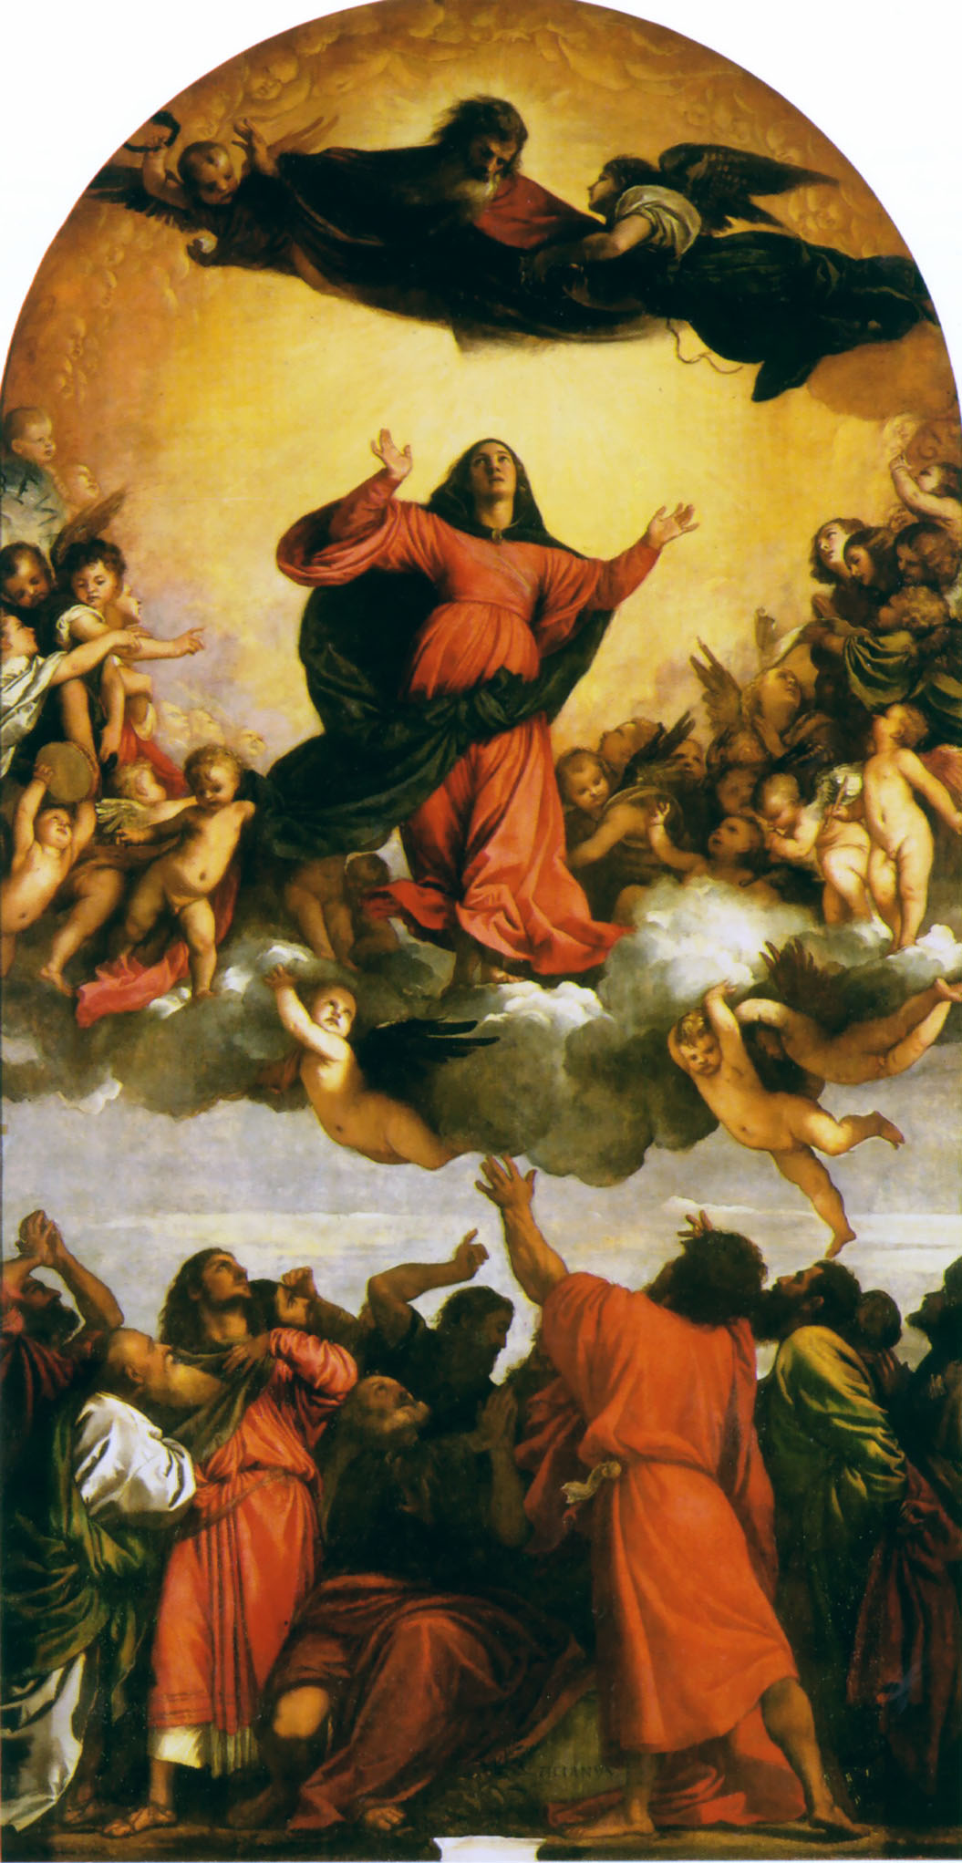

Titian (c.1488/90– 27 August 1576) The Assumption of the Virgin (detail)

TWENTY-FIRST SUNDAY IN ORDINARY TIME 23 August 2020

**Gospel Reading** *Matthew 16. 13-20*

When Jesus came to the region of Caesarea Philippi he put this question to his disciples, ‘Who do people say the Son of Man is?’ And they said, ‘Some say he is John the Baptist, some Elijah, and others Jeremiah or one of the prophets.’ ‘But you,’ he said ‘who do you say I am?’ Then Simon Peter spoke up, ‘You are the Christ,’ he said, ‘the Son of the living God.’ Jesus replied, ‘Simon son of Jonah, you are a happy man! Because it was not flesh and blood that revealed this to you but my Father in heaven. So I now say to you: You are Peter and on this rock I will build my Church. And the gates of the underworld can never hold out against it. I will give you the keys of the kingdom of heaven: whatever you bind on earth shall be considered bound in heaven; whatever you loose on earth shall be considered loosed in heaven.’ Then he gave the disciples strict orders not to tell anyone that he was the Christ.

**Reflection**

We are all of us very like Peter; we are fallible. Sometimes we can get things right, as did Peter when he said, ‘You are the Christ, the Son of the living God,’ and on another occasion when he declared, ‘You have the message of eternal life.’ But we can also get things very wrong, as when Peter did not want Jesus to wash his feet and, even worse, when later that same night he three times denied ever knowing Jesus.

Fortunately, after the Resurrection, Jesus gave Peter an opportunity for reconciliation which ended with the Apostle being told to be the Shepherd of Christ’s sheep. And so it is with us. We can get things wrong many times but the love of Christ will never desert us. Jesus is always ready to forgive and forget. All that is needed is that we must be prepared to acknowledge our faults and ask for forgiveness. If you are not sure how to go about that, just consult a priest!

*Fr John Hunter SSC*

TWENTY-SECOND SUNDAY IN ORDINARY TIME 30 August 2020

**Gospel Reading** *Matthew 16. 21-27*

Jesus began to make it clear to his disciples that he was destined to go to Jerusalem and suffer grievously at the hands of the elders and chief priests and scribes, to be put to death and to be raised up on the third day. Then, taking him aside, Peter started to remonstrate with him. ‘Heaven preserve you, Lord;’ he said ‘this must not happen to you.’ But he turned and said to Peter, ‘Get behind me, Satan! You are an obstacle in my path, because the way you think is not God’s way but man’s.’

Then Jesus said to his disciples, ‘If anyone wants to be a follower of mine, let him renounce himself and take up his cross and follow me. For anyone who wants to save his life will lose it; but anyone who loses his life for my sake will find it. What, then, will a man gain if he wins the whole world and ruins his life? Or what has a man to offer in exchange for his life?

‘For the Son of Man is going to come in the glory of his Father with his angels, and, when he does, he will reward each one according to his behaviour.’

**Reflection**

Take up thy cross then in his strength,  
And calmly every danger brave;  
'Twill guide thee to a better home,  
And lead to victory o'er the grave.  
  
Take up thy cross, and follow Christ,  
Nor think till death to lay it down;  
For only he who bears the cross  
May hope to wear the glorious crown.  
  
To thee, great Lord, the One in Three,  
All praise for evermore ascend;  
O grant us in our home to see  
The heavenly life that knows no end.

Take up thy cross, the Saviour said,  
If thou wouldst my disciple be;  
Deny thyself, the world forsake,  
And humbly follow after me.  
  
Take up thy cross; let not its weight  
Fill thy weak spirit with alarm;  
His strength shall bear thy spirit up,  
And brace thy heart, and nerve thine arm.  
  
Take up thy cross, nor heed the shame,  
Nor let thy foolish pride rebel;  
The Lord for thee the Cross endured,  
To save thy soul from death and hell.

*Charles W. Everest (1814 – 1877)*

TWENTY-THIRD SUNDAY IN ORDINARY TIME 6 September 2020

**Gospel Reading** *Matthew 18. 15-20*

Jesus said to his disciples: ‘If your brother does something wrong, go and have it out with him alone, between your two selves. If he listens to you, you have won back your brother. If he does not listen, take one or two others along with you: the evidence of two or three witnesses is required to sustain any charge. But if he refuses to listen to these, report it to the community; and if he refuses to listen to the community, treat him like a pagan or a tax collector.

‘I tell you solemnly, whatever you bind on earth shall be considered bound in heaven; whatever you loose on earth shall be considered loosed in heaven.

‘I tell you solemnly once again, if two of you on earth agree to ask anything at all, it will be granted to you by my Father in heaven. For where two or three meet in my name, I shall be there with them.’

**Reflection**

Today’s readings (especially the first) stress the duty of speaking out against the evil in our society. This duty naturally falls most heavily on the leaders of the Christian community. But each of us, by virtue of our Baptism, is called to be a prophet, that is, someone who speaks for God. Hence we should not remain silent when silence can be taken to mean that we approve of the evil that is happening around us. In that case we would have to bear some responsibility for the ongoing evil. In recent history Christian leaders in Nazi Germany were accused of not speaking out against what was happening in the death camps, and today, in this country, we must be prepared to speak out against the evil of racism.

Albert Camus wrote “What the world expects of Christians is that they should speak out loud and clear, and that they should voice their condemnation in such a way that never a doubt could arise in the heart of the simplest person.”

*Fr John Hunter SSC*

TWENTY-FOURTH SUNDAY IN ORDINARY TIME

13 September 2020

**Gospel Reading** *Matthew 18. 21-35*

Peter went up to Jesus and said, ‘Lord, how often must I forgive my brother if he wrongs me? As often as seven times?’ Jesus answered, ‘Not seven, I tell you, but seventy-seven times.

‘And so the kingdom of heaven may be compared to a king who decided to settle his accounts with his servants. When the reckoning began, they brought him a man who owed ten thousand talents; but he had no means of paying, so his master gave orders that he should be sold, together with his wife and children and all his possessions, to meet the debt. At this, the servant threw himself down at his master’s feet. “Give me time” he said “and I will pay the whole sum.” And the servant’s master felt so sorry for him that he let him go and cancelled the debt. Now as this servant went out, he happened to meet a fellow servant who owed him one hundred denarii; and he seized him by the throat and began to throttle him. “Pay what you owe me” he said. His fellow servant fell at his feet and implored him, saying, “Give me time and I will pay you.” But the other would not agree; on the contrary, he had him thrown into prison till he should pay the debt. His fellow servants were deeply distressed when they saw what had happened, and they went to their master and reported the whole affair to him. Then the master sent for him. “You wicked servant,” he said “I cancelled all that debt of yours when you appealed to me. Were you not bound, then, to have pity on your fellow servant just as I had pity on you?” And in his anger the master handed him over to the torturers till he should pay all his debt. And that is how my heavenly Father will deal with you unless you each forgive your brother from your heart.’

**Reflection**

The person who asks forgiveness is a person who has renounced the privilege of being right or safe; he has acknowledged that he is hungry for healing, for the bread of acceptance and restoration to relationship.  But equally the person who forgives has renounced the safety of being locked into the position of the offended victim; he has decided to take the risk of creating afresh a relationship known to be dangerous, known to be capable of causing hurt.  Both the giver and the receiver of forgiveness have moved out of the safety zone; they have begun to ask how to receive their humanity as a gift.

*Rowan Williams, Stuttgard, 2010*

TWENTY-FIFTH SUNDAY IN ORDINARY TIME

20 September 2020

**Gospel Reading**  *Matthew 20. 1-16*

Jesus said to his disciples: ‘The kingdom of heaven is like a landowner going out at daybreak to hire workers for his vineyard. He made an agreement with the workers for one denarius a day, and sent them to his vineyard. Going out at about the third hour he saw others standing idle in the market place and said to them, “You go to my vineyard too and I will give you a fair wage.” So they went. At about the sixth hour and again at about the ninth hour, he went out and did the same. Then at about the eleventh hour he went out and found more men standing round, and he said to them, “Why have you been standing here idle all day?” “Because no one has hired us” they answered. He said to them, “You go into my vineyard too.” In the evening, the owner of the vineyard said to his bailiff, “Call the workers and pay them their wages, starting with the last arrivals and ending with the first.” So those who were hired at about the eleventh hour came forward and received one denarius each. When the first came, they expected to get more, but they too received one denarius each. They took it, but grumbled at the landowner. “The men who came last” they said “have done only one hour, and you have treated them the same as us, though we have done a heavy day’s work in all the heat.” He answered one of them and said, “My friend, I am not being unjust to you; did we not agree on one denarius? Take your earnings and go. I choose to pay the last comer as much as I pay you. Have I no right to do what I like with my own? Why be envious because I am generous?” Thus the last will be first, and the first, last.’

**Reflection**

“A fair day’s pay for a fair day’s work.” That would probably be the slogan of most workers, especially those of what one might call the ‘labouring classes’. And that was almost certainly the thought in the minds of many of those we heard of in today’s parable.

They had obviously forgotten what God had said in an earlier part of Scripture. “My ways are not your ways,’ says the Lord. God does not think as we do. Our ideas of fairness do not count in the mind of God. We look at what we can see going on on the outside of a person, but God is much more likely to see what is going on in the heart. What matters is the spirit we bring to our work.

As Christians we may wish to think about our service of God and the faith of the Church. Do we get any enjoyment and true contentment from what we do, or it is all a matter of duty and so a source of display to those around us? Think on these things!

*Fr John Hunter SSC*

TWENTY-SIXTH SUNDAY IN ORDINARY TIME

27 September 2020

**Gospel Reading**  *Matthew 21. 28-32*

Jesus said to the chief priests and elders of the people, ‘What is your opinion? A man had two sons. He went and said to the first, “My boy, you go and work in the vineyard today.” He answered, “I will not go,” but afterwards thought better of it and went. The man then went and said the same thing to the second who answered, “Certainly, sir,” but did not go. Which of the two did the father’s will?’ ‘The first’ they said. Jesus said to them, ‘I tell you solemnly, tax collectors and prostitutes are making their way into the kingdom of God before you. For John came to you, a pattern of true righteousness, but you did not believe him, and yet the tax collectors and prostitutes did. Even after seeing that, you refused to think better of it and believe in him.’

**Reflection**

Today the liturgy presents to us the Gospel parable of the two sons sent by their father to work in his vineyard. One of them immediately agrees to go but then does not; the other instead refuses but later repents and complies with his father's wishes. With this parable Jesus reaffirms his predilection for sinners who convert and teaches us that humility is necessary in order to accept the gift of salvation. St Paul too, in the passage from his Letter to the Philippians on which we are meditating today, urges us to be humble: "Do nothing from selfishness or conceit", he writes, "but... let each of you... in humility count others better than yourselves" (Phil 2: 3). These are the same sentiments as those of Christ who, emptying himself of divine glory out of love for us, became a man and humbled himself even to dying on a Cross (cf. Phil 2: 5-8). The verb used - *ekenôsen* - means literally that he "emptied himself" and sheds clear light on the deep humility and infinite love of Jesus, the humble Servant *par excellence*.

*Pope Benedict XVI, Angelus Address, Sunday 28 September 2008*

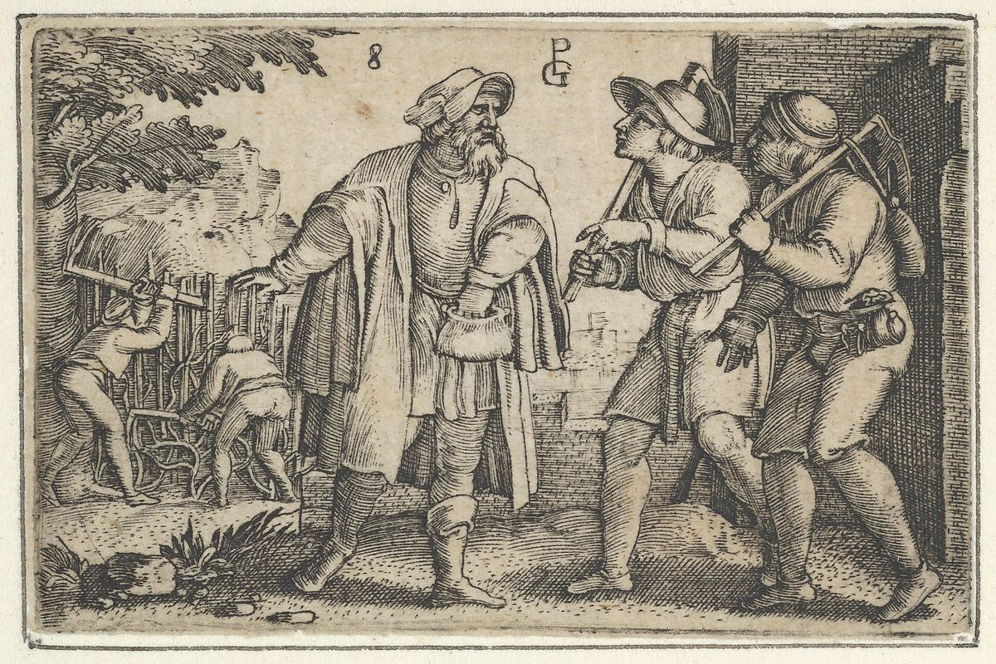

Georg Pencz (c.1500 – 1550) The Parable of the Father and His Two Sons in the Vineyard

CONTACTING US

**The Parish Office**

**Phone** 020 7370 3418

**Email** saint.stephen@homecall.co.uk

**Parish Priest** Fr Philip Barnes

**Phone** 020 7637 4263

**Email** frphilipbarnes@btinternet.com

**Hon. Assistant Priest** Fr John Hunter

**Phone** 020 7736 7544

**Email** frjohnhunter@hotmail.com

**www.saint-stephen.org.uk**