St Bertelin’s Church
Stafford

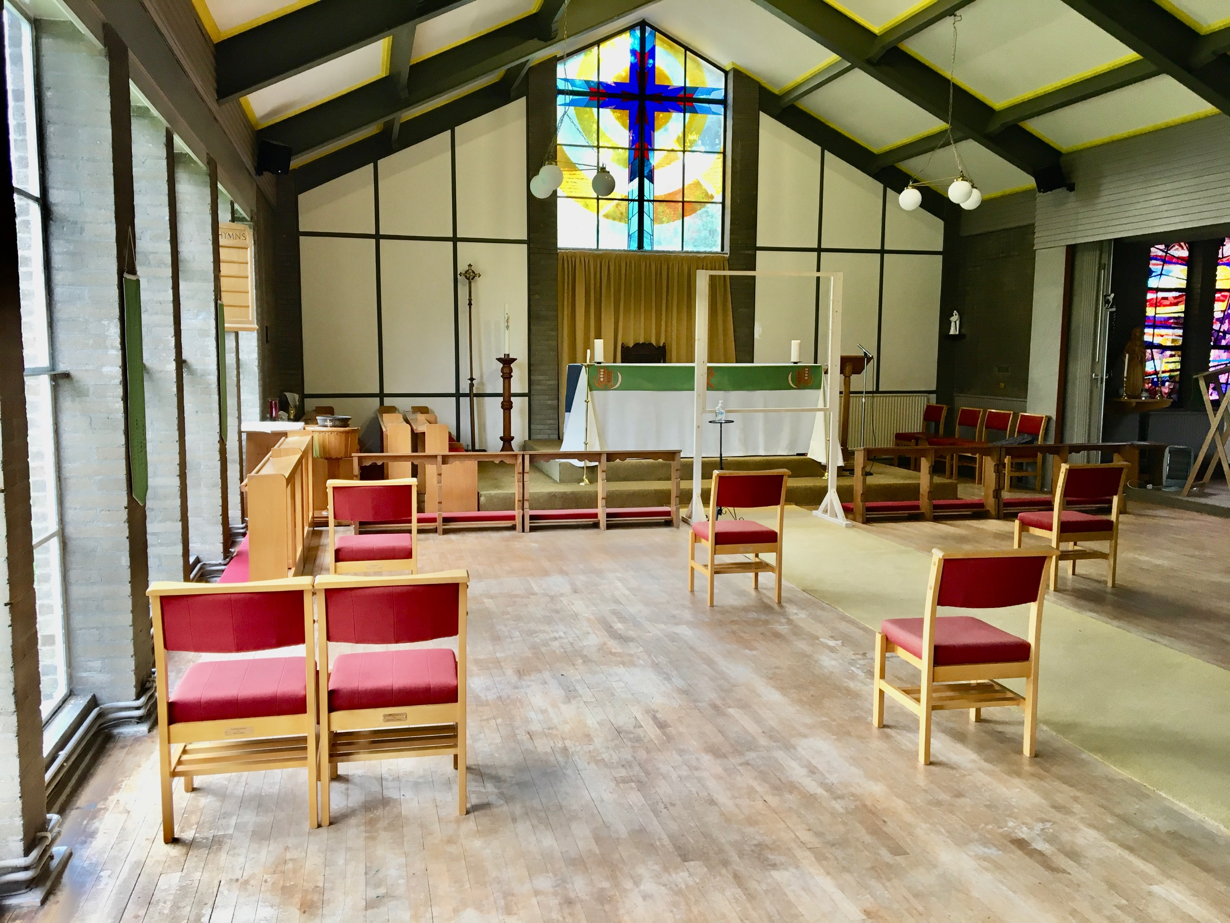

Returning to worship at
St Bertelin’s Church
after COVID-19
What You Need to Know

It will be good to be able to gather together in St Bertelin’s once again to worship God after such a long time when we were “locked down”.

I am really looking forward to seeing you once again face to face.

The service in church on a Sunday will be Holy Communion, because many of us have missed gathering at God’s table to do what Jesus commanded us to and share bread and wine together in remembrance of him.

There are some restrictions on what we as a church can and cannot do when we gather together again, and the purpose of this booklet is to explain these restrictions in more detail so that it doesn’t come as too much of a shock to you.

St Bertelin’s isn’t quite as large inside as you might think and therefore the number of people who will be able to come to a service is much smaller.

In order to avoid disappointment, please “book” your space by ringing 01785 252874 on Saturday afternoon between 12 and 6. Once all the spaces have been taken you won’t be able to come, but there will be still be an opportunity to worship God together via “Phone Church” at 6pm on Sunday evenings. Up to 50 people at a time can join the conference call and it will not cost you more than national call rates. It may even be free if you have a phone plan which gives you free minutes.

Here is what you will need to know….

The capacity of the church is very much less that it was in March 2020. In order to make sure that people are seated 2 metres distant from other people (to comply with current social distancing guidelines), there are only places for 14 individual people at any one service.
If you are attending with another person from your household, or someone you have formed a “social bubble” with, then there is space for an additional 6 people. If there are more than 2 people in your family or “bubble”, extra chairs may be added to a row so that you can all sit together. However, the official guidance is that the building should not be full to its maximum safe limit.

***Because of this very limited capacity, you are asked to telephone Revd Elaine on the Saturday to make sure that there will be a space for you on Sunday morning. ***
***If you haven’t let us know that you will be coming, and we don’t have a spare space for you, you will not be able to attend the service and will have to return home.***

You will notice that all the windows and most of the doors will be open. This is to make sure that there is sufficient ventilation through the building. Please bring a scarf with you if you are likely to feel a draught, and make sure that you are wearing warm clothes if you feel the cold.
There is currently no requirement to wear a face covering in church, but if you would like to wear a face covering, please do so. You might want to wear a face covering in the hallway. (Advice on face coverings may change so please follow advice which is current on the day you attend church.)

Please bring a pen with you, to sign the Contact Tracing Form. This form will be destroyed after 21 days if no one attending the service has any symptoms of COVID-19. If someone does develop the disease, your details will be used by NHS England for the purposes of contact tracing only.

When you arrive, you will be asked to sanitise your hands as you enter the building.
If you prefer to use your own hand sanitiser, please make sure that you have it with you and that you use it before entering the building, before receiving Holy Communion and as you leave the building. There will be hand sanitiser available at the entrance and at the communion rail.

Please try and maintain 2 metres social distancing in the hallway and within the church.

There will be a plate for any cash donation you wish to make as you enter the church (if you forget, it will be there as you leave too!) but it would be so much easier for everyone if you would consider donating via your bank if you don’t already do so. Standing Order forms will be available – just ask for one. (Cash collections have to be counted by two people, reconciled and taken to the bank…)

If you would like to light a votive candle, the candle stand is now at the back of the church (not in the Lady Chapel) and please also bring your own matches or lighter with you. You should make sure that your hands are completely dry after using hand sanitiser before you light a candle.

You will be shown to a seat where you can sit, and the seats will be filled up in order from the front. You may not be able to choose where you would like to sit.
Copies of the order of service, a pew sheet and a contact tracing form will be on each chair. Please take the order of service and pew sheet away with you at the end of the service, and leave the contact tracing form on the table in the hallway as you leave.

We are not able to sing any hymns, but there will be some music played during communion and before the service.

You will only be offered the bread at Communion, and the priest leading the service will be following all of the Guidelines from the Church of England about how to do that as safely as possible. You can find the guidance on the Church of England website at www.churchofengland.org and look under the Coronavirus tab.

You will be invited to come to the front and expected to sanitise your hands again before receiving the host (and afterwards if you would like to). Hand sanitiser is available at the front of church. You will not be kneeling at the Communion Rail but will receive standing up. There will be a Perspex screen between you and the priest.
You then return to your seat before the next person is invited to come forward for communion.

At the end of the service, please leave the church in order, with the back rows leaving first.

Please make sure that you have taken the order of service and the pew sheet with you, and that you have picked up all of your belongings. Please use hand sanitiser on the way out.

Please do not linger in the hallway but leave the building and go straight home. We are not able to serve refreshments at this time.

The toilet facilities will be of course be available for you to use, but if you are able to “hang on” until you get home it would be much appreciated as well as less disruptive for other worshippers!

However, the service will be shorter than usual – for 30 to 40 mins maximum.

Because of the limited amount of space within the building, and the need to keep 2 metres distant from other people, it will not be possible for anyone other than the person leading the service to read the Bible in the service or to offer prayers from the Lectern.

If you have any of the symptoms of COVID (a new continuous cough, a high temperature, the loss or change to your sense of smell or taste) please stay at home (along with anyone else in your household or support “bubble”) and get a test to check if you have coronavirus as soon as possible.

Aged over 70?

The advice from the Government for those aged 70 and over continues to be that they should take particular care to minimise contact with others outside their household.
If they do go out, they should be careful to maintain distance from others. They and everyone should continue to comply with any general social distancing restrictions.
Those aged 70 and over can be absolutely fit and healthy and it’s not the case that everybody over 70 has an underlying disease.
But unfortunately, we also know that as you get older, there is a higher risk of coronavirus infection resulting in more serious disease. Complications and deaths are more common in the elderly, even those without pre-existing conditions.

Only you can make an informed decision about whether or not to come to church.

We will take all precautions in line with the guidance from the Government, Public Health England and the Church of England to follow all the guidelines to keep you as safe as possible, but you can also play your part to keep everyone safe by doing as you are asked.

Please ask if you would like to see the Risk Assessment for this church.

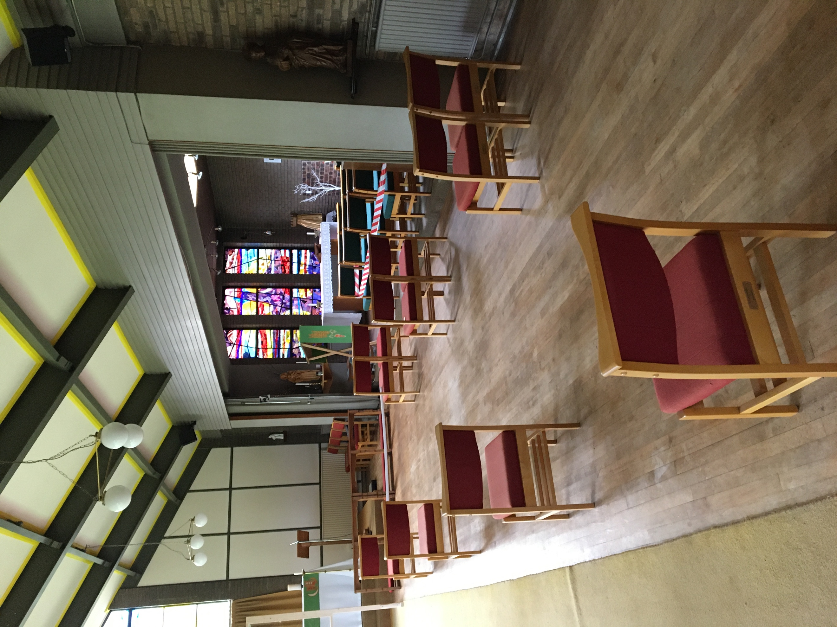

Checklist before you leave home

Have you got
- A pen (to sign the Contact Tracing Form)
- Some matches or a lighter (if you want to light a candle)
- A scarf and warm coat or jacket (the church will feel cooler and draughtier that usual because the windows and some of the doors will be open)
- Hand sanitiser (if you prefer to use your own)

The Revd Elaine Evans 01785 252874
email: vicarstbertelin@gmail.com

Version 1:2
July 2020

