All Saint, Torre, St. Luke, St. John the Apostle
Sunday Bulletin for Week beginning 12th July, 2020

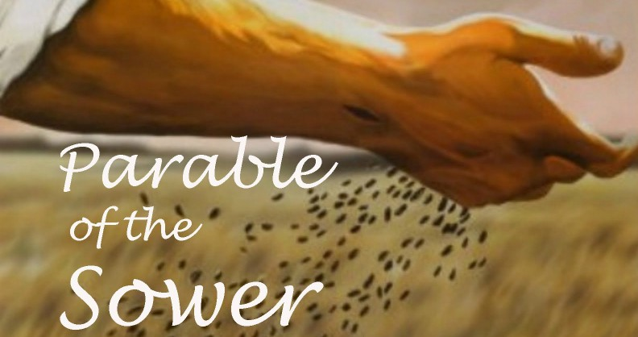

Services this week

We begin to offer public worship again in accordance with government and church guidelines.

Wednesday 15th July
All Saints, Torre, 10.30am Said Eucharist

Thursday 16th July
St Luke, 10.15am, Said Eucharist

Friday 17th July
St John, 11.00am, Said Eucharist

Sunday 19th July
All Saints, Torre, 9.30am Said Eucharist.
St. Luke, 11.00am Said Eucharist.
St John, 11.00am Said Eucharist.

Please note church will be open 15 minutes before the start of the service.

This Sunday is “Sea Sunday” when we remember all who live and work at Sea. We also remember The Mission to Seafarers and pray for them in their work with seafarers and their families.

July at a glance

3rd St Thomas, Apostle.
11th St Benedict
12th Sea Sunday – Pray for those who live and work at sea.
15th St Swithun
22nd St Mary Magdalene
23rd St Bridget
25th St James
31st St Ignatius Loyola
Throughout this month we continue in ordinary time, a ‘green’ season when we pray for the growth of the church both in numbers and in spiritual commitment.
.

Time to Read and Pray with
Scripture each day.

Here are the Gospel readings set for each day this week. You might like to take the time to read them and pray with them.

Sunday, Matthew 13:1-9 & 18-23
Monday, Matthew 10:34-11:1
Tuesday, Matthew 11:20-24
Wednesday, Matthew 11:25-27
Thursday, Matthew 11:28-end
Friday, Matthew 12:1-8
Saturday, Matthew 12:14-21

Keeping in Touch
Send us your email address if you would like to receive the weekly bulletin and updates.
Follow the Parishes on Facebook:
All Saints Church, Torre, Torquay, St Luke’s Parish Church Torquay, St John’s Over the Harbour

Fr. Peter March S.S.C 01803 312754 p.j.march@hotmail.co.uk

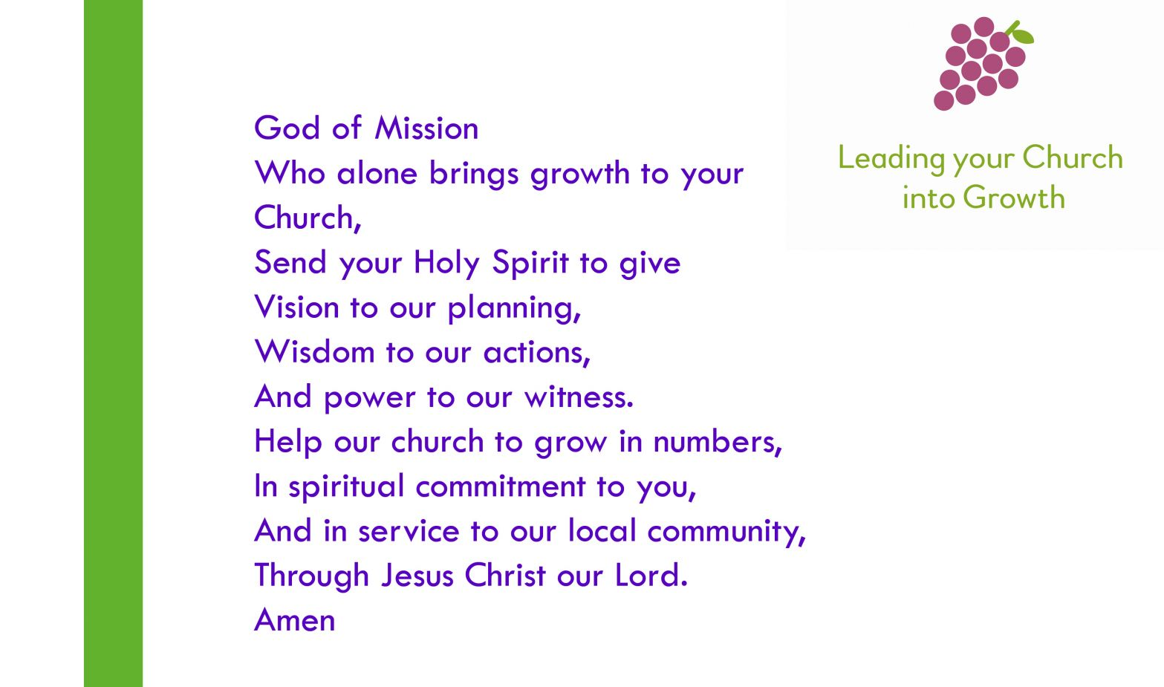

Bible passages on the themes of healing and well-being

Isaiah 35.3-6 Strengthen the weak hands

Ecclesiasticus 38.1-9 The Lord created medicines out of the earth

Luke 7.1-10 Jesus heals a centurion’s servant

Romans 12.1-8 The gifts of the Body of Christ

Colossians 3.9-14 Put on compassion and kindness

James 5.13-16 Anointing the sick

Revelation 22.1-5a The tree of life

How generous is your goodness, O God,
how great is your salvation,
how faithful is your love;
help us to trust you in trial
and praise you in deliverance;
through Jesus Christ our Lord.
Amen

Prayers for use at this time

Keep us, good Lord,
under the shadow of your mercy
in this time of uncertainty and distress.
Sustain and support the anxious and fearful,
and lift up all who are brought low;
that we may rejoice in your comfort
knowing that nothing can separate us
from your love in Christ Jesus our Lord.
Amen

Lord Jesus Christ,
you taught us to love our neighbour,
and to care for those in need
as if we were caring for you.
In this time of anxiety, give us strength to comfort the fearful, to tend the sick, and to assure the isolated of our love, and your love,
for your name’s sake.
Amen

God of compassion,
be close to those who are ill, afraid or in isolation.
In their loneliness, be their consolation;
in their anxiety, be their hope;
in their darkness, be their light;
through him who suffered alone on the cross,
but reigns with you in glory,
Jesus Christ our Lord.
Amen.

Find more prayers like these on the Church of England website: www.churchofengland.org.

Lectio Divina

Introduction

Make whatever preparations you need to leave the shadow world behind and encounter the fire of the Spirit and the light of God.
If you have chosen to prepare the space and the place in some way (perhaps drawing a curtain or lighting a candle), make that preparation.
Eliminate distractions and the possibility of interruption.

Sign of the Cross

We invoke God, in whose name we act.

In the name of the Father, ✠
and of the Son,
and of the Holy Spirit,
Amen.

Invocation of the Holy Spirit

We invoke the Holy Spirit, who will speak to us and listen in us.

Come, Holy Spirit, fill the hearts of your faithful
and kindle in them the fire of your love.

Send forth your Spirit, and they shall be created.
And you shall renew the face of the earth.

Act of Contrition

By acknowledging our sinfulness and admitting that by ourselves we can do nothing that is not flawed, we ask God to take the initiative in this encounter.

Have mercy on us, O Lord:
For we have sinned against you.
Show us, O Lord, your mercy:
And grant us your salvation.

May almighty God have mercy on us, forgive us our sins, and bring us to everlasting life.
Amen.

The Gospel

A reading from the holy Gospel according to Matthew

The Parable of the Sower
13 That same day Jesus went out of the house and sat beside the lake. ² Such great crowds gathered around him that he got into a boat and sat there, while the whole crowd stood on the beach. ³ And he told them many things in parables, saying: ‘Listen! A sower went out to sow. ⁴ And as he sowed, some seeds fell on the path, and the birds came and ate them up. ⁵ Other seeds fell on rocky ground, where they did not have much soil, and they sprang up quickly, since they had no depth of soil. ⁶ But when the sun rose, they were scorched; and since they had no root, they withered away. ⁷ Other seeds fell among thorns, and the thorns grew up and choked them. ⁸ Other seeds fell on good soil and brought forth grain, some a hundredfold, some sixty, some thirty. ⁹ Let anyone with ears^{[a]} listen!’

The Parable of the Sower Explained
¹⁸ ‘Hear then the parable of the sower. ¹⁹ When anyone hears the word of the kingdom and does not understand it, the evil one comes and snatches away what is sown in the heart; this is what was sown on the path. ²⁰ As for what was sown on rocky ground, this is the one who hears the word and immediately receives it with joy; ²¹ yet such a person has no root, but endures only for a while, and when trouble or persecution arises on account of the word, that person immediately falls away.^{[a]} ²² As for what was sown among thorns, this is the one who hears the word, but the cares of the world and the lure of wealth choke the word, and it yields nothing. ²³ But as for what was sown on good soil, this is the one who hears the word and understands it, who indeed bears fruit and yields, in one case a hundredfold, in another sixty, and in another thirty.’
________

The Response

Meditatio (reflection)

What does the Gospel say to me?
God has willed me to be here, now, today, for a reason. Now is the time to reflect, and find that reason, and hear what God has chosen to tell me.

A good pattern is this:
- What has drawn my attention or struck me in some way?
- Why? Was it a person? A word? A situation? A gesture?
- What, therefore, is God saying to me through these words, here and now, today?

The “I” and the “me” are important. To say “we” or “us” is to evade the encounter by softening the focus and hiding behind membership of a group. The meeting with Jesus is face to face, one to one.

Oratio (prayer)

God has spoken to me. What do I reply?
Silently, each of us responds to what God has said to them through the passage we have read.
Contemplatio (contemplation)

Sometimes we may be led beyond prayer into a quiet and attentive resting in the presence of God.

Conclusion

We prepare to return to the everyday world, carrying with us what we have received in our minds and our hearts today.

Our Father, who art in heaven,
hallowed be thy name.
Thy kingdom come.
Thy will be done on earth, as it is in heaven.
Give us this day our daily bread,
and forgive us our trespasses,
as we forgive those who trespass against us,
and lead us not into temptation,
but deliver us from evil.
________

May the Lord bless us, and keep us from all evil, and bring us to everlasting life.
Amen

