Church of St. Peter, Milton Bryan
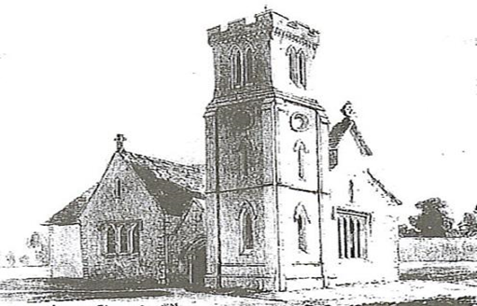 Sunday 28 June 2020 THE THIRD SUNDAY AFTER TRINITY
11:30am
The Collect, the Bible and Prayer in our Homes ‘Apart but Together’
IMPORTANT REFRESHMENTS NOTICE:
We invite you to synchronise with us in having refreshments, tea, coffee,
And a biscuit or something nice at around 12:00 midday today.

The Collect, Bible Reading, and Prayers of Intercession
Prepared by Kelvin White, Lay Leader of Worship, from St. Peter’s, Milton Bryan for YOU to read and use in your homes as we worship Apart but Together.
Kelvin White will be Ringing one bell at 11:30am to mark the start of worship and prayer in Church alone, please join with him from the comfort of your homes.
Two versions of today’s Bible Reading are provided: NIV (New International Version) and KJV (King James Version), other versions can be found on www.biblegateway.com.
Please take a moment to be still.
The Collect for Today:
Almighty God, you have broken the tyranny of sin and have sent the Spirit of your Son into our hearts whereby we call you Father: give us grace to dedicate our freedom to your service, that we and all creation may be brought to the glorious liberty of the children of God; through Jesus Christ your Son our Lord, who is alive and reigns with you, in the unity of the Holy Spirit, one God, now and for ever. Amen.
Bible Reading: Matthew 10:40-42 (NIV)
40 “Anyone who welcomes you welcomes me, and anyone who welcomes me welcomes the one who sent me. 41 Whoever welcomes a prophet as a prophet will receive a prophet’s reward, and whoever welcomes a righteous person as a righteous person will receive a righteous person’s reward. 42 And if anyone gives even a cup of cold water to one of these little ones who is my disciple, truly I tell you, that person will certainly not lose their reward.”
This is the Word of the Lord. All: Thanks be to God

Bible Reading: Matthew 10:40-42 (KJV)
40 He that receiveth you receiveth me, and he that receiveth me receiveth him that sent me.
41 He that receiveth a prophet in the name of a prophet shall receive a prophet's reward; and he that receiveth a righteous man in the name of a righteous man shall receive a righteous man's reward.
42 And whosoever shall give to drink unto one of these little ones a cup of cold water only in the name of a disciple, verily I say unto you, he shall in no wise lose his reward.
This is the Word of the Lord. All: Thanks be to God

Prayers of Intercession for Sunday 28 June 2020 Prepared by Kelvin White. Lay Leader of Worship.
In the power of the spirit and in union with Christ, Let us pray to the Father. Almighty God, our heavenly father, You promised through your Son Jesus Christ….. To hear us, when we pray in faith.
Heavenly Father,
We praise you for the creation and beauty of the earth and all mankind, we pray that through the body and blood of Jesus Christ,
our world and human presence is restored in your image alone. May you guide us to be the neighbour and the giver to those in need,
and we pray for your heartbeat to work in us and through us,
as a refreshed and renewed creation in Jesus Christ our Lord. Amen.
Hear us Lord, as we bring before you all those affected by the Coronavirus. Keep us, good Lord, under the shadow of your mercy. Sustain and support the anxious, be with those who care for the sick, and lift up all who are brought low; that we may find comfort knowing that nothing can separate us from your love in Christ Jesus our Lord. Amen.
We continue with our prayer for the village of Milton Bryan We pray for the village of Milton Bryan giving thanks for all who seek to help and support those who are isolated, or in need and unable to go out in these difficult times. We pray for those who are unwell and that they may know the healing love and comfort of you Lord. We give thanks and pray for the Milton Bryan Charity, the Milton Bryan Parish Meeting, the Milton Bryan Village Hall, the Friends of St. Peter’s, the Cricket Club, the Scout Camp, the Red Lion Pub, the Village Stall opposite the pub, Allotment Keepers and Gardeners, Leys Farm, Town Farm, Stable and Horse Keepers and the general farming community in the surrounding villages and those who look after our peaceful village pond. We give thanks for our Milkman and the postman and all who provide services in the local area along with our churchyard maintenance contractor. We also pray for our own Church leadership, its PCC members and general volunteering community that they may find encouragement, peace and joy in Jesus Christ our Lord. Father God may you guide, protect and bless all who work for the general wellbeing of the people and parish of Milton Bryan. Let us not take anyone or anything for granted and may we continually praise you for the beauty of all creation of the Mid-Bedfordshire countryside in which we live. Amen.
Lord Heavenly Father, We give thanks for the generosity and good will in our communities and churches as we all respond to support the needs of those around us and afar in these challenging times. We give thanks for our emergency services; front line workers and the core services that keep our country working.
We pray for those who are finding new routines and patterns of work as they return to their workplaces and we pray for all who find themselves with uncertain futures in their jobs.
We pray for all people in this world as we come to terms with and find a way forward through the longer term impacts of the coronavirus and the evolving situation. Lord we call upon you and seek your face and your help.
We pray for those who go hungry, those who are weak, the vulnerable and the homeless and where war continues may it be still.
Lord in your Mercy – Congregation: Hear our Prayer
Thank you Lord, for your Word through Scripture, Worship and Prayer here in Milton Bryan and throughout our Benefice. We give thanks and pray for our Rector Rev Steve Nuth and the Benefice Leadership Team. We pray for Steve as he continues to work and serve you Lord from the Vicarage and we pray for all in the Nuth family. Amen.
Strengthen our Bishops Alan and Richard and all your church in the service of Christ, That those who confess your name may be united in your truth, Live together in your love, and reveal your glory in the world.
Lord in your mercy – Congregation: Hear our prayer
We pray for Elizabeth our queen; that you give wisdom to all in authority; And direct this and every nation in the ways of justice and peace; That we may honour one another, and seek the common good.
Lord in your mercy - Congregation: Hear our prayer
Father, Give grace to us, our families and friends and to all our neighbours, That we may serve Christ in one another, and love as he loves us.
Comfort and heal all those who suffer in body, mind, or spirit….;
We remember the family of Fiona Chapman and pray for your love to be a source of comfort as they remember Fiona who passed away peacefully on the 6th June. Lord we ask for your presence to be with Fiona’s husband Allan and Fiona’s wider family in the weeks and months ahead.
We take a moment to be silent and still as we pray for those we know who suffer, are unwell or struggling at this time:
Lord, Give them courage and hope in their troubles; And bring them the joy of your salvation.
Lord in your mercy - Congregation: Hear our prayer
Hear us as we remember those who have died in the Faith of Christ….; According to your promises, Grant us with them a share in your eternal kingdom.
Rejoicing in the glorious fellowship of all your saints, We commend ourselves and the whole creation to your unfailing love.
Merciful Father: Accept these prayers; For the sake of you son, Our Saviour Jesus Christ. Amen.
A Closing Blessing:
The God of all grace, who called us to his eternal glory in Christ Jesus, establish, strengthen and settle you in the Faith; And the blessing of God almighty, the Father, the Son, and the Holy Spirit, be among us and remain with us always. Amen.

REFRESHMENTS NOTICE:
We invite you to synchronise with us in having refreshments, tea, coffee and a biscuit or something nice at around 12:00 midday today.

Fundraising Notice: Kelvin White has pedalled his way through 500 miles and finishes this weekend. Please consider sponsoring him online or by hard copy sponsor form, if you haven’t already done so. https://www.justgiving.com/crowdfunding/kelvin-white-500milesforstpetersmb

Have a safe, healthy and blessed day.
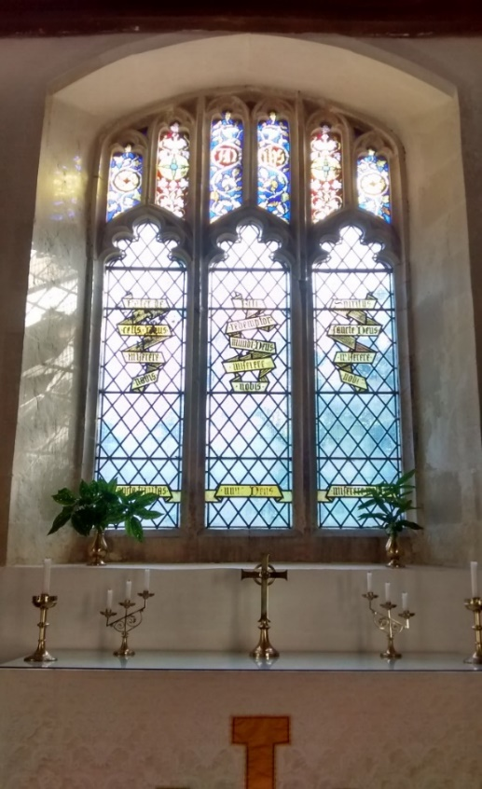
miltonbryanparishchurch@gmail.com kelvinbrucewhite@gmail.com - staceysarahwhite@gmail.com rectornuth@gmail.com – woburnbenefice@gmail.com Kelvin and Stacey White Tel: 01525 210337
WhatsApp group for St. Peter's, Milton Bryan: 'Apart but Together'. The 'Apart but Together' group is for the community of St. Peter's Church, Milton Bryan and beyond. The purpose of this group is to maintain contact, including sharing, caring, support and prayer during the difficult times and the separation we face during the Coronavirus (COVID-19) situation. If you would like to join this WhatsApp group please contact Stacey or Kelvin.
https://www.achurchnearyou.com/church/7658/ https://www.facebook.com/stpetersmb/ https://www.instagram.com/st.peters.mb/

