The Parishes of Topcliffe, Baldersby with Dishforth, Dalton and Skipton on Swale

Benefice Pew Sheet w/c 17th May 2020
The May edition of Cross Talk is available on the ‘A Church Near You’ website

Sixth Sunday of Easter

Thank you for your photos of VE Day 75th Anniversary celebrations around the Benefice.

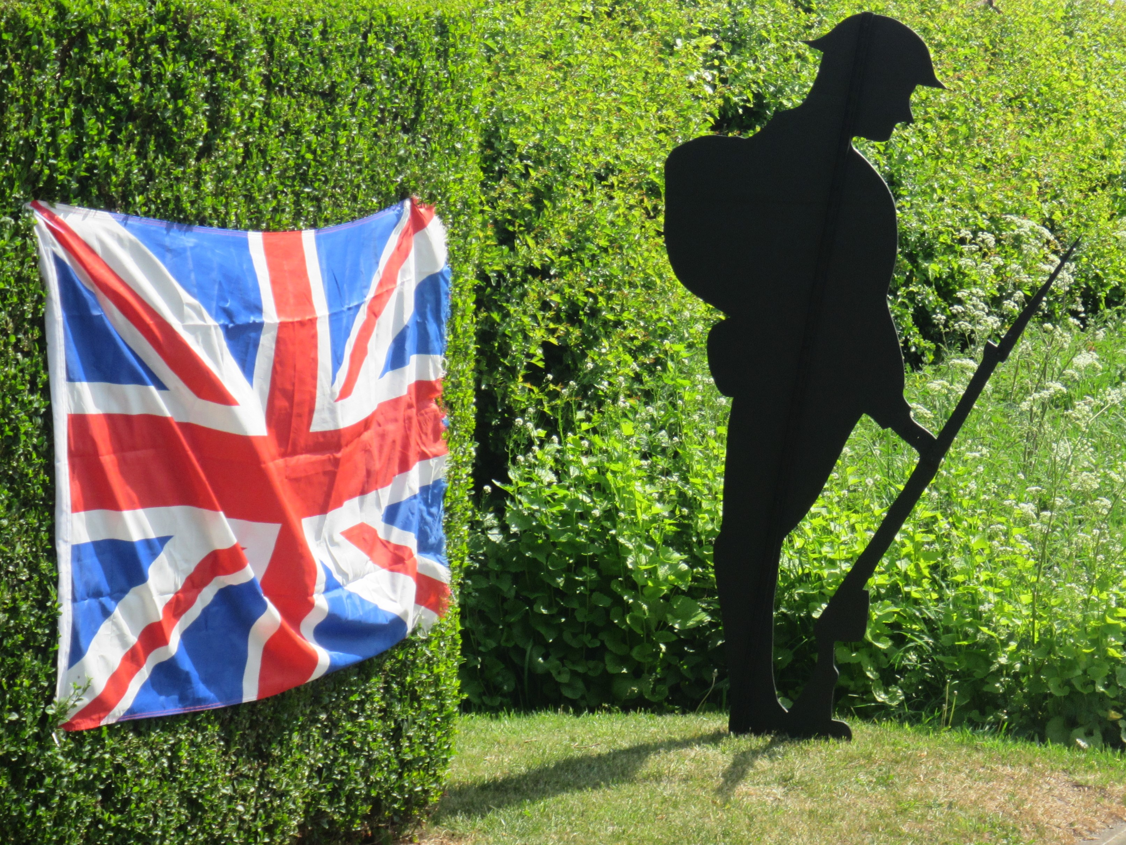
The soldier was the work of Stuart Carter of "Wayside" Baldersby, St. James and the photo was taken by Tim Helps. In Asenby, John and Claire Phillips had a great day with their immediate neighbours for a socially distanced tea party on their front law. The third photo is of Topcliffe Post Office decorated for the VE Day 75th Anniversary celebrations.
© Tim Helps 2020
Inevitably many people have tried to make comparisons between the war time years and what we are facing during the Covid-19 pandemic. In both cases people having been willing to risk their
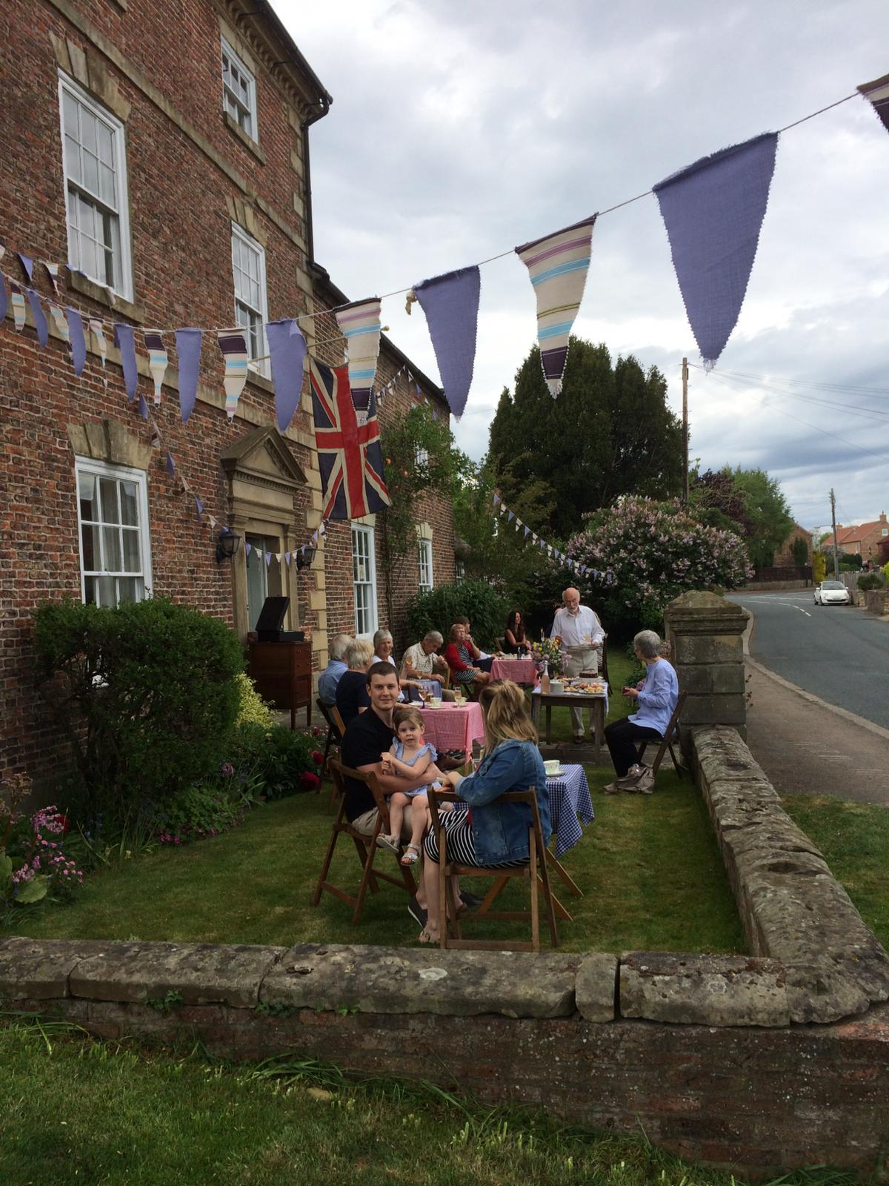
own safety to protect others be it people in the armed forces in the war or NHS and other key workers during the pandemic. In both cases ordinary people in communities have gone out of their way to support their neighbours, particularly neighbours who are infirm. As with the wartime generation, we are hoping that something good can come out of a thoroughly unhappy situation such as a better community spirit and more cooperation nationally between people with differing opinions. However, we should not just focus on the future and what that new normality will look like. Jesus tells us ‘Do not worry about tomorrow, for tomorrow will bring worries of its own. Today's trouble is enough for today’ which I take to mean that if we become so focused on how much better things may be in the future we will miss out on the important things of today.
© Richard Byas 2020 © John Phillips 2020
We should be helping neighbours where we can, contacting those who may be lonely in the lockdown but also enjoying what we have around us, friends, our homes and gardens, and if we are working helping others without putting them or ourselves in danger. It struck me, that however grim life was at times, the wartime generation found ways to simply enjoy life often despite their situation. Likewise, as Christians today, we acknowledge that joy is one of the gifts of the Holy Spirit and in these difficult times it is a gift we should nurture to its fullest extent.
Richard Byas

Collect, Readings, Reflection and Blessing for the Sixth Sunday of Easter.

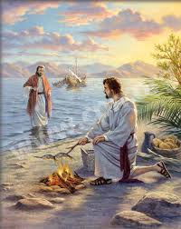
Collect

Risen Christ,
by the lakeside you renewed your call to your disciples:
help your Church to obey your command
and draw the nations to the fire of your love,
to the glory of God the Father. Amen

Acts 17. 22-31

Then Paul stood in front of the Areopagus and said, ‘Athenians, I see how extremely religious you are in every way. For as I went through the city and looked carefully at the objects of your worship, I found among them an altar with the inscription, “To an unknown god.” What therefore you worship as unknown, this I proclaim to you. The God who made the world and everything in it, he who is Lord of heaven and earth, does not live in shrines made by human hands, nor is he served by human hands, as though he needed anything, since he himself gives to all mortals life and breath and all things. From one ancestor he made all nations to inhabit the whole earth, and he allotted the times of their existence and the boundaries of the places where they would live, so that they would search for God and perhaps grope for him and find him—though indeed he is not far from each one of us. For “In him we live and move and have our being”; as even some of your own poets have said, “For we too are his offspring.”

Since we are God’s offspring, we ought not to think that the deity is like gold, or silver, or stone, an image formed by the art and imagination of mortals. While God has overlooked the times of human ignorance, now he commands all people everywhere to repent, because he has fixed a day on which he will have the world judged in righteousness by a man whom he has appointed, and of this he has given assurance to all by raising him from the dead.’

1 Peter 3. 13-end

Now who will harm you if you are eager to do what is good? But even if you do suffer for doing what is right, you are blessed. Do not fear what they fear, and do not be intimidated, but in your hearts sanctify Christ as Lord. Always be ready to make your defence to anyone who demands from you an account of the hope that is in you; yet do it with gentleness and reverence. Keep your conscience clear, so that, when you are maligned, those who abuse you for your good conduct in Christ may be put to shame. For it is better to suffer for doing good, if suffering should be God’s will, than to suffer for doing evil. For Christ also suffered for sins once for all, the righteous for the unrighteous, in order to bring you to God. He was put to death in the flesh, but made alive in the spirit, in which also he went and made a proclamation to the spirits in prison, who in former times did not obey, when God waited patiently in the days of Noah, during the building of the ark, in which a few, that is, eight people, were saved through water.
And baptism, which this prefigured, now saves you—not as a removal of dirt from the body, but as an appeal to God for a good conscience, through the resurrection of Jesus Christ, who has gone into heaven and is at the right hand of God, with angels, authorities, and powers made subject to him.

John 14. 15-21

‘If you love me, you will keep my commandments. And I will ask the Father, and he will give you another Advocate, to be with you for ever. This is the Spirit of truth, whom the world cannot receive, because it neither sees him nor knows him. You know him, because he abides with you, and he will be in you.
‘I will not leave you orphaned; I am coming to you. In a little while the world will no longer see me, but you will see me; because I live, you also will live. On that day you will know that I am in my Father, and you in me, and I in you. They who have my commandments and keep them are those who love me; and those who love me will be loved by my Father, and I will love them and reveal myself to them.’

Reflection:

We have been born to make a difference for God in the year 2020 in the midst of the worldwide coronavirus pandemic.
Thankfully, we are not called to do it entirely by our own efforts but with the aid of the Holy Spirit. Jesus tells us ‘They who have my commandments and keep them are those who love me’ and those commandments are 'Love the Lord your God with all your heart and with all your soul and with all your strength and with all your mind'; and, 'Love your neighbour as yourself.'’ In practice this will mean something different for each one of us – it is for us to ask the Holy Spirit’s guidance about what it means to us in the situation we find ourselves in and then to act accordingly.

The Covid-19 pandemic is worldwide, here is a prayer from Australia that is equally relevant to the UK.

A prayer for all during the Covid-19 pandemic

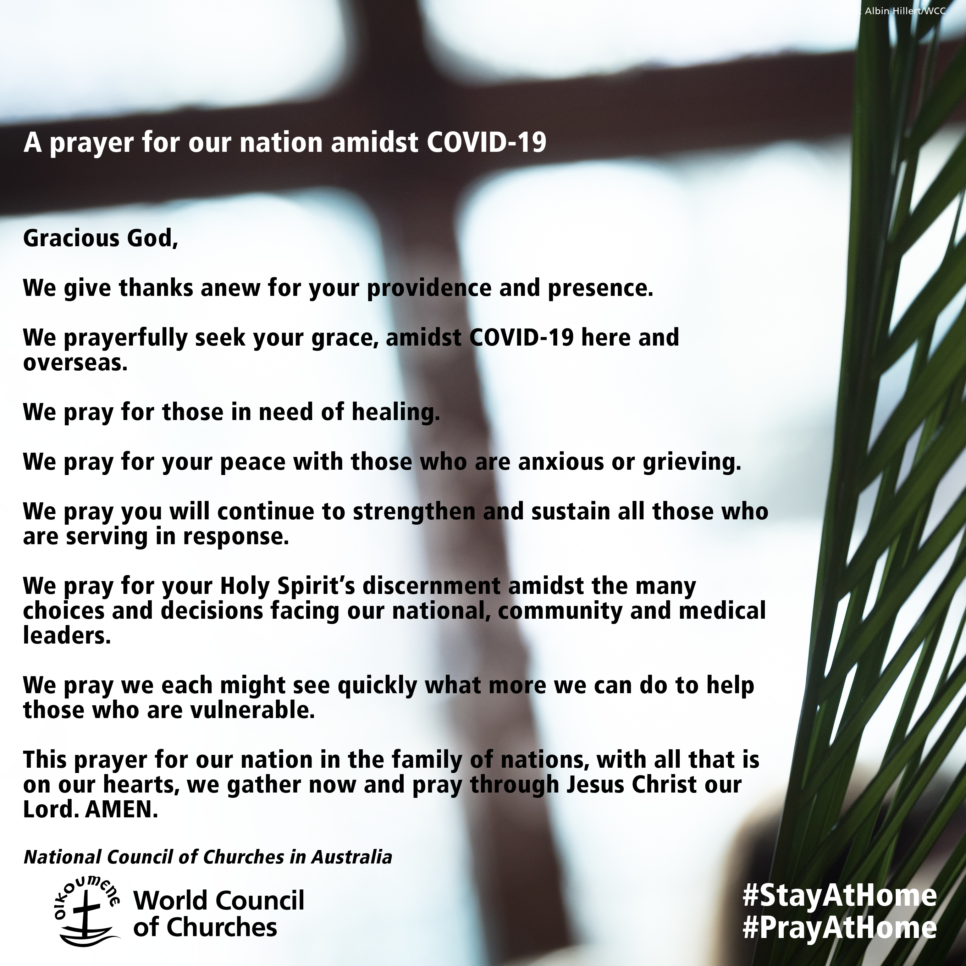
Blessing

The God of peace, who brought again from the dead our Lord Jesus that great shepherd of the sheep, through the blood of the eternal covenant, make us perfect in every good work to do his will, working in us that which is well-pleasing in his sight.
And the blessing of God Almighty,
the Father, the Son, and the Holy Spirit,
be among us and remain with us always. Amen.

Around the Benefice.

Thy Kingdom Come
– the annual wave of prayer leading up to Pentecost Sunday
21st (Ascension Day) – 31st May (Pentecost) 2020

Do you want to join in the global wave of prayer
and light up the world?
See the Thy Kingdome Come website
Or, nearer the time, download the App.

VE Day 75th Anniversary Celebration Memories from Tim Helps

Contrary to expectation a number of households in Baldersby, including mine, held VE Day 75 parties based on their gardens - exercising social distancing - between 6 and 9.30 pm. I walked my dog round the village chatting to those partying, and that done went to pay my respects to the grave of Ordinary Seaman E Bowes RN accompanied by "Oti".
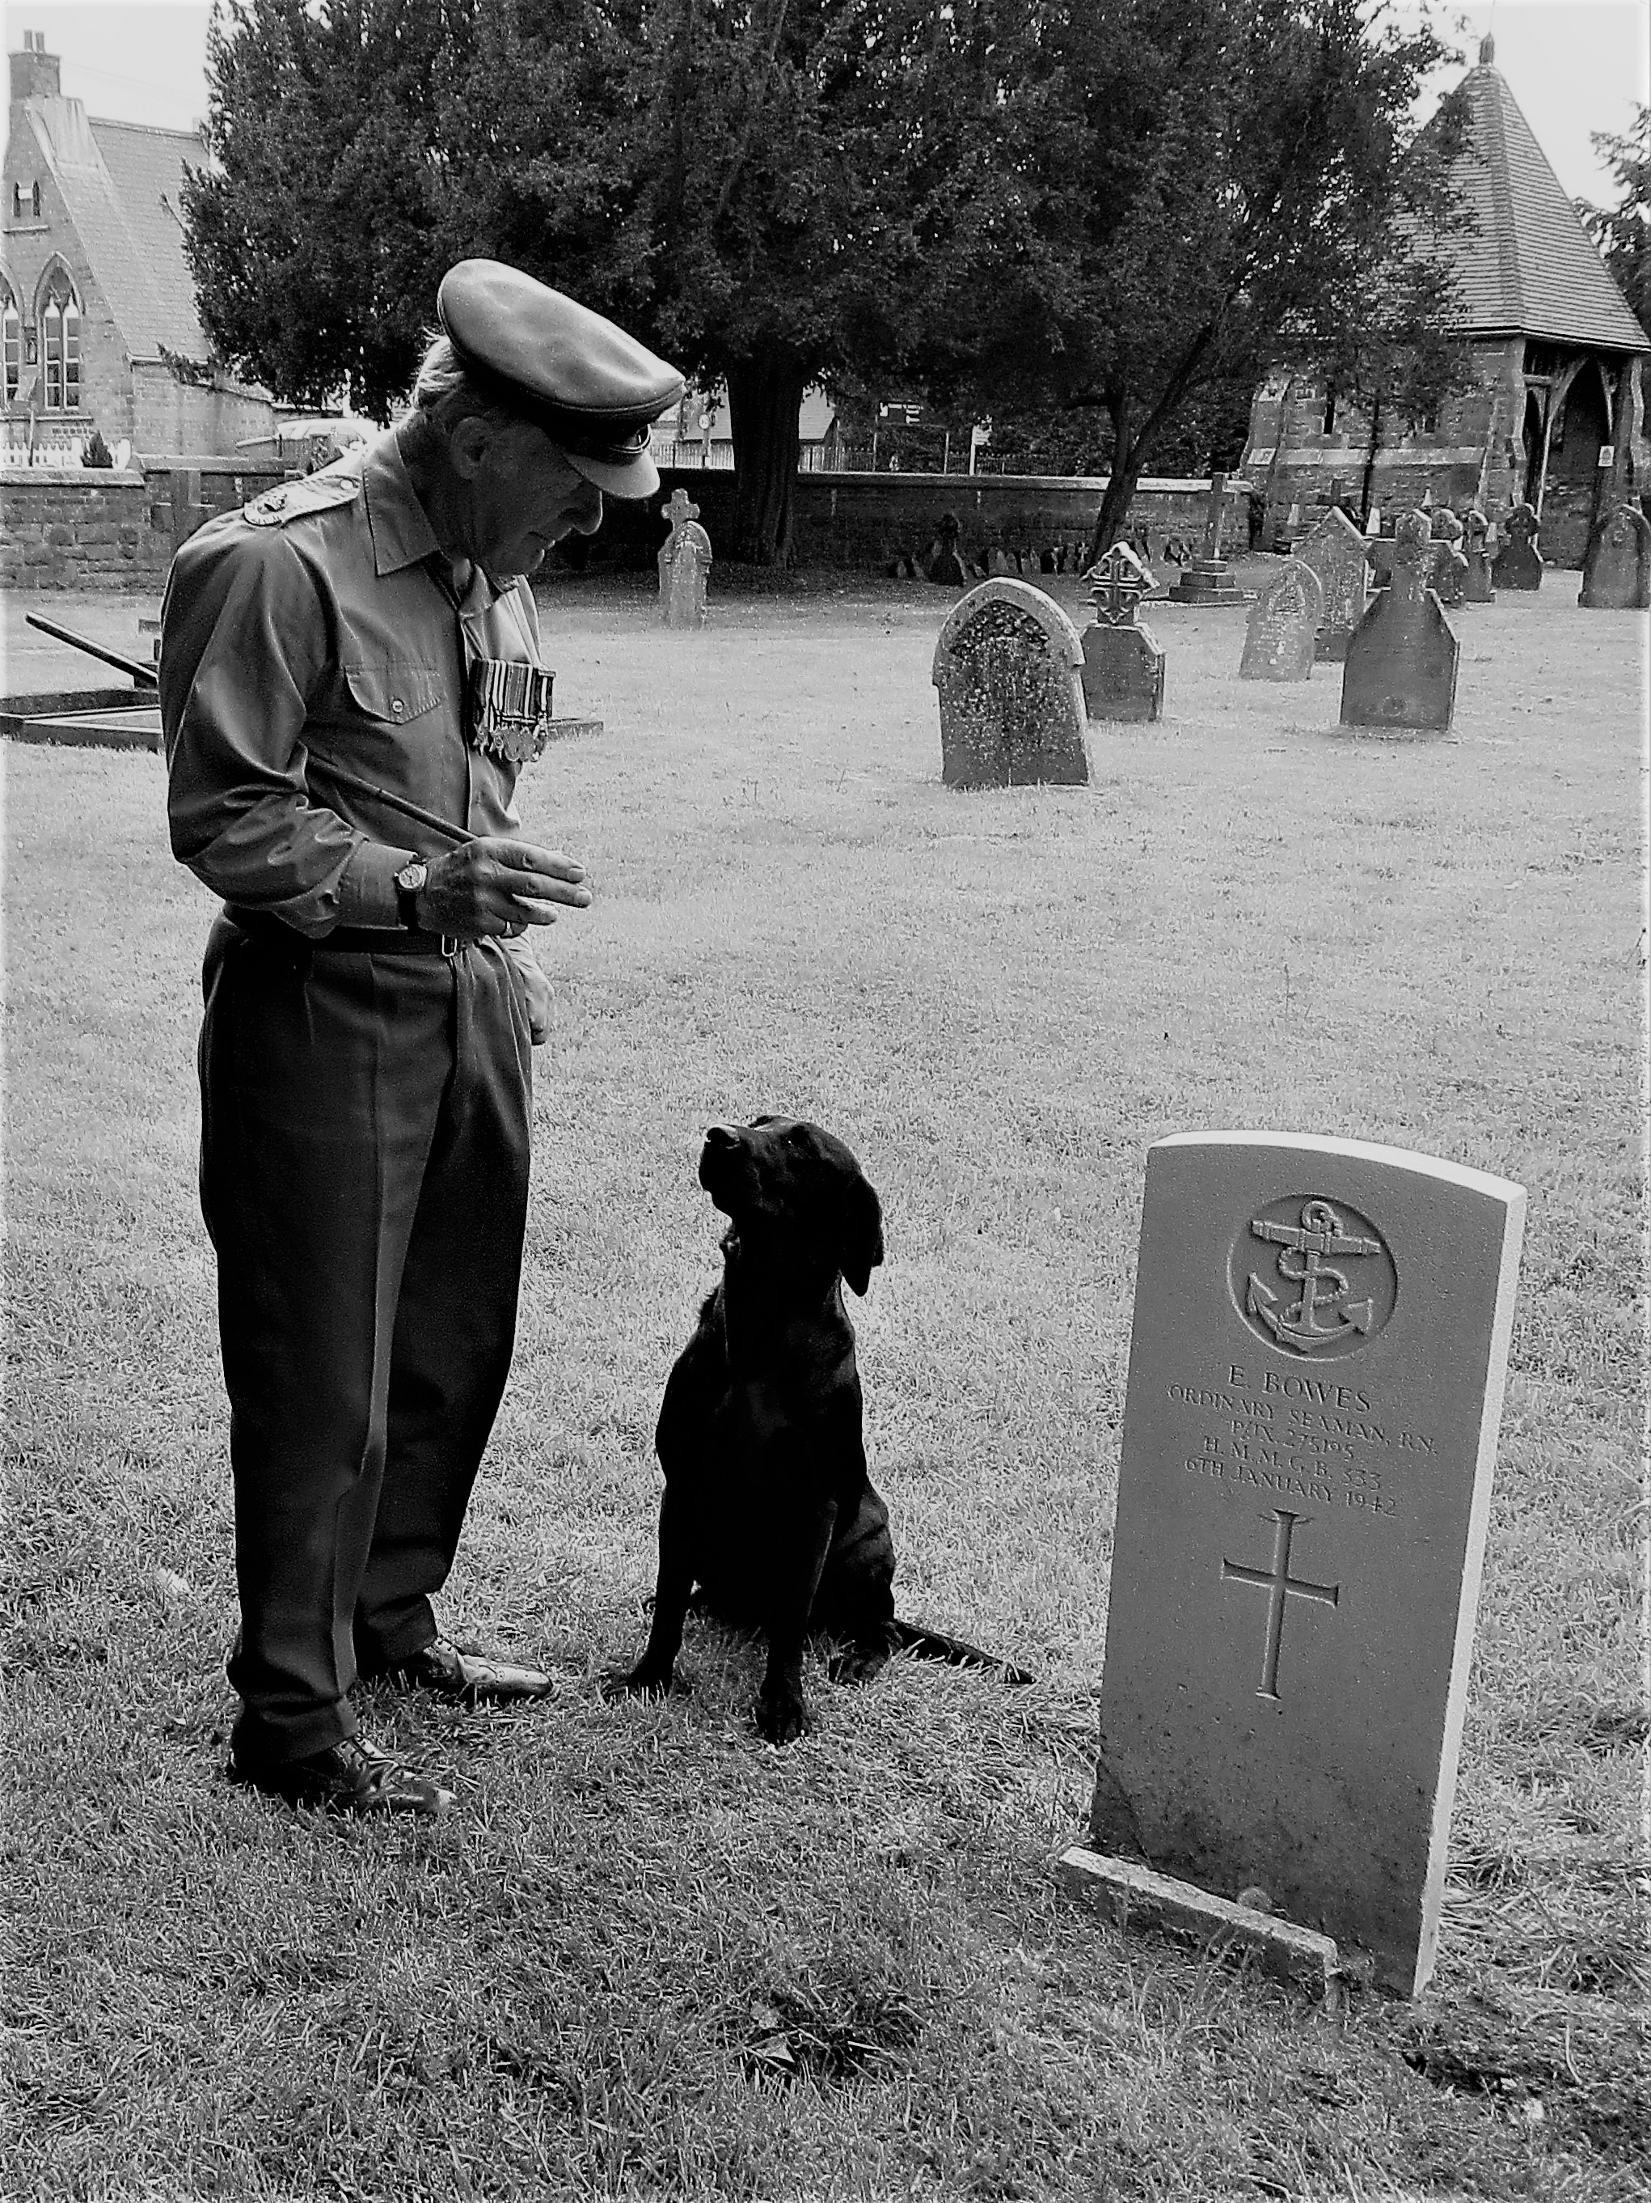
A number of people in Baldersby dressed in the 1940's style and I decided to wear my father's medals and dress as near as I could to the uniform of the time.

My father was a TA Officer in the Royal Warwickshire Regiment. When the tide of the war changed and their was talk of an invasion he volunteered to be a "Reinforcement Officer" and was trained to be a Company Commander to replace those that might become casualties. He thus found himself, a Major , taking over a company of the 5th Battalion , The East Yorkshire Regiment, on D Day + 6. He survived but suffered a shrapnel wound in early August 1944 and was repatriated to the Alder Hey Hospital, Knotty Ash , Liverpool.

I don't think he ever met Sir Ken Dodd! Tim
© Tim Helps 2020

A Celtic Blessing
May the road rise up to meet you
The wind be always at your back;
May the sun shine warmly on your faces,
And the rains fall softly on your fields.
And until we meet again,
May God hold you in the hollow of his hand.

I was rather short of space on the pew sheet last week when John Phillips told me about the streamed Sunday Service from All Saints Wokingham.
Here is in full what he said:
‘I have been following a streamed Sunday service from All Saints Wokingham which is nicely produced from inside their church with words on screen for the choir led hymns etc. It is a modern form of Eucharist and you are encouraged to join in the sharing of bread and wine, which is rather nice and feels more inclusive. Also a good meaty sermon and thoughtful intercessions.
It is available on demand from 8am (I think) on the Sunday’.
Go to allsaintswokingham.org.uk to see the service.

If you have come across any other services you can recommend please do let me know

As there are no envelope collections this year, to donate to the Christian aid week appeal either go on-line or ring Christian Aid on 020 8038 6993.

‘Love never fails. Coronavirus impacts all of us. But love unites us all’.

Collect and Readings for Ascension Day, Thursday 21st May

Collect:

GRANT, we beseech thee, Almighty God,
that like as we do believe thy only-begotten Son
our Lord Jesus Christ to have ascended into the heavens;
so we may also in heart and mind thither ascend,
and with him continually dwell,
who liveth and reigneth with thee and the Holy Ghost,
one God, world without end. Amen.

Readings: Acts 1. 1-11
Ephesians 1. 15-end
Luke 24. 44-end

In the church porch, a young boy was looking at the memorial with the names of those had died in various wars. He asked the vicar, "Who are these people?"
The vicar said, "Those are local people who died in the services."
The boy asked, "The morning service or the evening service?"

The Parishes of Topcliffe, Baldersby with Dishforth, Dalton and Skipton on Swale

During the interregnum our Area Dean is The Revd Fiona Mayer-Jones. on 07450 402953 or revdfmj@gmail.com
Items for next week’s Benefice Pew Sheet should be emailed to Richard Byas at richard@sandhillvet.co.uk

