Notices from St Peter’s
Week beginning
SUNDAY 22nd MARCH, 2020

MOTHERING SUNDAY

The notice sheet is taking on a slightly different form at the moment whilst the church is closed for worship services.

During this time of crisis, we will do all we can to support those in need – please do get in touch via email or phone with prayer requests. For other requests, such as shopping and medicine collections, we will do all we can to help.

Vicar: Revd BJ Facey, Tel: 704835, bjfacey@btinternet.com

Church website: www.achurchnearyou.co.uk

Email: stpetersoffice10@btinternet.com

Church Hall: stpeterschurchhallchellaston@hotmail.co.uk
Happy Mothering Sunday.

I would normally begin the service with a hymn and then give out the notices. It all seems a little strange to be greeting you through the written word and I miss you all. The smiles, handshakes and hugs. So, I’m sitting at my computer imagining the happy noise in church and praying that you are all well and keeping yourselves safe.

We can still join together at our normal service times and think about each other even though we can’t be physically together.

So, as we would normally do at spend a moment in quiet before we come together to worship God.

Below are the hymns David has chosen for Mothering Sunday. The hymns are on the notice sheet .

10.30 Altogether Holy Communion
Song 631 - Tell out, my soul, the greatness of the Lord
Gloria 966 - Peruvian Gloria
Offertory 819 - He's got the whole world in his hands
Song Teach me to dance

Sing with all your heart (even if you think you might go off key!!!) and dance around the room or just waggle an arm or a leg if dancing is too much!

Tell out, my soul, the greatness of the Lord.
Unnumbered blessings, give my spirit voice;
Tender to me the promise of his word;
In God my Saviour shall my heart rejoice!

We have so many blessings to thank God for. With all the difficulties we are facing at the moment the signs of spring are all around us, the birds are singing and nesting, and the daffodils are in full bloom. Hope springs eternal in the human breast, as the old saying goes. We have hope that all shall be well and that God is with us closer than our own breath. At 7.00pm on Sunday night we are invited to spread that hope to those around us by lighting a candle, putting it (safely) in our windows and praying for our world. The light shines in the darkness and lets people know we are thinking about them.

Till we meet together in person again and have a massive celebration keep in touch with each other and with the Ministry Team (our numbers are listed in the notice sheet) and let us know if you need help with anything. For those of you who are having to isolate yourselves in your homes remember you are loved, prayed for and missed. If you have received this by email and you know someone who doesn’t use the internet perhaps you could share it with them by printing it out and popping it through their letterbox.

Take care, keep safe and remember my love and prayers are with you as I see your faces when I close my eyes and imagine us together in church as we usually would be.

And the blessing of God Almighty,
Father, Son and Holy Spirit
Be with you all, now and forever. Amen

BJ xxx

The following poem is by a friend of Helen Keep’s, Sylvia Bradford, who passed away some years ago. Sylvia was a Methodist Local Preacher.

The scene is a garden as springtime approaches,
the winter is gone, but the cold still encroaches,
A wonderful portrait is soon to be painted-
By the Lord of Nature by whom all is created.
He sets up his easel, canvas & paint,
With colours of night, to hues light & feint.
He takes up his brushes & starts the background-
It is the brown earth where new life is bound.
The sky is then formed with clouds of grey-
For there is no sun to cheer the day.
Now from the palette he takes a bright green-
And there on the portrait, green shoots are seen.
Then comes a deft splash, as white as snow,
As dainty little snowdrops show-
The tiny heralds of the spring,
Braving the cold, new hope to bring.
Now come colours, bright & true,
Purple, yellow, white & blue,
And gaiety is all about
As fresh new crocus come bursting out.
The garden still looks bare, but wait-
See what the genius now creates,
On the canvas, richer, fuller.
Comes a cavalcade of colour-
Tulips, jonquil & iris tall-
How we wonder at it all,
And best of all, the sight that thrills,
The happy, dancing daffodils,
With golden trumpets raised to sound
The praises of God to all around.
The portrait is not finished yet-
The master stroke has not been set,
For now the sky he starts to shade
And tints of brightness are displayed,
To proclaim the miracle begun-
The glorious coming of the sun.
With warmth & light within each beam,
The crowning glory of the scene.
The garden which was dull & bare
The wondrous works of God declares-
Now the paint & brushes cease,
The Lord has finished his masterpiece.
Is your life filled with blue & grey?
Does winter bleakness cloud your day?
Then you need an artist to retouch your life,
To paint out all the gloom & strife.
God is the artist of us all,
He can help if you will call-
And into your life, he'll colour bring,
Like the portrait of the spring.

Such a wonderful and cheering picture and full of hope that God is the artist and if we turn to him he will paint colour into our lives. If you have a good news story or something to share to cheer us at this time, please send it to Rachel – stpetersoffice10@btinternet.com
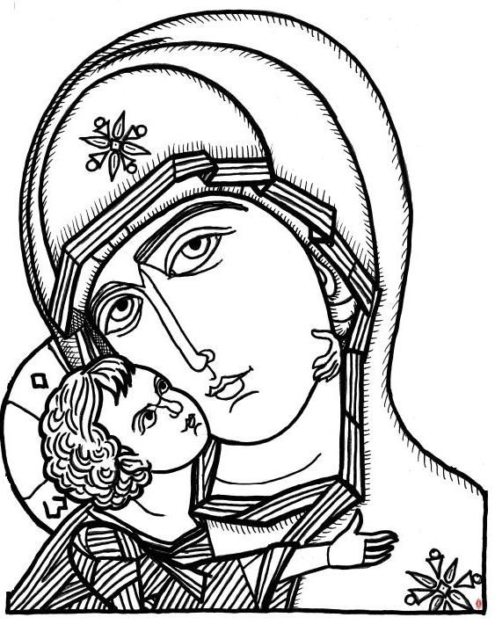
If you’re bored and looking for something to do, print this and get your crayons out and colour away!

READINGS and COLLECT FOR THE WEEK

God of compassion, whose Son Jesus Christ, the child of Mary, shared the life of a home in Nazareth, and on the cross drew the whole human family to himself: strengthen us in our daily living that in joy and sorrow we may know the power of your presence to bind together and to heal: through Jesus Christ your Son our Lord, who is alive and reigns with you, in the unity of the Holy Spirit, one God, now and for ever. Amen.

1 Samuel 1: 20 - end
In the course of time Hannah became pregnant and gave birth to a son. She named him Samuel,^{[b]}saying, ‘Because I asked the Lord for him.’
²¹ When her husband Elkanah went up with all his family to offer the annual sacrifice to the Lord and to fulfil his vow, ²² Hannah did not go. She said to her husband, ‘After the boy is weaned, I will take him and present him before the Lord, and he will live there always.’^{[c]}
²³ ‘Do what seems best to you,’ her husband Elkanah told her. ‘Stay here until you have weaned him; only may the Lord make good his^{[d]} word.’ So the woman stayed at home and nursed her son until she had weaned him. ²⁴ After he was weaned, she took the boy with her, young as he was, along with a three-year-old bull,^{[e]} an ephah^{[f]} of flour and a skin of wine, and brought him to the house of the Lord at Shiloh. ²⁵ When the bull had been sacrificed, they brought the boy to Eli, ²⁶ and she said to him, ‘Pardon me, my lord. As surely as you live, I am the woman who stood here beside you praying to the Lord. ²⁷ I prayed for this child, and the Lord has granted me what I asked of him. ²⁸ So now I give him to the Lord. For his whole life he shall be given over to the Lord.’ And he worshipped the Lord there.

Colossians 3: 12 - 17
¹² Therefore, as God’s chosen people, holy and dearly loved, clothe yourselves with compassion, kindness, humility, gentleness and patience. ¹³ Bear with each other and forgive one another if any of you has a grievance against someone. Forgive as the Lord forgave you. ¹⁴ And over all these virtues put on love, which binds them all together in perfect unity. ¹⁵ Let the peace of Christ rule in your hearts, since as members of one body you were called to peace. And be thankful. ¹⁶ Let the message of Christ dwell among you richly as you teach and admonish one another with all wisdom through psalms, hymns, and songs from the Spirit, singing to God with gratitude in your hearts. ¹⁷ And whatever you do, whether in word or deed, do it all in the name of the Lord Jesus, giving thanks to God the Father through him.

John 19: 25 - 27
²⁵ Near the cross of Jesus stood his mother, his mother’s sister, Mary the wife of Clopas, and Mary Magdalene. ²⁶ When Jesus saw his mother there, and the disciple whom he loved standing near by, he said to her, ‘Woman,^{[a]} here is your son,’ ²⁷ and to the disciple, ‘Here is your mother.’ From that time on, this disciple took her into his home.

This week’s Sermon.

Alison Henshaw was going to be preaching this Sunday so here is her talk for you to read, enjoy and reflect on. (Read the readings first!!)

Today is Mothering Sunday, the day we think about our mothers and give them a card and a present and perhaps breakfast in bed if they are lucky. Apprentices and servants used to get the day off to go back home to visit their mothers. It is also a day for thinking about our mother church – isn’t it interesting that traditionally God is seen as a father figure, and the Church as a mother figure. Today is also about half way through Lent and is sometimes called Refreshment Sunday or Rose Sunday and you are allowed to relax your fasting a little if you want to.
In the reading about Samuel his mother loved her son so much that she took him to serve God in the temple. with Eli. It may be hard for us to understand this, but she knew that she was doing the best she could for him. I’d like us now to think about our mothers and so take yourselves back to when you were a child and think about your mother. If you don’t want to do that you could think instead about a family you know now, a family special to you and the mother in that family. I was a child in the late 50s and 60s and lived in London. I had a mother and father and a younger brother, and Grandma, mother’s mother, lived downstairs. So, what was my mother like?
When she went shopping she took her basket with her. Here it is. But it hasn’t got just her shopping in it today. There are lots of other things in here as well.
shopping, cooking, cleaning, washing, ironing – she keeps the house and me nice and makes sure I have all I need. Hannah’s mother in the story we have just heard made Samuel a little jacket which he took with him when she left him with Eli, and she made a bigger one for him each year.
1st Aid – she sticks on a plaster when I fall over, she kisses me better, she cares for me, looks after me when I am sick, and when I was little she did things for me like doing up my buttons and tying my laces. One of today’s readings was the story of baby Moses whose mother made a cunning plan to make sure that he escaped death at the hands of Pharaoh.
car – she took me to school and made sure that I was where I needed to be and that I was safe. Mary and Joseph took Jesus into Egypt to escape from Herod
smile/arms/ears/heart – she loves me, listens to me, cuddles and comforts me when I am upset and shares my joys and my sorrows. Mary was there on many occasions, even when Jesus was crucified.
sad face – she tells me off and corrects when I am naughty and forgives me when I say sorry; she would go and look for me if I was lost and brings me back to where I should be. Mary and Joseph looked for Jesus when they thought he was lost.
book/game – she spends time with me, perhaps reading to or with me and perhaps helping me with my homework, enabling me to do better. We have ‘family time’ perhaps playing a game together. Samuel’s mother had to give this up when she dedicated him to serve God but she did it for the right reasons.
pay slip – she was a teacher. She supports me so we can have the things we need and perhaps go on holiday together.
phone – my mother of course did not have a mobile phone but there was a land line and she was always there for me, and ready to listen to me, but she might also ring me up and ask me to do something for her.
mirror – a mother’s love is a reflection of God’s love for all of us; we are all his children. He takes care of us, heals us and makes us better, he looks after us, he protects and supports us, he listens to us, comforts us and shares our joys and our sorrows, he corrects and forgives us, he meets our needs, he always has time for us and enables us to be the best we can be, and above all he is always there for us and looking out for us. The Gospel reading reminds us that Jesus, God incarnate, saw his mother standing at the foot of the cross and even in the agony of hanging on the cross, made sure that after his death she had somewhere to go and live and someone to be with. God is bigger/greater than we are.
So let us say thank you to God for everyone who cares for us and has cared for us, not only our mothers but our Grandmas or a big sister or another family member, a godparent, a friend, a neighbour, a carer, a foster mother, a teacher, and remember that God loves all of us whatever we are like and let us think about how we can show his love to other people. In a minute everyone will be invited up to receive a bunch of flowers so children you can give yours to your Mum or to someone else to thank them and show them how much you love them, and God loves them, and all of us can give a bunch of flowers to someone as a sign of God’s love for all of us that we are sharing with them.

Notices

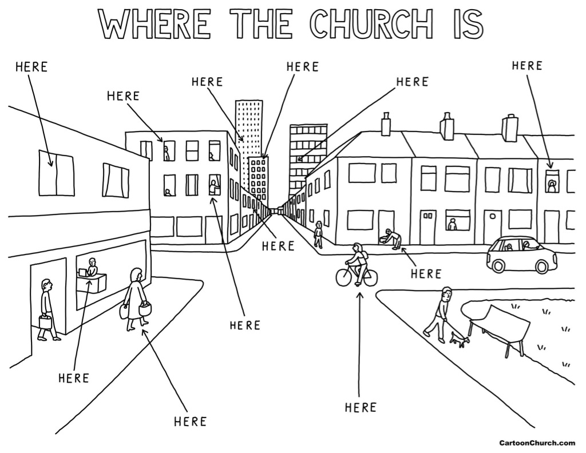
As you are all aware all, services and gatherings are suspended for the time being. But that doesn’t mean church is suspended!

The Ministry Team are looking at setting up a ‘buddy’ system to make sure that as we all practice social distancing and self-isolation, everyone in church has a group of people that ring each other regularly and we all check up on each other. We realise that many of you do this already but we want to make sure that no one slips through the net.

There are various Christian broadcasts available this week – this list is
not exhaustive – please let Rachel know if you know of anything that is available!
(email stpetersoffice10@btinternet.com)

Sunday 8.10am Radio 4 Sunday Worship
Sunday 3pm Radio 3 Choral Evensong
Sunday 1.15pm BBC1 Songs of Praise
Monday 8pm ITV St David’s: Britain’s Smallest Cathedral
Wednesday 3.30pm Radio 3 Choral Evensong
Wednesday 8.45pm Radio 4 Lent Talks

The Archbishop of Canterbury will be broadcasting a service for Mothering Sunday on Sunday at 9am! You can watch that on www.churchofengland.com. The CofE site also contains various resources for daily prayer.

If you are on Face Book you can access services from Derby Cathedral and other Parishes around the Diocese.

And Simeon Wood is doing a free concert from his living room on Sunday 22nd March at 8pm – you can watch and listen on Face Book – see link below:
https://www.facebook.com/simeon.wood.7

Light a candle of hope:

A national call to prayer
Presidents of Churches Together in England have issued a call to prayer in the light of the Coronavirus pandemic. This is for all churches and people of prayer to join on Sunday 22nd March, Mothering Sunday.
At 7pm this Sunday, light a candle in the windows of your homes as a visible symbol of the light of life, Jesus Christ, our source and hope in prayer.

“Cast all your anxiety on him,
because he cares for you” 1 Peter 5:7

For our Prayers this week:

Red Prayers: Jason Reynolds, Bob and Kathleen Winrow, Patricia Bowers, Lucy, Isis Spendlow-Rawlings, Frank, Stephen Thorp, Gwen Lunt, Andrew Mason, Jean Lewis, Richard Lewis, Marney, Marion and Tony, Andrew, Tony Gray, Eriko Curtis, Lacey and Robin
Amber Prayers: Mike Curtis, Mark Whiteman, Sue Reynolds, Val Mason, Freda Duffield, Beryl Ratcliffe, Ava,
Green Prayers: Phil Hewitt, Margaret Wheldon, Doreen Tivey, Betty Lister, Lin, Arthur, Nancy

We pray for those who have died:
Elizabeth O’ Toole, Michael Reid, Horace Weedon

Thanksgivings: We give you thanks for community

Praying for Chellaston: We pray for the residents of Glenwood Road, Weston Rise, Boyd Grove, Woodlands Lane and Aston Close

Prayer Wheel: See page 7 for how to use this.

Prayer Walk: There will not be a prayer walk until after the Covid-19 crisis is over! Do prayer walk virtually

Prayer Requests: forms available in church

Prayer Group: First Saturday of the month in Church at 9.45am for simple breakfast. Prayer begins at 10am and lasts for about an hour.

Prayer of the Week:
God of all, we thirst to know you better, to grow closer to you each day. Reach out now and speak your word of life. Equip us to worship you in Spirit and in truth, so that your grace may pour upon us, and your love well up in our hearts, refreshing, reviving and renewing, satisfying body, mind and soul. Meet us here, in all our weakness, and grant us the living water that you alone can give. Amen
Prayer for Covid-19:
Keep us, good Lord, under the shadow of your mercy in this time of uncertainty and distress. Sustain and support the anxious and fearful,
and lift up all who are brought low; that we may rejoice in your comfort
knowing that nothing can separate us from your love in Christ Jesus our Lord. Amen.

Prayer Wheel
Prayer requests may be made to either Rachel or BJ and they will send them round the people on the list for the wheel.
Rachel Harrison 07732337717
Revd BJ Facey 01332 704835

Ideally the wheel should complete within an hour. Once a request has returned to Rachel or BJ the wheel stops.

Hymns

Tell out my soul

1 Tell out, my soul, the greatness of the Lord:
Unnumbered blessings give my spirit voice;
Tender to me the promise of his word;
In God my Saviour shall my heart rejoice.
2 Tell out, my soul, the greatness of his Name:
Make known his might, the deeds his arm has done;
His mercy sure, from age to age to same;
His holy Name, the Lord, the Mighty One.
3 Tell out, my soul, the greatness of his might:
Powers and dominions lay their glory by;
Proud hearts and stubborn wills are put to flight;
The hungry fed, the humble lifted high
4 Tell out, my soul, the glories of his word:
Firm is his promise, and his mercy sure.
Tell out, my soul, the greatness of the Lord
To children's children and for evermore.

Peruvian Gloria
Glory to God, glory to God, glory to the Father!
Glory to God, glory to God, glory to the Father!
To God be glory forever!
To God be glory forever!
Alleluia, Amen!
Alleluia, Amen! Alleluia, Amen! Alleluia, Amen!
Glory to God, glory to God, Son of the Father!
Glory to God, glory to God, Son of the Father!
To God be glory forever!
To God be glory forever!
Alleluia, Amen!
Alleluia, Amen! Alleluia, Amen! Alleluia, Amen!

Glory to God, glory to God, glory to the Spirit!
Glory to God, glory to God, glory to the Spirit!
To God be glory forever!
To God be glory forever!
Alleluia, Amen!
Alleluia, Amen! Alleluia, Amen! Alleluia, Amen!

He’s got the whole world in his hands

He's got the whole world in his hand. (x3)
He's got the whole world in his hand.

He's got you and me, brother, in his hand. (x3)
He's got the whole world in His hand.

He's got you and me, sister, in his hand. (x3)
He's got the whole world in His hand.

He's got you and me, mother, in his hand. (x3)
He's got the whole world in His hand.

He's got everybody here in his hand. (x3)
He's got the whole world in his hand. (x4)

Teach me to dance

Teach me to dance to the beat of your heart,
Teach me to move in the power of your Spirit,
Teach me to walk in the light of your presence,
Teach me to dance to the beat of your heart.
Teach me to love with your heart of compassion,
Teach me to trust in the word of your promise,
Teach me to hope in the day of your coming,
Teach me to dance to the beat of your heart.

You wrote the rhythm of life,
created heaven and earth,
In You is joy without measure,
So, like a child in your sight,
I dance to see your delight,
For I was made for your pleasure,
pleasure.

Let all my movements express,
a heart that loves to say 'yes',
A will that leaps to obey you,
Let all my energy blaze,
to see the joy in your face,
Let my whole being praise you,
praise you.
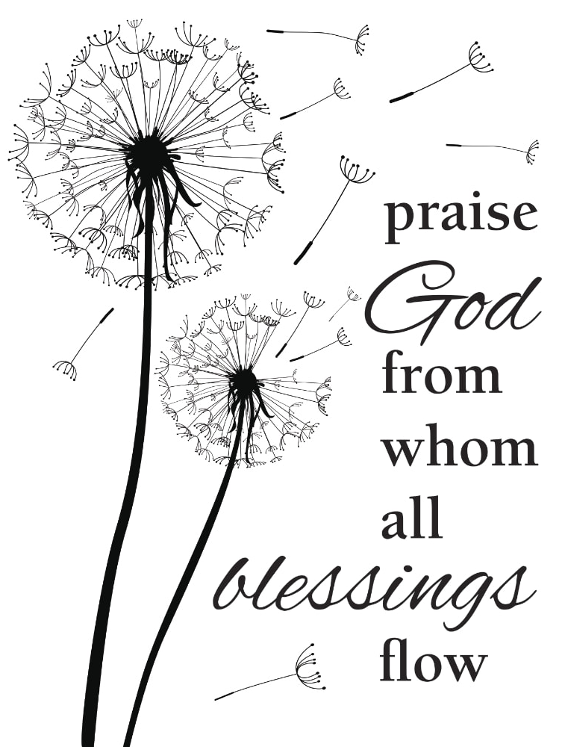

LECTIONARY READINGS FOR THE WEEK
Monday 23rd March | Psalm 77  Exodus 2: 11 - 22  John 4: 43 - end
Tuesday 24th March | Psalm 79  Exodus 2: 23 – 3: 20  Hebrews 9: 15 - end
Wednesday 25th March  Annunciation of our Lord to the BVM | Psalm 111  1 Samuel 2: 1 - 10  Romans 5: 12 - end
Thursday 26th March | Psalm 86  Exodus 4: 27 – 6: 1  Hebrews 10: 19 - 25
Friday 27th March | Psalm 102  Exodus 6: 2 - 13  Hebrews 10: 26 - end
Saturday 28th March | Psalm 32  Exodus 7: 8 – end  Hebrews 11: 1 - 16
Next Sunday: Sunday 29th March
The Fifth Sunday of Lent

Readings: Psalm 130
Ezekiel 37: 1 – 14
Romans 8: 6 – 11
John 11: 1 - 45

Romans

Lord Jesus Christ, you said to your disciples,
‘I am with you always’.
Be with me today, as I offer myself to you.
Hear my prayers for others and for myself,
and keep me in your care.

Christ be with me, Christ within me,
Christ behind me, Christ before me,
Christ beside me, Christ to win me,
Christ to comfort and restore me.
Christ beneath me, Christ above me,
Christ in quiet, Christ in danger,
Christ in hearts of all that love me,
Christ in mouth of friend and stranger. from St Patrick’s Breastplate

