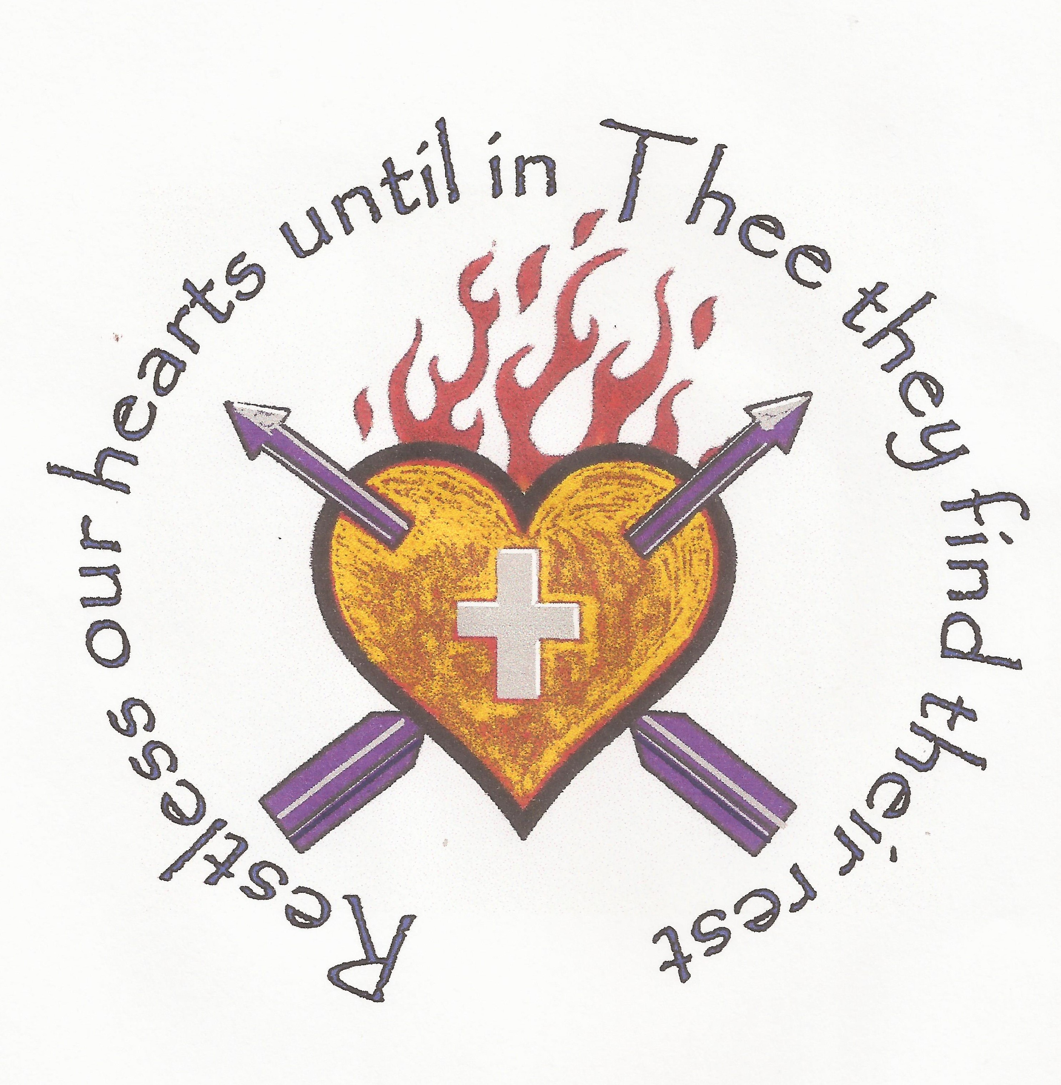
Parishes of
St Peter and St Paul
and St Augustine
Wisbech

Deanery of Wisbech Lynn Marshland

Suspension of public worship, but…
‘The Way’ continues

Jesus said ‘I am the way the truth and the life’

Dear Friends

The Archbishop of Canterbury has ruled that in Anglican Churches, ‘public worship will have to stop for a season’ and that ‘…our usual pattern of Sunday services and other mid-week gatherings must be put on hold’. This is to ensure that we do not make places of worship and healing the very places from which the Covid-19 virus is spread. But ‘the Way of the Cross’ never ceases and we have work to do…

In his message Archbishop Justin urges us to find other and more creative ways to remain together as the Body of Christ and to do whatever we can to continue to serve the public. What is set out below is our ‘starting position’: more will follow.

- Staying in touch

Last Sunday I asked all members of both congregations to form into ‘self supporting pods’ building on existing networks and groupings and to make sure that no-one is missed out. Please would you make sure you have done this and remain in regular contact with your other ‘pod members’?

Revd Claire and I will be ringing members of the congregation from time to time using the information we have been provided on the electoral roll. Please bear with us: there are quite a lot of you …but you can always ring or e-mail us!

- Praying and worshipping together

We will be using the church Facebook pages to post regular articles and chats, and also to direct you to prayer resources. We also hope to be able to post regular ‘thoughts and reflections’ on the Facebook page called ‘Vicar’s Verbals’ - search for it or look for the link from your church Facebook page. I am also working on the possibility of a live-streamed service. This may not be ready for a week or so but I hope to have something in place soon.

The Archbishop has asked us all to keep Mothering Sunday (this Sunday 22nd March) as a day of prayer and action. Please say prayers at 10am and at 7pm in the evening, and (if it is safe to do so) place a lighted candle in a window at 7pm. We will be praying with you.

- Visiting and other pastoral offices

It will not be possible for any minister to visit you if you have Covid-19 or symptoms which suggest this is a possibility: we are simply not permitted to do so. Further to this, if you are self-isolating you should not be receiving visits from us for your own safety. It is a matter for you whether you visit or receive visits from other people in your ‘pod’, but be careful not to expose yourself or anyone else to risk when a chat over the phone would be safer.

I am still waiting for guidance about baptisms, weddings and funerals, but as these are ‘public’ services, they appear to come under the blanket ban. We think that ministers may be asked to carry out ‘private’ services (close family only) in the event of an emergency.

In the meanwhile, please stay in touch with me - e-mail is great - and keep me updated. If you become ill I will phone you and pray with you (but I need to know).

- Church buildings

We have been asked to ensure that those places of worship which are habitually open for the public to use for quiet prayer remain open for as long as possible. St Peter & St Paul will remain open for people to pray, to light candles and to sit for a while, for as long as we can manage this with a revised system for opening and closing. St Augustine will remain closed to the public for now; most if not all of the regular users are suspending their meetings.
……..

This will be a testing time for all of us, but I am privileged to serve two congregations which are loving, prayerful, generous, caring and robust. Many of the older folk, whom the media describe as ‘vulnerable’ have lived through troubled times before and will be both resilient and wise. They will be our strength by praying for us and reassuring the younger generation. Father David, Revd Claire, Keith Aplin and your ALM’s, and of course I will be praying for you all: please pray for us too.

With every blessing: stay safe and well

Matthew

