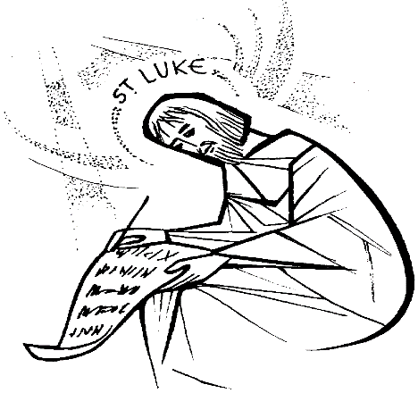

The Parish of St Luke the Evangelist
Patronal Festival

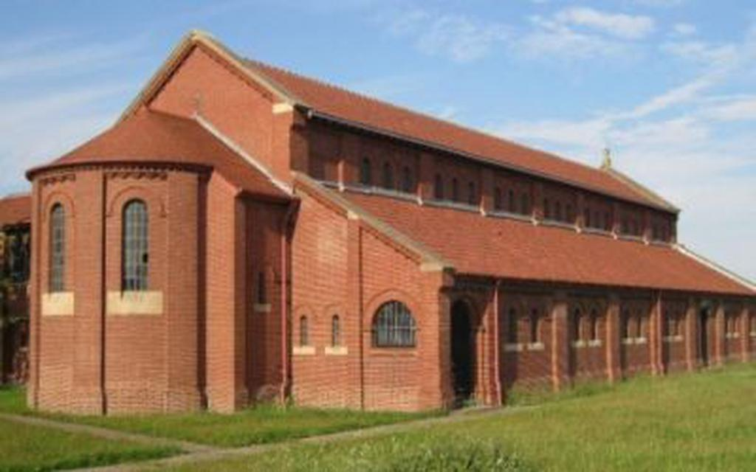

Friday, 18th October, 7.00p.m.
Celebrant and Preacher, Bishop Martyn Jarrett.

Members of the Society and SSC are invited to concelebrate.

Refreshments and fellowship to follow. All welcome. Please come and join in this wonderful celebration.

Please RSVP at: saintlukesnewrossington90@gmail.com

