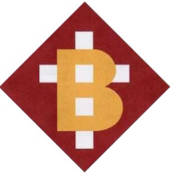
Bartestree Cross Benefice
Easter Services

Mothering Sunday 31st March
10.00am Group Family Communion Lugwardine

Palm Sunday 14th April
9.30 Family Service Lugwardine
9.30am Holy Communion Withington
11.00am Morning Prayer Westhide

Maundy Thursday 18th April
7.00pm Group Holy Communion Westhide

Good Friday 19th April
2.00pm Group GF Service Dormington

EASTER DAY 21st April
9.30am Communion Lugwardine
9.30am Communion Withington
11.00am Family Communion Dormington
11.00am Communion Westhide

11.15am Holy Communion Weston Beggard
followed by Easter Egg Hunt

