The United Benefice of Barton with Peel Green & Winton.
St Michael & All Angel’s, Peel Green.
St Mary Magdalene, Winton.

Web: www.stmichaelpeelgreen.org.uk
www.stmarymagdaleneeccles.org.uk
Twitter: @peelgreenwinton

Welcome...
to our Benefice churches. Tea & coffee is served after Mass. Please do join us, and if you are a visitor, make yourself known to Father Ian, or to Anne & Bryan, the churchwardens at St Mary Magdalene’s, or Fiona, the churchwarden at St Michael & All Angels.
Barton with Peel Green & Winton
United Benefice Prayer
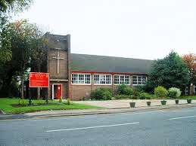
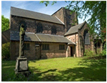
Lord, you said, ‘Go make disciples of all people’. Through lives of prayer and service may we reach out and share our faith with all your people. Renew St Michael & All Angels & St Mary Magdalene churches for mission and service by what we are, by what we say, and by what we do for others. Amen.

MASS & SERVICE TIMES THIS WEEK
Tues. 22nd Jan. 10.00am (St Mary Magdalene’s)
Wed. 23rd Jan. 10.00am (St Michael’s)
11.00am (St Mary Magdalene’s)

Thurs. 24th Jan. No Mass

Fri. 25th Jan. 10.00am (St Mary Magdalene’s)
followed by the Divine Mercy
Chaplet at 10.30am
(Conversion of St Paul)

Sunday 27th Jan. 9.15am Sung Mass St Mary
Magdalene’s

11.00am Sung Mass St Michael’s
(3rd Sunday in Ord. Time Yr. C)
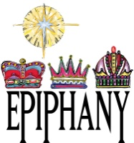
There is Epiphany water & chalk available in both churches. Please do take some of this water & chalk & use the sheets available at the back of church to bless your homes during the epiphany season.
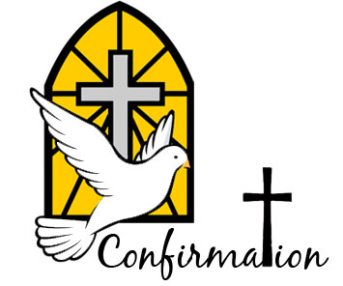
On Wednesday 27th Feb 2019 at 7.00pm in St Michael’s there is a Confirmation Mass celebrated by the Bishop of Beverley for our United Benefice. If you or someone you know wants to be confirmed please give all names to Fr Ian. And please put this date on your calendars as we need a good attendance from both churches.
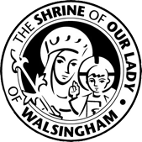
The United Benefice Pilgrimage to the Shrine of Our Lady of Walsingham will take place this year from Mon 10th – Fri 14th June. The cost will be £229.40p half board. If you would like to go on this please can you sign the sheet at the back of each church & give Fr Ian a £30 deposit to secure your place ASAP. We are restricting numbers to 14 people for transport purposes so it will be on a first come basis.
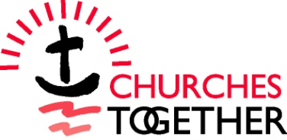
The Churches Together in Eccles Unity Service will take place in Patricroft United Reformed Church this afternoon, Sunday 20th January, at 4.00pm. All welcome.
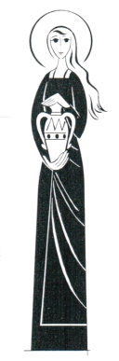

...AT ST. MARY
MAGDALENE’S, WINTON

TO BOOK BAPTISMS OR WEDDINGS (INCLUDING BANNS) PLEASE SEE FR IAN OR ONE OF OUR BAPTISM TEAM, KAREN OR LYNN, AFTER ANY 9.15AM SUNDAY MASS.

INTERCESSION RESPONSE:
May we come to share in the divine life of Christ,
Who humbles himself to share our human life

CHILDREN’S CHURCH 9.10am-10.25am EVERY SUNDAY. PAINTING, CRAFTS, STORIES & LOTS OF FUN. ALL WELCOME

The High Altar lamp is burning this week FOR THE DUKE OF EDINBURGH

The Lady Chapel lamp is burning this week FOR THE GOVERNMENT & THEIR BREXIT TALKS

PLEASE PRAY FOR:
The sick, among them: Ella Martin, Dorothy Gregory, Millie Parker, Tasha Marsley & family, Adrienne Bolton, all the sick in the parish & any known to us.

Those who have died recently:

And from the years mind: Leah Davis 1975, Constance Mary Clemson 1983, Edna May Dobson 1993, Elsie Dickie 1996 (20), John Bigland 1976, Malcolm Brizland 1977, William Thompson Forster 1977, May Gibbons 1978, Eric Poole 1992, Freda Simpson 1994, Phyllis Winifred Lindop 1998, David William Smith 2007 (21), Dorothy Wood 1970 (22), Isabel Jones 1979 (24), William Young 1975, Lily Brook 1979 (25), Iris Marjorie Wolsey 1978, Ellen Hallsworth 1993 (26).

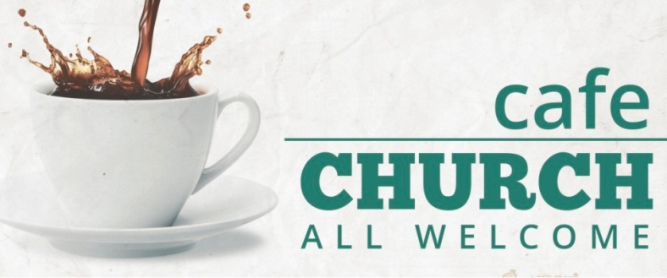
On Sunday 10th February 2019, we will be launching a new venture for St Mary Magdalene’s Church, which is ‘THE CAFE CHURCH @ THE MAGDALENE CENTRE’. On the second Sunday of every month from 11.15am – 12.15am we will be holding a different type of church in the Magdalene Centre with a much more informal type of worship. Free food, coffee & tea will be served & newspapers & magazines will be available. There will be crafts & games for the children. Fr Ian will give a brief talk on the subject of the day & the adults will discuss the topics & feedback will be taken. All of this will be interspersed with modern songs & hymns. We realise this is not everyone’s ‘cup of tea’, so certain people in our church are helping with this venture, which we hope will appeal to those in our community who have very little experience of Christianity & the church & would be ‘put off’ with more formal worship. We will be giving this Cafe Church a year after which we will review how it has gone. All we ask is that you support this venture with your prayers & be positive about what we are trying to achieve. Thank you.
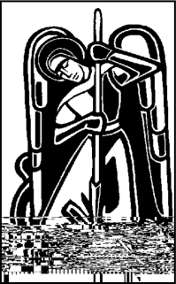

..AT ST. MICHAEL’S,
PEEL GREEN

The Sanctuary lamp is burning this week: FOR THE GOVERNMENT & THEIR BREXIT TALKS

The Lady Chapel lamp is burning this week: FOR THE DUKE OF EDINBURGH

Altar Flowers this Week: IN LOVING MEMORY OF DORIS COLLANTINE (W. Collantine)

PLEASE PRAY FOR:
The sick, among them: Kate Lamb, Rita Byrne, all the sick of the parish & any known to us.

Those who have died recently:

And from the years mind: Jean Patterson & Joseph Patterson.

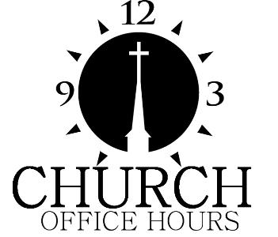
TO BOOK BAPTISMS & WEDDINGS (INCLUDING BANNS) PLEASE COME TO ST MICHAEL’S SOCIAL CLUB ANY SUNDAY AFTER MASS BETWEEN 12.15PM-1.15PM

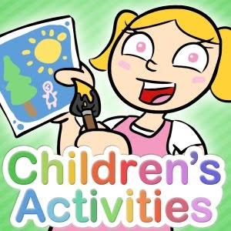
ALL CHILDREN ARE WELCOME TO JOIN IN THE ACTIVITIES THAT TAKE PLACE DURING SUNDAY MASS. THE CHILDREN’S AREA CAN BE FOUND NEAR THE MUSIC GROUP.

Parish Priest: Fr Ian Hall SSC Tel: 0788 4117943
Retired Priests: Fr David Schofield SSC & Fr Robert Varley
Churchwardens: Anne & Bryan Croft (Winton) and Fiona
Heppleston (Peel Green)

