AGAPE | Suffolk Heights Benefice  Parishes of All Saints’, Chedburgh; All Saints’, Chevington;  St Mary the Virgin, Depden; St Edmund’s, Hargrave;  St Mary’s, Hawkedon; and All Saints’ Rede
February 2019

CANDLEMAS
The Feast of the Presentation of Christ in the Temple
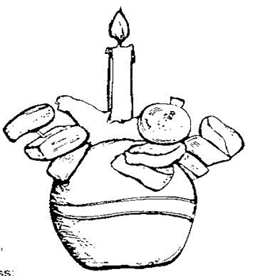
That moment, when Simeon takes the babe in his arms,
echoes through the centuries:

Lord, now lettest thou thy servant depart in peace:
according to thy word.

For mine eyes have seen:
thy salvation;

Which thou hast prepared
before the face of all people;

To be a light to lighten the Gentiles:
and to be the glory of thy people Israel.

It was a very special moment. God’s gift in Christ is for all peoples, a love that continues to unfold through our living God’s life on earth.

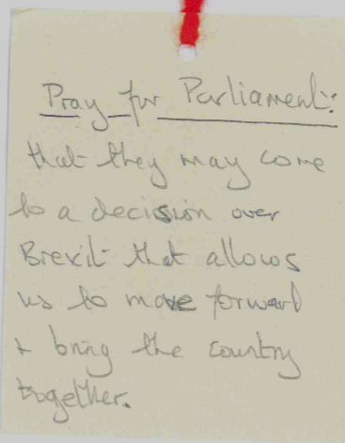
Messy Church meets on Saturday 2nd in Hargrave Village Hall between 4 and 6pm in preparation for the Candlemas Praise at Hargrave on Sunday 3rd at 11am. Then there will be a Taizé Communion at All Saints’, Chevington on Sunday, 3rd February at 6pm . This offers an opportunity to be quiet and reflect on Simeon’s Prayer, that God may grant us the grace to use aright the time that is left to us on earth; that he will dispel the darkness in our lives, and strengthen us to follow the steps of Jesus Christ, in the way that leads to the fullness of eternal life. Please join in our worship on this special day.

From the Christmas Tree Prayer Tags

Do join us at
All Saints’, Chevington for
Morning Prayer
on Friday, 25th January
at 9.30am
on the
Feast of the
Conversion of St Paul

__________________________________________________________________
From the Rectory 01284 850857
Chevington mlima001@btinternet.com
WEEK OF PRAYER FOR CHRISTIAN UNITY
(January 18th to January 25th)

Heavenly Father you have called us in the Body of your Son Jesus Christ to continue his work of reconciliation and reveal you to humankind. Forgive us the sins which tear us apart; give us the courage to overcome our fears and to seek that unity which is your gift and your will, through Jesus Christ our Lord. Amen

The Week of Prayer for Christian Unity is an international Christian ecumenical observance kept annually over eight days between 18 January (Feast of the Confession of St Peter) and 25 January (Feast of the Conversion of Paul). The theme, chosen this year by the Church in Indonesia, is ‘Justice, only justice, you shall pursue’ (cf. Deuteronomy 16.²⁰). Speaking powerfully to the local churches throughout Indonesia, the theme also recognises this common need throughout the world. Only by heeding Jesus’ prayer, ‘that they all may be one’ can we witness to living Christian unity in diversity. We are all called together to form a united witness for justice and so Christian unity becomes a means of Christ’s healing grace for the brokenness of the world.
CHURCH ELECTORAL ROLL

Every six years the electoral roll has to be updated. This is currently underway. Please return your form as soon as possible in readiness for the Annual Parochial Church Meeting, details of which are as follows:

All Saints’, Chedburgh on Sunday, 24th March at 10.45am;

All Saints’, Chevington on Sunday, 17th March at 9am

St Mary’s, Depden on Sunday, 17th March at 11am;

St Edmund’s, Hargrave on Sunday, 17th March at 3pm;

St Mary’s, Hawkedon on Sunday, 10th March at 9am; and

All Saints’, Rede on Sunday, 14th April at 10.45am.

LENT LUNCHES

On Ash Wednesday (March 6th) there will be Communion with the Imposition of Ashes at All Saints’, Chevington at 7.30pm

During Lent, there will be a soup and cheese lunch at noon in the following Village Halls:
Wednesday, 13th March in Hargrave Village Hall;
Wednesday, 27th March in Rede Village Hall; and
Wednesday, 10th April in Chevington Village Hall.

On Maundy Thursday, April 18th there will be an Agape Supper in Chevington Village Hall at 7pm.

Donations are invited in support of the church’s work in Kagera, Tanzania
A reflection on the ‘Calling’ of St Paul

‘Go, for he is an instrument whom I have chosen to bring my name before Gentiles and kings and before the people of Israel’. (Acts 9:15)

On January 25th we celebrate this famous event in Paul’s life where, on the road to Damascus, he received his calling from Christ. Through the vision, courage and the hands of Ananias, in the tiny house of Judas in Straight Street, Paul was empowered by the Holy Spirit to proclaim that: ‘Jesus is the Son of God’. This event was not a ‘conversion’, for Paul never lost his faith in God, nor his zealousness to do God’s will. But it was a ‘calling’, as he was chosen by God to proclaim the good news to many peoples.

The perception of children never ceases to amaze me. This week, in studying the history of the Tenach (the Hebrew Bible), or the Old Testament as we name it, we reflected that these were the scriptures that Jesus, as a Jew, knew. Their thinking, as 10 year olds, caused them to ask: ‘If Jesus was a Jew, and we are called to follow Jesus, why are we called Christians?’

Over the years we, as a Church, have implicitly inferred that Jesus was a Christian and have more explicitly taught that Paul was the first Christian, hence the feast day of the ‘Conversion of St Paul’ on January 25th. In Advent we reflected on heresy, the historical and contemporary bad thinking about God. Such inaccurate thinking also characterises our understanding of the early Church history and consequent assumptions about Jesus and Paul.

I have no doubt that Paul would never have imagined that his letters to specific communities in specific contexts would become part of the Scriptures within the New Testament. His letters contain advice, but also his own wrestling with life and beliefs, as he seeks to theologise what his own calling and the commitment of the embryonic faith communities in their cultural contexts, means. In his last letter, to the Romans, considered the most developed theologically, he affirms his identity as a Jew – ‘I myself am an Israelite, a descendant of Abraham, a member of the tribe of Benjamin.’(Romans 11:1) Interestingly, he never gives detailed references to any aspects of Jesus’ life or ministry. His arguments are steeped in quotations from the Holy Scriptures. ‘For there is no distinction between Jew and Greek; the same Lord is Lord of all and is generous to all who call on him. For, “Everyone who calls on the name of the Lord shall be saved.”’ (Romans 10: 12-13 cf. Joel 2: 32)

Jewish identity was defined through God’s covenant with His people, in the giving of the Law. Law in its widest sense was conveyed by the 613 commandments contained in the Torah, not to become a rod of judgment, but a means of loving and worshipping God. Paul affirms that ‘the law is holy, and the commandment is holy and just and good’ (Romans 7: 12) and ‘I delight in the law of God in my inmost self,’ (Romans 7: 22). The call to love God and to love our neighbour presents a timeless challenge to God’s people.

Paul’s vision was developed through his encounter with Christ, to continue to make God’s glory known in the world. ‘Do not be conformed to this world, but be transformed by the renewing of your minds, so that you may discern what is the will of God – what is good and acceptable and perfect.’ (Romans 12: 2) We are called like Paul, to ‘Go’ to be ‘instruments of thy peace’ (Francis of Assisi) and to reflect wisely on our Jewish spiritual heritage: ‘For who has known the mind of the Lord?’ (Isaiah 40: 13/ Romans 11: 34)

We too are descendants of Abraham. Do our lives show that we are children of the same heavenly Father?

Simon has not just become the incurable romantic! But this is a familiar symbol of February 14th – known to you all as Valentine’s Day. Less well-known is that Valentine was martyred in Rome in the third century. His connection with love is a mystery, but he certainly should be the patron saint of commerce for it is estimated that we spend £958 million celebrating this day with gifts, flowers and meals!

